Computer Networks Lab-9

Name: Shagufta Anjum  
Roll No: 19XJ1A0568

**Installation of Mininet:**

1. Clone the mininet github repository

git clone <https://github.com/mininet/mininet>

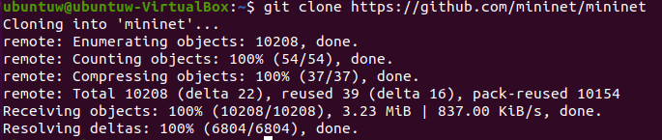

1. Download and install pip

wget <https://bootstrap.pypa.io/pip/2.6/get-pip.py>

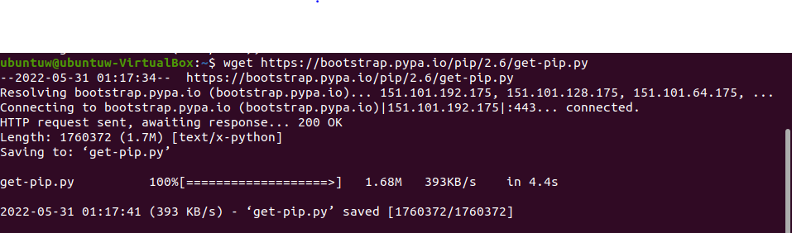

1. Install Mininet:

mininet/util/install.sh -a

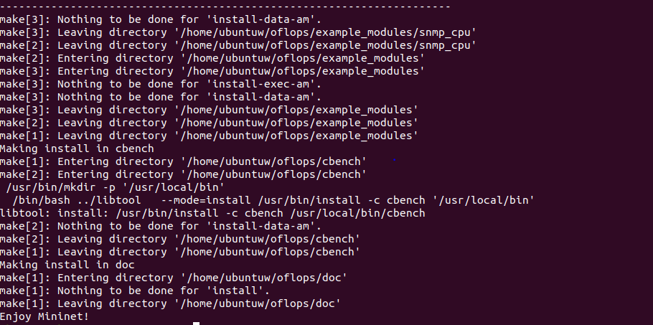

1. Check if Mininet is properly installed

sudo mn --switch ovsbr --test pingall

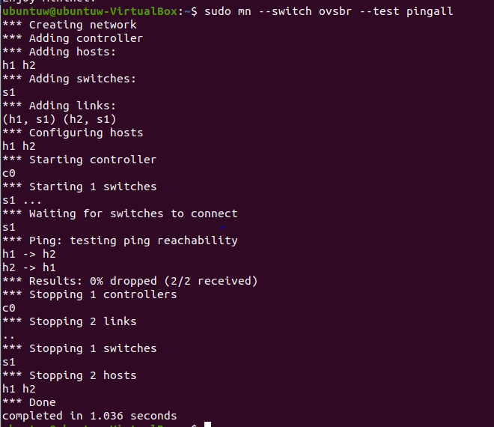

**Execution:**

Open two separate terminals.

Terminal-1

Run the lab9.py program  
ryu-manager Lab9.py

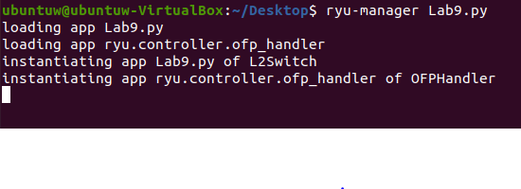

Terminal-2

Start mininet  
sudo mu

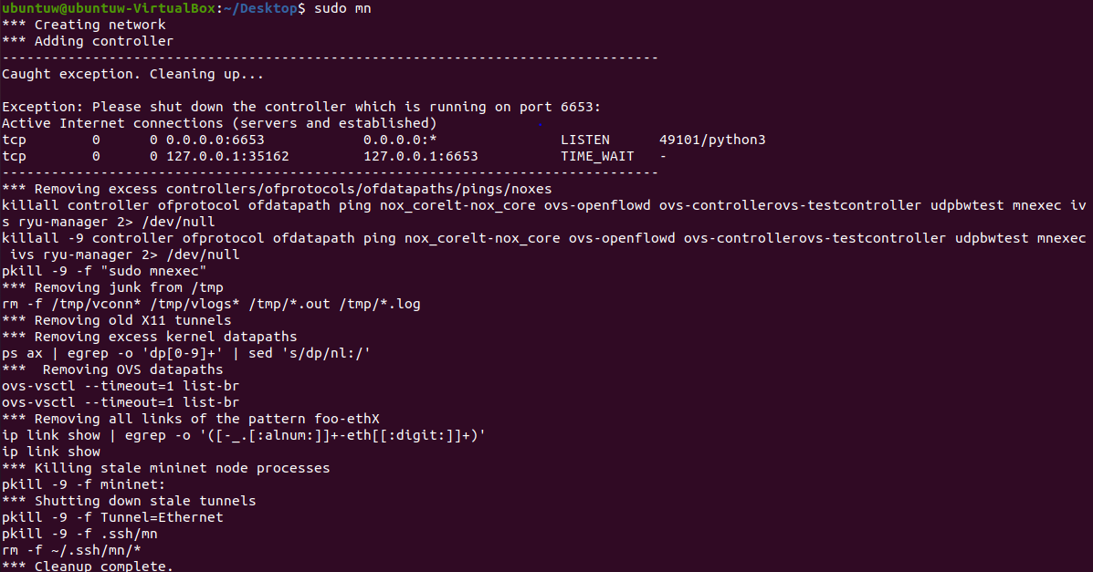

Terminal-1

