**LAB-1**

1. **Write a Java program to print "Hello, World!" to the console.**

package demo;

public class hello {

public static void main(String[] args)

{

// TODO Auto-generated method stub

System.out.println("Hello World!");

//Print Hello World! to the console

} }

**Output:**

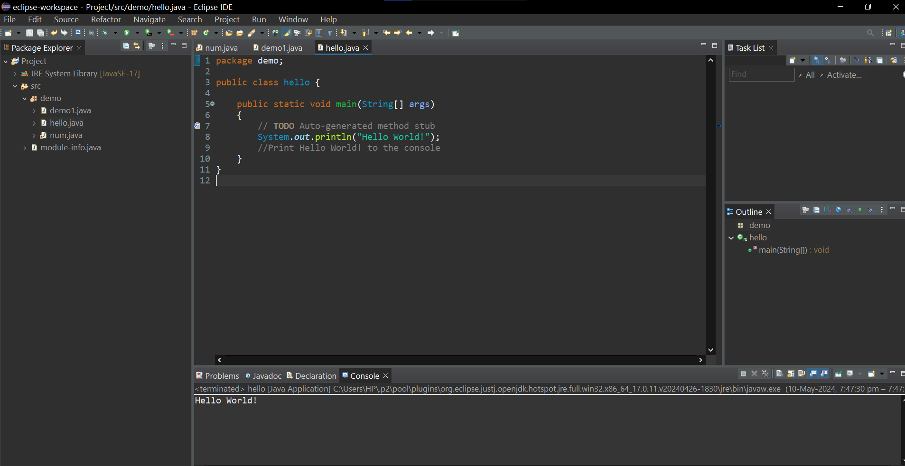

1. **Write a program to find the sum of two numbers entered by the user.**

package demo;

import java.util.Scanner;

//Import the Scanner class

public class addition {

public static void main(String[] args) {

// TODO Auto-generated method stub

int a,b,c;

Scanner sc=new Scanner(System.in);

System.out.println("Enter 1 no:");

a=sc.nextInt();

//Takes user input

System.out.println("Enter 2 no:");

b=sc.nextInt();

//Takes user input

c=a+b;

//Calculate the sum of numbers

System.out.println("Sum is : " + c);

//Print the sum of numbers

}

}

**Output:**

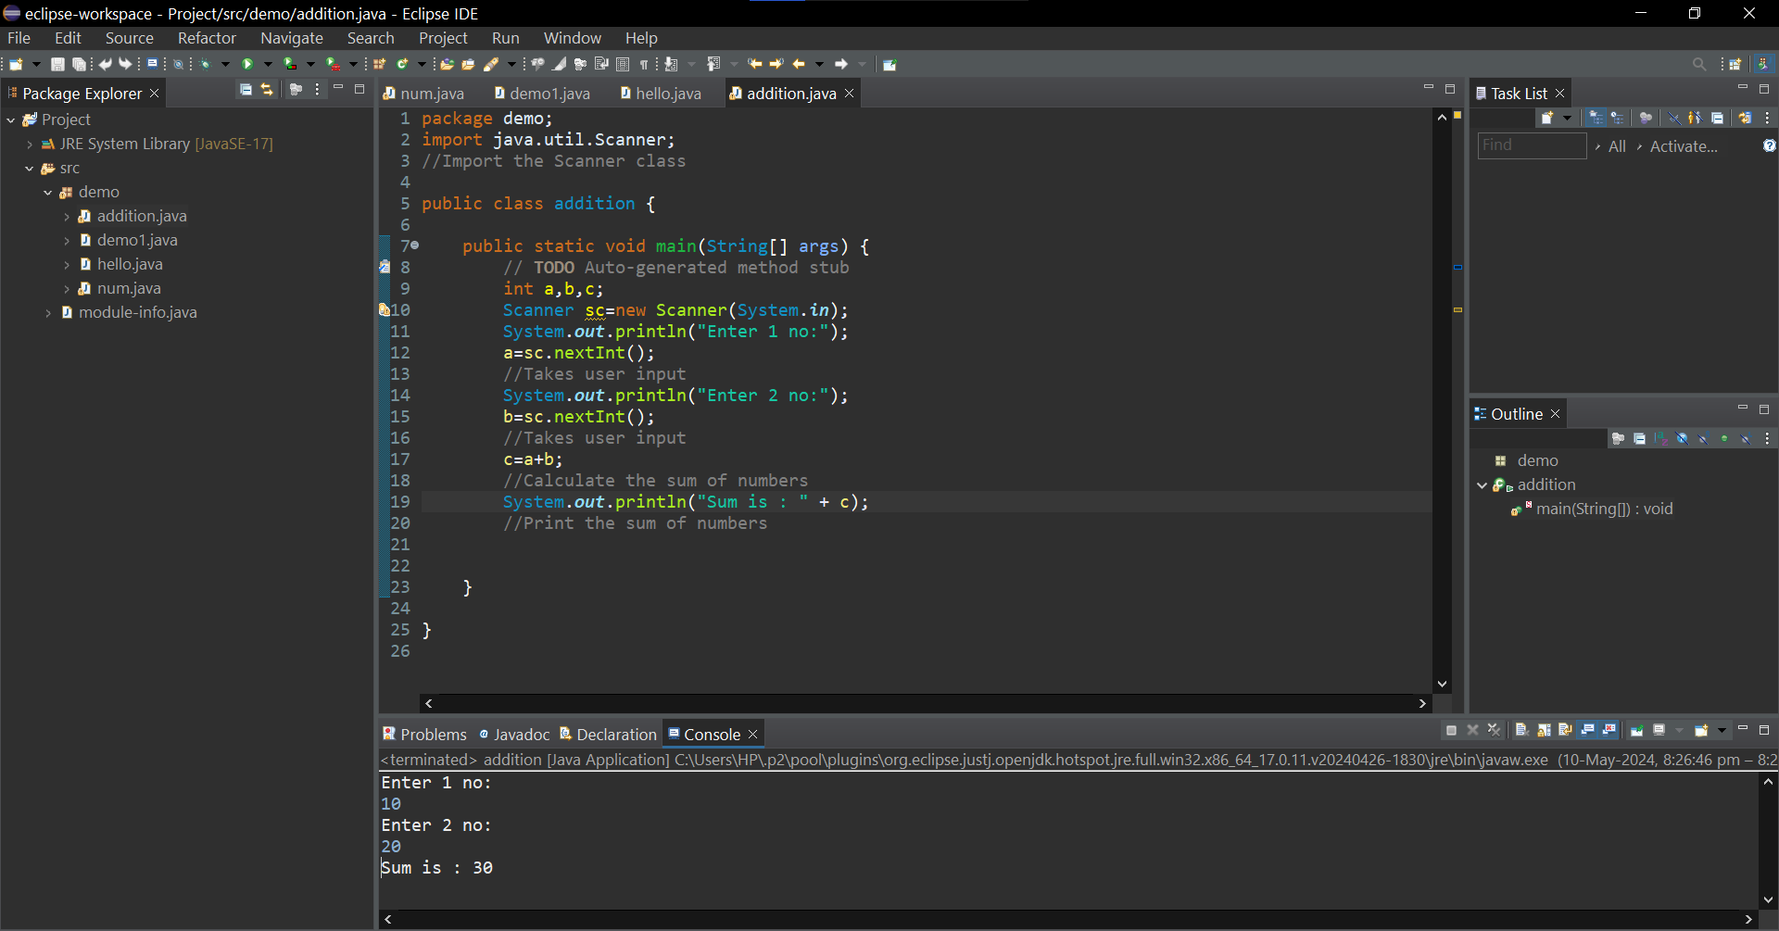

1. **Write a Java program to check whether a given number is even or odd.**

package demo;

import java.util.Scanner;

//Import the Scanner class

public class num {

public static void main(String[] args) {

// TODO Auto-generated method stub

Scanner sc = new Scanner(System.in);

System.out.println("Enter a no:");

//Takes input from user

int a=sc.nextInt();

if(a % 2==0)

//Checks the condition if the number divided by 2 gives 0 as remainder or not

System.out.println(a + " is even");

// the number is even

else

System.out.println(a + " is odd");

// the number is odd

}

}

**Output:**

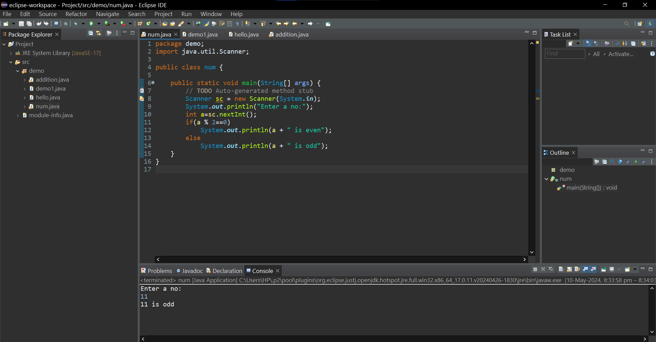

1. **Write a java program to find greatest of 2 numbers.**

package demo;

public class demo1 {

public static void main(String[] args) {

// TODO Auto-generated method stub

int num1 = 50, num2 = 20;

//Declare and initialize the variables

if (num1 == num2)

//checks if both the values are equal

System.out.println ("both are equal");

//Prints if the values are equal

else if (num1 > num2)

//check if the num1 is greater than num2

System.out.println (num1 + " is greater");

//Prints if num1 is greater

else

System.out.println (num2 + " is greater");

//Prints num2 is greater

}

}

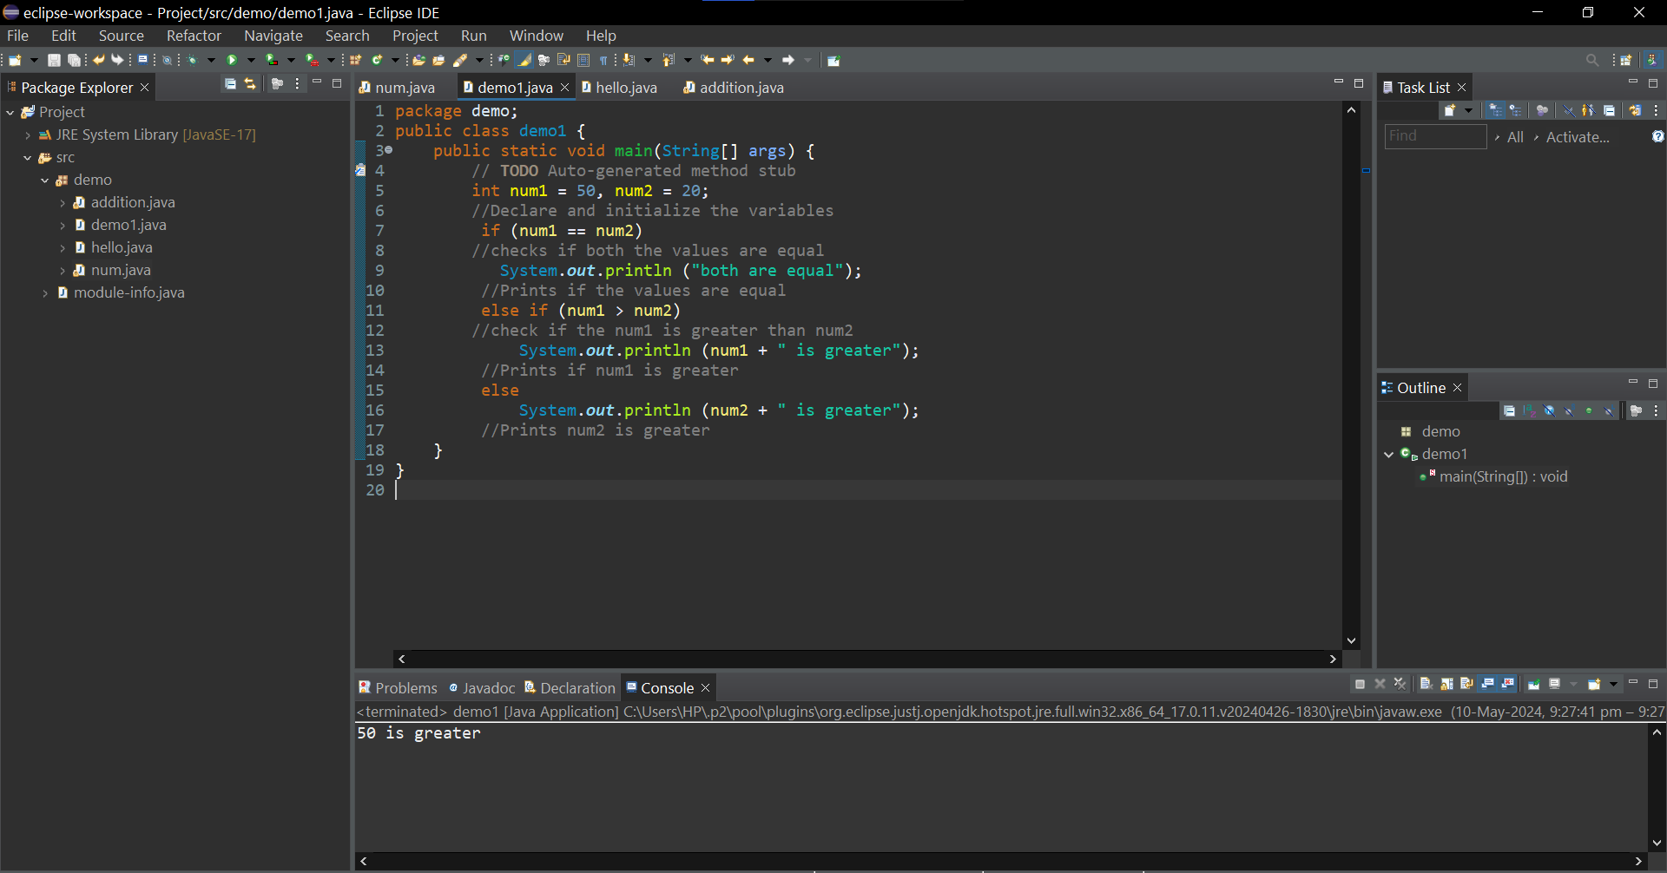

1. **Write a program to implement a basic calculator that takes input as a string expression and evaluates it.**

package demo;

import java.util.Scanner;

//Import the Scanner class

public class calculator {

public static void main(String[] args) {

// TODO Auto-generated method stub

Scanner sc=new Scanner(System.in);

//Taking input from the user

System.out.println("Enter the numbers:");

int a=sc.nextInt();

//Takes user input

int b=sc.nextInt();

//Takes user input

System.out.println("Choose the operation you want to perform");

char opr=sc.next().charAt(0);

int ans = 0;

switch(opr) {

//Case to add two numbers

case '+':

ans=a+b;

break;

//Case to subtract two numbers

case '-':

ans=a-b;

break;

//Case to multiply two numbers

case '*':

ans=a*b;

break;

//Case to divide two numbers

case '/':

ans=a/b;

break;

default:

System.out.println("You enter wrong input");

}

System.out.println("The final output is:"+ a+" "+opr+" "+b+" = "+ans);

}

}

**Output:**

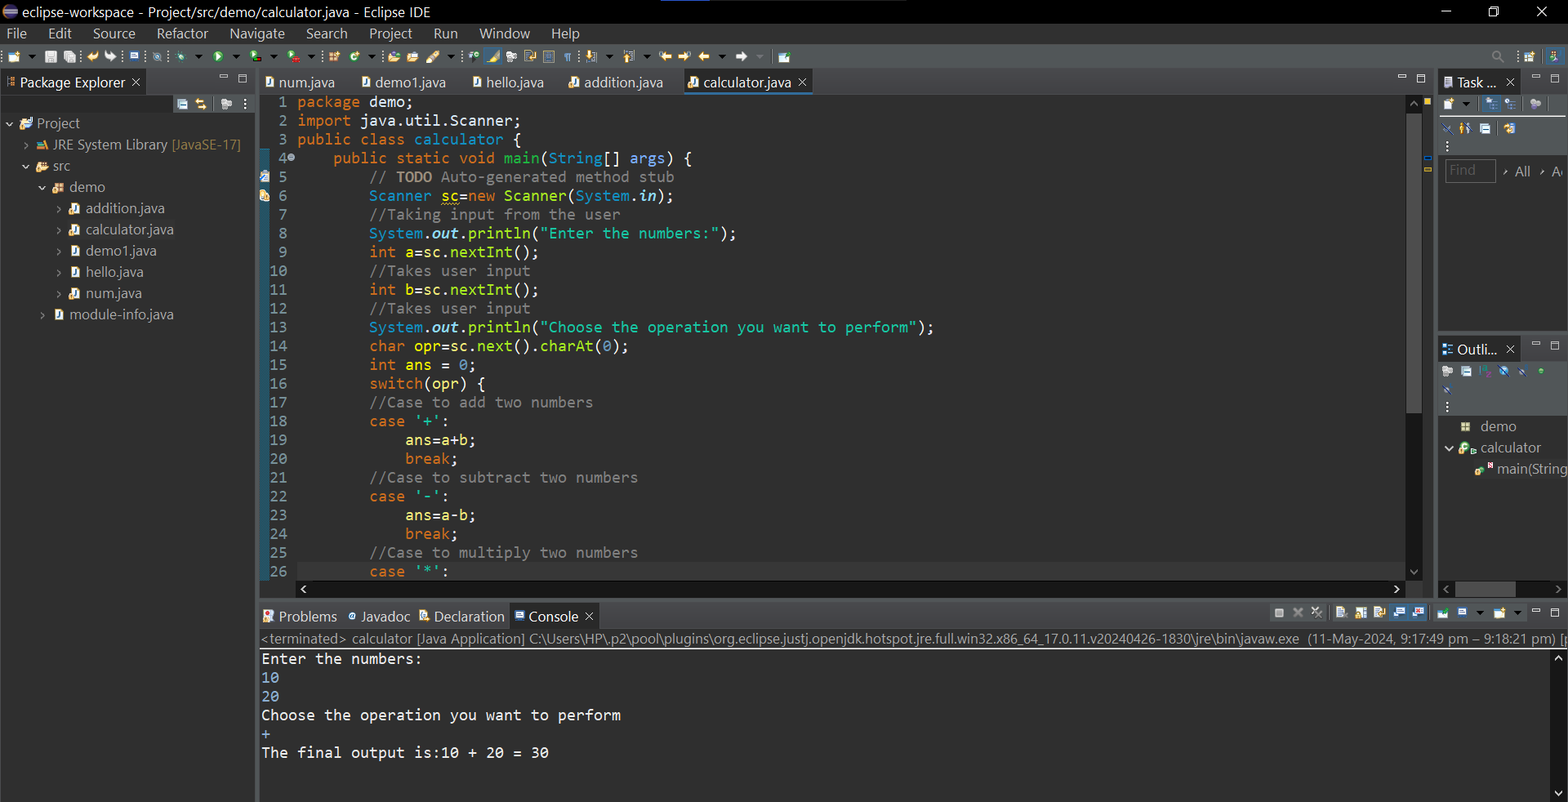

**6.Write a Java program to check whether a given number is even or odd.**

package demo;

import java.util.Scanner;

//Import the Scanner class

public class num {

public static void main(String[] args) {

// TODO Auto-generated method stub

Scanner sc = new Scanner(System.in);

System.out.println("Enter a no:");

//Takes input from user

int a=sc.nextInt();

if(a % 2==0)

//Checks the condition if the number divided by 2 gives 0 as remainder or not

System.out.println(a + " is even");

// the number is even

else

System.out.println(a + " is odd");

// the number is odd

}

}

**Output:**



**7.Create a Java program that compares two numbers and prints the larger one.**

package demo;

import java.util.Scanner;

//Import the Scanner class

public class no {

public static void main(String[] args) {

// TODO Auto-generated method stub

Scanner sc=new Scanner(System.in);

//Taking input from the user

System.out.println("Enter the numbers:");

int num1=sc.nextInt();

//Takes user input

int num2=sc.nextInt();

//Takes user input

{

if (num1 == num2)

//checks if both the values are equal

System.out.println ("both are equal");

//Prints if the values are equal

else if (num1 > num2)

//check if the num1 is greater than num2

System.out.println (num1 + " is greater");

//Prints if num1 is greater

else

System.out.println (num2 + " is greater");

//Prints num2 is greater

}

sc.close();

} }

**Output:**

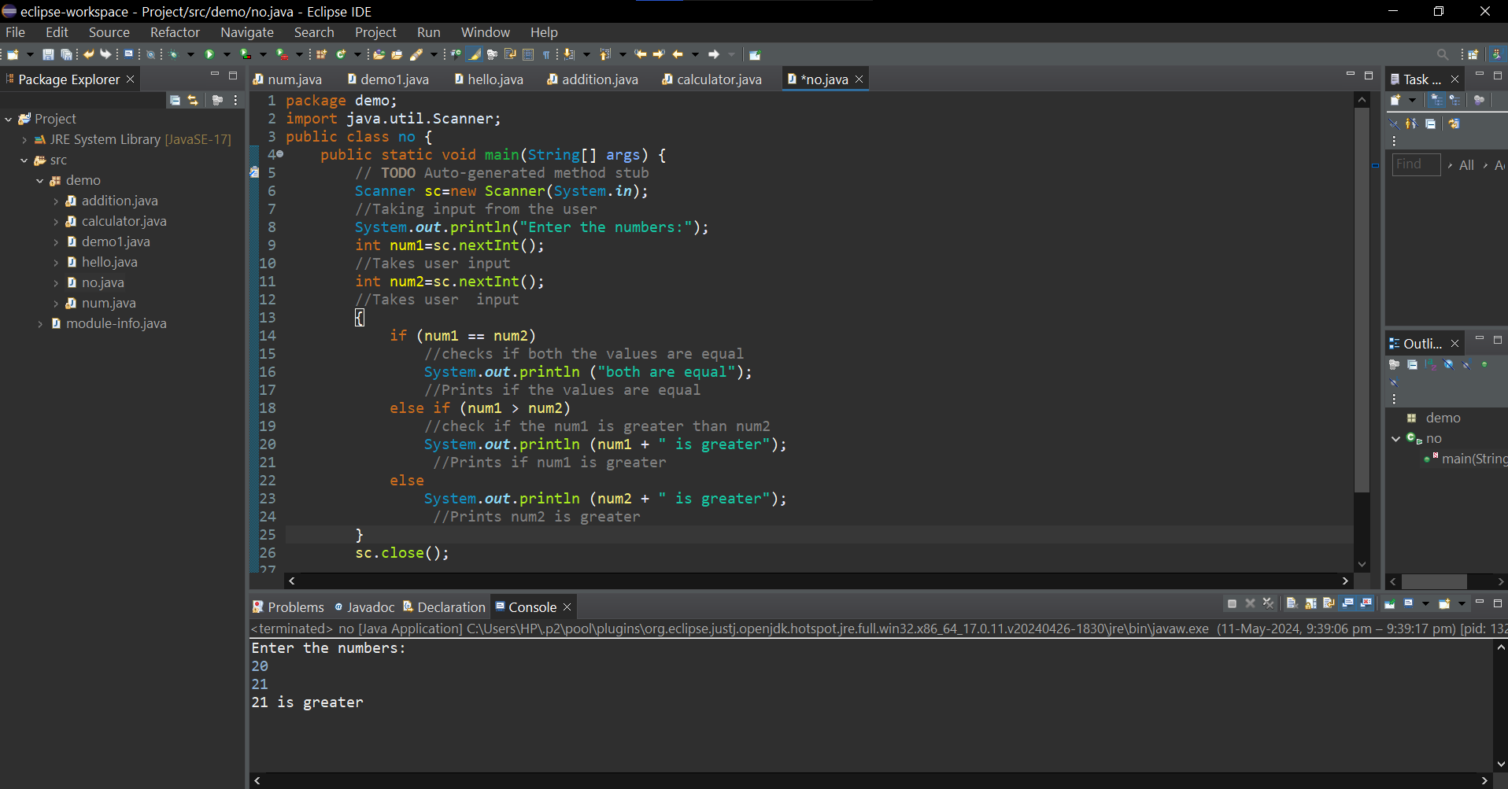

1. **Write a Java program that takes an age input from the user and determines if they are eligible to vote (considering the legal voting age).8.Write a Java program that takes an age input from the user and determines if they are eligible to vote (considering the legal voting age).**

package demo;

import java.util.Scanner;

//Import the Scanner class

public class Age {

public static void main(String[] args) {

// TODO Auto-generated method stub

Scanner sc=new Scanner(System.in);

System.out.println("Enter your age:");

//Takes user input

int age=sc.nextInt();

if(age>=18)

//checks if the age is greater than or equal to 18

{

System.out.println("You are eligible to vote.");

//print that you are eligible to vote

}

else

//if the age is less than 18

{

System.out.println("You are not eligible to vote.");

//prints that you are not eligible to vote

}

sc.close();

}

}

**Output:**

