NAME: Aksharaa.B REG NO.:192311278
COURSE CODE:CSA0603-DAA

Q1. Debugging Selection Sort Code The following Selection Sort code contains logical errors and produces incorrect output for some inputs. Carefully analyze the code, identify all errors in comparison and swapping logic, and explain their root causes. Apply systematic debugging to correct the algorithm step-by-step. Optimize the implementation by reducing unnecessary comparisons if possible. Analyze the corrected algorithm in terms of time complexity. Rewrite the final optimized code with proper structure and comments.
def selection_sort(arr):
n = len(arr)
for i in range(n):
min_idx = I
for j in range(i+1, n):
if arr[j] &gt; arr[min_idx]: # ERROR min_idx = j
arr[i], arr[min_idx] = arr[min_idx], arr[i] return arr
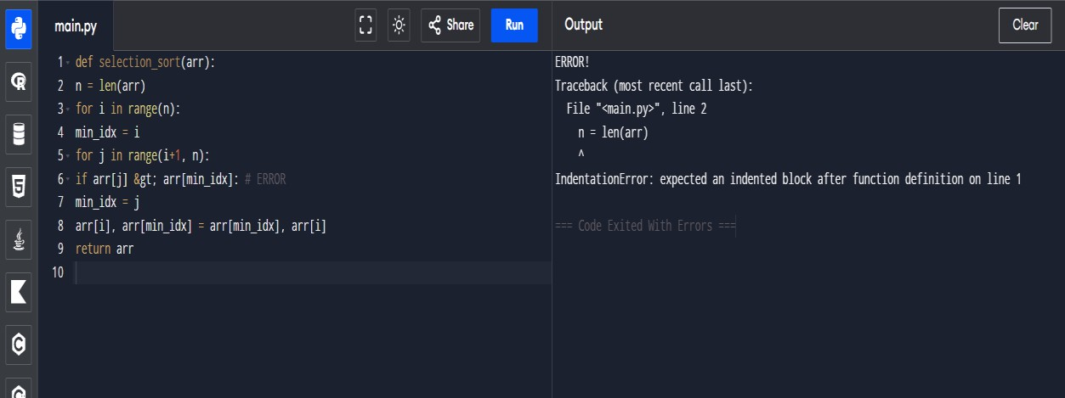

SOLUTION:

Step 1: Understand How Selection Sort Works
Selection Sort repeatedly:
- Finds the smallest element in the unsorted portion of the array.
- Swaps it with the first unsorted element.
- Expands the sorted portion by one position. For ascending order:
  - min_idx should always store the index of the minimum element.
  - Therefore, comparisons should use <, not >.
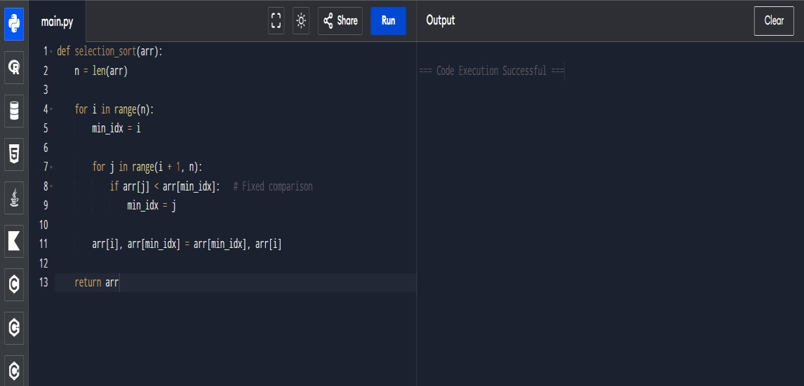

Step 2: Identify the Errors
  - Error 1: Incorrect Comparison Operator
  - Problem: if arr[j] > arr[min_idx]:
This updates min_idx whenever a larger element is found.

Root Cause
  - The variable name min_idx implies that we are searching for the minimum element, but the condition actually searches for the maximum element.
‘
Error 2: Unnecessary Swaps
  - Problem: arr[i], arr[min_idx] = arr[min_idx], arr[i]

  - A swap occurs even when: min_idx == i
  - The algorithm performs redundant operations when the current element is already the minimum.
  - Problem: if min_idx != i:
  - Sol: arr[i], arr[min_idx] = arr[min_idx], arr[i]
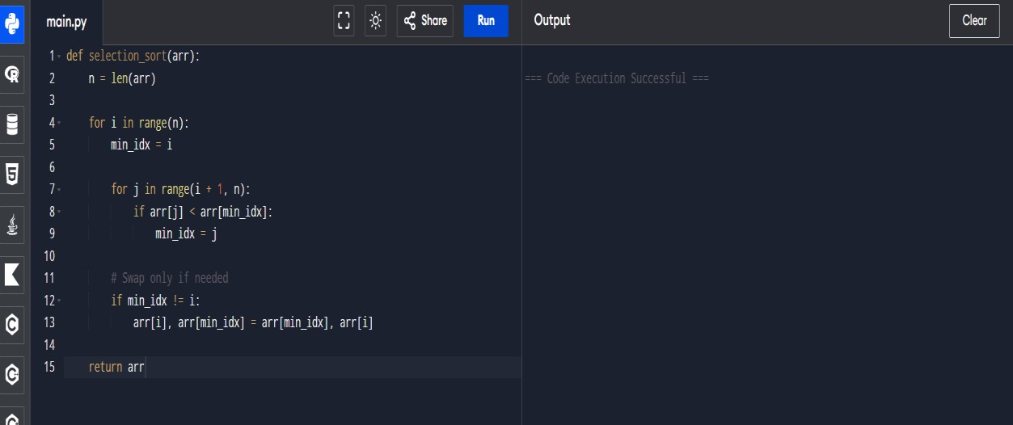

Step 3: Optimization
The outer loop does not need to run for the last element because after sorting the first n−1 positions, the final element is automatically in the correct position.
Instead of
for i in range(n):
Use
for i in range(n - 1):
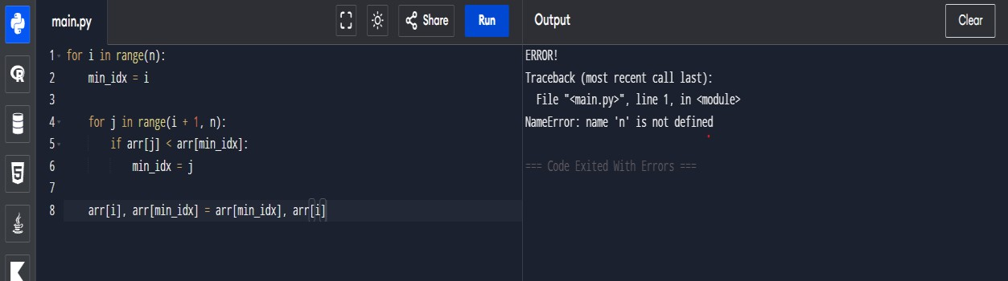

Before optimization

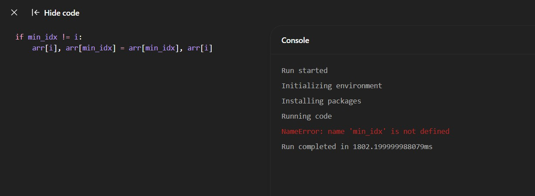
After optimization

Final Optimized Code
def selection_sort(arr)
Sorts a list in ascending order using Selection Sort. Parameters:
arr (list): List of comparable elements Returns:
list: Sorted list """
n = len(arr)
# Traverse through all positions except the last for i in range(n - 1):
# Assume the current position contains the minimum min_idx = i
# Find the smallest element in the unsorted portion for j in range(i + 1, n):
if arr[j] < arr[min_idx]: min_idx = j

# Swap only if a smaller element was found if min_idx != i:
arr[i], arr[min_idx] = arr[min_idx], arr[i] return arr

# Example usage
arr = [64, 25, 12, 22, 11]
print(selection_sort(arr))

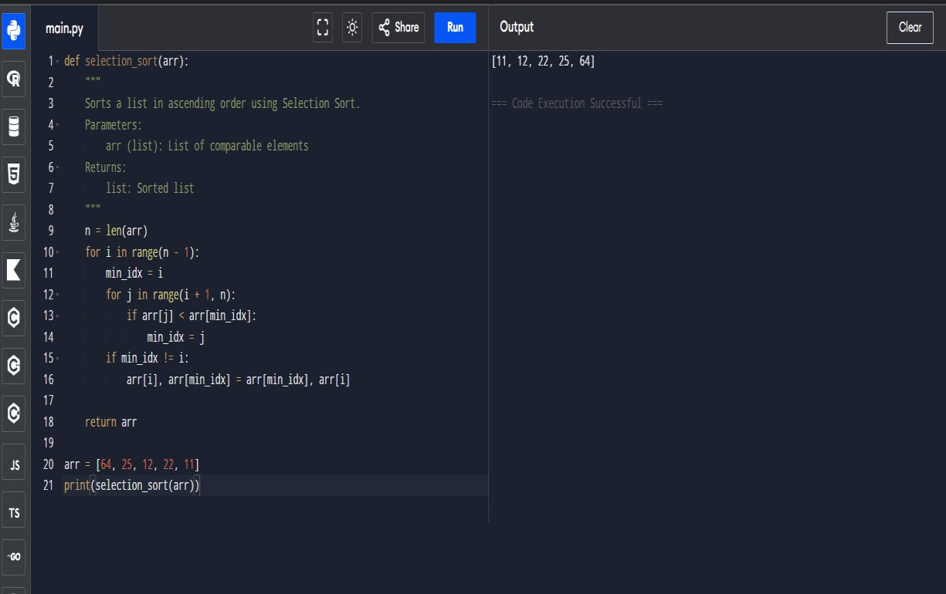

The corrected Selection Sort algorithm successfully sorts the array in ascending order by repeatedly finding the smallest element from the unsorted portion of the list and placing it in its correct position. During each pass, the algorithm maintains min_idx as the index of the minimum element and swaps it with the current position only when necessary.
Thus, the output is a fully sorted array in ascending order. The optimization of avoiding unnecessary swaps improves efficiency by reducing write operations, although the number of comparisons remains the same. Overall, the algorithm

has a time complexity of O(n²) and a space complexity of O(1), making it suitable for small datasets but less efficient than advanced sorting algorithms for large inputs.

