df -h(disk file system)
tells the available and used space of the file system with where this is mounted.
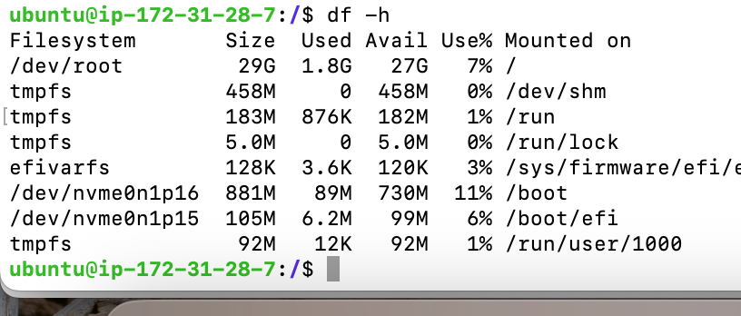

/dev/root - is a device and it is mounted on /.
Created an extra volume and attached the volume with the corresponding instance.
After that ran df -h but still won’t able to see the created extra volume

Reason: Linux system doesn’t know where that volume is mounted.

To overcome the above issue, we have to run lsblk command that will list down all the blocks/volume.

lsblk

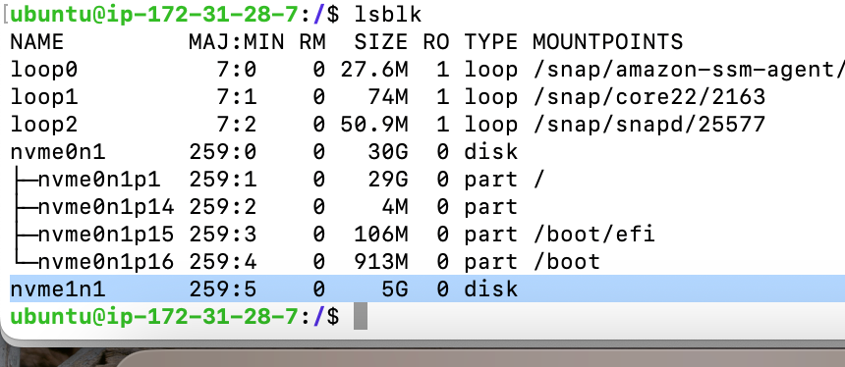
nvme01n1 is a volume that is already attached with the instance server

nvme1n1 is a volume that we bought an extra space.

But this extra volume/block is not mounted as per the above screenshot.

To mount the volume there is a directory called mnt(recommended)
Created a directory called data inside the mnt directory but unable to mount due to the file type.
Ran the below comman to make it file type compatible. - format
mkfs is make file system
mkfs -t ext4 /dev/nvme1n1
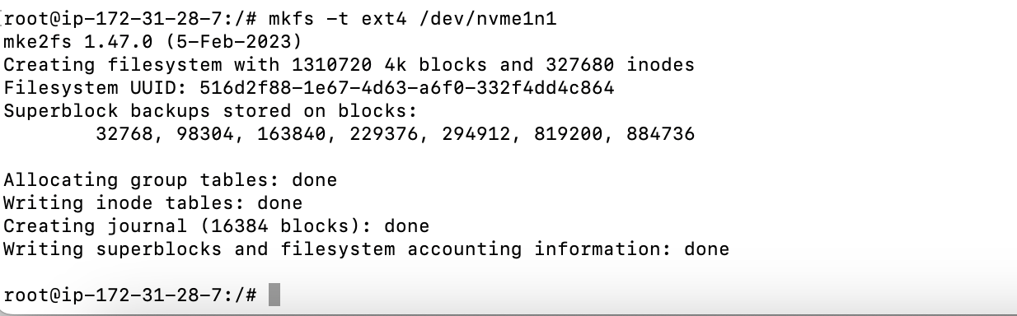

mount /dev/nvme1n1 /mnt/data

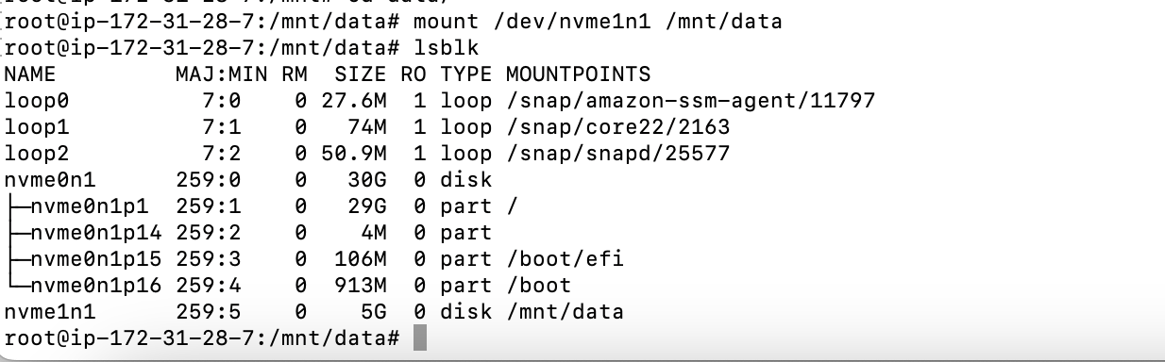

took another volume of 8 gb and mount it without login to the server:
If I do not want to login to the server, I can directly run the below command and it will the file system table.
vim /etc/fstab
automatically mount the file that will reach to the server directly and can be anything.
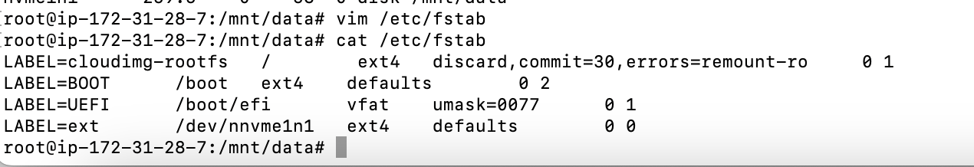

lvm - logical volume is a tool.
pvs: physical volumes
lvs: logical volumes
vgs: volume groups

Create a physical volume and volume group:
pvcreate /dev/nvnvme2n1
vgcreate test_group_volume nvme2n1

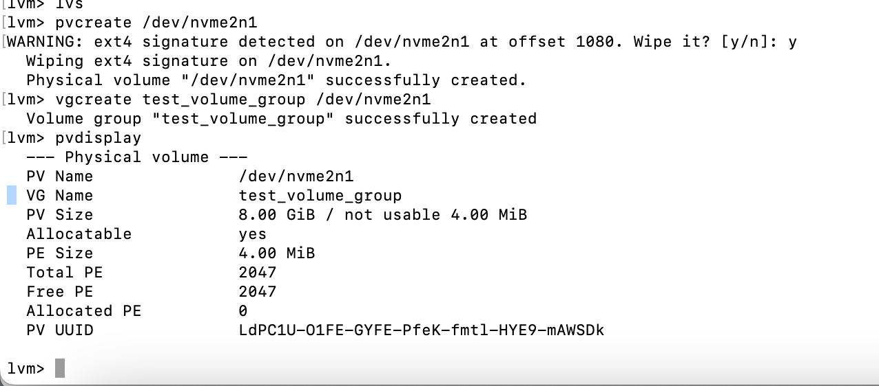

vgdisplay can will display all the information.
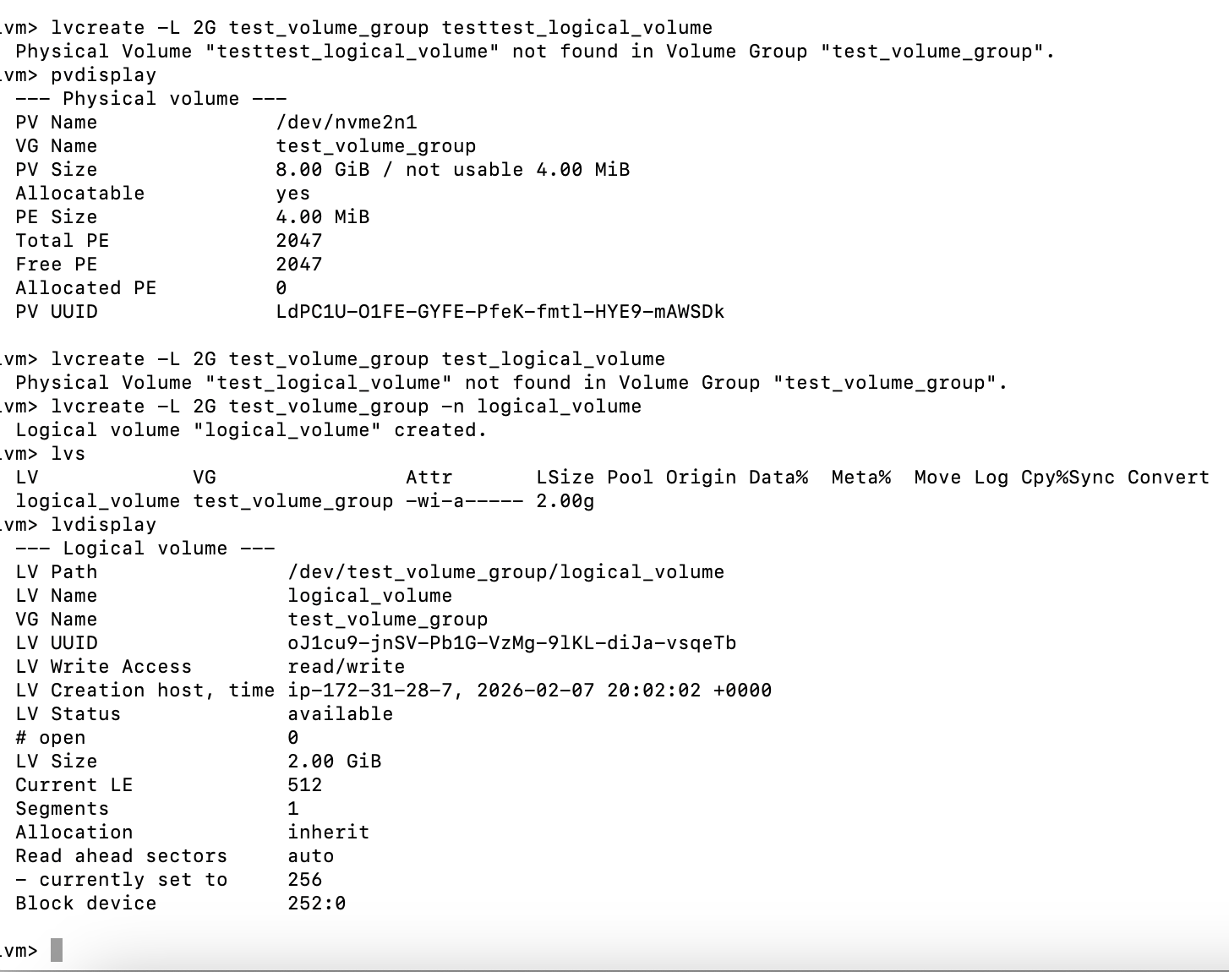
lvdisplay:
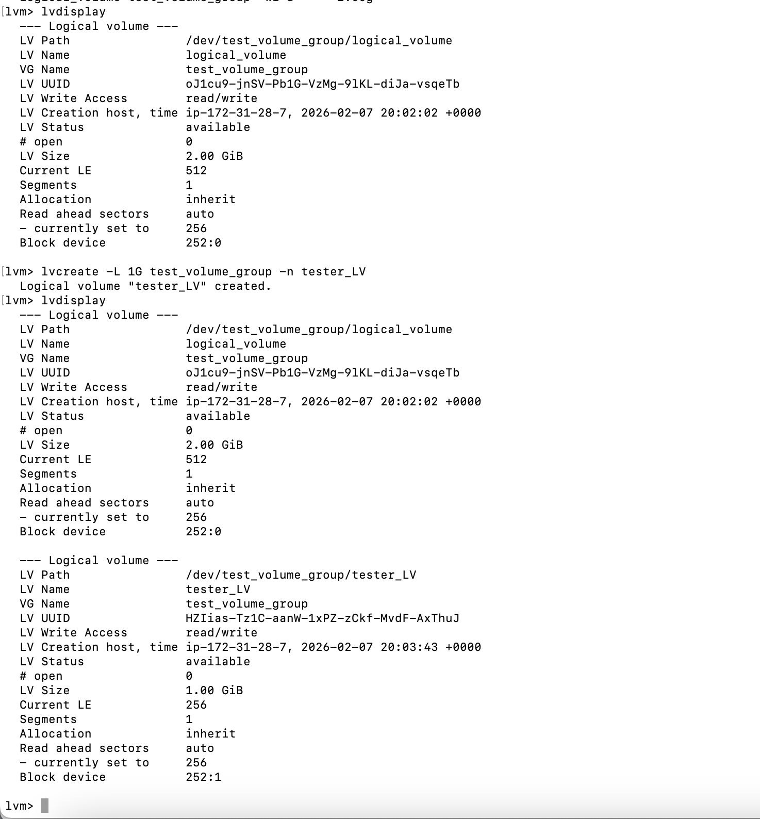

lsblk will show the logical volumes as below:
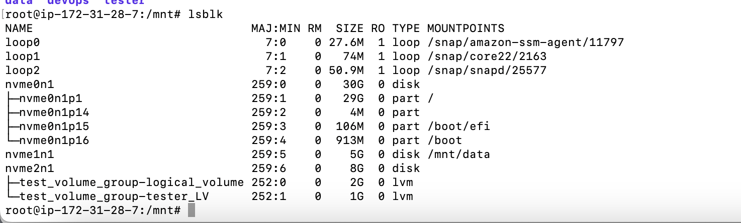

format the group:
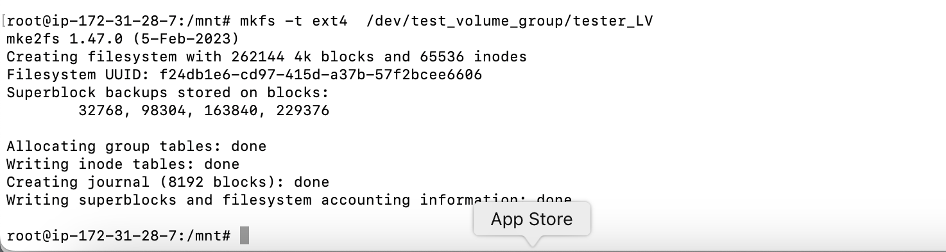

Mount the volume:
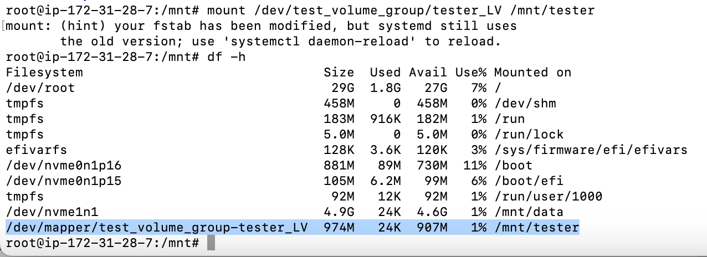

Extend the volume:
lvextend -L +200M /dev/test_volume_group/tester_LV
