Software Requirements Specification

for

Customer Support System

Version 1.0

Prepared by

Group Name: Group B – Cyber Warriors

|  |  |  |
| --- | --- | --- |
| Shagun Kazan | 213741707 | shagun26@my.yorku.ca |
| Melanie Dyer | 213444674 | meldyer@my.yorku.ca |
| Jia Ying Ou | 213385786 | caryou@my.yorku.ca |
| Edgardo Romero Aguero | 212434866 | edgardor@my.yorku.ca |

|  |  |
| --- | --- |
| Instructor: | Dr. Khalil Abuosba |
| Course: | EECS 4481 |
| Date: | November 4, 2018 |

Contents

Revisions 3

1 Introduction 4

1.1 Document Purpose 4

1.2 Product Scope 4

1.3 Intended Audience and Document Overview 4

1.4 Definitions, Acronyms and Abbreviations 5

1.5 Document Conventions 5

2 Overall Description 6

2.1 Product Perspective 6

2.2 Product Functionality 6

2.3 Users and Characteristics 7

2.4 Operating Environment 7

2.5 Design and Implementation Constraints 7

2.6 User Documentation 8

2.7 Assumptions and Dependencies 8

3 Specific Requirements 9

3.1 External Interface Requirements 10

3.2 Functional Requirements 11

3.3 Behaviour Requirements 11

4 Other Non-functional Requirements 12

4.1 Performance Requirements 12

4.2 Safety and Security Requirements 12

4.3 Software Quality Attributes 12

Appendix A – Data Dictionary 14

Appendix B - Group Log 15

Revisions

| Version | Primary Author(s) | Description of Version | Date Completed |
| --- | --- | --- | --- |
| 1.0 | Shagun Kazan,  Jia Ying Ou,  Edgardo Agüero,  Melanie Dyer | Phase 1 | 02/11/2018 |

This document will outline our requirements for the first phase of the project.

# Introduction

## Document Purpose

The purpose of this Software Requirements Specification (SRS) is to provide an in depth description of the Customer Support System (Help Desk Software) application. The document will explain the purpose and functionality of the software, the interface and interactions of the system, as well as the intended users. This document’s primary function is to act as a proposal for customer approval and as a reference to the development team for the first version of the application.

## Product Scope

The purpose of the Customer Support System application is to provide a secure channel of communication over a public network. This secure communication channel will allow customers to securely talk to customer support representatives in order to resolve any issue they may have.

The following are the list of requirements the Customer Support System application must fulfill. The application must support two different types of users, customer support representative and customers. In addition, it must be able to authenticate customer support representatives, as well as being able to assign customer support representatives to customers in need of help. The customers must be able to message customer support representatives in order to communicate with them. Moreover, customer support representatives must be able to communicate with each other and with customers, transfer customers to a different customer support representative, the application must also be able to display the recipient and sender customer support representative when talking to each other. Lastly, the communication between users of the application must be secure.

## Intended Audience and Document Overview

This document is intended for developers, testers and the professor. This document contains features of the application, an outline of the operating system that the application is supposed to run on and specifies the rules for the user when using the application. For the developer, the most important sections to read (in order) would be the product functionality, the design and implementation constraints, assumptions and dependencies, and the users and characteristics. For the tester, the most important sections to read are the product functionality, the users and characteristics and the operating environment. For the professor the sequence of sections to read are the product functionality, the users and characteristics, and the user documentation.

## Definitions, Acronyms and Abbreviations

Component Diagram- A diagram displaying the different software component of the system and their interaction with to each other.

* GUI- Graphical User Interface.
* HTTP- HyperText Transfer Protocol.
* OS- Operating System.
* SRS- Software Requirements Specification.
* UI – User Interface.
* Use Case- A diagram for the system and the interaction among its users.

## Document Conventions

This document is structured into four different sections and each section is further split into different more detailed subsections. The “Introduction” section gives a brief description of the application and introduces some of the terminology used throughout the document. The “Overall Description” section gives a more detailed description of the application and its functionality. The “Specific Requirements” sections provides the UI, software, and hardware requirements. Finally, the “Other Non-Functional Requirements” section provides a description of the rest of the application’s requirements. Throughout the document headers use 18 point Arial font, sub headers use 14 point Arial font and the details of the document use 12 point Arial font.

# Overall Description

## Product Perspective

The Customer Support System application is a web based, new, self-contained product. The application will consists of two main parts, one side for the customer where they will be able to use a GUI in order to contact customer support representatives. In addition, there will be a GUI for customer support representatives for them to authenticate themselves, access their messages, contact other users of the application, as well as transfer customers to a new customer support representative.

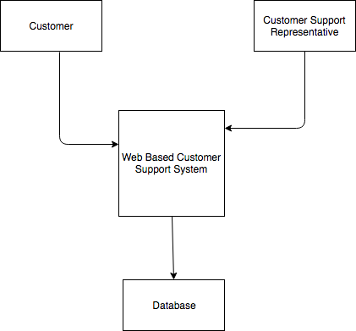In addition, the application will need to communicate with a database where a list of customer support representatives login and passwords will be stored in order to authenticate them.

## Product Functionality

* Must be able to authenticate customer support representative.
* The system must be able to assign a customer support representative to each customer.
* Customer must be able to send messages to their assigned customer support representative.
* Customer support representative must be able to message one of their selected assigned customers.
* Customer support representative must be able to message other customer support representatives.
* Customer support representatives must be able to transfer a customer to a different customer support representative.
* The system must be able to display the sender and recipient for each message between customer support representatives.
* Communication between users must be secure.

## Users and Characteristics

There will be two types of users will use this product:

1. Customers – from here on referred to as anonymous user (client).

2. Customer Support Representatives – from here on referred to as help-desk user (provider).

For anonymous users, they do not need to have an account. Once they are on the web of customer support system, they will be able to send text messages to their assigned online help-desk users.

For help-desk users, they have to have an account. A help-desk user is able to send text messages to their assigned and selected anonymous user; able to send message to another help-desk user; able to transfer non-authenticated user to another help-desk user.

## Operating Environment

The Customer Support System is a web-based application that will run on desktop devices through a browser. The minimum hardware requirement needs to be enough to run any modern day browser (Google Chrome, Firefox, Safari, etc.). The application will be able to run on a multiple of OS, such as Windows, Mac OS, and Linux.

## Design and Implementation Constraints

This subsection will be divided into several subcategories such as tools used, technologies and security considerations.

Tools Used.

* Apache.

Technologies.

* Any modern day web browser (see section 2.4 for examples).
* Database will be an instance of DB2.

Programming Languages & Protocols.

* PHP.
* HTML.
* CSS.
* JavaScript.
* HTTP.

Security Considerations.

The application must be safe from Man-in-the-Middle attacks, Page-in-the-Middle attacks, Browser-in-the-middle attacks and SQL injections. To do this, the code and the database must be secure through encryption.

Programming Standards.

The designers of the application will be responsible for maintaining the application as well as providing bug fixes.

## User Documentation

Given that this is a fairly small and simple application no manual is necessary since the users do not need to install the application, as it is web-based.

An on-line help forum should be sufficient to help the client and the professor understand the software and deal with any trouble they may encounter.

## Assumptions and Dependencies

One assumption about the product is that the application will only be accessed through desktop devices only. In addition, it is assumed the users will have the hardware requirements to run any modern day browsers and that one of these browsers will be installed on the users machine.

# Specific Requirements

## External Interface Requirements

### User Interfaces

Below are screenshots of the different user interfaces and a brief description of how each works below each image.

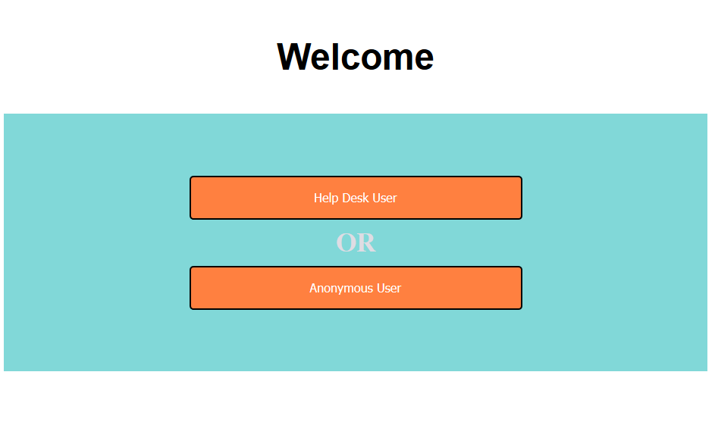This is the first UI encountered by each user. The help desk user button will redirect the user to a login page and the anonymous user button will assign the user a help desk user and redirect them to a message screen.

If the help desk user is already register they can provide credentials in the textboxes and use the login button, otherwise they can use the register button to be redirected to a registering screen. Finally the back to main page button will bring them to the first screen.

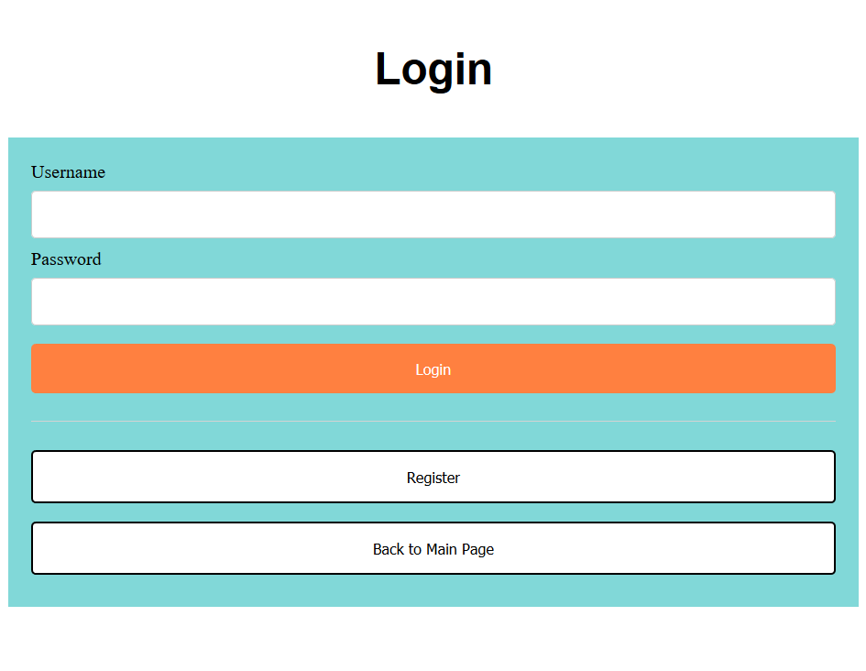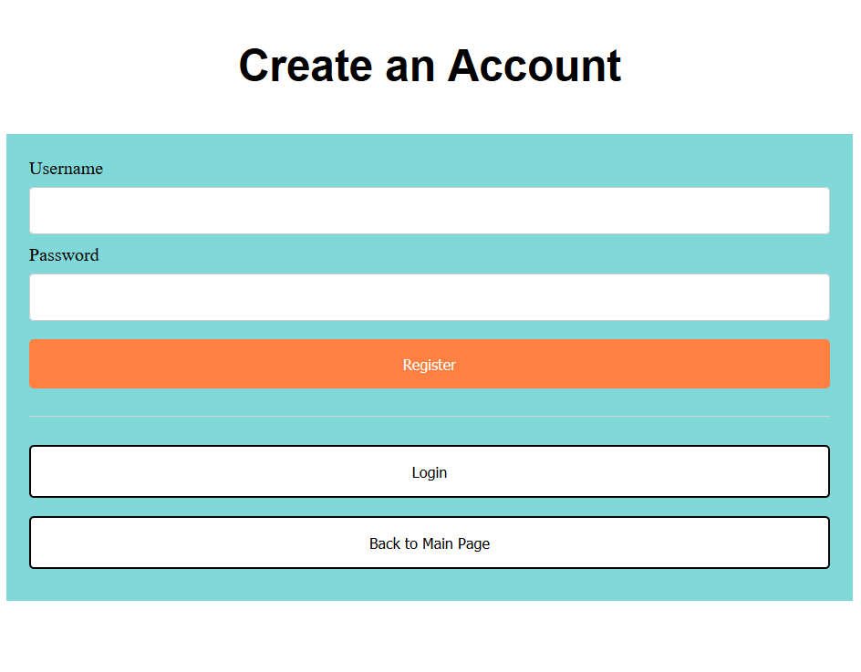

Help desk users that have not registered can create credentials here and use the register button after typing the credentials they want. The login button will bring them back to the login screen and the back to main page button will bring them back to the original screen.

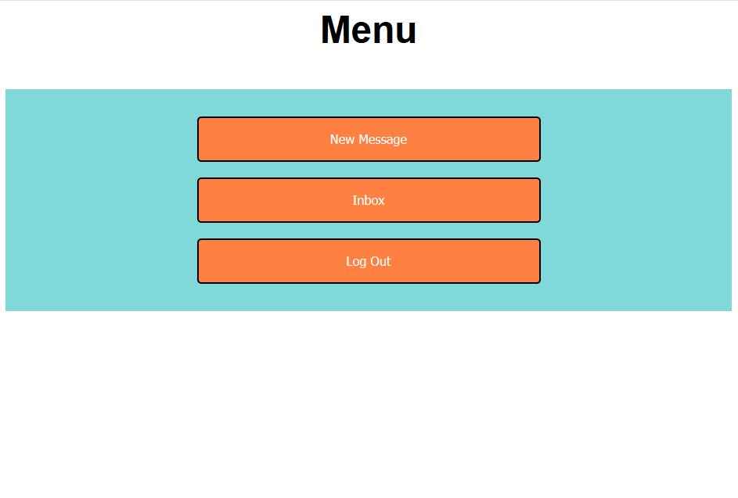After help desk users have authenticated they will see this screen. New message button will allow them to send a new message to other help desk users. Inbox button will redirect them to their unread messages. Lastly, the logout button will sign them out and bring them to the original screen.

### Hardware Interfaces

Since the web-based application does not have any designated hardware, it does not have any direct hardware interfaces.

### Software Interfaces

The application will communicate the user, OS and database, through a web browser. The communication with the database will be both read and write in order to create new help desk users and authenticate them when they attempt to login.

### Communications Interfaces

The Customer Support System is a web-based application therefore it will use HTTP to communicate with the browser and the end users. In addition, the communication channel provided must be secured meaning communication between each user, and the application, must be encrypted. There are two encryption standards being considered, they are DES and AES; thus, one of these two standards will be used in the final release of the product.

## Functional Requirements

Functional Requirement 1.

Help desk user authentication: The help desk users should be able to provide a username/password login in order to be authenticated into the application and redirected to their message inbox.

Functional Requirement 2.

Anonymous user assignment: The system must be able to automatically assign each new anonymous user to a random available help desk user.

Functional Requirement 3.

Message interaction: Each anonymous user must be able to send messages to their assigned help desk user. In addition, each help desk user must be able to message the selected anonymous users as well as be able to message other help desk users.

Functional Requirement 4.

Help desk user name: When two help desk users are messaging each other the system must be able to display the username of the sender and recipient for each message.

Functional Requirement 5.

Anonymous user transfer: Each help desk user must have the ability to transfer their selected anonymous user to any other help desk user.

Functional Requirement 6.

Secure communication: The communication between every user must be secure, meaning all communication must be encrypted.

## Behaviour Requirements

### Use Case View

# Other Non-functional Requirements

## Performance Requirements

1. Help desk users shouldn’t take more than 30 seconds to be authenticated.
2. The system should not take more than a minute to assign an anonymous user to a help desk user.
3. The system should assign an anonymous user to the help desk user with the least amounts of customers assigned to them.
4. The help desk users inbox should be refreshed every 10 seconds for a new message.
5. It should not take the system more than a minute to reassign a help desk user to an anonymous user after they have been transferred.

## Safety and Security Requirements

* Communication security: The message should be encrypted for login communication so that no one can obtain usernames and passwords.
* Login security: If a help desk user tries to authenticate with a nonexistent username the system should not authenticate them.
* Account creation security: If a user tries to create and account and the username is already taken, the user should be asked to pick a different username.

The goal of this application is to provide secure communication over an open channel; therefore, the security level expected from this application is fairly high and should make all communications either between users, or user/system encrypted.

## Software Quality Attributes

Reliability.

The system must reliably deliver messages to each user. This will be accomplished by using the appropriate protocols. As this is a web-based application HTTPS will be user which runs on top of TCP. The TCP protocol will provide the reliability needed to ensure the delivery of messages.

Availability.

In order for the system to be available the user must be connected to the Internet. Moreover, it will be ensured that the server hosting the application will be large enough to accommodate the number of users required. This way when a new user requests a connection they will not be turned away.

Maintainability.

The application will be made maintainable by ensuring the code use follows appropriate development standards so that future features will be easily implemented.

Portability.

The application will be portable to any operating system as long as it is able to run a modern web browser. Portability will be ensured by using the correct PHP code so that most browsers are able to parse the application without a problem.

Appendix A – Data Dictionary

*<Data dictionary is used to track all the different variables, states and functional requirements that you described in your document. Make sure to include the complete list of all constants, state variables (and their possible states), inputs and outputs in a table. In the table, include the description of these items as well as all related operations and requirements.>*

Appendix B - Group Log

We have group meeting for about 3 hours to discuss what we want to do and how do we want to do it. Also, we did the diagrams (such as user case, etc.) together. Then we discuss the progress of the project before or after lectures every week. When we have questions while doing the project, we talk about it through a group chat online.

For this document, Edgardo has spent 3 hours, Jia has spent 2.5 hours, Melanie has spent 2.75 and Shagun has spent 2.5 hours on it.