**Software Design Document (SDD)**

Shagun Saurabh LIT2022046

Shagun Singh LCB2022019

Anushka Samadder LCB2022020

1. **Data Flow Diagram**

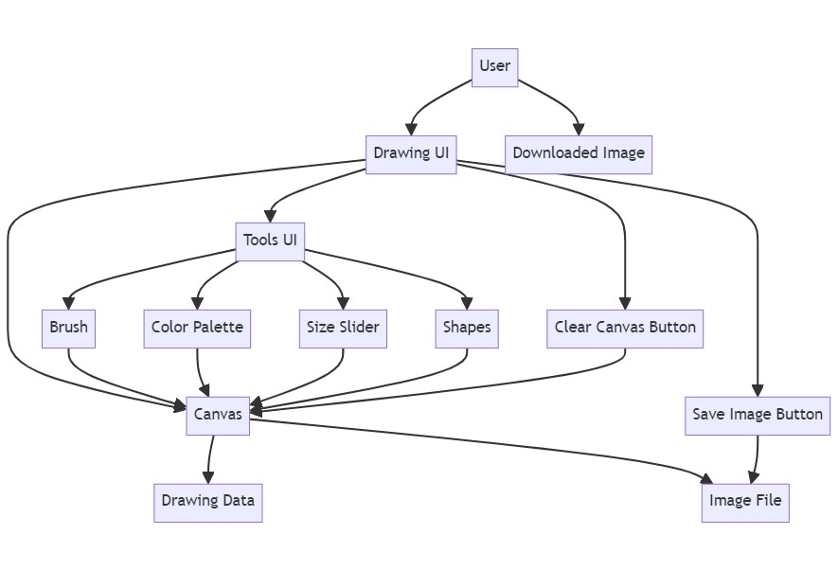

1. **ER diagram**

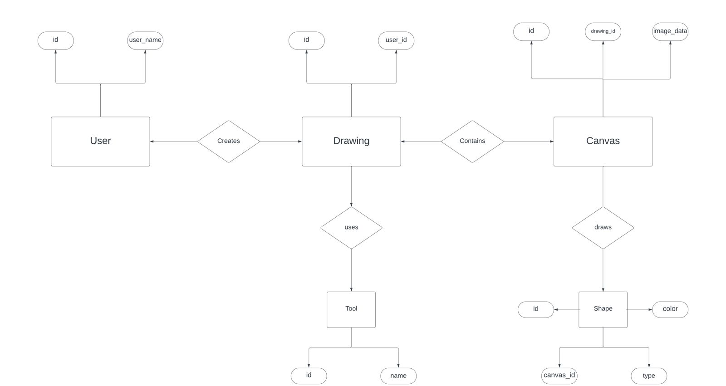

1. **Usecase Diagram**

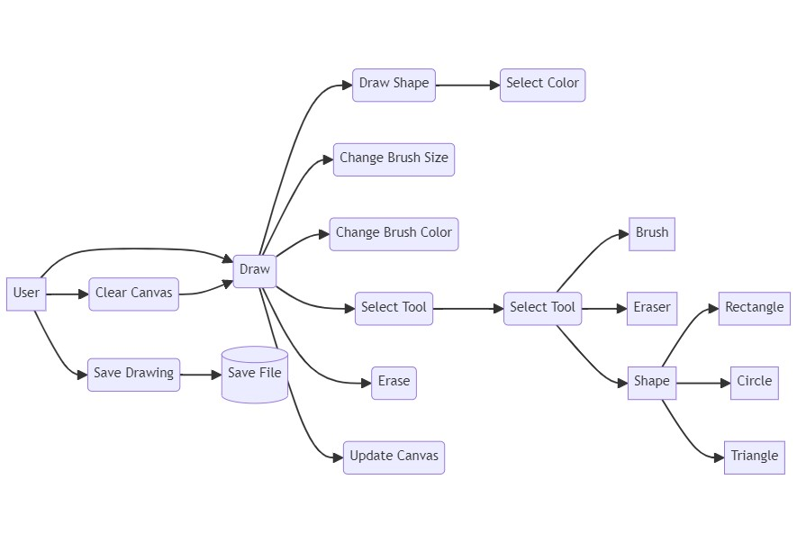

1. **State Transition Diagram**

