Report
Of
DATA ANALYTICS WITH PYTHON & POWER BI

Submitted
To
School of Computer Science and Engineering
IILM University, Greater Noida, U.P.

In partial fulfilment of the requirement of degree of
B.Tech CSE



By
Roll Number of Student:
Name of Student: SHAGUN SRIVASTAVA
Batch: 2024-28

2026-27

CANDIDATE’S DECLARATION

I, SHAGUN SRIVASTAVA, do hereby declare that the internship report titled “Data Analytics with Python & Power BI” has been completed by me to fulfil the requirement for the award of the degree of Bachelor of Technology in CSE. All the references have been quoted and I have not taken as such any material from any other source. I affirm to you that this report is my own and has not been submitted to any other institute for any degree/diploma requirement and further I shall be solely responsible for any kind of copyright violation in this regard.

Signature : Shagun Srivastava
Student Name: SHAGUN SRIVASTAVA
Roll No.: 2410030277

ACKNOWLEDGEMENT

I am using this opportunity to express my gratitude to everyone who supported me throughout the Internship Program. I am thankful for their aspiring guidance, invaluably constructive criticism and friendly advice during this work. I am sincerely grateful to them for sharing their truthful and illuminating views on a number of issues related to this work.
I express my gratitude to my parents for their blessings.

Signature: Shagun Srivastava
Student Name: SHAGUN SRIVASTAVA
Roll No.: 2410030277

Chapter No. | Chapter Name | Page Nos.
 | Cover Page | ----
1. | Candidate’s Declaration | i
2. | Acknowledgment | ii
3. | Internship Completion Certificate
4. | Project Description  4 .1 Introduction  4.2 Organization Profile  4.3 Problem Statement  4.4 Project Objectives  4.5 Scope of the Project  4.6 Technologies and Tools Used  4.7 System Architecture  4.8 Methodology  4.9 Expected Outcomes  4.10 Certificates of completion and other communication mail proof must be attached | 1  1  2  2  2  3  4  5  6  7  7
5. | Bibliography/References | 8

Instruction for the report format
- Cover Page, Copy of the Certificate issued by industry/organisation will have no Page Number.
- Page no. of Sr. No. 1 to 6 along with a list of tables and list of figures will bear the Roman Numbering System (e.g. i, ii, iii).
- Bibliography/References should be in proper format.

Size of Paper: A4
Printing: Single Sided
Left Margin: 1.5 inch
Right Margin: 1 inch
Top Margin: 0.75 inch
Bottom Margin: 1 inch (with Page No. at the centre)
Page Numbering: Centered at the bottom of the Page
Line Spacing: 1.5 for text and 1 for References
Paragraph: Justified
Font Type: Times New Roman
Font Size: 12 for text and for with in tables can vary from 8-12
(But should be same throughout the report)
Heading Font Size: 12 for Sub Headings and 14 for main Headings
with Bold Text
Cover Page: As Specified Above
Tables, Figures and Graphs: With Numbers indicating the chapters (1.1, 1.2 or 2.1,
2.2 etc.) and contain titles (above for tables

INTERNSHIP COMPLETION CERTIFICATE
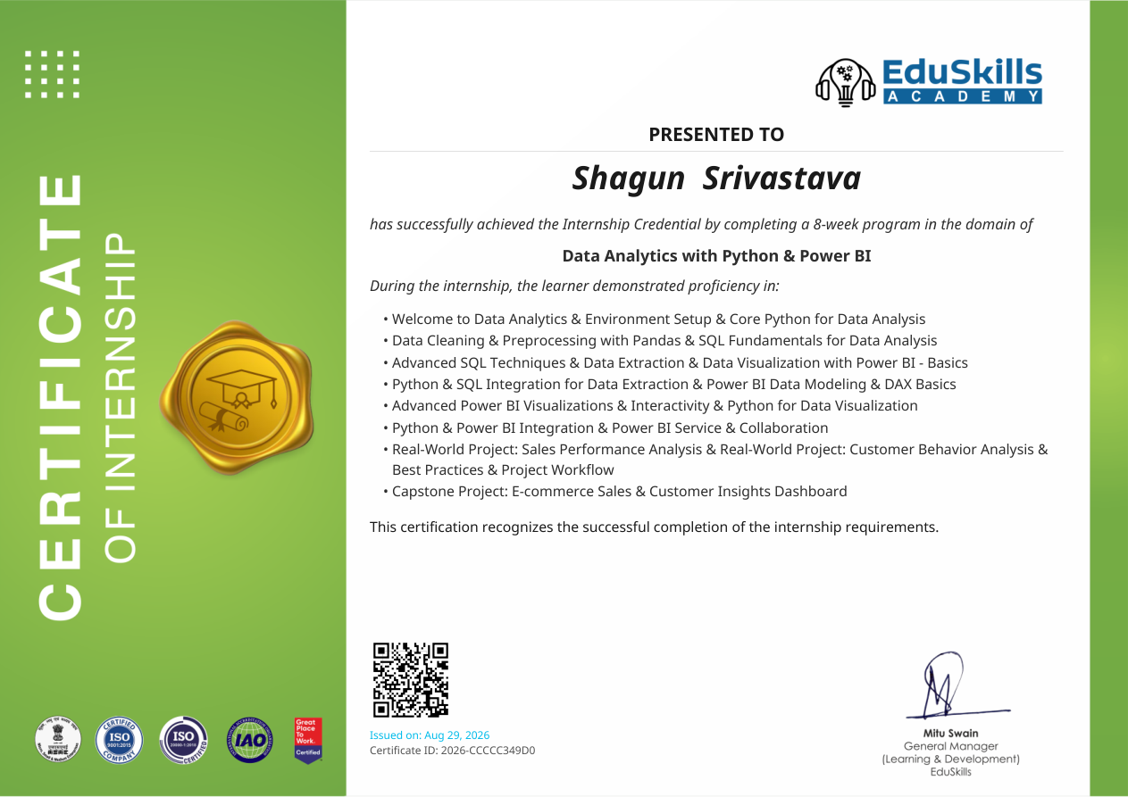
Certificate issued by EduSkills Academy for successful completion of the 8-week internship in Data Analytics with Python & Power BI.

4. PROJECT DESCRIPTION
4.1 Introduction
The internship was an 8-week program in the domain of Data Analytics with Python & Power BI. The program covered the practical workflow of data analytics, beginning with environment setup and core Python for data analysis and progressing through data cleaning, preprocessing, SQL, Power BI, DAX, visualization, integration, collaboration and project workflow.
The learning path connected Python-based data analysis with database querying and business intelligence. Pandas was used for data cleaning and preprocessing, SQL for data extraction and analytical querying, and Power BI for visualization, data modeling, interactivity and dashboard-oriented reporting. The program also included Python for data visualization and the integration of Python, SQL and Power BI.
The internship included real-world projects on Sales Performance Analysis and Customer Behavior Analysis and culminated in an E-commerce Sales & Customer Insights Dashboard. These components provided a project-oriented application of the technologies and concepts covered during the program.
4.2 Organization Profile
EduSkills Academy is the organization named on the internship completion credential. The supplied credential identifies the internship as an 8-week program in Data Analytics with Python & Power BI and lists the learning areas covered during the internship.
The documented training structure progressed from data analytics fundamentals and environment setup to Python, Pandas, SQL, Power BI, DAX, integration, real-world projects and a capstone dashboard. Since the supplied material contains no additional organizational profile, this report does not add unsupported information about the organization's history, workforce, clients or business operations.
4.3 Problem Statement
Business datasets can contain information about sales, customers and other activities, but raw data does not directly provide useful insights. It must be cleaned, transformed, queried, analyzed and visualized before patterns and trends can be communicated effectively.
The internship therefore focused on developing an end-to-end analytical workflow using Python, SQL and Power BI. For the capstone project, the specific focus was an E-commerce Sales & Customer Insights Dashboard, with the objective of organizing sales and customer information into an interactive analytical view.
4.4 Project Objectives
• Understand the fundamentals of data analytics and establish an appropriate Python analysis environment.
• Develop practical proficiency in Python for data analysis.
• Perform data cleaning and preprocessing using Pandas.
• Use SQL fundamentals and advanced SQL techniques for data extraction.
• Develop data visualizations using Python and Power BI.
• Understand Power BI data modeling and the basics of DAX.
• Create advanced Power BI visualizations and interactive analytical views.
• Integrate Python with SQL for data extraction and connect Python with Power BI workflows.
• Apply analytical techniques to Sales Performance Analysis and Customer Behavior Analysis.
• Develop the capstone E-commerce Sales & Customer Insights Dashboard and follow best practices and project workflow.
4.5 Scope of the Project
The project covers the major stages of a practical data analytics workflow: understanding the data, cleaning and preprocessing, extracting relevant information, analyzing data, creating calculations, visualizing results and presenting insights through dashboards.
The internship scope includes Python, Pandas, SQL, Power BI, DAX, Python visualization, Power BI Service, Python and SQL integration, and Python and Power BI integration. The project scope further includes Sales Performance Analysis, Customer Behavior Analysis and the capstone E-commerce Sales & Customer Insights Dashboard.
The supplied internship credential does not provide the detailed dataset structure, numerical analysis results, source code, deployment configuration or dashboard screenshots. Such implementation-specific details have therefore not been invented in this report.
4.6 Technologies and Tools Used
S. No. | Technology / Tool | Purpose / Application
1 | Python | Core programming and data analysis
2 | Pandas | Data cleaning, preprocessing and analysis
3 | SQL | Data extraction and analytical querying
4 | Power BI | Data visualization, dashboards and business intelligence
5 | DAX | Power BI calculations and analytical measures
6 | Python Visualization | Analytical data visualization
7 | Power BI Service | Publishing, collaboration and service-based workflow
8 | Python & SQL Integration | Combining Python analysis with SQL-based data extraction
9 | Python & Power BI Integration | Connecting Python-based analysis with Power BI workflows
Table 4.1: Technologies and tools covered during the internship
4.7 System Architecture
The project workflow follows a layered data analytics architecture. Business data forms the input layer. The preparation layer cleans and preprocesses the data using Pandas. The extraction layer uses SQL to obtain required information. The analysis and modeling layer applies Python analysis together with Power BI modeling and DAX calculations. The visualization layer presents the results through interactive Power BI and Python visualizations. Power BI Service supports the final service and collaboration workflow.
Layer | Main Activity | Tools
1. Data Input | Access business data for analysis | Datasets / SQL
2. Data Preparation | Clean, transform and preprocess data | Python, Pandas
3. Data Extraction | Query and extract required information | SQL
4. Analysis & Modeling | Analyze data and create calculations | Python, Power BI, DAX
5. Visualization | Create interactive charts and dashboards | Power BI, Python
6. Integration & Collaboration | Connect tools and share analytical outputs | Python, Power BI Service
Figure 4.1: Logical system architecture of the internship project workflow
4.8 Methodology
The internship followed a progressive and project-oriented methodology in which each stage introduced analytical concepts and then connected them to practical project work.
Stage 1 – Data Analytics and Python Fundamentals: The program began with data analytics fundamentals, environment setup and core Python concepts required for data analysis.
Stage 2 – Data Cleaning and Preprocessing: Pandas was used for organizing, cleaning and preprocessing analytical data.
Stage 3 – SQL Fundamentals and Advanced SQL: SQL concepts progressed from fundamentals to advanced techniques for data extraction and analysis.
Stage 4 – Power BI Visualization: Power BI was introduced for basic visualization and then extended to advanced visualizations and interactivity.
Stage 5 – Data Modeling and DAX: Power BI data modeling and DAX basics were covered to support structured analytical calculations.
Stage 6 – Python, SQL and Power BI Integration: Python and SQL integration was covered for data extraction, while Python and Power BI integration connected programmatic analysis with dashboard workflows.
Stage 7 – Real-World Projects and Capstone: The learned skills were applied to Sales Performance Analysis and Customer Behavior Analysis and then to the E-commerce Sales & Customer Insights Dashboard.
Stage 8 – Power BI Service and Collaboration: Power BI Service and collaboration were included as part of the final analytics workflow.
4.9 Expected Outcomes
• Ability to use Python for practical data analysis.
• Improved understanding of data cleaning and preprocessing using Pandas.
• Ability to use SQL fundamentals and advanced techniques for data extraction.
• Understanding of Power BI visualization, interactivity and dashboard development.
• Basic understanding of Power BI data modeling and DAX.
• Ability to connect Python, SQL and Power BI in an analytical workflow.
• Practical exposure to sales performance and customer behavior analysis.
• Ability to structure an e-commerce sales and customer insights dashboard.
• Improved understanding of project workflow, best practices and Power BI Service collaboration.
4.10 Certificates of completion and other communication mail proof must be attached
The internship completion certificate is attached in this report as supporting proof of successful completion. The certificate identifies Shagun Srivastava as the learner and confirms completion of an 8-week Data Analytics with Python & Power BI program. It also lists the covered modules, real-world projects and the capstone E-commerce Sales & Customer Insights Dashboard.
No separate communication-mail proof was included in the supplied internship material. If required by the institute, the relevant official communication e-mails can be inserted after this section without changing the report format.

5. BIBLIOGRAPHY/REFERENCES
EduSkills Academy. Internship Completion Credential: Data Analytics with Python & Power BI. Issued August 29, 2026. Certificate ID: 2026-CCCCC349D0.
Internship Report Format updated 26-27. School of Computer Science and Engineering, IILM University, Greater Noida, U.P.

