**Day 11: Introduction to MongoDB & Connecting to Database using Mongoose**

**What is MongoDB?**

MongoDB is a NoSQL database used to store flexible, JSON-like data.

**What is Mongoose?**

Mongoose is an ODM (Object Data Modeling) library for Node.js that helps interact with MongoDB easily.

**Code:**

const mongoose = require('mongoose');

mongoose.connect('mongodb://127.0.0.1:27017/internshipDB', {

useNewUrlParser: true,

useUnifiedTopology: true

})

.then(() => console.log('Connected to MongoDB successfully'))

.catch(err => console.error(' Connection failed:', err));

const studentSchema = new mongoose.Schema({

name: String,

email: String,

course: String

});

const Student = mongoose.model('Student', studentSchema);

// Test data (optional):

const s = new Student({ name: 'Shagufta', email: 'shagufta@example.com', course: 'MongoDB' });

s.save().then(() => console.log('Student saved'));

**output terminal:**

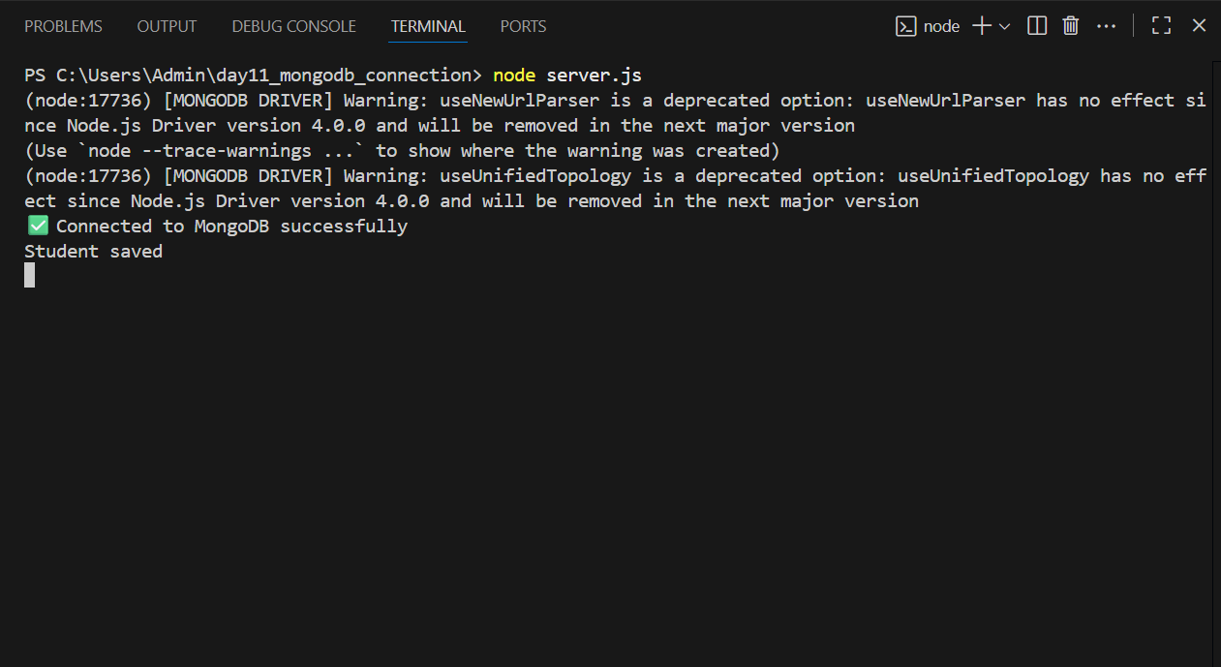

**MongoDB Compass:**

