**Day 12 – MongoDB Insert using Mongoose**

**How data is inserted:**

Using .save() method on Mongoose model object.

**Role of model:**

Mongoose model helps define structure & perform DB actions.

**.save():**

Saves the document to MongoDB from the model instance.

**Code:**

const express = require('express');

const mongoose = require('mongoose');

const app = express();

app.use(express.json());

async function connectDB() {

try {

await mongoose.connect('mongodb://127.0.0.1:27017/webteamdb');

console.log('Connected to MongoDB');

} catch (error) {

console.error('DB Connection Failed:', error);

}

}

connectDB();

// Student Schema

const StudentModel = mongoose.model('Student', {

name: String,

email: String,

course: String

});

app.post('/add-student', async (req, res) => {

const data = req.body;

const newStudent = new StudentModel(data);

try {

await newStudent.save();

res.status(200).send('Student added successfully');

} catch (err) {

res.status(400).send('Failed to add student');

}

});

const PORT = 3000;

app.listen(PORT, () => {

console.log(`Server is running on http://localhost:${PORT}`);

});

**Output:**

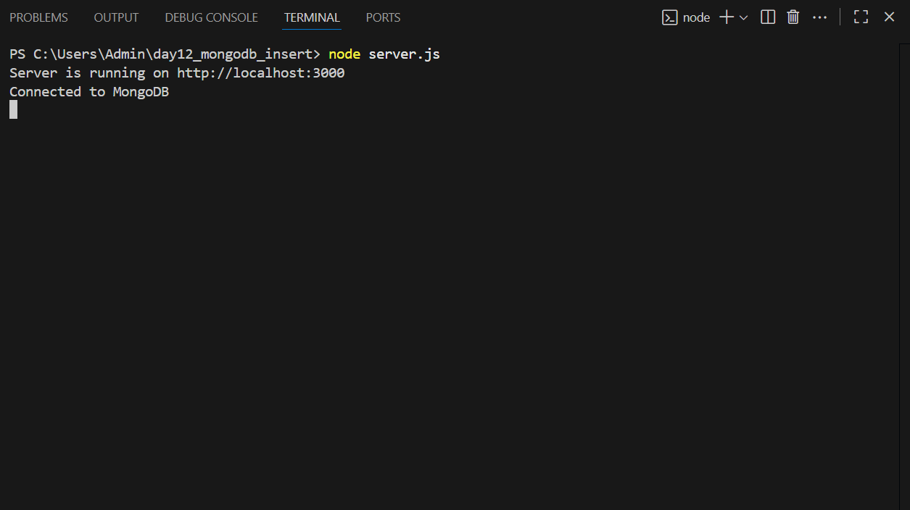

**Postman POST:**

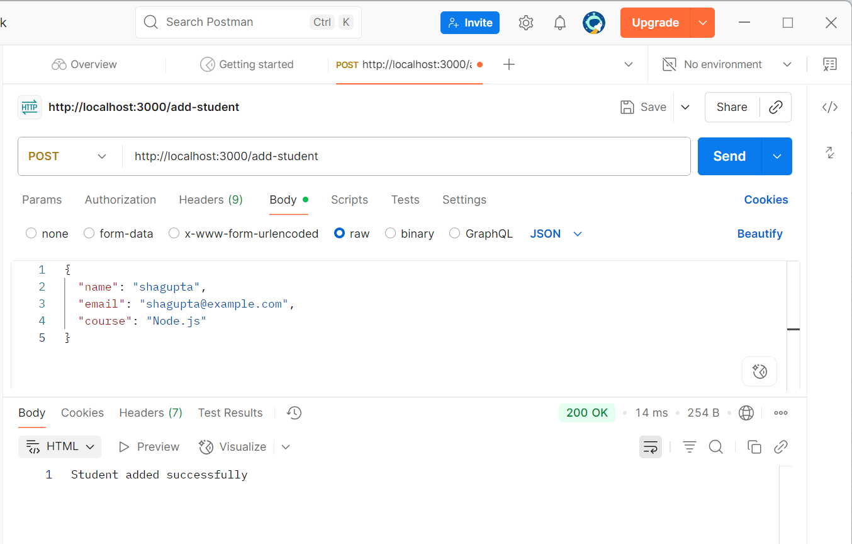

**MongoDB Compass:**

