**Day 17: Creating and Using Functional Components in React**

**What are functional components in React?**

Functional components are simple JavaScript functions that return JSX to show UI.

**Difference between Functional and Class Components:**

|  |  |
| --- | --- |
| **Functional Component** | **Class Component** |
| JavaScript function | ES6 class |
| Simple and clean | More complex |
| Not used | Used(this.state, this.props) |
| Not used directly  (use hooks instead) | Used(like componedtDidMount) |
| Yes(useState, useEffect, etc.) | No(hooks not used) |
| Faster and lighter | Slightly heavier |

**What are props?**

Props are used to pass data into components from parent to child.

**What are components?**

Components are reusable building blocks used to create UI in React.

**Code:**

**Header.js:**

import React from 'react';

function Header() {

return <h1>Welcome to Student Info Portal</h1>;

}

export default Header;

**StudentCard.js:**

import React from 'react';

function StudentCard(props) {

return (

<div style={{ border: '1px solid #ccc', padding: '10px', marginBottom: '10px' }}>

<h3>{props.name}</h3>

<p>Course: {props.course}</p>

</div>

);

}

export default StudentCard;

**App.js:**

import React from 'react';

import Header from './components/Header';

import Footer from './components/Footer';

import StudentCard from './components/StudentCard';

function App() {

return (

<div>

<Header />

<StudentCard name="Shagufta Pinjari" course="ReactJS" />

<StudentCard name="Sahil Pinjari" course="MongoDB" />

<Footer />

</div>

);

}

export default App;

**Browser Output:**

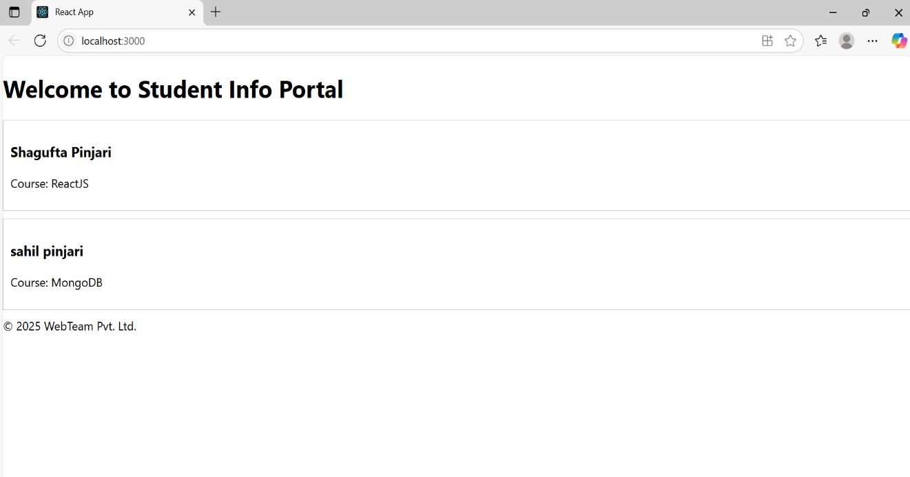

**VS Code Folder Structure and App.js code:**

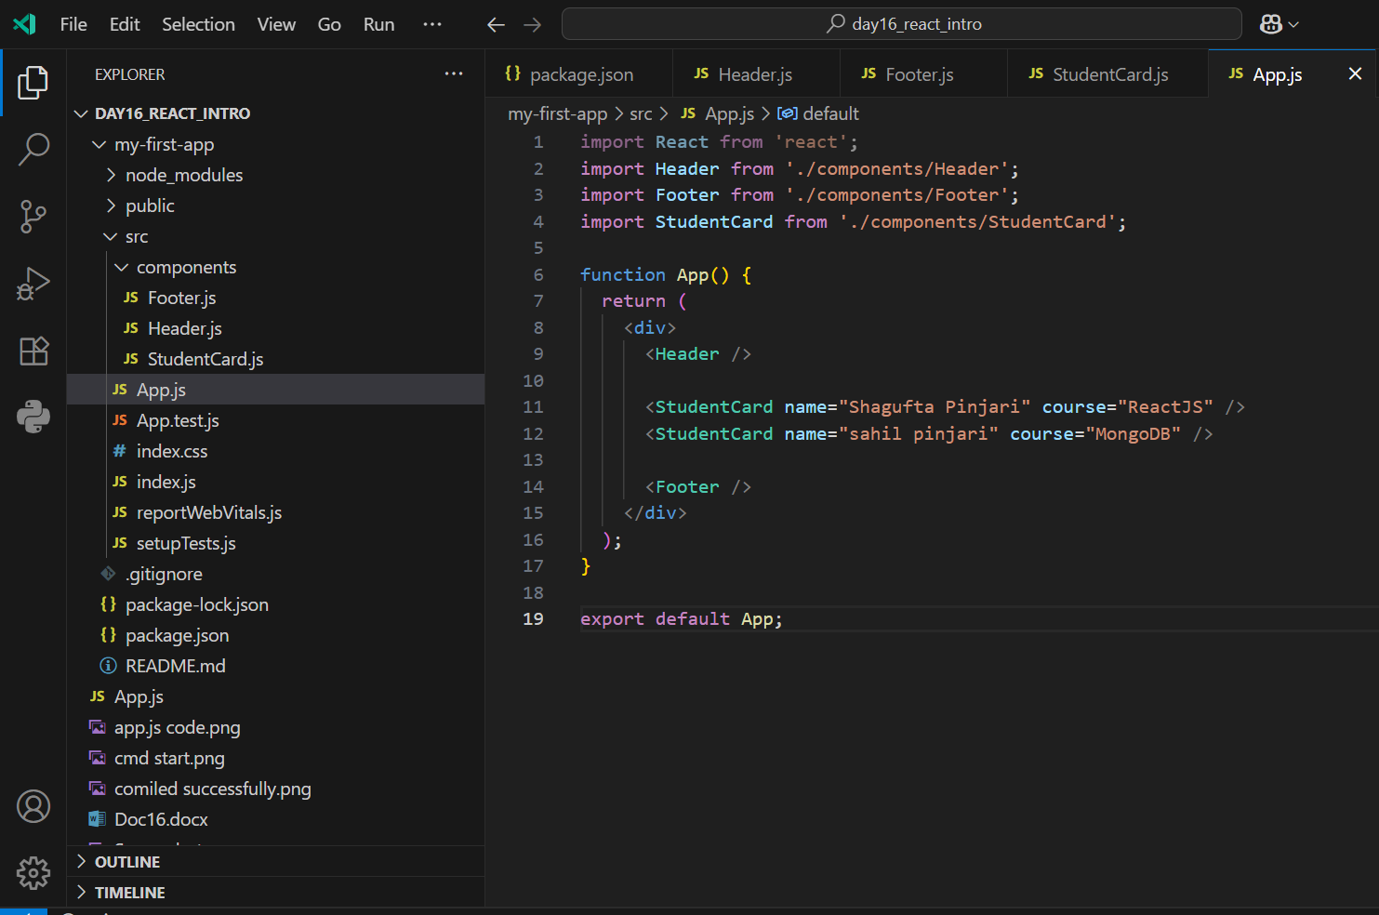

**CMD compiled successfully Output:**

