**Day 18 – React State Management using useState Hook**

**What is useState in React?**

useState is a React Hook that lets you create and manage state (dynamic data) in functional components.

**When and why is it used?**

It is used when a component needs to store and update data that can change (like a counter, input value, toggle, etc.)

**Code:**

**Counter.js:**

import React, { useState } from 'react';

function Counter() {

const [count, setCount] = useState(0);

return (

<div>

<h2>Counter: {count}</h2>

<button onClick={() => setCount(count + 1)}>Increment</button>

<button onClick={() => setCount(count - 1)}>Decrement</button>

</div>

);

}

export default Counter;

**App.js:**

import React from 'react';

import Counter from './components/Counter';

function App() {

return (

<div>

<h1>React Counter App</h1>

<Counter />

</div>

);

}

export default App;

**Browser Output:**

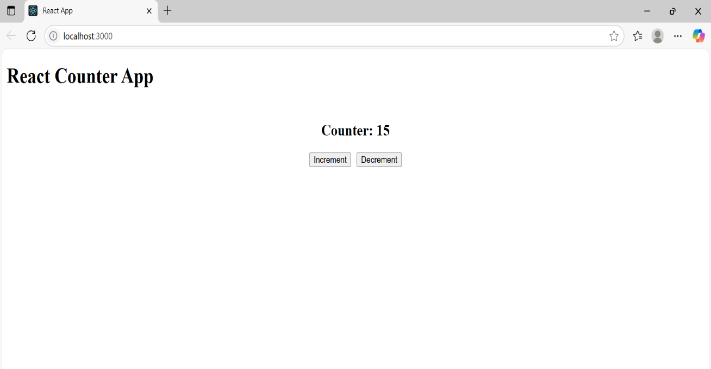

**VS code – Counter.js:**

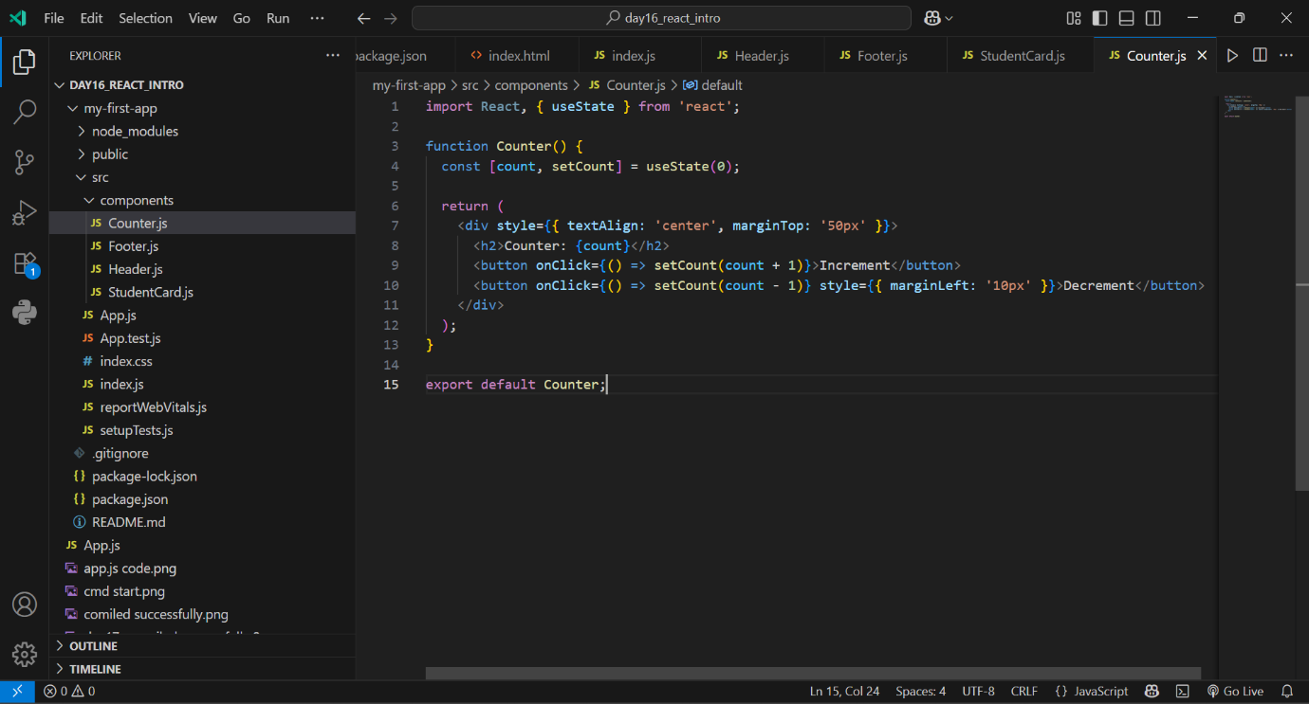

**CMD npm start:**

