**Day 21 – Angular Components: Creation and Usage**

**What is an Angular Component?**

An Angular component is a building block of Angular UI. It controls a section of the screen and includes HTML, CSS, and TypeScript

**Key Parts of a Component:**

Template – HTML view of the component

Class – TypeScript logic file

Style – CSS styling

Selector – Used to embed component in another

**Components Created:**

HeaderComponent – Displays the heading

StudentCardComponent – Shows student name & course

FooterComponent – Displays footer note

**Code:**

**app.component.html:**

<app-header></app-header>

<app-student-card name="Shagupta" course="Angular"></app-student-card>

<app-student-card name="Aarav" course="React"></app-student-card>

<app-footer></app-footer>

**student-card.component.html:**

<div class="card">

<h3>Student Name: {{ name }}</h3>

<p>Course: {{ course }}</p>

<p>Email: student@example.com</p>

</div>

**Output:**

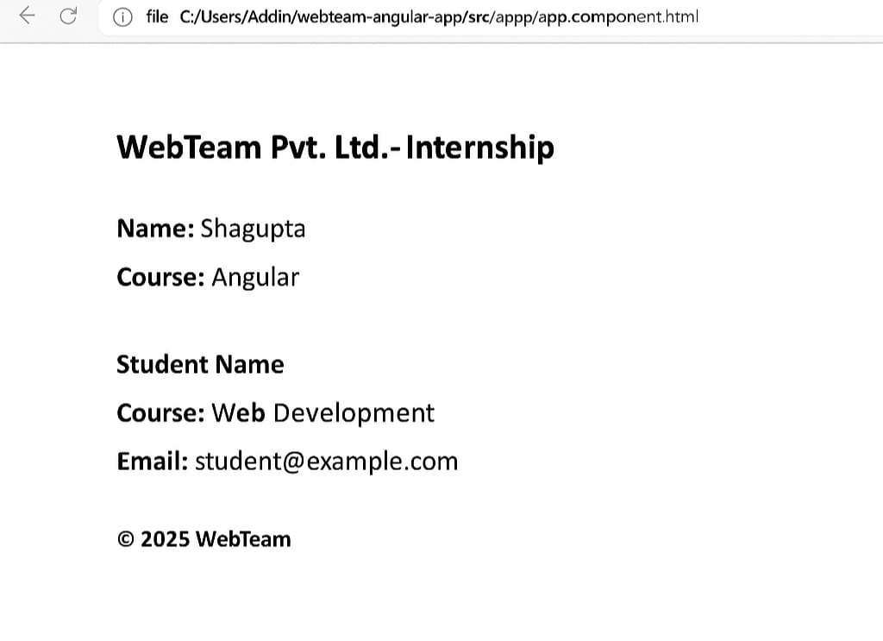

**header.component.html:**

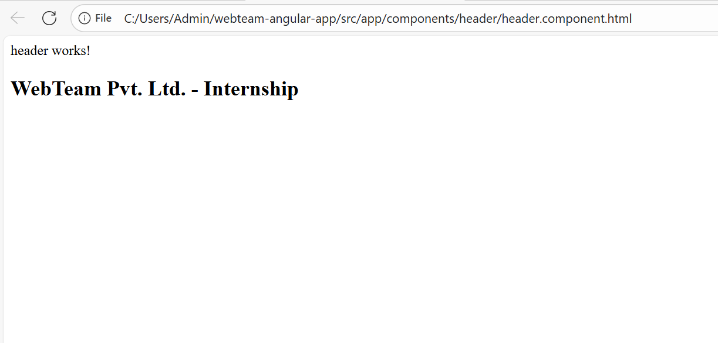

**Student-card.component.html:**

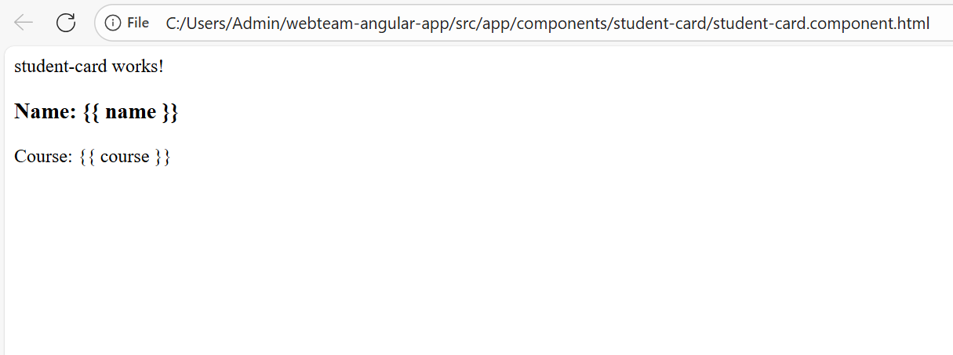

**Footer.component.html:**

