**Introduction to Express.js and Creating a Basic Web Server**

**What is Express.js?**

Express.js is a web framework used with Node.js.

It helps to create web servers and APIs easily.

**Key Features of Express.js:**

Simple and fast to create web apps and APIs

Routing system to handle different URLs

Middleware support to manage request/response

Easy integration with Node.js

Supports HTTP methods like GET, POST, etc.

**Code:**

const express = require('express');

const app = express();

app.get('/', (req, res) => {

res.send('Welcome to Express Server');

});

app.get('/about', (req, res) => {

res.send('About Page');

});

app.get('/contact', (req, res) => {

res.send('Contact Page');

});

app.listen(3000, () => {

console.log('Server is running on http://localhost:3000');

});

**Output:**

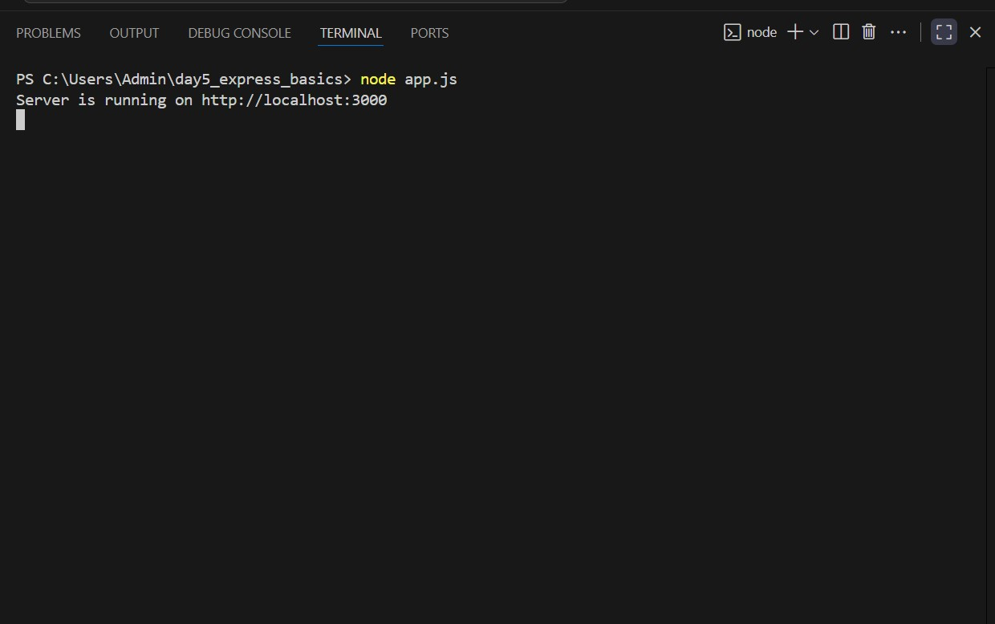

**Express install:**

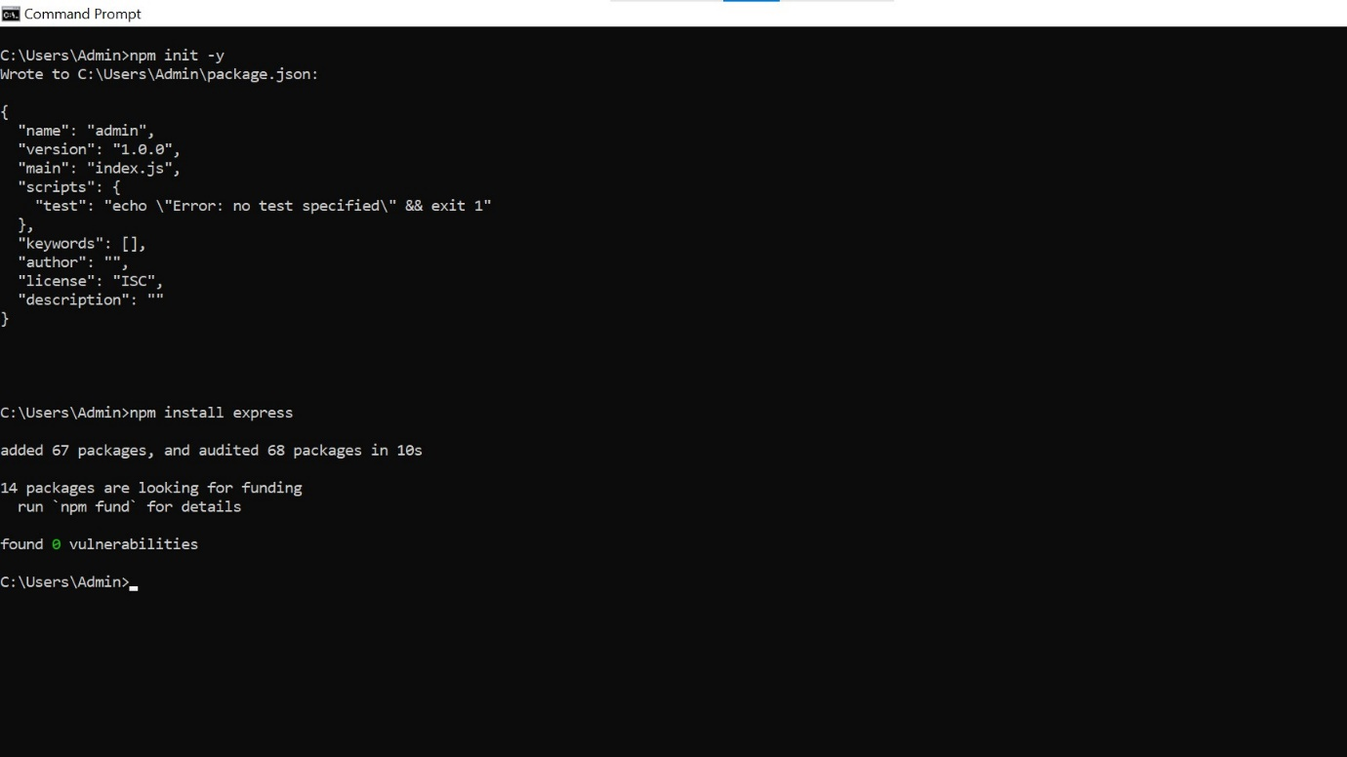

**Home:**

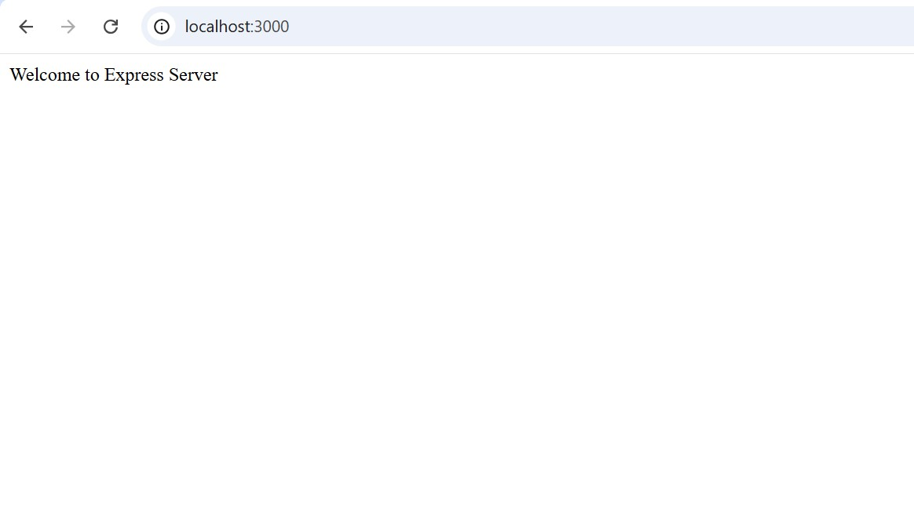

**About:**



**Contact:**

