**Day6_Node_Output_docx**

**What is REST API?**

REST API is a system that allows communication between client and server using HTTP methods like GET and POST. It sends and receives data in JSON format.

**Difference Between GET and POST**

|  |  |
| --- | --- |
| **GET** | **POST** |
| GET is used to fetch data | POST is used to send data |
| Data is sent in URL | Data is sent in Body |
| Example: /students | Example: /add-student |

**Code:**

const express = require('express');

const app = express();

app.use(express.json());

const students = [

{ name: "shagupta", age: 18, course: "Node.js" },

{ name: "shifa", age: 20, course: "React" }

];

app.get('/students', (req, res) => {

res.json(students);

});

app.post('/add-student', (req, res) => {

console.log("New Student:", req.body);

res.send("Student data received");

});

app.listen(3000, () => {

console.log("Server is running on http://localhost:3000");

});

**GET Request Output:**

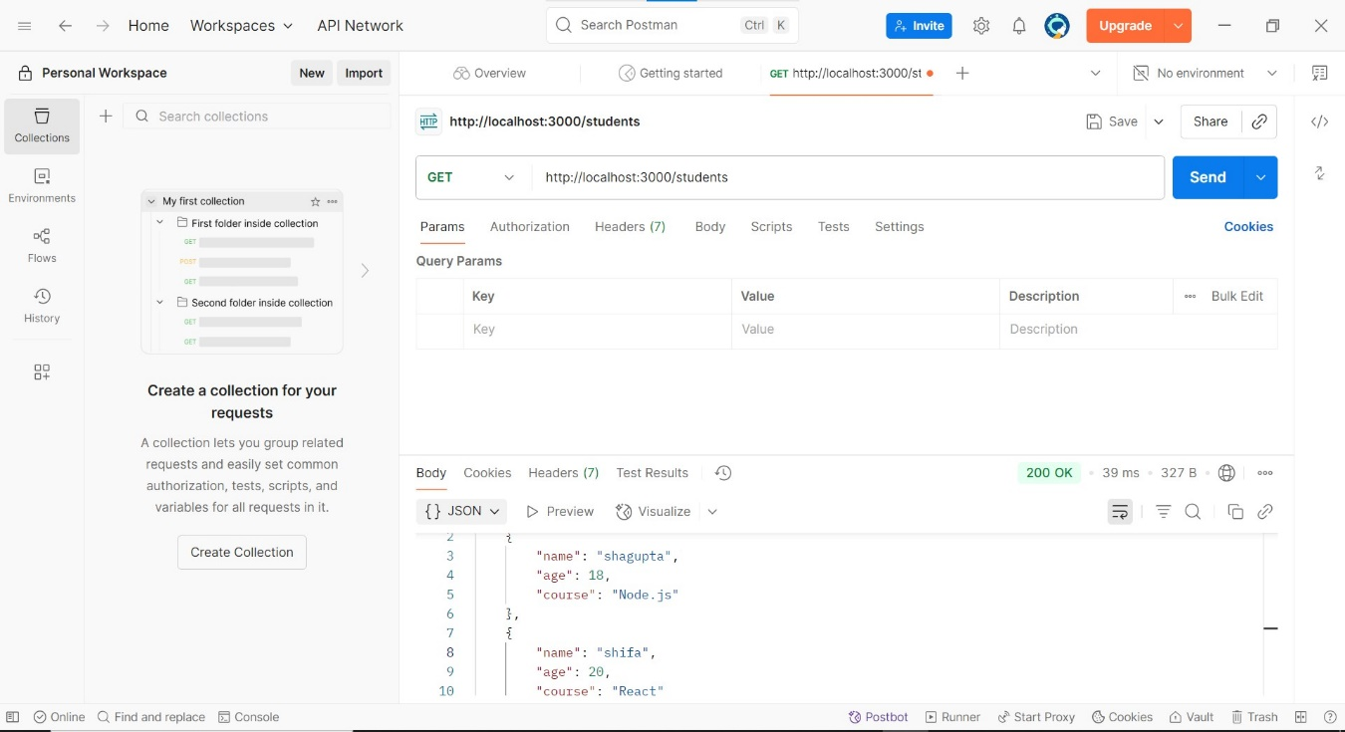

**Post Request output:**

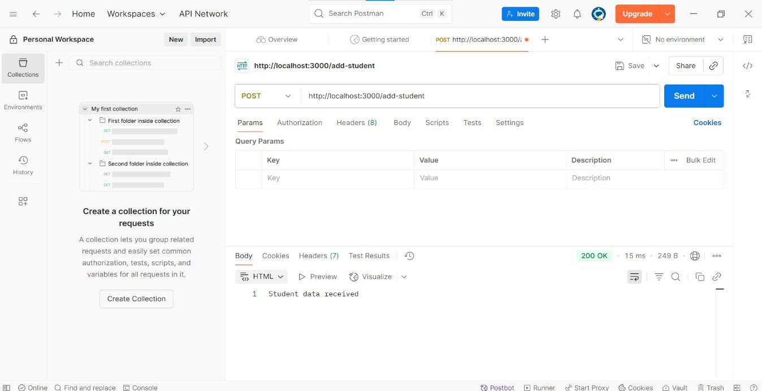

**POST add:**

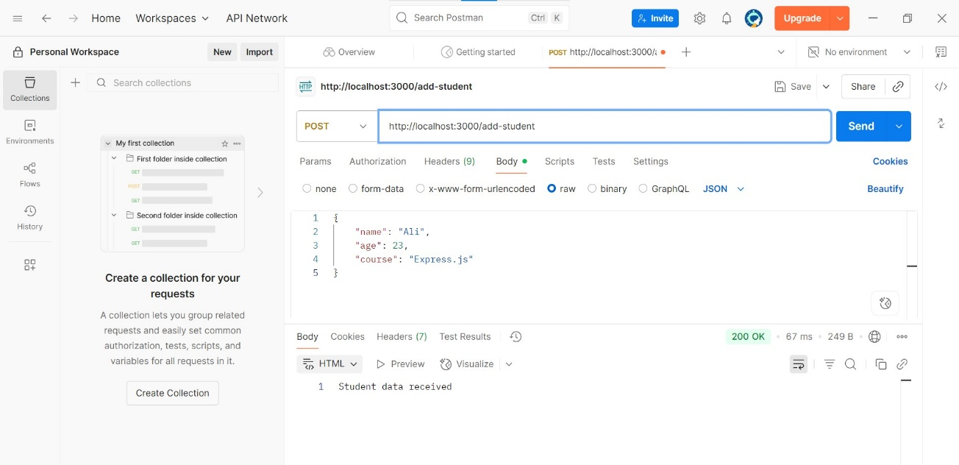

**Cmd output:**

