**Day7_Node_Route Parameters & Dynamic API in Express.js_docx**

**What are route parameters?**

Route parameters allow us to capture values from the URL to use in our backend. Example: /student/2

**How are they different from query parameters?**

Route params are part of the URL path. Query params come after ? in the URL.

Example:

Route param → /student/2

Query param → /student?id=2

**Code:**

const express = require('express');

const app = express();

const PORT = 3000;

const students = [

{ id: 1, name: 'Shagupta', course: 'Express.js' },

{ id: 2, name: 'Shifa', course: 'Node.js' },

{ id: 3, name: 'Anika', course: 'React' }

];

app.get('/student/:id', (req, res) => {

const studentId = parseInt(req.params.id);

const student = students.find(s => s.id === studentId);

if (student) {

res.json(student);

} else {

res.status(404).json({ message: "Student not found" });

}

});

app.listen(PORT, () => {

console.log(`Server running on http://localhost:${PORT}`);

});

**Terminal output:**

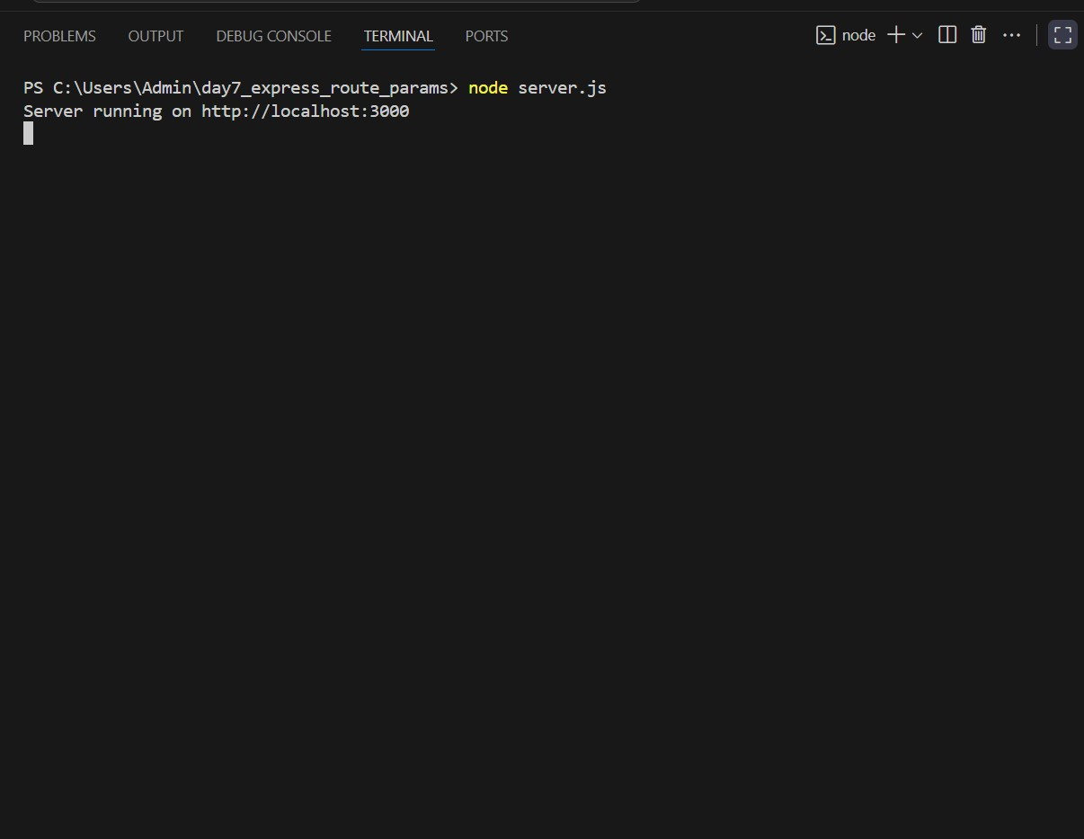

**Success output:**

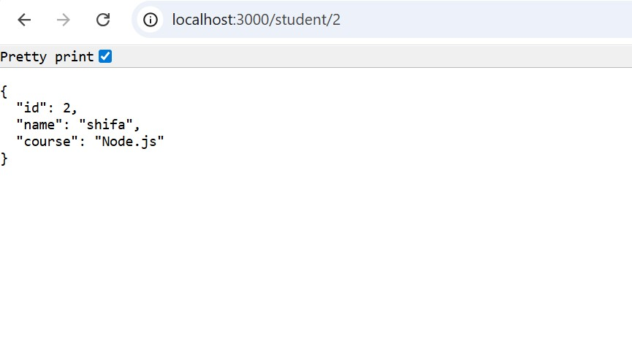

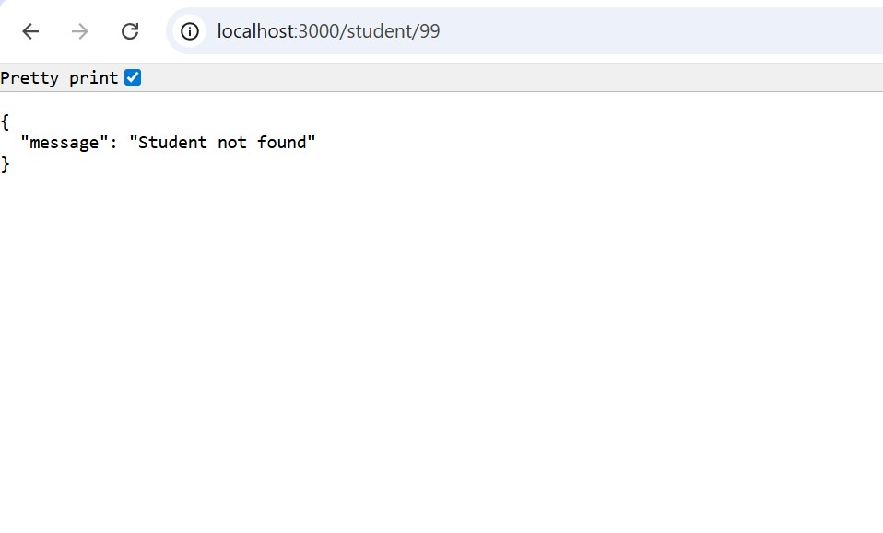

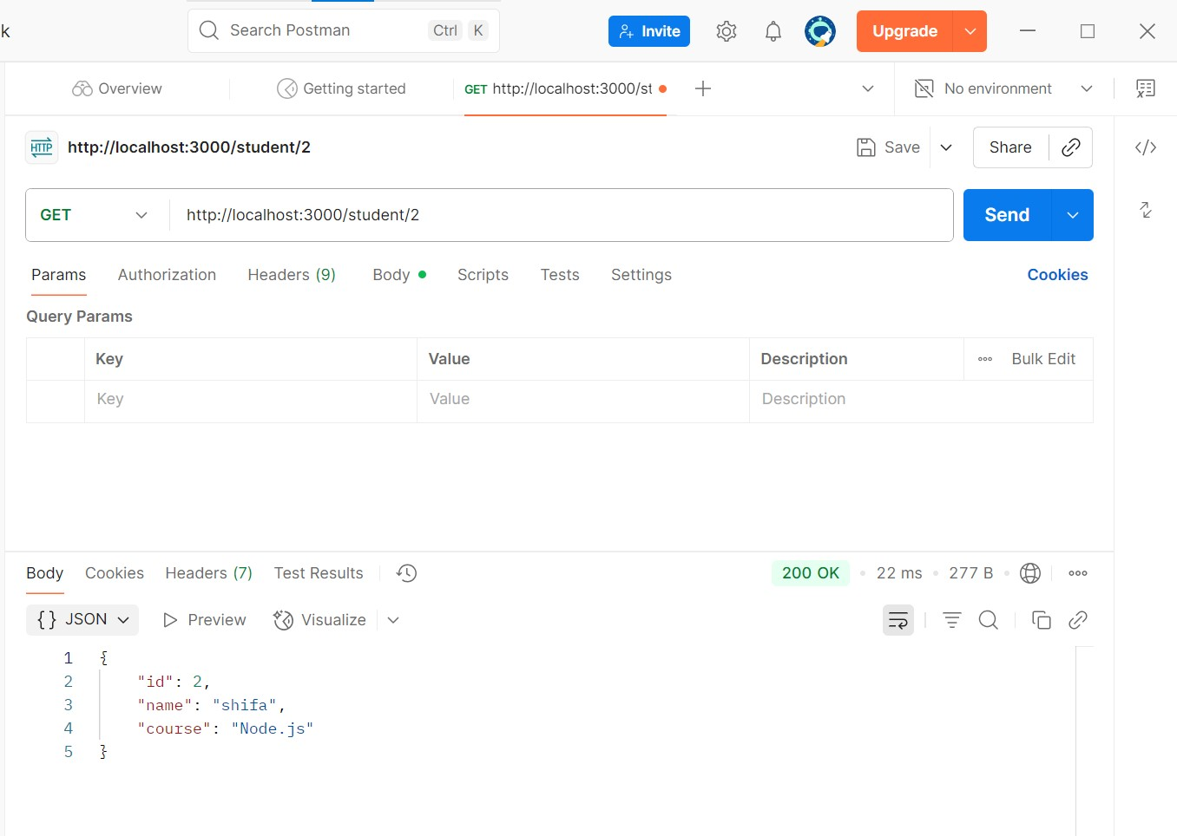

**Error output:**

**Browser error:**



**Postman error:**

