**Day 8: Handling JSON POST Data & Middleware in Express.js**

**What is middleware in Express.js?**

Middleware is a function that runs before the route to process requests.

**Common use cases of middleware:** Logging, authentication, JSON parsing, error handling.

**What is express.json()?**

It’s a built-in middleware to parse incoming JSON data in requests.

**Code:**

const express = require('express');

const app = express();

const PORT = 3000;

app.use(express.json());

app.use((req, res, next) => {

console.log(`[${new Date().toISOString()}] ${req.method} ${req.url}`);

next();

});

app.post('/register', (req, res) => {

const { name, email, course } = req.body;

console.log('Received Data:', req.body);

res.send(`Registration successful for ${name}`);

});

app.listen(PORT, () => {

console.log(`Server is running on http://localhost:${PORT}`);

});

**Server.js output:**

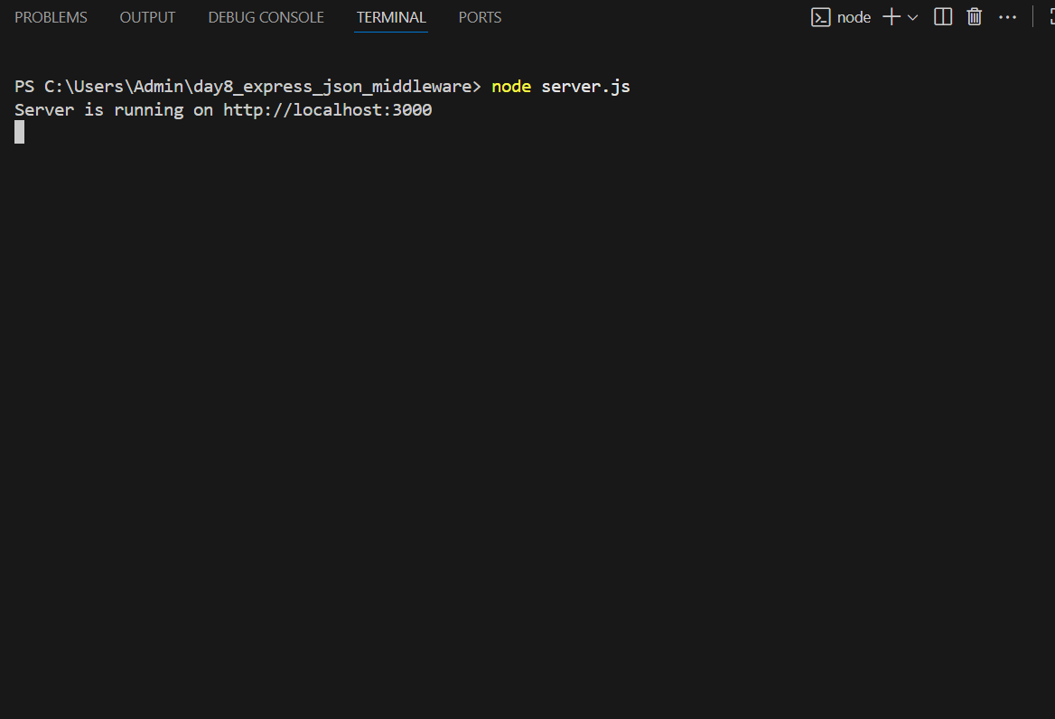

**JSON Body Post(postman):**

{

"name": "Shagupta",

"email": "shagupta@example.com",

"course": "Express.js"

}

**Output response:**

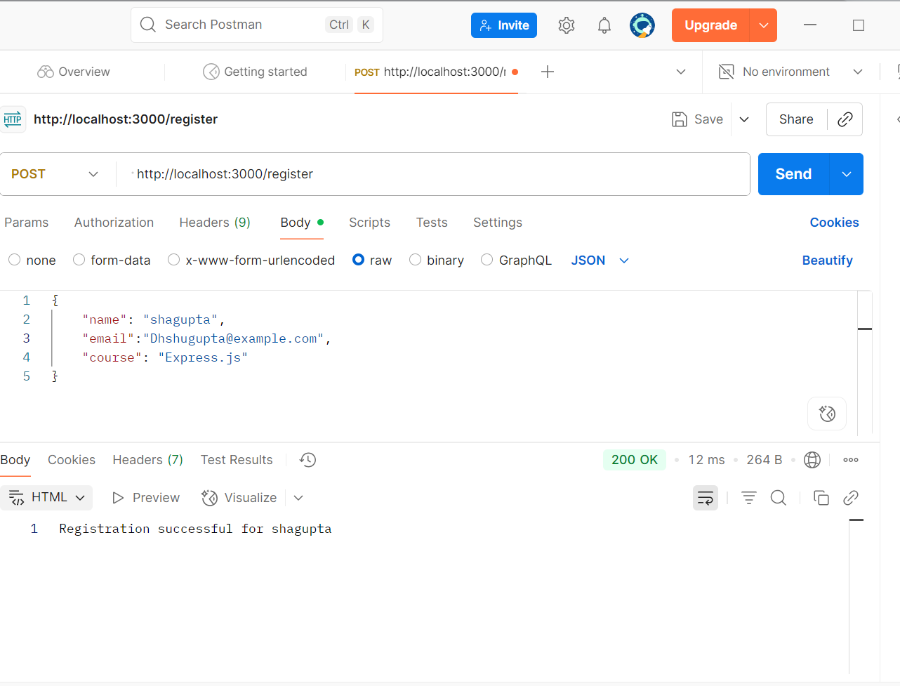

**Terminal post output:**

