

**Department of Computer Science &Engineering(CSE)**

**LAB - 1**

Name : Shah Ibne Fahad

Student ID : C193048

Semester : 7th

Section : 7BM

Email : c193048@ugrad.iiuc.ac.bd

Contact : 01860793742

Course Code : CSE-4742

Course Title : Computer Graphics Lab

Name of the course Teacher :

**Mahadi Hassan**

Associate Professor

Dept of Computer Science and Engineering,IIUC

1. **Install python for graphics programming :**

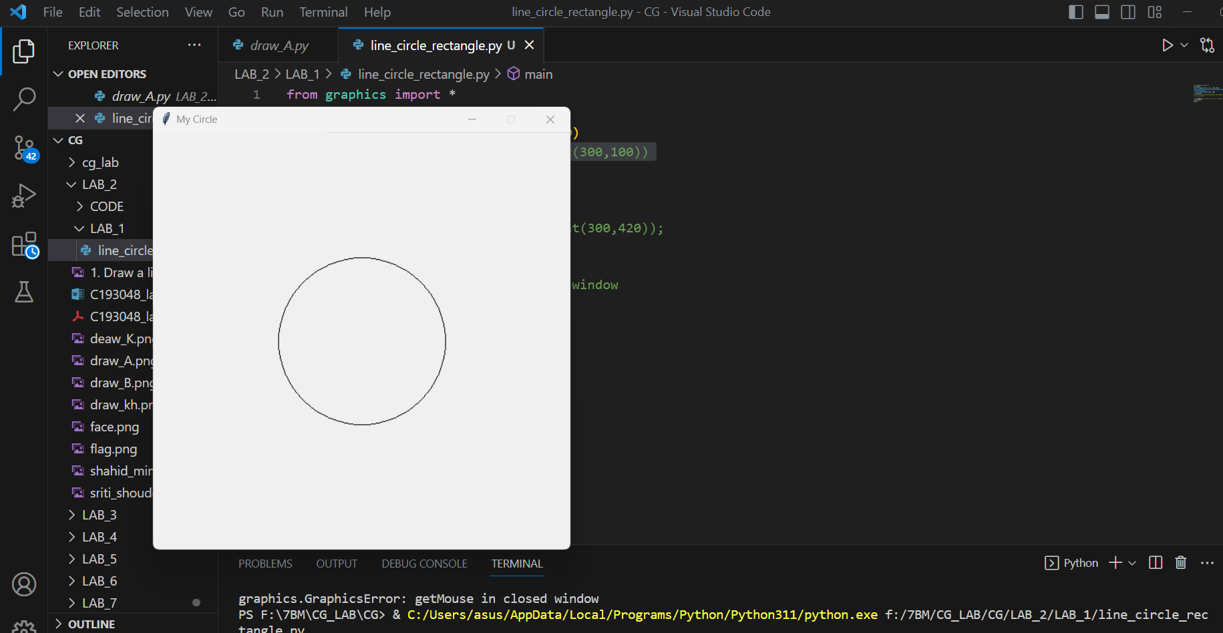

1. **Draw a line, circle, rectangle :**

from graphics import *

def main():

win = GraphWin("My Circle", 500, 500)

aLine = Line(Point(100,100), Point(300,100))

aLine.draw(win)

c = Circle(Point(250,250), 100)

c.draw(win)

rec = Rectangle(Point(100,360),Point(300,420));

rec.draw(win)

win.getMouse() # pause for click in window

win.close()

main()

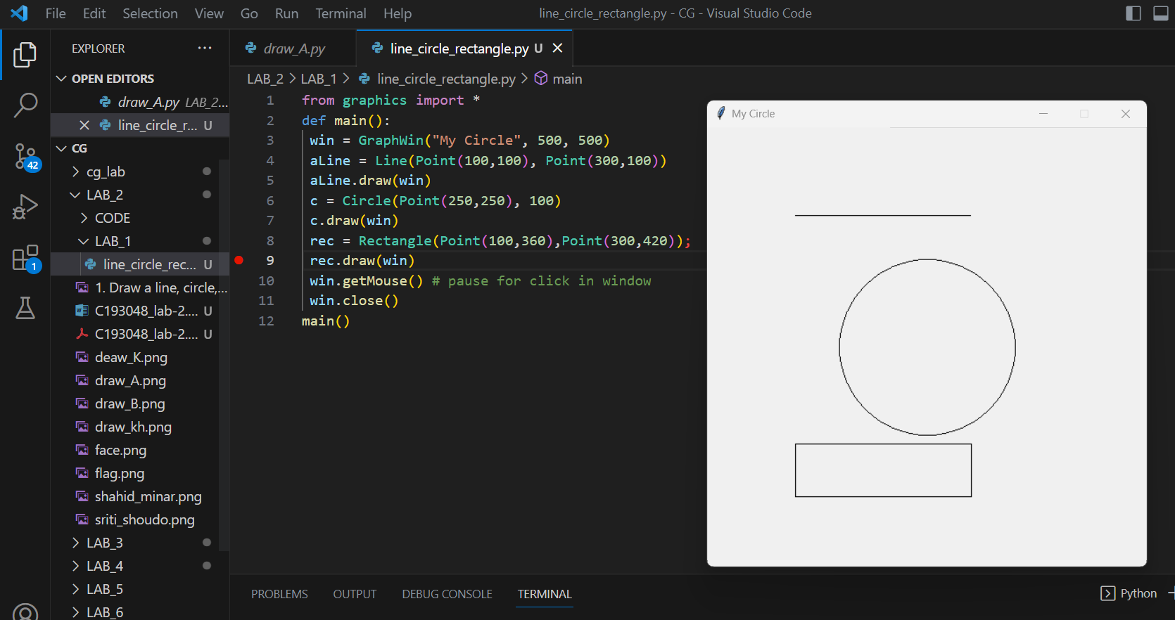

**3, Draw text "Hello world" with large font size and colorful.**

from graphics import *

def main():

win = GraphWin("My Circle", 500, 500)

message = Text(Point(100,100), "Hello!")

message.setFill(color_rgb(135,0,135))

message.setSize(18)

message.draw(win);

win.getMouse()

win.close()

main()

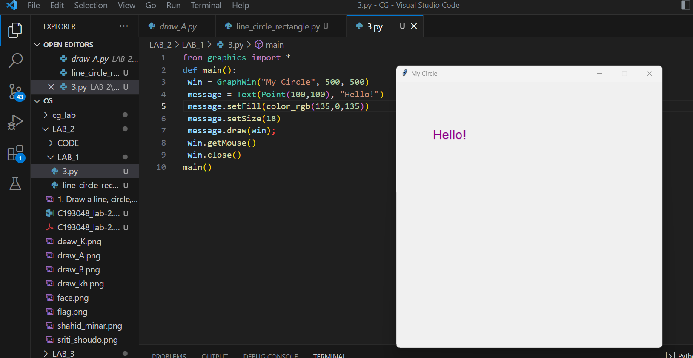

1. **Display image.**

from graphics import *

def main():

win = GraphWin("My Circle", 500, 500)

flowerImage = Image(Point(100,100), "deaw_K.png")

flowerImage.draw(win)

win.getMouse()

win.close()

main()