

**Department of Computer Science &Engineering(CSE)**

Name : Shah Ibne Fahad

Student ID : C193048

Semester : 7th

Section : 7BM

Email : c193048@ugrad.iiuc.ac.bd

Contact : 01860793742

Course Code : CSE-4742

Course Title : Computer Graphics Lab

Name of the course Teacher :

**Mahadi Hassan**

Associate Professor

Dept of Computer Science and Engineering,IIUC

1. **Draw Line using line equation :**

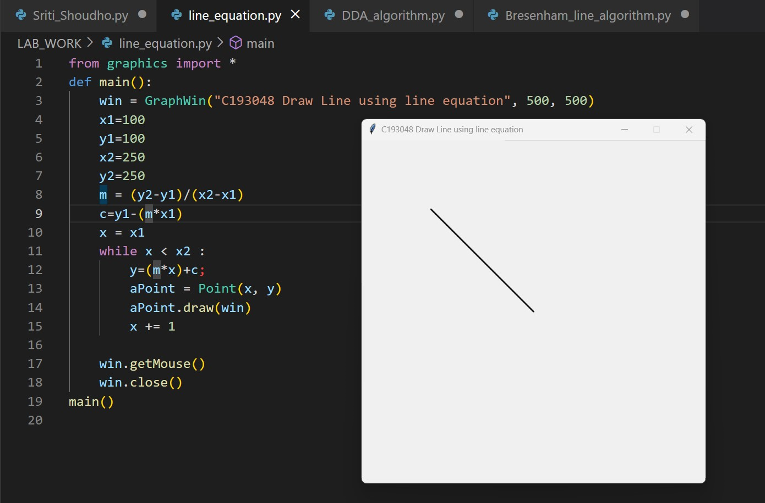

1. **Draw line using DDA algorithm :**

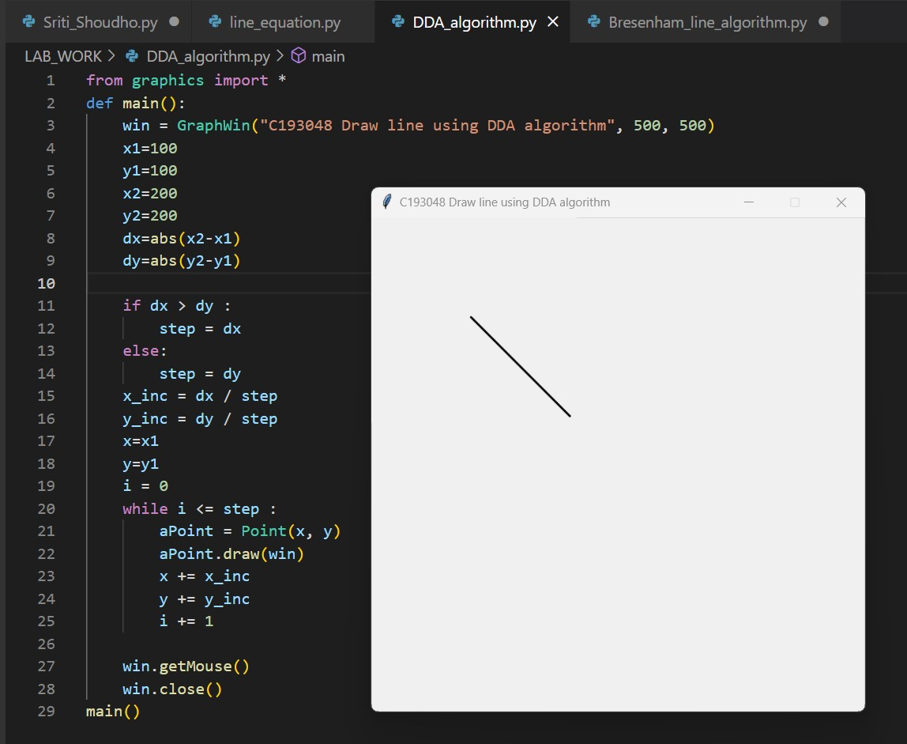

1. **Draw Line using Bresenham's line algorithm :**

