

**Department of Computer Science &Engineering(CSE)**

**LAB - 4**

Name : Shah Ibne Fahad

Student ID : C193048

Semester : 7th

Section : 7BM

Email : c193048@ugrad.iiuc.ac.bd

Contact : 01860793742

Course Code : CSE-4742

Course Title : Computer Graphics Lab

Name of the course Teacher :

**Mahadi Hassan**

Associate Professor

Dept of Computer Science and Engineering,IIUC

1. **Draw a Circle using polynomial method**

#include<graphics.h>

#include<conio.h>

#include<math.h>

void setPixel(int x, int y, int h, int k)

{

putpixel(x+h, y+k, RED);

putpixel(x+h, -y+k, RED);

putpixel(-x+h, -y+k, RED);

putpixel(-x+h, y+k, RED);

putpixel(y+h, x+k, RED);

putpixel(y+h, -x+k, RED);

putpixel(-y+h, -x+k, RED);

putpixel(-y+h, x+k, RED);

}

main()

{

int gd=0, gm,h,k,r;

double x,y,x2;

h=200, k=200, r=100;

initgraph(&gd, &gm, "C:\\TC\\BGI ");

setbkcolor(WHITE);

x=0,y=r;

x2 = r/sqrt(2);

while(x<=x2)

{

y = sqrt(r*r - x*x);

setPixel(floor(x), floor(y), h,k);

x += 1;

}

getch();

closegraph();

return 0;

}

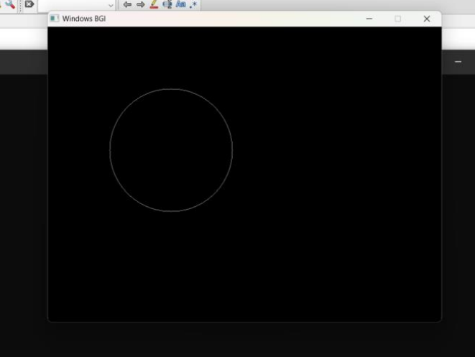

1. **Draw a Circle using Trigonometric method**

#include<graphics.h>

#include<bits/stdc++.h>

#include<math.h>

void plot8pixel(int x,int y,int h,int k)

{

putpixel(x+h,y+k,8);

putpixel(x+h,-y+k,8);

putpixel(-x+h,y+k,8);

putpixel(-x+h,-y+k,8);

putpixel(y+h,x+k,8);

putpixel(y+h,-x+k,8);

putpixel(-y+h,x+k,8);

putpixel(-y+h,-x+k,8);

}

int main()

{

int gd=DETECT,gm;

initgraph(&gd,&gm,"");

setbkcolor(WHITE);

int x,y,x1,y1,r,h,k,theta;

float n=3.14159/180;

h=200;k=200;r=100;

for(theta=0; theta<=45; theta++)

{

x1=r*cos(theta*n);

y1=r*sin(theta*n);

x=int(x1+0.5);

y=int(y1+0.5);

plot8pixel(x,y,h,k);

}

getch();

closegraph();

}

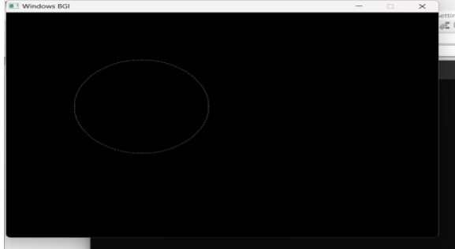

1. **Draw a Circle using using Bresenham's Algorithm**

#include<graphics.h>

#include<bits/stdc++.h>

#include<math.h>

void plot8pixel(int x,int y,int h,int k)

{

putpixel(x+h,y+k,8);

putpixel(x+h,-y+k,8);

putpixel(-x+h,y+k,8);

putpixel(-x+h,-y+k,8);

putpixel(y+h,x+k,8);

putpixel(y+h,-x+k,8);

putpixel(-y+h,x+k,8);

putpixel(-y+h,-x+k,8);

}

int main()

{

int gd=DETECT,gm;

initgraph(&gd,&gm,"");

setbkcolor(WHITE);

int x,y,r,d,h,k,theta;

h=200;

k=200;

r=100;

x=0;

y=r;

d=3-(2*r);

while(x<=y)

{

plot8pixel(x,y,h,k);

if(d<0) d=d+(4*x)+6;

else

{

d=d+(4*(x-y))+10;

y--;

}

x++;

}

getch();

closegraph();

}

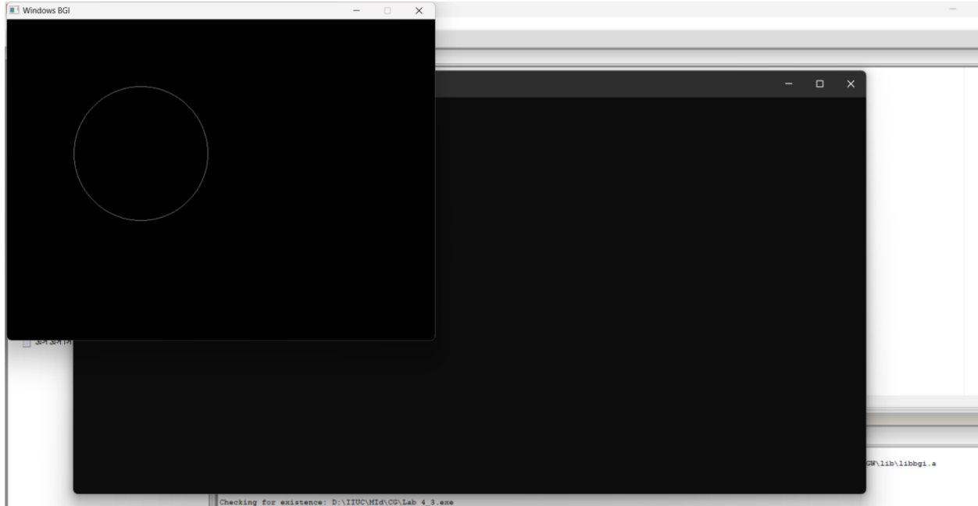

1. **Draw a Circle using Midpoint Algorithm**

#include<graphics.h>

#include<bits/stdc++.h>

#include<math.h>

void plot8pixel(int x,int y,int h,int k)

{

putpixel(x+h,y+k,8);

putpixel(x+h,-y+k,8);

putpixel(-x+h,y+k,8);

putpixel(-x+h,-y+k,8);

putpixel(y+h,x+k,8);

putpixel(y+h,-x+k,8);

putpixel(-y+h,x+k,8);

putpixel(-y+h,-x+k,8);

}

int main()

{

int gd=DETECT,gm;

initgraph(&gd,&gm,"");

setbkcolor(WHITE);

int x,y,r,d,h,k,theta;

h=200;

k=200;

r=100;

x=0;

y=r;

d=3-(2*r);

while(x<=y)

{

plot8pixel(x,y,h,k);

if(d<0) d=d+(2*x)+3;

else

{

d=d+(2*(x-y))+5;

y--;

}

x++;

}

getch();

closegraph();

}

