

**Department of Computer Science &Engineering(CSE)**

**LAB - 5**

Name : Shah Ibne Fahad

Student ID : C193048

Semester : 7th

Section : 7BM

Email : c193048@ugrad.iiuc.ac.bd

Contact : 01860793742

Course Code : CSE-4742

Course Title : Computer Graphics Lab

Name of the course Teacher :

**Mahadi Hassan**

Associate Professor

Dept of Computer Science and Engineering,IIUC

1. Ellipse using polynomial method

#include<bits/stdc++.h>

#include<graphics.h>

#include<conio.h>

#include<math.h>

using namespace std;

void plot4pixels(int x,int y,int h,int k)

{

putpixel(x+h,y+k,8);

putpixel(x+h,-y+k,8);

putpixel(-x+h,y+k,8);

putpixel(-x+h,-y+k,8);

}

int main()

{

int x,y,r,i,h,k,a,b;

a=50;

b=30;

x=0;

y=30;

int gd=DETECT,gm;

initgraph(&gd,&gm,"");

setbkcolor(GREEN);

while(x<a)

{

plot4pixels(x,y,200,200);

x++;

y=b*sqrt(((a*a)-(x*x*1.0))/(a*a));

}

plot4pixels(x,y,200,200);

setcolor(8);

getch();

}

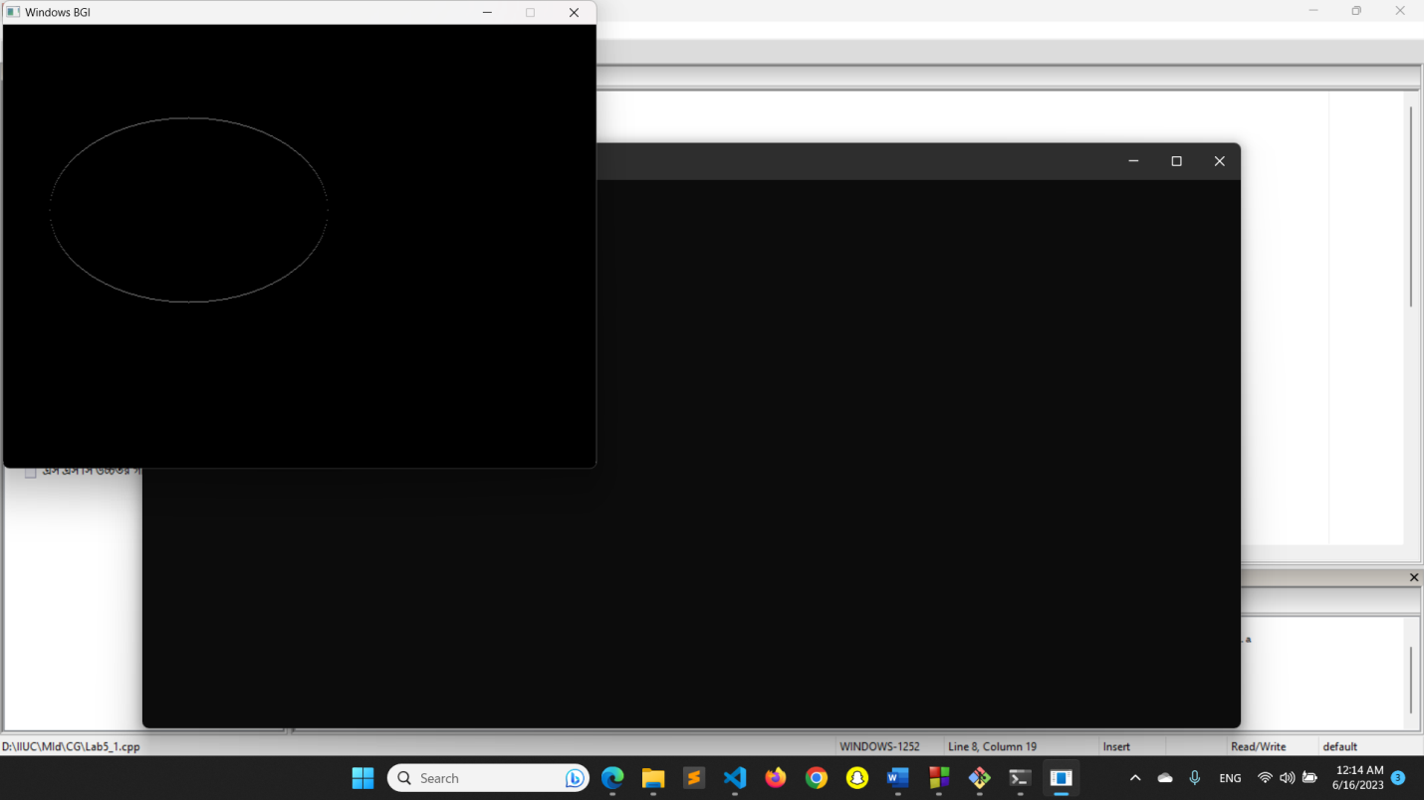

1. Ellipse using Trigonometric method

#include<bits/stdc++.h>

#include<graphics.h>

#include<conio.h>

#include<math.h>

using namespace std;

void plot4pixels(int,int,int,int);

int main()

{

int x,y,x1,y1,a,b,h,k,theta;

float p=3.14159/180;

int gd=DETECT,gm;

initgraph(&gd,&gm,"");

setbkcolor(WHITE);

for(theta=0; theta<=90; theta++)

{

x1=50*cos(theta*p);

y1=30*sin(theta*p);

x=int(x1+0.5);

y=int(y1+0.5);

plot4pixels(x,y,200,200);

}

setcolor(8);

getch();

closegraph();

}

void plot4pixels(int x,int y,int h,int k)

{

putpixel(x+h,y+k,8);

putpixel(x+h,-y+k,8);

putpixel(-x+h,y+k,8);

putpixel(-x+h,-y+k,8);

}

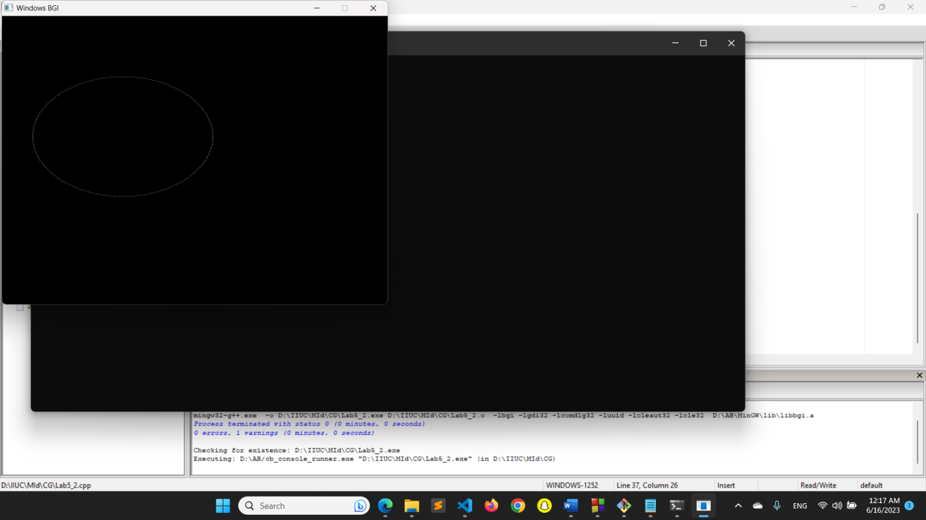

1. Arcs

#include<bits/stdc++.h>

#include<graphics.h>

#include<conio.h>

using namespace std;

int main()

{

int gd = DETECT, gm;

int x = 250;

int y = 250;

int start_angle = 155;

int end_angle = 300;

int radius = 100;

initgraph(&gd, &gm, "");

arc(x, y, start_angle, end_angle, radius);

getch();

closegraph();

return 0;

}

1. Sectors

#include<bits/stdc++.h>

#include<graphics.h>

#include<conio.h>

using namespace std;

int main()

{

int gd = DETECT, gm;

initgraph(&gd, &gm, "");

sector(200, 200, 0, 150, 50, 65);

getch();

closegraph();

return 0;

}