**Level measurement using DPT**

DPT works on the principle of differential capacitance. In this design, the sensing element is a taut metal diaphragm located equidistant between two stationary metal surfaces, comprising three plates for a complementary pair of capacitors. An electrically insulating fill fluid (usually a liquid silicone compound) transfers motion from the isolating diaphragms to the sensing diaphragm, and also doubles as an effective dielectric for the two capacitors:

Any difference of [pressure](https://instrumentationtools.com/basics-of-pressure-measurement/) across the cell causes the diaphragm to flex in the direction of least pressure. The sensing diaphragm is a precision-manufactured spring element, meaning that its displacement is a predictable function of applied force. The applied force in this case can only be a function of differential pressure acting against the surface area of the diaphragm in accordance with the standard force-pressure-area equation F = PA.

In this case, we have two forces caused by two fluid pressures working against each other, so our force-pressure-area equation may be rewritten to describe resultant force as a function of differential pressure (P1 − P2) and diaphragm area: F = (P1 − P2)A. Since diaphragm area is constant, and force is predictably related to diaphragm displacement, all we need now in order to infer differential pressure is to accurately measure displacement of the 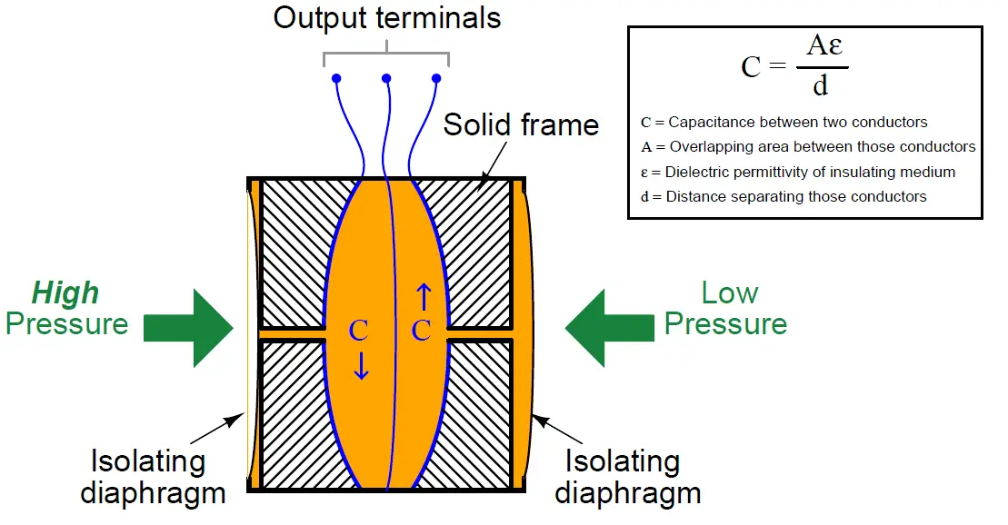diaphragm.

**DPT for level measurement**

The differential pressure transmitter, enables an automatic subtraction of the pressure on the LP side, from the total pressure appearing at the HP side. This is accomplished as shown in diagram above, where the LP is connected above the maximum predicted level. With this arrangement, each increment of pressure above the liquid surface is applied to both capsule assemblies of the transmitter, and since they are in opposition, the increment is cancelled. Only the hydrostatic pressure, which is applied to the HP, is effective in causing any response to the transmitter, which is 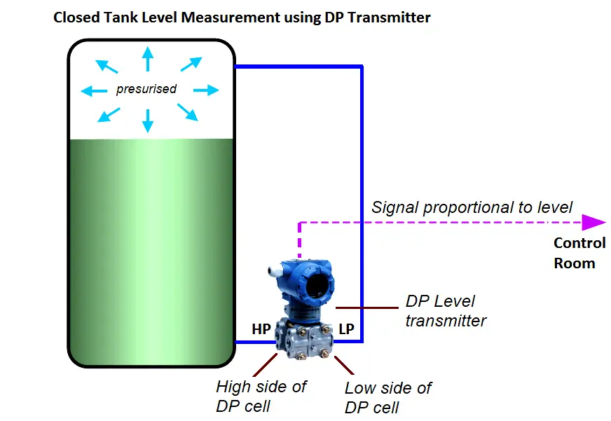proportional to the level.