**Internship Report**

***Report submitted to Shri Ramdeobaba College of Engineering & Management, Nagpur in partial fulfillment of requirement for the award of degree of***

# **Bachelor of Technology**

*in*

**Electrical Engineering**

*by*

## **Mr. Zeeshan Ahmed Shah**

## **Mr. Anshit Nikhade**

*Guide*

## **Prof. S.C. Rangari**



## **Shri Ramdeobaba College of Engineering & Management, Nagpur**

(An Autonomous Institute affiliated to Rashtrasant Tukdoji Maharaj Nagpur University, Nagpur)

June 2024

# **ACKNOWLEDGEMENT**

We would like to express our deep and sincere gratitude to our guide **Prof. S.C. Rangari**, Assistant Professor in the Department of Electrical Engineering, RCOEM for giving us the opportunity to work on this project and providing valuable guidance throughout the project. It was a great privilege and honor to work under her guidance.

### **Mr. Zeeshan Ahmed Shah Mr. Anshit Nikhade**

# **TABLE OF CONTENTS**

| Sr. No | Chapters | Page No. |
| --- | --- | --- |
| 1 | Substation Instruments |  |
| 2 |  |  |
| 3 |  |  |
| 4 |  |  |
| 5 |  |  |

Substation Equipments

**Metering Cubicle**

**Make** : Huphen Electromech

**Title** : 11kv H.T. Metering Cubicle

**CT ratio** : 55/5A

**PT ratio** : 11k / √ 3 / 110 / √ 3 volts

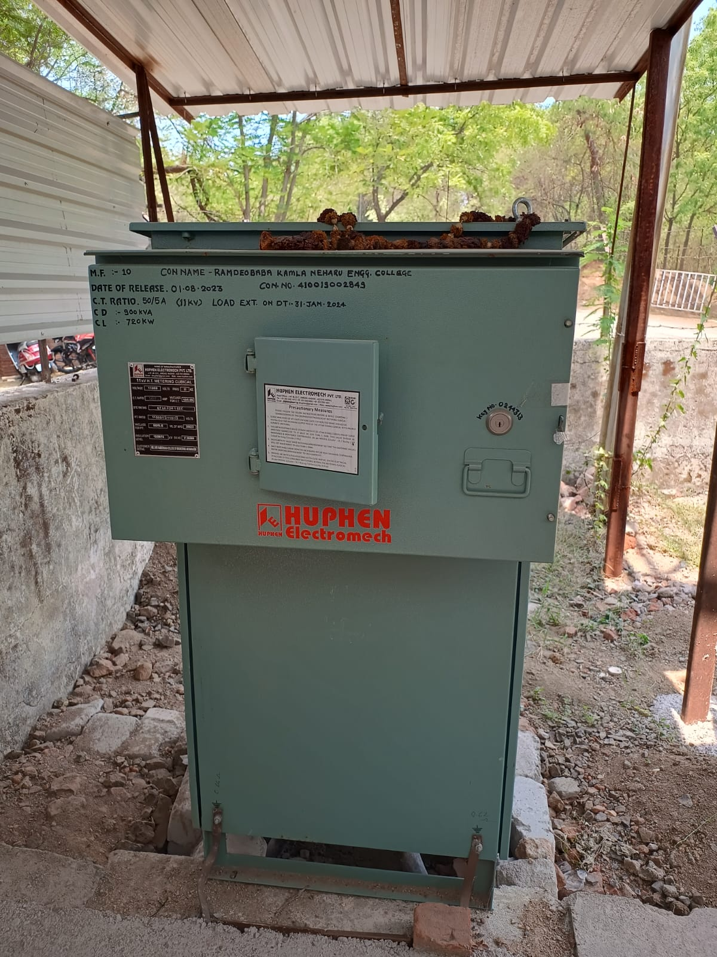

**Description :**

The 11kV HT (High Tension) metering cubicle is an electrical device

used for measuring and monitoring the energy consumption in high

voltage (11,000 volts) power distribution systems. It serves as a

critical component in substations and industrial facilities for accurate

billing and load management.

**Key Features:**

**Components:**

It typically includes current transformers (CTs),

potential transformers (PTs), meters, and protective relays.

**Functionality:**

The CTs and PTs step down high voltage and current to measurable

levels for the meters to accurately record consumption.

**Protection:**

Equipped with protective devices to safeguard against overloads,

short circuits, and faults.

**Installation:**

Installed in a compact and secure enclosure to ensure safety and ease of maintenance.

**Compliance:**

Designed to meet regulatory standards for accuracy and safety in

high voltage applications.

These cubicles are essential for ensuring reliable and precise energy measurement, which is crucial for both utility providers and consumers.

**Ring Main Unit - (RMU)**

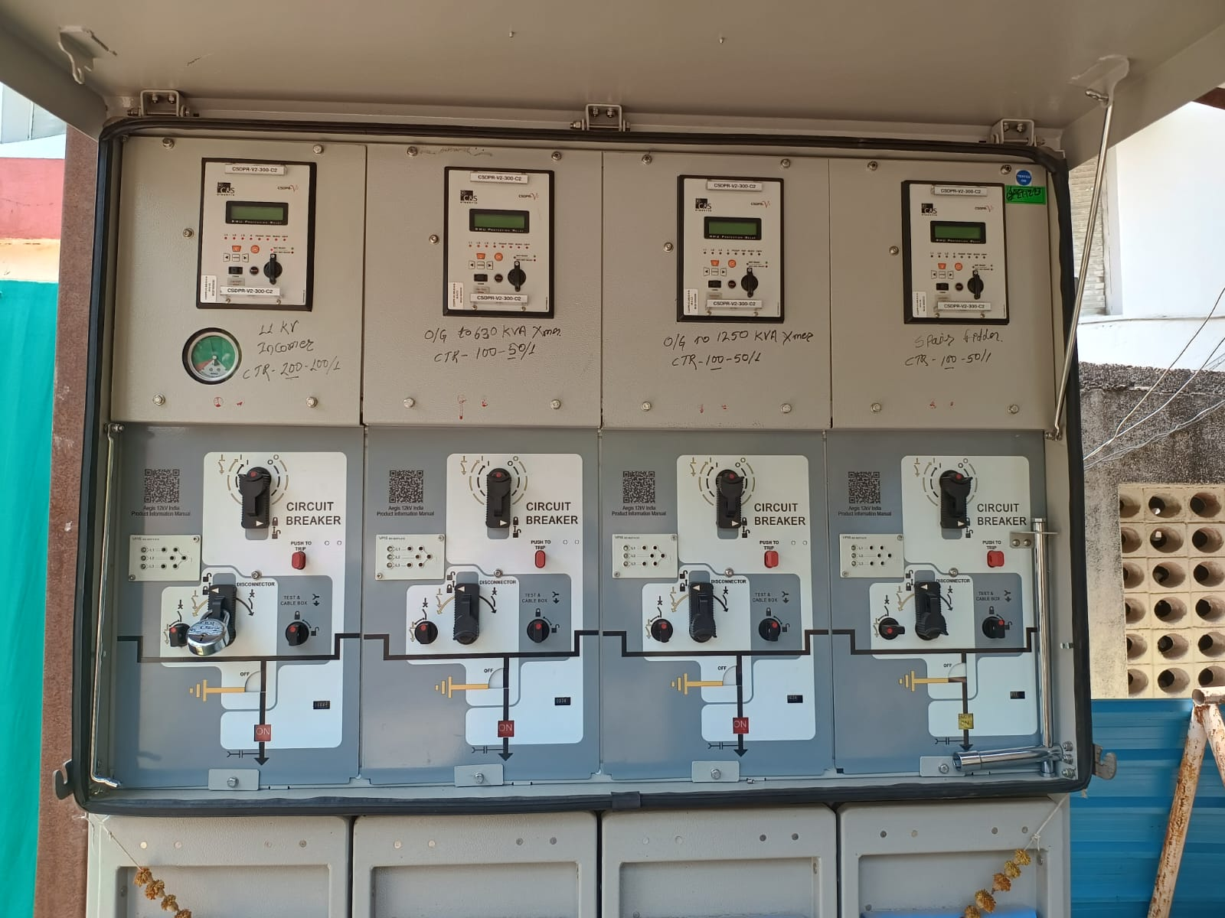

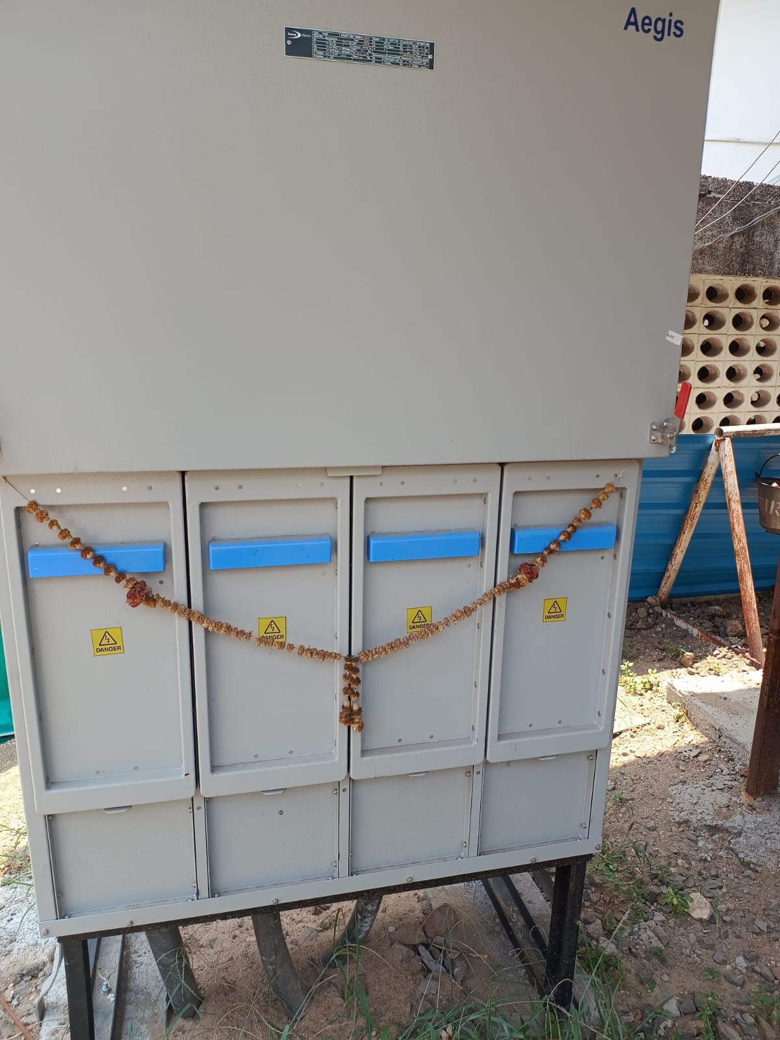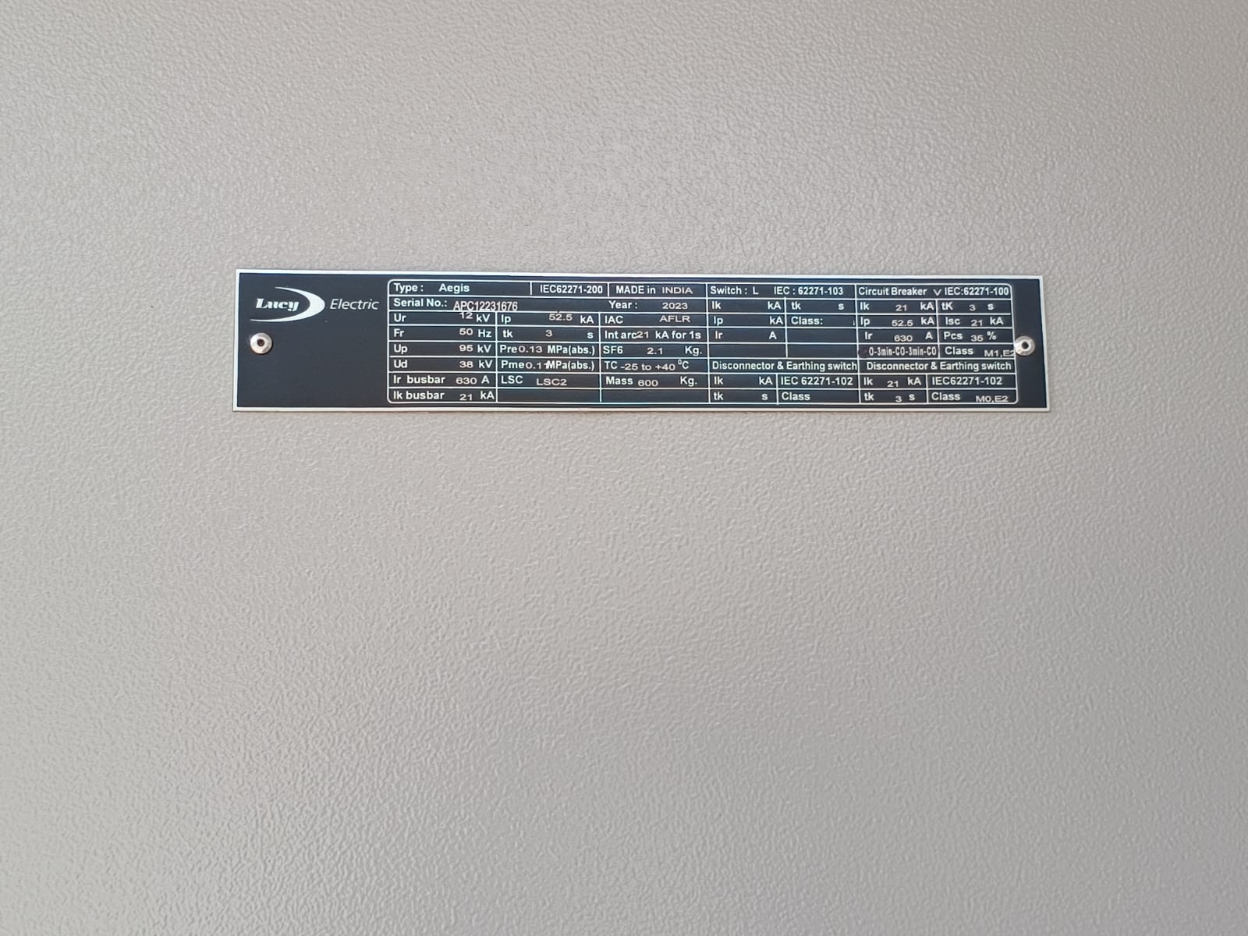

**Make** : Lucy Electric

**Title** : Aegis

Connection : 1 incoming, 3 outgoing - 1 650KVA Xmer, 1 1250KVA Xmer, 1 Spare.

**Description :**

A Ring Main Unit (RMU) is a type of electrical switchgear used in medium voltage (MV) power distribution systems, typically ranging from 11kV to 33kV. It is essential for ensuring reliable and flexible power distribution in urban and industrial settings.

**Key Features:**

**Compact Design:**

RMUs are designed to be compact, allowing them to be installed in constrained spaces such as urban areas, substations, and industrial plants.

**Components:**

Typically includes load break switches, circuit breakers, and

protective relays.

**Configuration:**

Can be configured in various ways, such as ring, radial, or dual

radial, to enhance network reliability and flexibility.

**Safety:**

Equipped with interlocking systems and gas insulation (usually SF6) to enhance operational safety and longevity.

**Uses:**

**Distribution Automation:**

Facilitates automated switching and fault detection, improving the

efficiency of power distribution networks.

**Load Management:**

Helps in managing and distributing electrical loads efficiently across

the network.

**Fault Isolation:**

Allows for quick isolation of faulty sections without disrupting the

entire network, ensuring minimal downtime.

**Network Flexibility:**

Supports flexible network configurations, enabling easier network

expansions and maintenance operations.

RMUs are crucial for modern power distribution, offering reliability, safety, and efficiency, especially in densely populated and industrial areas.

**Transformer 1**

**Rating :** 630 KVA

**Cooling type :** ONAN

**Voltage hv/lv :** 11k/415 V

**Current hv/lv :** 33.066/876.46 A

**Phase :** 3 Phase / 3 Phase

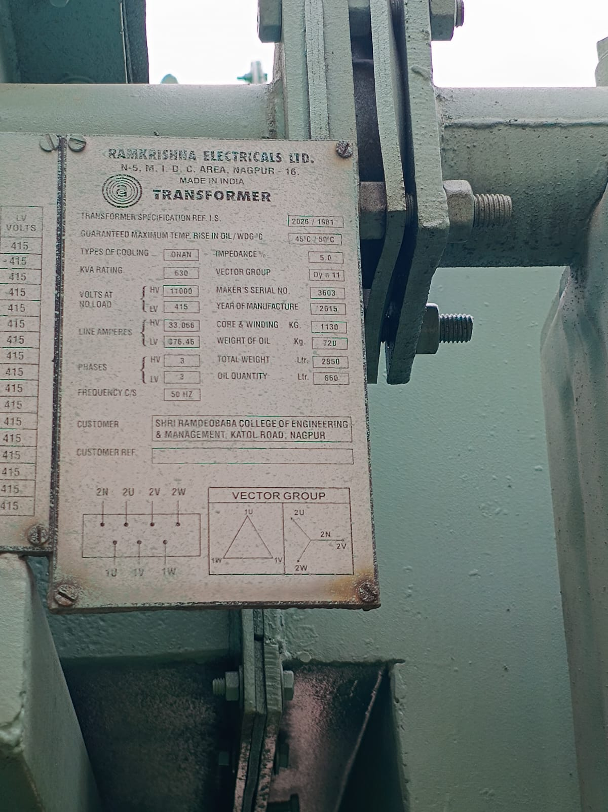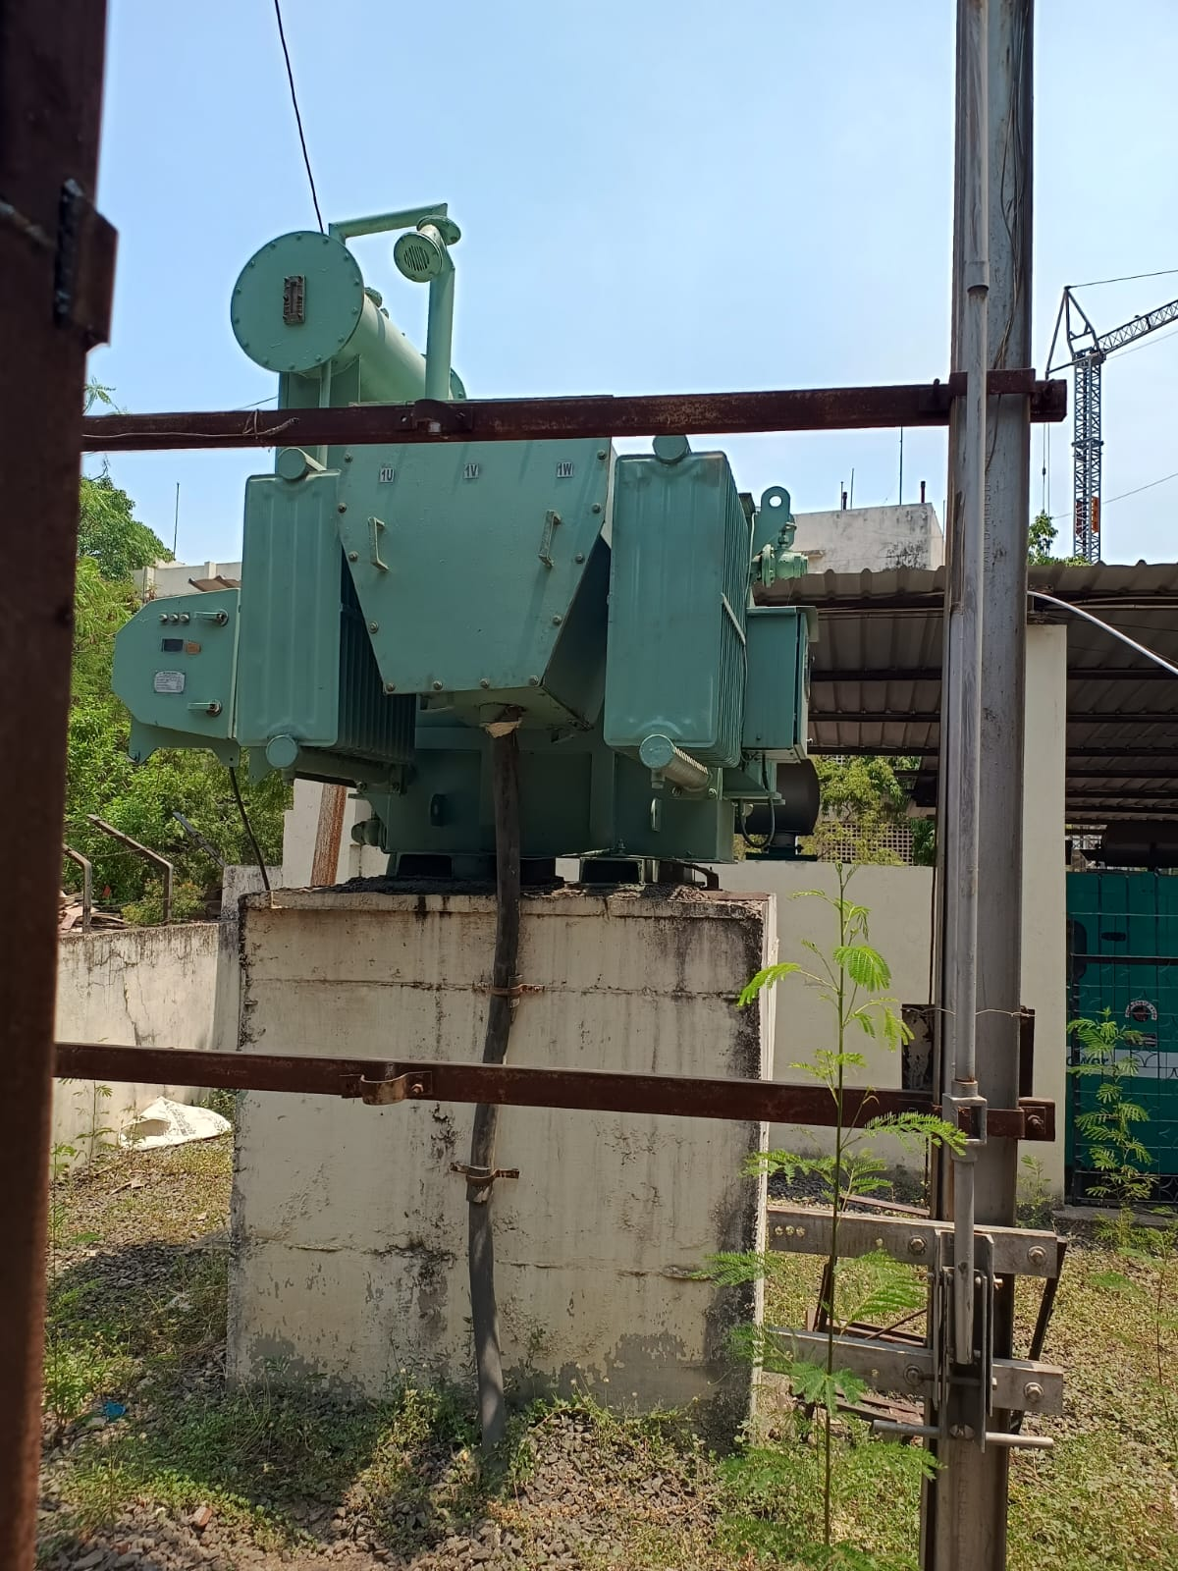

An 11kV/415V transformer rated at 630kVA is a type of electrical transformer used to step down high voltage (11,000 volts) to low voltage (415 volts) for safe and efficient distribution of electrical power in various settings, such as commercial, industrial, and residential areas.

**Key Features:**

**Power Rating :**

The transformer has a capacity of 630 kilovolt-amperes (kVA),

indicating its ability to handle a substantial electrical load.

**Voltage Levels:**

Steps down the voltage from 11kV on the primary side to 415V on

the secondary side, making it suitable for use in standard low-voltage distribution systems.

**Cooling Method:**

Typically uses oil or air for cooling, with options such as ONAN (Oil

Natural Air Natural) or AN (Air Natural) depending on the design and

Application.

**Construction:**

Comprises a core and windings housed in a durable enclosure, often featuring protective devices like fuses, circuit breakers, and temperature monitors.

**Efficiency:**

Designed to operate efficiently with minimal losses, ensuring reliable

performance and energy conservation.

**Uses:**

**Power Distribution:**

Provides reliable power supply for residential neighborhoods,

commercial buildings, and industrial facilities.

**Substations:**

Integral component in substations where high voltage transmission

lines terminate and power is distributed to lower voltage networks.

**Industrial Applications:**

Powers machinery, equipment, and lighting systems in factories and

manufacturing plants.

**Commercial Buildings:**

Supplies electricity to office buildings, shopping centers, and other

commercial establishments.

This transformer ensures safe and efficient power distribution, making it a crucial element in modern electrical infrastructure.

**Switchgear / Circuit Breaker**

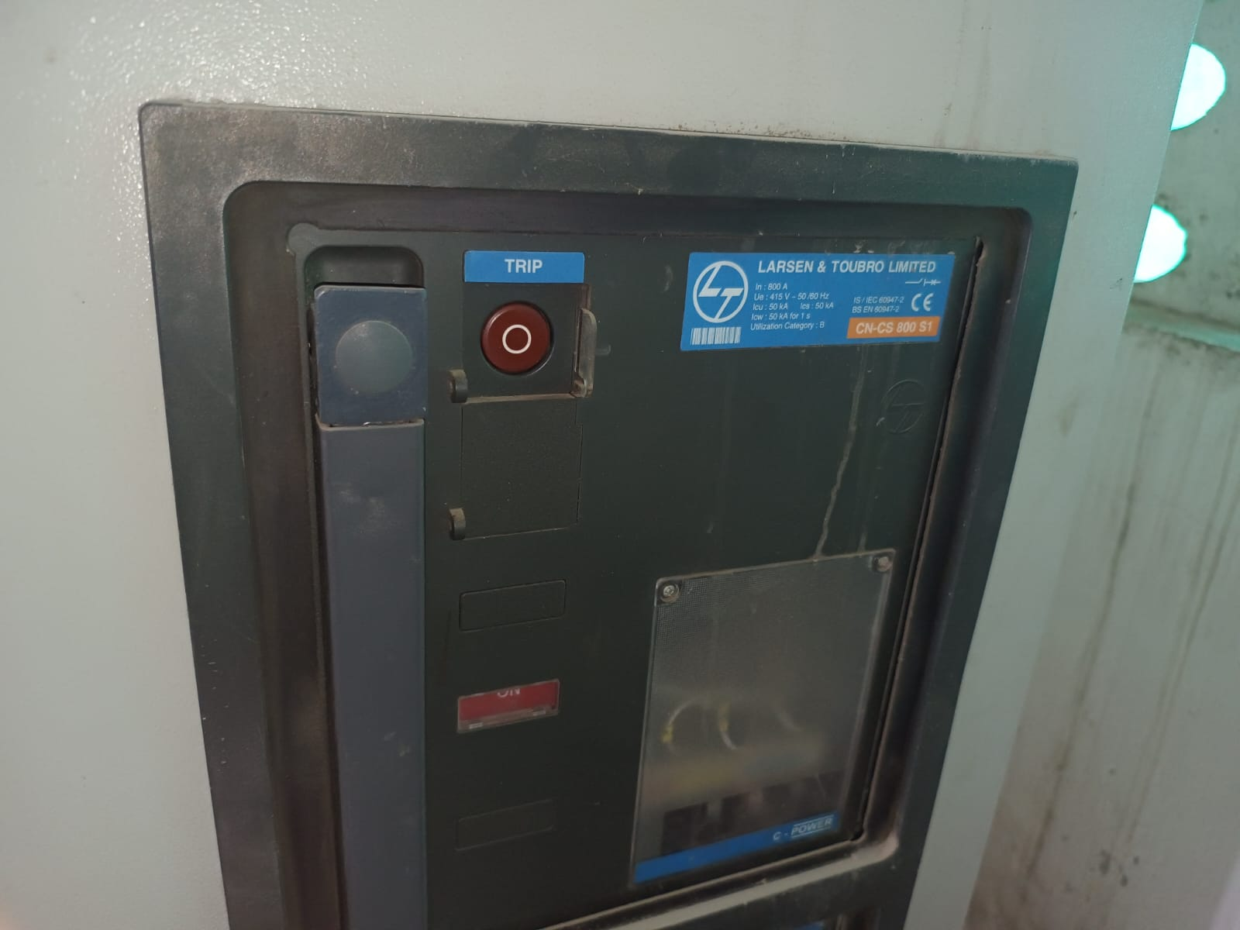

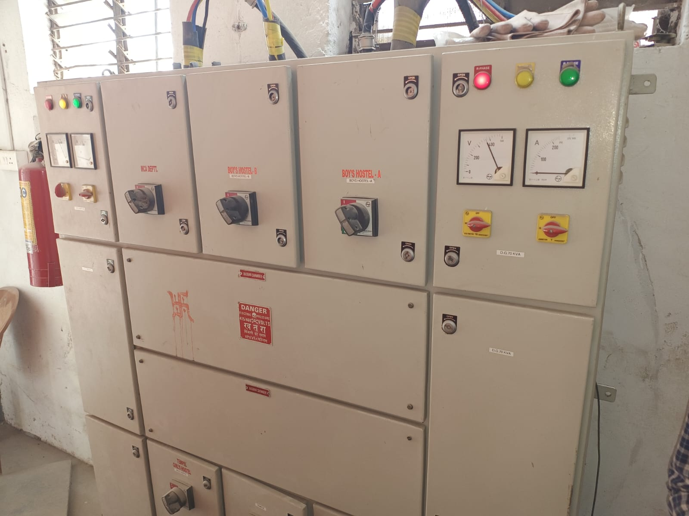

**The Larsen & Toubro (L&T) CN CS 800 S1 is a specific model of an electrical switchgear unit produced by Larsen & Toubro Limited.**

**Key Features:**

**Rating:**

Typically rated for medium voltage applications, such as 11kV systems,

with various current and power ratings to suit different needs.

**Construction:**

Robust and compact design, ensuring durability and ease of installation in

various environments, including indoor and outdoor settings.

**Safety:**

Equipped with advanced protective devices and mechanisms to ensure

safe operation and maintenance, reducing the risk of electrical hazards.

**Components:**

May include load break switches, circuit breakers, current transformers,

potential transformers, and protective relays, depending on the specific

Configuration.

**Standards:**

Designed and manufactured to comply with international standards for

electrical switchgear, ensuring reliability and performance.

**Uses:**

**Power Distribution:**

Essential for managing and protecting electrical power distribution in

industrial plants, commercial buildings, and utility substations.

**Load Management:**

Facilitates efficient load management and distribution, ensuring stable and

reliable power supply to various end-users.

**Fault Protection:**

Provides quick isolation and protection of the electrical network in case of

faults, minimizing downtime and damage.

**Network Automation:**

Supports the integration of automated systems for enhanced control and

monitoring of the electrical distribution network.

L&T's CN CS 800 S1 switchgear is a critical component for ensuring the reliability, safety, and efficiency of medium voltage power distribution systems.

**Transformer 2**

**Rating :** 630 KVA

**Cooling type :** ONAN

**Voltage hv/lv :** 11k/415 V

**Current hv/lv :** 65.60/1599 A

**Phase :** 3 Phase / 3 Phase

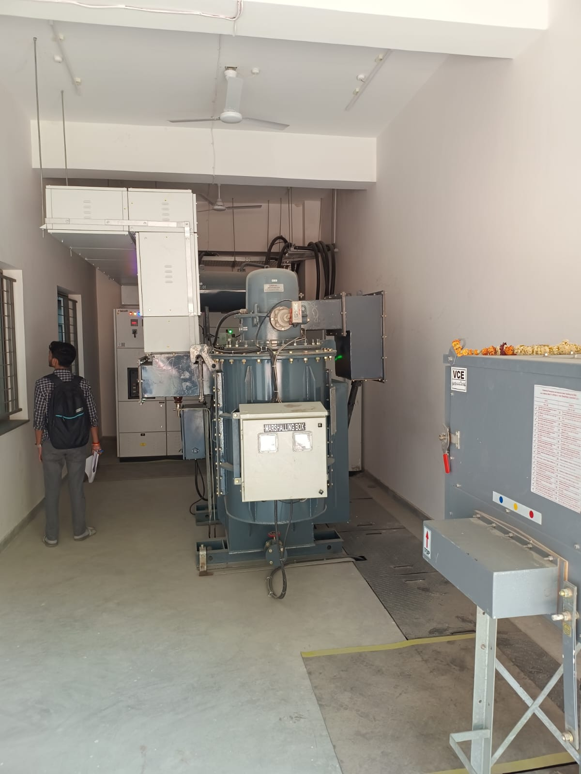

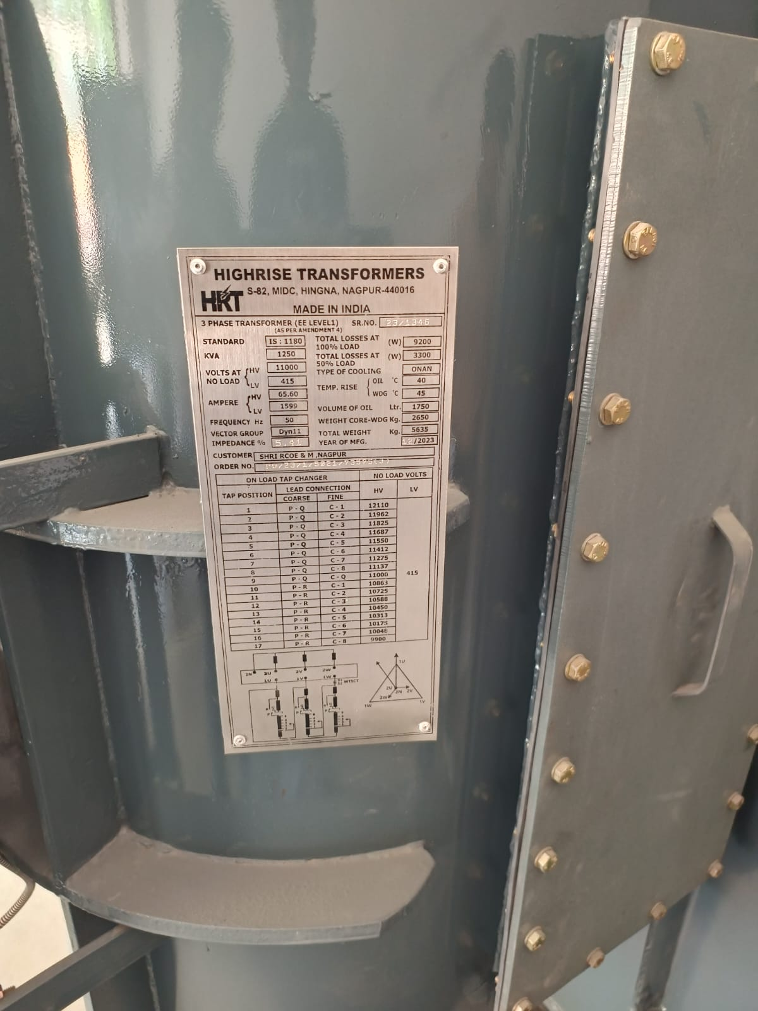

**Single Line Diagram**

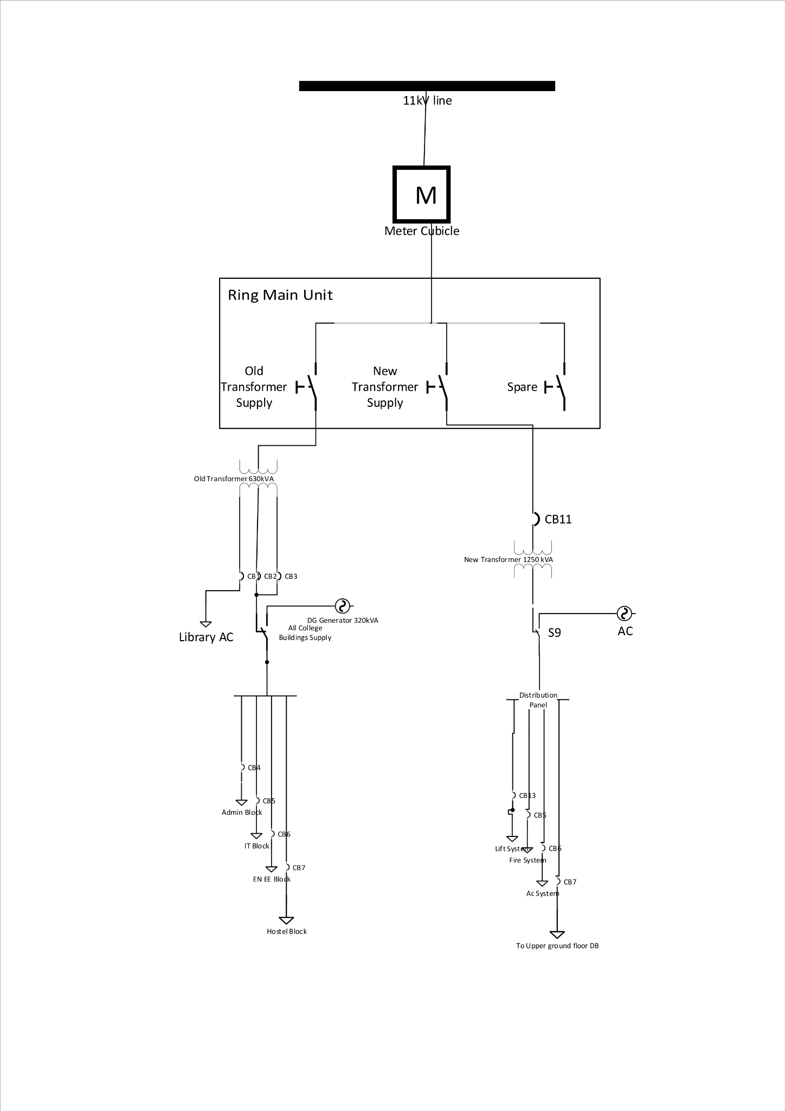

**Load Calculation**

| **Equipment Name** | **Quantity** | **Rating (W)** | **Power Consumption** |
| --- | --- | --- | --- |
| Ceiling Fan - BLDC | 85 | 35 | 2975 |
| Downlighter | 328 | 12 | 3936 |
| Concrete Mounted Lights | 77 | 15 | 1155 |
| Tube Light LED | 29 | 9 | 261 |
| Exhaust Fan | 13 | 40 | 520 |
| Bracket Fan | 4 | 50 | 200 |
| Speakers | 32 | 30 | 960 |
| Interactive Panel | 7 | 320 | 2240 |
| Air Conditioner | 23 | 50 | 1150 |
| Ac Outdoor | 2 | 28000 | 56000 |
| Miscellaneous | 3 | 50 | 150 |
| Computers | 150 | 200 | 30000 |
| Water Cooler | 2 | 700 | 1400 |
| Total |  |  | 100947 |

**Wire and Fuse Ratings**

| Fuse and Wire ratings | | | |
| --- | --- | --- | --- |
| Location | Wire Size (sq mm) | Ampere Rating | Fuse Rating |
| From RMU to Transformer | 300 | 66 | 630 |
| From Upper Ground Floor to Each Floor | 50 | 150 | 100 |
| Floor Distribution to Room DB | 6x4 | 40 | 40A |
| RYB Phase Separate | 6x1 |  | 25A |
| RYB to MCB | 2.5 | 25 | 10A |

**Digital Tower Lighting Distribution**

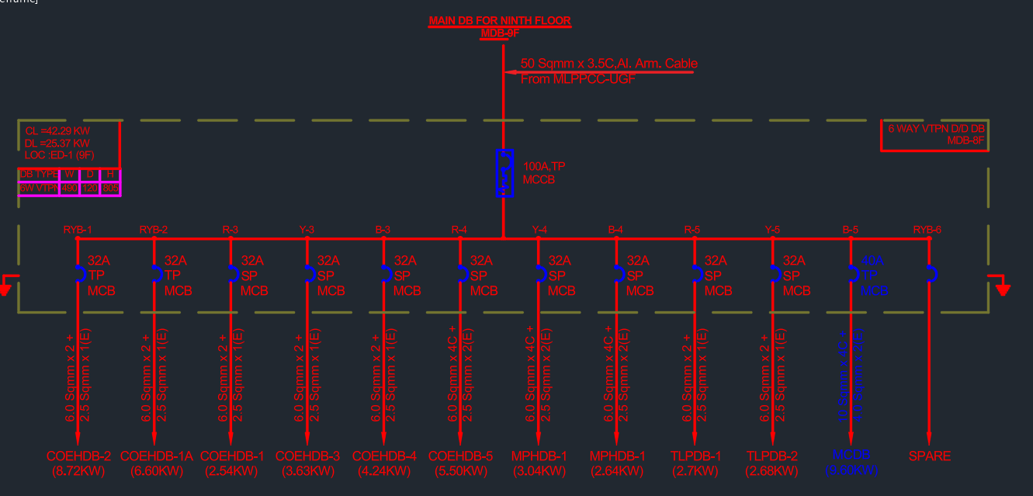

**Digital Tower Computer Distribution**

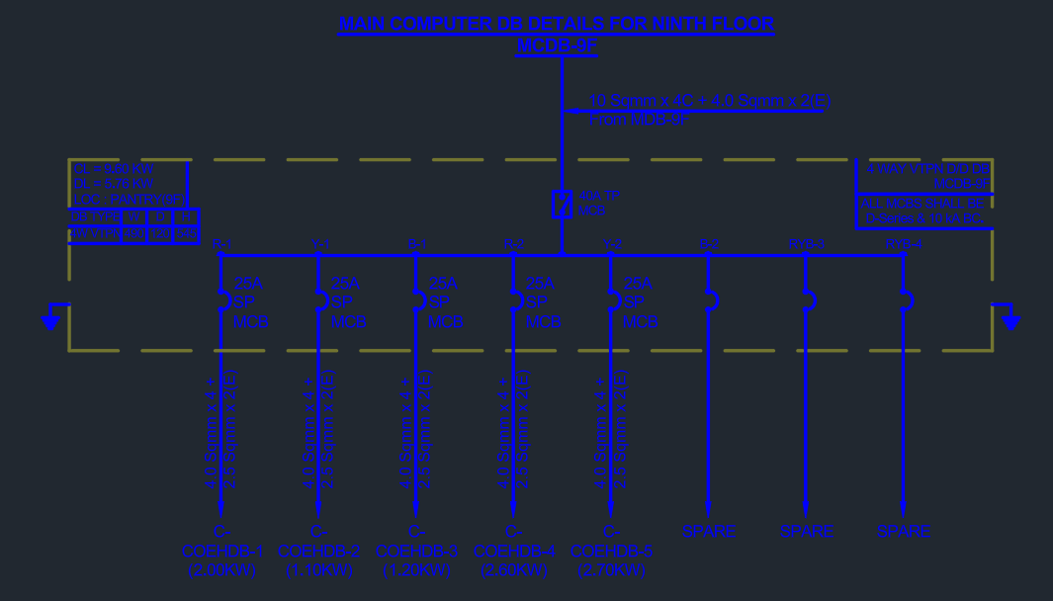

**Digital Tower Computer Distribution**

