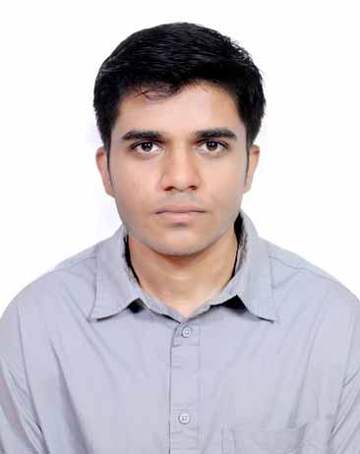

**Zeeshan Ahmed Shah**



•184, Teachers’ Colony, Tajbagh • Nagpur, Maharashtra • DOB: 03-12-2002 • shahzeeshan744@gmail.com • +919834886225

[Linkedin](http://linkedin.com/in/zeeshanahmedshah), [GitHub](http://github.com/shah-zeeshan), [Hackerrank](http://hackerrank.com/profile/shahzeeshan)

# Profile

Undergraduate in Electrical Engineering with a keen interest in Software Development, continually refining skills in programming languages such as Python and Java. Expanding knowledge in data science, cloud computing, and web development technologies, positioning for a seamless transition into the computer science sector. Recognized for adept leadership and collaboration, committed to driving innovation with a diverse skill set and interdisciplinary perspective.

# **Education**

**Shri Ramdeobaba College of Engineering and Management, Nagpur**

Electrical Engineering with minor specialization in Data Science. **2025**

**Shivaji Science College**, **Nagpur (HSC) |** Percentage : **90.48%**  **2021**

**Tejswini Vidya Mandir, Nagpur (SSC) |** Percentage: **94.80%** **2019**

**Experiences**



**Tata CIIIT | IoT Intern September - October 2023**

* Developed IoT projects using Arduino Uno and ESP.
* Learned and performed the interfacing of various sensors and processors, integrating with ThingSpeak and Adafruit.

**Alhansat Solutions | Full Stack Developer Intern September -November 2023**

* Contributed to Web Application Projects.
* Assisted in User Interface Design and Bug Fixing.

# Projects

**Secure File Storage in Blockchain**

* Developed a web-based application for decentralized file storing using blockchain.
* Upload and download files using flask, files and transactions are stored using a blockchain.

**Business Analytics using Power BI**

* Utilized PowerBI to create data visualizations, extracting meaningful insights from complex datasets.
* Developed data analysis reports for executives, leveraging advanced visualization techniques to highlight key trends, patterns, and actionable insights.

**Ultradar: Automated security device**

* A radar system which gives alerts over the internet on detection of objects in remote regions and displays the range of sight and detections remotely on a device. Used Processing 4.3 to produce a visual depiction of the radar activity.

# Leadership & Activities

**Students’ Representative Council, RCOEM** | **Dance Club Coordinator October 2023 – Current**

* Coordinated and managed the Dance club, fostering a vibrant and inclusive campus community.
* Facilitated activities, provided guidance to club members, and ensured compliance with university regulations.

**IEEE Student Chapter, RCOEM | Editorial Head 2023 - 2024**

* Edited yearly departmental magazines ‘Vidyut’ and ‘Empower’.

**Skills & Interests**

**Technical:**  Java, Python, C programming, R programming, Power BI, SQL, DBMS, Adobe Illustrator, Microsoft Excel,

Problem Solving.

**Language:** English, Hindi, Marathi

**Interests:** Music production, martial arts, poetry.

# Certifications

* Python Essentials (Cisco Networking Academy) - [Certificate link](https://www.credly.com/badges/8efe2a66-82f0-41d5-9401-9c4ebc46ae05/public_url)
* Networking Basics (Cisco Networking Academy) - [Certificate link](https://www.credly.com/badges/43f9b2b9-e5d9-4b42-9fdb-73d6443c8b58/public_url)
* Fundamentals of Data Analytics (L&T Edutech) - [Certificate link](https://iggnitewebcertification.lntedutech.com/?certificationID=Y2DqGB_C5s7QfqG_289372607720571&name=Zeeshan%20Shakeel%20Ahmed%20Shah&course=Data%20Analytics%C2%A0Fundamentals)
* Campus to Corporate (L&T Edutech) - [Certificate link](https://iggnitewebcertification.lntedutech.com/?certificationID=Y2DqGB_J2U6qX7g_425014224833531&name=Zeeshan%20Shakeel%20Ahmed%20Shah&course=Campus%20to%20Corporate)
* Accenture North America - Data Analytics and Visualization Job Simulation - [Certificate Link](https://forage-uploads-prod.s3.amazonaws.com/completion-certificates/Accenture%20North%20America/hzmoNKtzvAzXsEqx8_Accenture%20North%20America_9CanKCdxnkSTBfRQo_1715535180692_completion_certificate.pdf)