**Sample Research Article**

**Title: (Font Size: 18)  
Artificial Intelligence Applications in Environmental Monitoring: A Case Study on Water Quality Assessment**

**Authors Name: (Font Size: 14)** Anil Sharma¹, Bharti Patel², and Chinkuppa Rao³  
**Author's affiliation (Institute/University/College)Name: (Font Size: 10)**

¹Professor, Department of Environmental Science, Scope Global Skill University, Bhopal, India  
 ²Professor, Department of Computer Science, Bhabha University, Bhopal, India  
 ³ Scientist-C, Curevita Research Pvt Ltd, India

## **(Font Size: 10, spacing: Single)**

## 

## **Article info**

**Articlehistory**

**Keywords:** Artificial Intelligence, Water Quality, Machine Learning, Environmental Monitoring, Sustainable Development

**Corresponding Author:** Dr Shyam K Tiwari.Professor,SLP Uninersity,UK.

**Email ID:** [shinfh@slp.ac.uk](mailto:shinfh@slp.ac.uk)

**Citation:** Sharma Anil , Patel Bharti, and Rao Chinkuppa .2025. Artificial Intelligence Applications in Environmental Monitoring: A Case Study on Water Quality Assessment. Curevita Research Journal .1,2,11-22.

## **Publisher: Curevita Research Pvt Ltd**

## 

## 

## **Abstract (Font Size: 10, spacing:1,5)**

Environmental degradation due to rapid urbanization necessitates efficient monitoring systems. Traditional water quality assessment relies on laboratory-based methods, which are time-consuming and resource-intensive. This study demonstrates the application of Artificial Intelligence (AI) and Machine Learning (ML) models in predicting water quality indices using physico-chemical parameters such as pH, dissolved oxygen, nitrate, phosphate, and turbidity. A dataset collected from Mallampally Lake, Telangana, was analyzed using Random Forest and Artificial Neural Network algorithms. Results showed that AI-based models achieved >92% accuracy in predicting water quality categories, highlighting their potential as reliable tools for real-time environmental monitoring.

## 

## 

## **(Font Size: 14 spacing :1,5)**

## 

## **Introduction**

Water quality monitoring is critical for the sustainable management of freshwater resources. Traditional approaches involve manual sampling and laboratory testing, which are often inefficient in large-scale monitoring. Recent advancements in AI and data science provide opportunities to develop predictive models for water quality assessment. This study explores AI-based approaches for evaluating water quality parameters, with the aim of establishing a framework for real-time decision-making in environmental management.

## /**Materials and Methods**

## **(Font Size: 14, spacing:1,5)**

### **Study Area**

Mallampally Lake in Siddipet District, Telangana, India, was selected for this study due to its ecological significance and ongoing pollution pressures, Sharma et al.,2025.

### **Data Collection**

Samples were collected monthly for six months (January–June 2025). Parameters measured included:

* pH
* Dissolved Oxygen (DO)
* Biological Oxygen Demand (BOD)
* Nitrates
* Phosphates
* Turbidity

### 

### 

### **AI Models**

Two machine learning algorithms were applied:

* **Random Forest (RF)** – for classification of water quality categories
* **Artificial Neural Networks (ANN)** – for predicting numerical values of WQI

The dataset was split into 70% training and 30% testing for performance evaluation.

## **Results and Discussion (Font Size: 14, spacing:1,5)**

* **Random Forest Model:** Achieved 94.3% classification accuracy.
* **ANN Model:** Achieved Mean Absolute Error (MAE) of 0.18 for WQI prediction.
* **Comparison:** RF was more robust for categorical classification, while ANN provided better continuous predictions, Saravan et al., 2025.

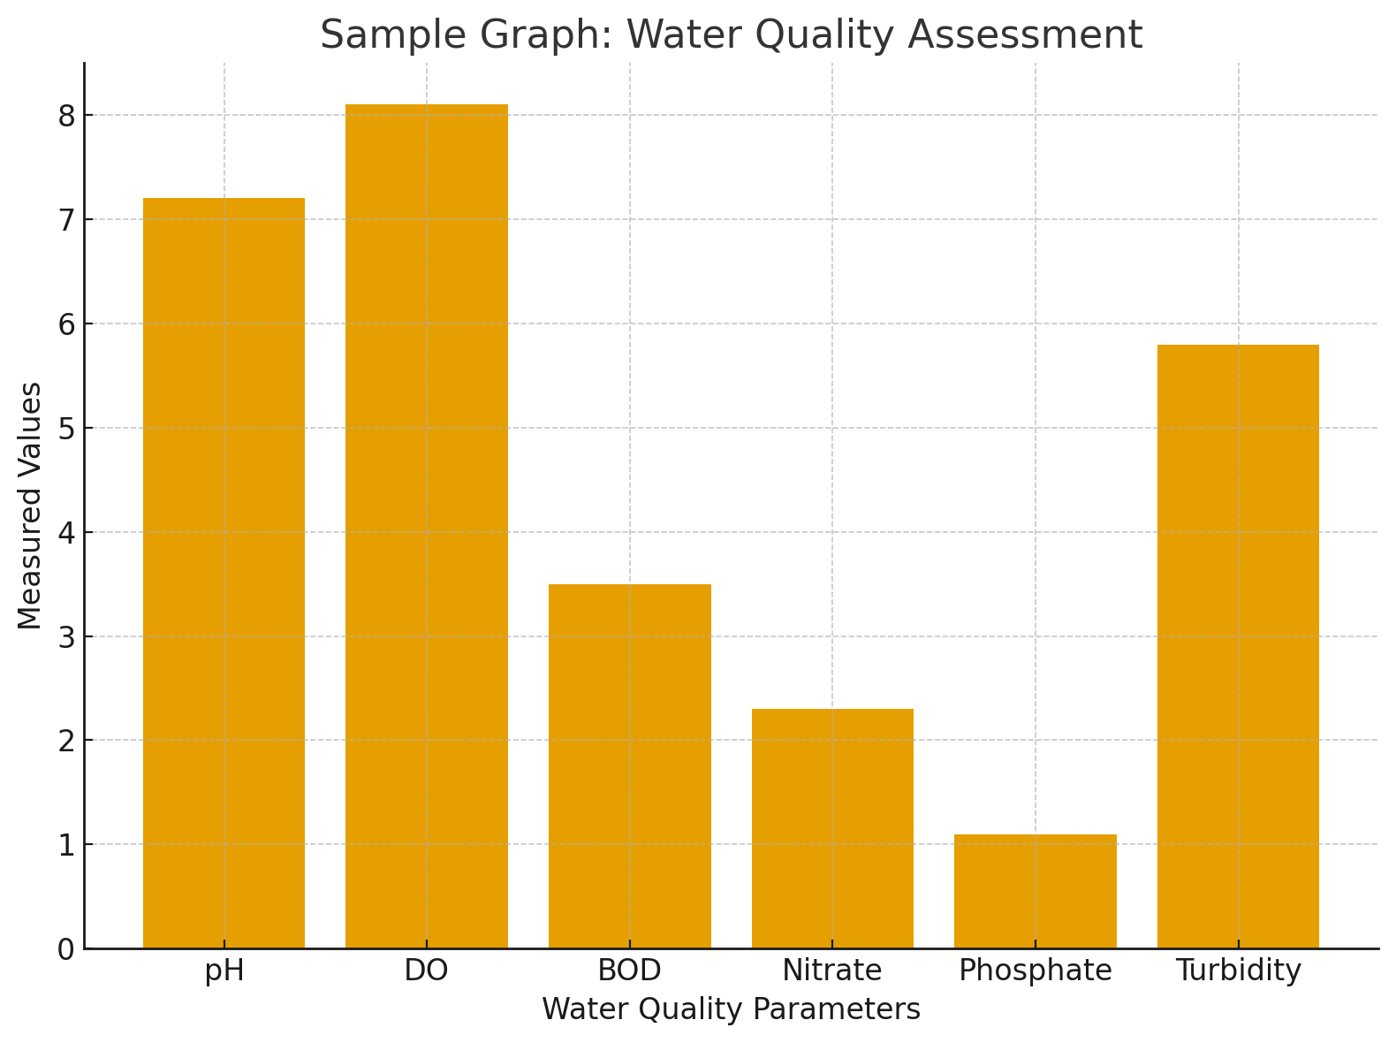

Fig.-1: Sessional variation of physicochemical **(Font Size: 12, spacing: Single)**

The findings suggest that AI-based models are efficient, scalable, and adaptable for environmental applications. They can significantly reduce dependency on manual testing and support policymakers in sustainable water management.

## 

## **Conclusion (Font Size: 14, spacing:1,5)**

AI techniques offer reliable alternatives to conventional water quality monitoring. By integrating environmental data with predictive models, stakeholders can obtain real-time insights into ecosystem health. This approach has potential applications in lake conservation, pollution management, and sustainable water governance.

## **References**

**(Font Size: 10)**

Singh, R., & Mehta, P. (2023). Machine learning approaches for environmental sustainability. *Journal of Environmental Informatics*, 45(2), 125–138.

Rao, S., & Patel, K. (2024). AI-driven monitoring of freshwater systems. *International Journal of Water Resources*, 12(1), 55–67.

WHO (2022). Guidelines for Drinking-water Quality. World Health Organization.