

**Computer Programming Lab**

Manual #6

Submitted by:

**Shah Jahan khan**

**469192 (section C)**

Submitted to:

**Sir Affan Tariq**

1. Generate the Fibonacci sequence using nested loops.

#include<iostream>

using namespace std;

int main(){

int n, num1, num2, sum;

cout<<"Enter the length of the sequence:";

cin>>n;

cout<<" Enter number 1:";

cin>>num1;

cout<<" Enter number 2:";

cin>>num2;

cout<<" Fibonnachi sequence is:";

for(int i=1; i<=n; i++){

cout<<num1<<" ";

sum=num1+num2;

num1=num2;

num2=sum;

}

return 0;

}

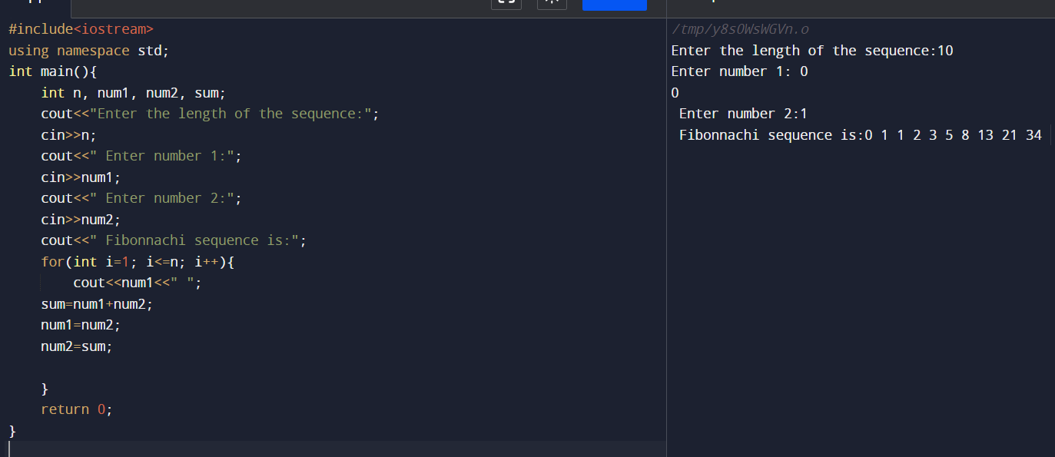

1. Create Floyd’s triangle with nested loops.

#include<iostream>

using namespace std;

int main(){

int n;

cout<<" Enter the number of rows:";

cin>>n;

int a=1;

for(int i=1; i<=n; i++){

for(int j=1; j<=i; j++){

cout<<" "<< a;

a++;

}

cout<<endl;

}

return 0;

}

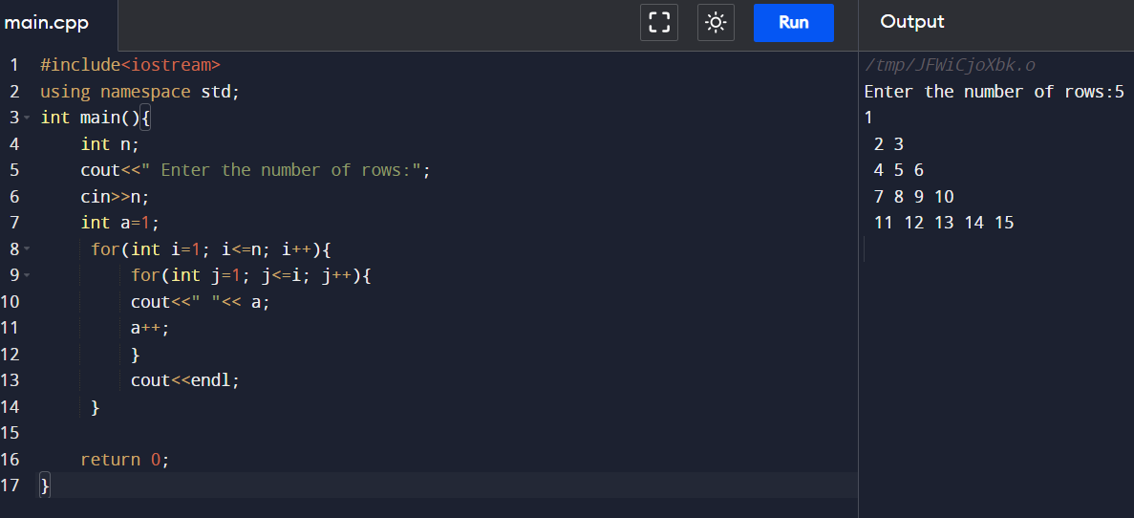

HOME TASKS:

* 1. Write a program in C++ to create the following pattern.

1

1 2

1 2 3

1 2 3 4

1 2 3 4 5

#include<iostream>

using namespace std;

int main(){

int n;

cout<<" Enter the number of rows:";

cin>>n;

for(int i=1; i<=n; i++){

for(int j=1; j<=i; j++){

cout<<" "<<j;

}

cout<<endl;

}

return 0;

}

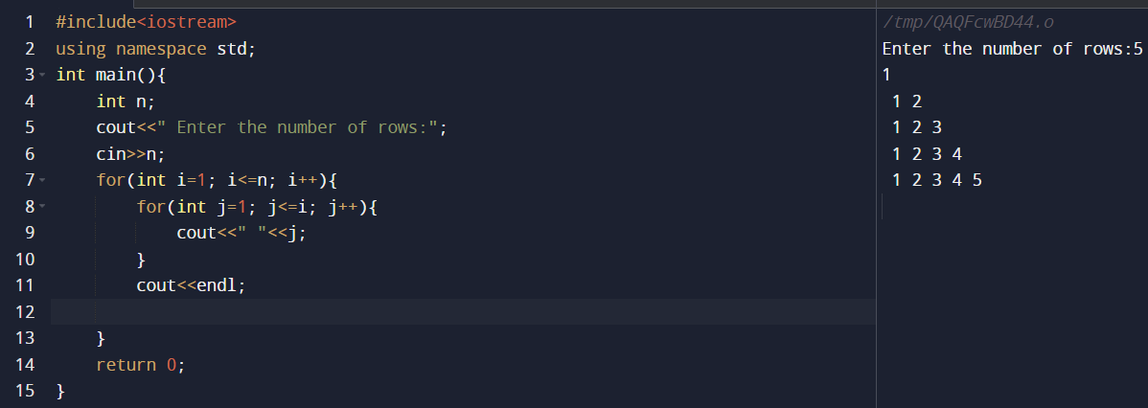

Write a c ++ program to display

1

2 2

4 4 4 4

6 6 6 6 6 6

#include<iostream>

using namespace std;

int main(){

int n;

cout<<" Enter the value of n:";

cin>>n;

cout<<"1"<<endl;

for(int i=2; i<=n; i=i+2){

for(int j=1; j<=i; j+=1){

cout<<i<<" ";

}

cout<<endl;

}

return 0;

}

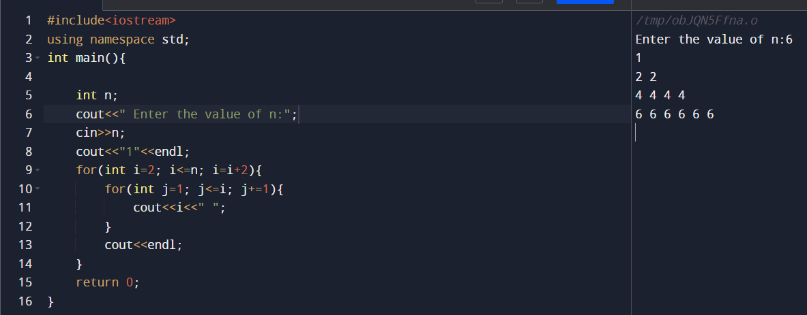

* 1. Write a program using break or continue statement that only adds prime numbers from 1 to 50 and display the sum on screen.

#include <iostream>

using namespace std;

int main() {

int n, check = 1, sum = 0;

cout << "upto what numbers we want to sum prime numbers: ";

cin >> n;

for(int i = 2; i <= n; i++) {

check = 1;

for(int j = 2; j < i; j++){

if (i % j == 0) {

check = 0;

break;

}

}

if(check)

sum += i;

}

cout << "Sum of prime numbers up to " << n << " is " << sum <<endl;

return 0;

}

