

**Computer Programming Lab**

Submitted by:

**Shah Jahan khan**

**469192 (section C)**

Submitted to:

**Sir Affan Tariq**

1.

#include <iostream>  
using namespace std;  
int main() {  
 int numbers;  
 cout << " Enter your natural numbers upto 10 =";  
 cin >> numbers;  
 int sum=0;  
 for ( int i = 1 ;i < 10; i++) {  
 sum += i;  
 }  
  
 cout << " The sum of first 10 natural numbers is " << sum << endl;  
  
 return 0;  
}

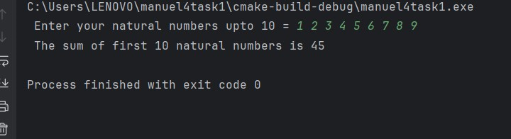

2.

#include <iostream>  
using namespace std;  
int main() {  
 int table;  
 cout<<" Enter your number=";  
 cin>>table;  
 for(int z = 1;z<= 10; z++){  
 int result = table* z;  
 cout<<table<<"*"<<z<<"="<<result<<endl;  
 }  
 return 0;  
}

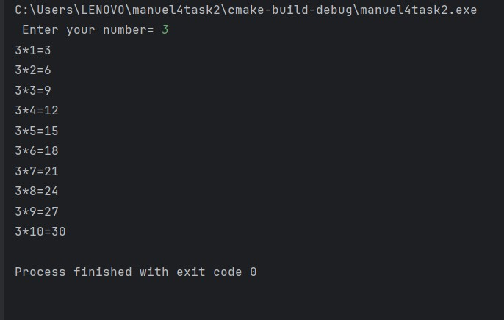

4.

#include <iostream>  
using namespace std;  
int main() {  
 int length,x,y,sum;  
 cout<<" Enter the length of the sequence:";  
 cin>>length;  
 cout<<" Enter your first number:";  
 cin>>x;  
 cout<<" Enter your second number:";  
 cin>>y;  
 for(int i=0; i<10;i++){  
 sum = x+y;  
 cout<<sum<<" ";  
 x=y;  
 y=sum;  
 }  
 return 0;  
}

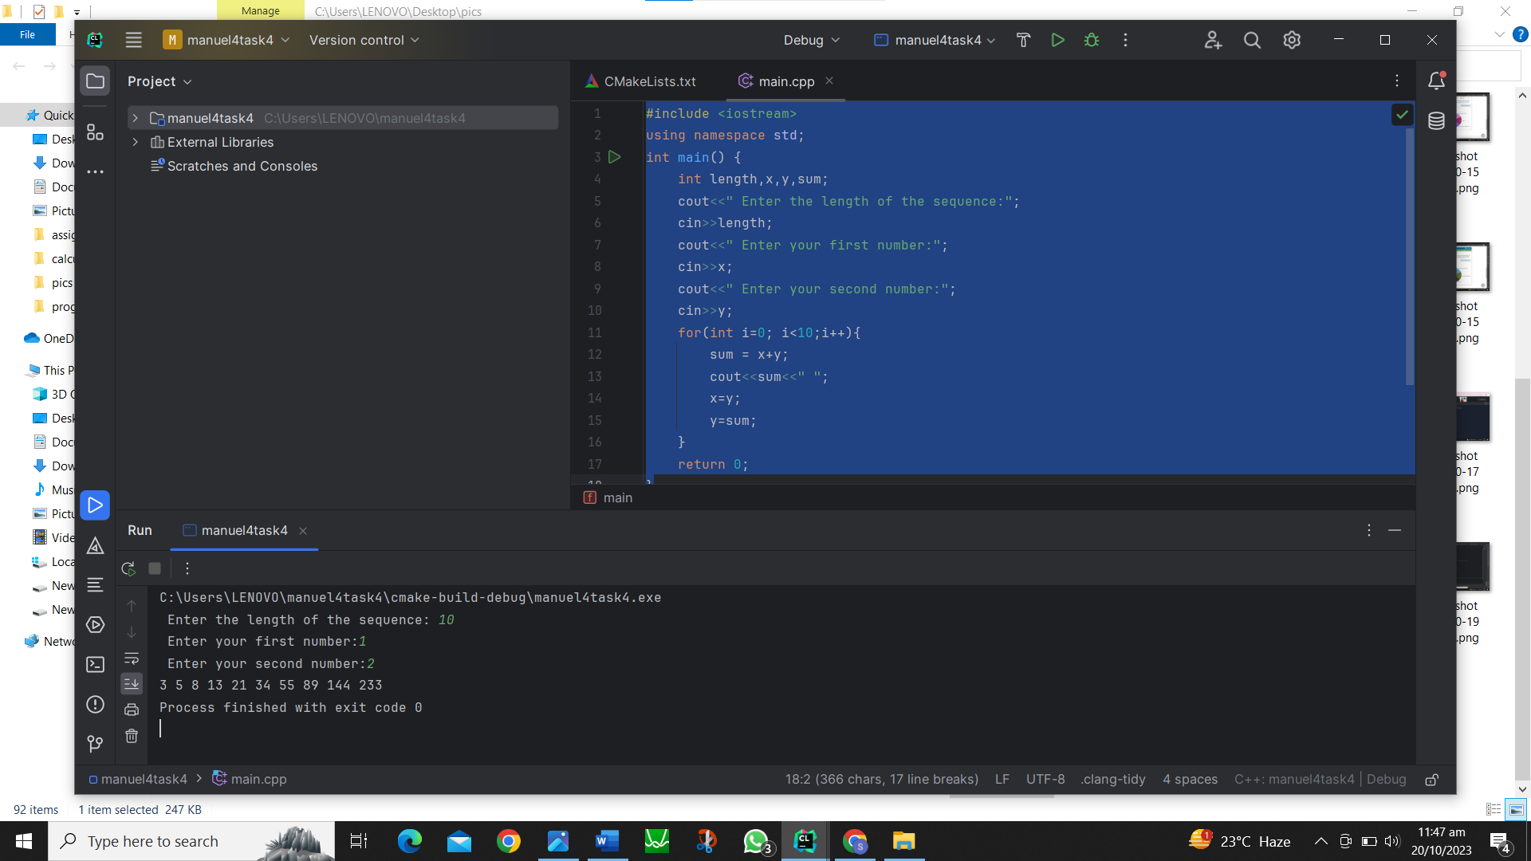

3.

#include <iostream>  
using namespace std;  
int main() {  
 int num;  
 int factorial =1;  
 cout<<" Enter your number =";  
 cin>>num;  
   
 if (num < 0)   
 cout << " Factorial of negative number is not possible" << endl;  
 }  
 else if (num = <1)  
   
  
 else{  
 for (i > 1; i <= num ; i--)  
 cout << " factorial of " << i << "! is " << factorial<<endl;  
  
 }  
  
 return 0;  
 }