**CS731 Software Testing**

**Finance Calculators - Data Flow Coverage Testing**



**Instructor**

*Prof. Meenakshi D Souza*

| **Team Members** | **Roll No.** |
| --- | --- |
| Dishangkumar Patel | MT2022039 |
| Jainam Shah | MT2022156 |

**International Institute of Information**

**And Technology, Bangalore**

**November 2023**

* **Individual Contribution Matrix:**

| Sr. no | Modules | Contributor | Type of Contribution |
| --- | --- | --- | --- |
| 1 | Employee Provident Fund (EPF) | Jainam | Business Logic, Code, TestCase design, TestCase Impl |
| 2 | Public Provident Fund (PPF) | Jainam | Business Logic, Code, TestCase design, TestCase Impl |
| 3 | Systematic Investment Plan (SIP) | Jainam | Business Logic, Code, TestCase design, TestCase Impl |
| 4 | Systematic Withdrawal Plan (SWP) | Jainam | Business Logic, Code, TestCase design, TestCase Impl |
| 5 | Taxation | Dishang | Business Logic, Code, TestCase design, TestCase Impl |
| 6 | Lumpsum | Dishang | Business Logic, Code, TestCase design, TestCase Impl |
| 7 | Gratuity | Dishang | Business Logic, Code, TestCase design, TestCase Impl |

* **Table Of Content:**

| Sr. no | Content: | Page no |
| --- | --- | --- |
| 1 | Overview | 3 |
| 2 | Project Statement | 3 |
| 3 | Test Case Design Technique | 3 |
| 4 | EMI Calculator Testing | 4 |
| 5 | Gratuity Calculator Testing | 7 |
| 6 | LumpSum Calculator Testing | 10 |
| 7 | PPF Calculator Testing | 13 |
| 8 | SIP Calculator Testing | 16 |
| 9 | SWP Calculator Testing | 19 |
| 10 | Taxation Calculator Testing | 23 |

1. Overview:

The goal of this project is to understand and perform practical aspects of testing. We have used Data Flow Coverage Criteria technique for testing the source code that covers all def and all du path coverage and have used Junit as a testing tool.

Repo link : [letsFinance](https://github.com/shahJainam961/letsFinance)

1. Project Statement:

letsFinance is a comprehensive Java terminal-based project designed to provide users with a set of powerful financial calculators to assist in various financial planning and investment decisions of their future. The suite includes following feature:

* Employee Provident Fund (EPF)
* Public Provident Fund (PPF)
* Systematic Investment Plan (SIP)
* Systematic Withdrawal Plan (SWP)
* Taxation
* Lumpsum
* Gratuity

1. Test Case Design Technique:

We have designed our test cases using **Data Flow Coverage Criteria** using **all defs** and **all du-path coverage.**

**All Def Coverage**:

For each def-path set S = du(n, v ), TR contains at least one path d in S.

**All DU-Path Coverage:**

For each def-pair set S = du(ni , nj , v ), TR contains every path d in S.

1. EMI Calculator Testing:

**Data Flow Graph**: The following is the data flow graph for the source code(refer the repo) and the corresponding def and du-path coverage.

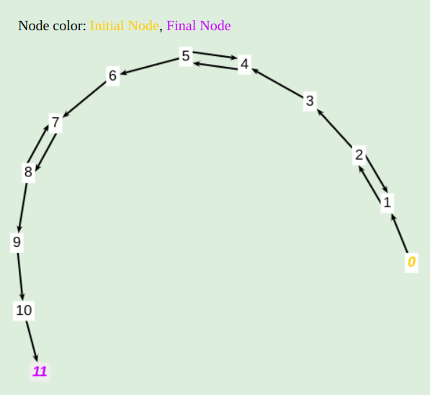

| EMI Calculator | | | | |
| --- | --- | --- | --- | --- |
| Variables | Definitions | Uses | All Def Coverage | All DU Path Coverage |
| val | { 2, 5, 8 } | { (2, 1), (2, 3), 3, (5, 4), (5, 6), 6, (8, 7), (8, 9), 9 } | [0,1,2,3,4,5,6,7,8,9,10,11], [0,1,2,3,4,5,4,5,6,7,8,9,10,11], [0,1,2,3,4,5,6,7,8,7,8,9,10,11] | [0,1,2,3,4,5,6,7,8,9,10,11], [0,1,2,1,2,3,4,5,6,7,8,9,10,11], [0,1,2,3,4,5,4,5,6,7,8,9,10,11], [0,1,2,3,4,5,6,7,8,7,8,9,10,11], [0,1,2,3,4,5,6,7,8,9,10,11] |
| loanAmount | { 3 } | { 10 } | [0,1,2,3,4,5,6,7,8,9,10,11] | [0,1,2,3,4,5,6,7,8,9,10,11] |
| interestRate | { 6 } | { 10 } | [0,1,2,3,4,5,6,7,8,9,10,11] | [0,1,2,3,4,5,6,7,8,9,10,11] |
| loanTenure | { 9 } | { 10 } | [0,1,2,3,4,5,6,7,8,9,10,11] | [0,1,2,3,4,5,6,7,8,9,10,11] |
| amount | { 10 } | { 11 } | [0,1,2,3,4,5,6,7,8,9,10,11] | [0,1,2,3,4,5,6,7,8,9,10,11] |

**Test Cases:**

Following are the test cases (passed) based on the above derived set of test paths.

package org.example;

import org.junit.Assert;

import org.junit.Test;

import java.io.ByteArrayInputStream;

public class EMICalculatorTest {

String input1 = "1000000\n5.5\n2\n"; // [0,1,2,3,4,5,6,7,8,9,10,11]

String input2 = "2000000\n-5\n3.5\n2\n"; // [0,1,2,3,4,5,4,5,6,7,8,9,10,11]

String input3 = "2000000\n3.5\n-2\n2\n"; // [0,1,2,3,4,5,6,7,8,7,8,9,10,11]

String input4 = "-10000\n2000000\n3.5\n2\n"; // [0,1,2,1,2,3,4,5,6,7,8,9,10,11]

public void testing(String input, Long expectedTax){

ByteArrayInputStream byteArrayInputStream = new ByteArrayInputStream(input.getBytes());

System.*setIn*(byteArrayInputStream);

EMICalculator emiCalculator = new EMICalculator();

Long actual = emiCalculator.init();

Assert.*assertEquals*(expectedTax,actual);

}

@Test

public void testCase1(){

testing(input1, 44095L);

}

@Test

public void testCase2(){

testing(input2, 86405L);

}

@Test

public void testCase3(){

testing(input3, 86405L);

}

@Test

public void testCase4(){

testing(input4, 86405L);

}

}

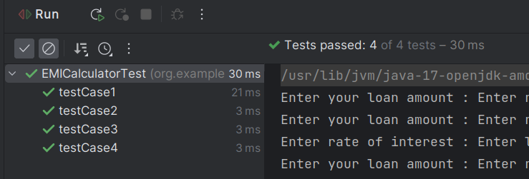

1. Gratuity Calculator Testing:

**Data Flow Graph**: The following is the data flow graph for the source code(refer the repo) and the corresponding def and du-path coverage.

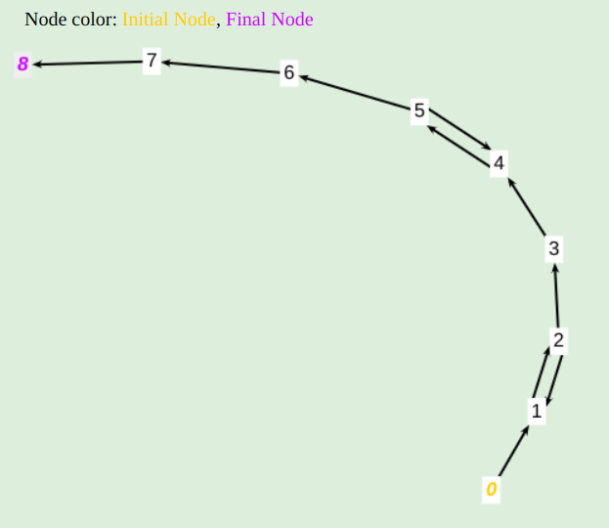

| Gratuity Calculator | | | | |
| --- | --- | --- | --- | --- |
| Variables | Definitions | Uses | All Def Coverage | All DU Path Coverage |
| ms | { 2 } | { (2, 1), (2, 3), 3 } | [0,1,2,3,4,5,6,7,8] | [0,1,2,3,4,5,6,7,8], [0,1,2,1,2,3,4,5,6,7,8] |
| monthlySalary | { 3 } | { 7 } | [0,1,2,3,4,5,6,7,8] | [0,1,2,3,4,5,6,7,8] |
| yos | { 5 } | { (5, 4), (5, 6), 6 } | [0,1,2,3,4,5,6,7,8] | [0,1,2,3,4,5,6,7,8], [0,1,2,3,4,5,4,5,6,7,8] |
| yearOfServices | { 6 } | { 7 } | [0,1,2,3,4,5,6,7,8] | [0,1,2,3,4,5,6,7,8] |
| amount | { 7 } | { 8 } | [0,1,2,3,4,5,6,7,8] | [0,1,2,3,4,5,6,7,8] |

**Test Cases:**

Following are the test cases (passed) based on the above derived set of test paths.

package org.example;

import java.util.Scanner;

public class GratuityCalculator {

private Double monthlySalary;

private Double yearsOfService;

public Double getMonthlySalary() {

return monthlySalary;

}

public void setMonthlySalary(Double monthlySalary) {

this.monthlySalary = monthlySalary;

}

public Double getYearsOfService() {

return yearsOfService;

}

public void setYearsOfService(Double yearsOfService) {

this.yearsOfService = yearsOfService;

}

public Long init(){

try{

Double ms, yos;

Scanner scanner = new Scanner(System.*in*);

while (true) {

System.*out*.print("Enter your monthly salary amount : ");

ms = scanner.nextDouble();

if (ms >= 0) {

break;

}

System.*out*.println("Please enter positive monthly salary : ");

}

setMonthlySalary(ms);

while (true) {

System.*out*.print("Enter years of service : ");

yos = scanner.nextDouble();

if (yos >= 0) {

break;

}

System.*out*.println("Please enter valid year of service");

}

setYearsOfService(yos);

Long totalValue = calculateReturn();

System.*out*.println("You are eligible for " + totalValue + " gratuity");

return totalValue;

} catch (Exception e){

return -1L;

}

}

public Long calculateReturn(){

Double amnt = getYearsOfService() * getMonthlySalary() * 15 / 26;

return Math.*min*(1000000, amnt.longValue());

}

}

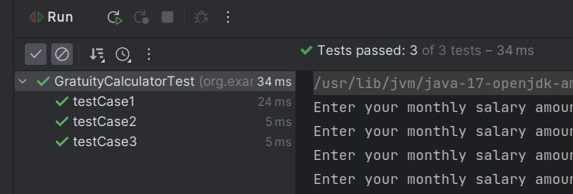

1. Lumpsum Calculator Testing:

**Data Flow Graph**: The following is the data flow graph for the source code(refer the repo) and the corresponding def and du-path coverage.



| Lumpsum Calculator | | | | |
| --- | --- | --- | --- | --- |
| Variables | Definitions | Uses | All Def Coverage | All DU Path Coverage |
| val | { 2, 5, 8 } | { (2, 1), (2, 3), 3, (5, 4), (5, 6), 6, (8, 7), (8, 9), 9 } | [0,1,2,3,4,5,6,7,8,9,10,11], [0,1,2,3,4,5,4,5,6,7,8,9,10,11], [0,1,2,3,4,5,6,7,8,7,8,9,10,11] | [0,1,2,3,4,5,6,7,8,9,10,11], [0,1,2,1,2,3,4,5,6,7,8,9,10,11], [0,1,2,3,4,5,4,5,6,7,8,9,10,11], [0,1,2,3,4,5,6,7,8,7,8,9,10,11], [0,1,2,3,4,5,6,7,8,9,10,11] |
| principleAmount | { 3 } | { 10 } | [0,1,2,3,4,5,6,7,8,9,10,11] | [0,1,2,3,4,5,6,7,8,9,10,11] |
| interestRate | { 6 } | { 10 } | [0,1,2,3,4,5,6,7,8,9,10,11] | [0,1,2,3,4,5,6,7,8,9,10,11] |
| timePeriod | { 9 } | { 10 } | [0,1,2,3,4,5,6,7,8,9,10,11] | [0,1,2,3,4,5,6,7,8,9,10,11] |
| amount | { 10 } | { 11 } | [0,1,2,3,4,5,6,7,8,9,10,11] | [0,1,2,3,4,5,6,7,8,9,10,11] |

**Test Cases:**

Following are the test cases (passed) based on the above derived set of test paths.

package org.example;

import org.junit.Assert;

import org.junit.Test;

import java.io.ByteArrayInputStream;

public class LumpsumCalculatorTest {

String input1 = "1000000\n5.5\n2\n"; // [0,1,2,3,4,5,6,7,8,9,10,11]

String input2 = "2000000\n-5\n3.5\n2\n"; // [0,1,2,3,4,5,4,5,6,7,8,9,10,11]

String input3 = "2000000\n3.5\n-2\n2\n"; // [0,1,2,3,4,5,6,7,8,7,8,9,10,11]

String input4 = "-10000\n2000000\n3.5\n2\n"; // [0,1,2,1,2,3,4,5,6,7,8,9,10,11]

public void testing(String input, Long expectedTax){

ByteArrayInputStream byteArrayInputStream = new ByteArrayInputStream(input.getBytes());

System.*setIn*(byteArrayInputStream);

LumpsumCalculator lumpsumCalculator = new LumpsumCalculator();

Long actual = lumpsumCalculator.init();

Assert.*assertEquals*(expectedTax,actual);

}

@Test

public void testCase1(){

testing(input1, 1113025L);

}

@Test

public void testCase2(){

testing(input2, 2142449L);

}

@Test

public void testCase3(){

testing(input3, 2142449L);

}

@Test

public void testCase4(){

testing(input4, 2142449L);

}

}

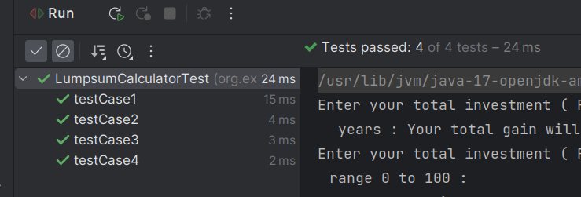

1. PPF Calculator Testing:

**Data Flow Graph**: The following is the data flow graph for the source code(refer the repo) and the corresponding def and du-path coverage.

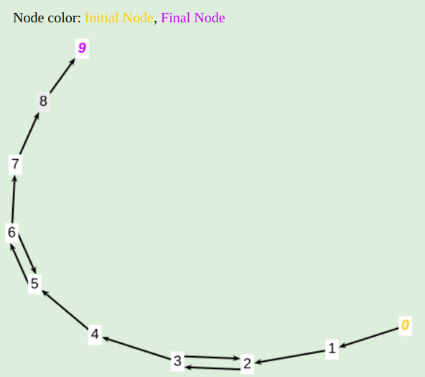

| PPF Calculator | | | | |
| --- | --- | --- | --- | --- |
| Variables | Definitions | Uses | All Def Coverage | All DU Path Coverage |
| yi | { 3 } | { (3, 2), (3, 4), 4 } | [0,1,2,3,4,5,6,7,8,9] | [0,1,2,3,4,5,6,7,8,9], [0,1,2,3,2,3,4,5,6,7,8,9] |
| tp | { 6 } | { (6, 5), (6, 7), 7} | [0,1,2,3,4,5,6,7,8,9] | [0,1,2,3,4,5,6,7,8,9], [0,1,2,3,4,5,6,5,6,7,8,9] |
| yearlyInvestment | { 4 } | { 8 } | [0,1,2,3,4,5,6,7,8,9] | [0,1,2,3,4,5,6,7,8,9] |
| timePeriod | { 7 } | { 8 } | [0,1,2,3,4,5,6,7,8,9] | [0,1,2,3,4,5,6,7,8,9] |
| rateOfInterest | { 1 } | { 8 } | [0,1,2,3,4,5,6,7,8,9] | [0,1,2,3,4,5,6,7,8,9] |
| amount | { 8 } | { 9 } | [0,1,2,3,4,5,6,7,8,9] | [0,1,2,3,4,5,6,7,8,9] |

**Test Cases:**

Following are the test cases (passed) based on the above derived set of test paths.

package org.example;

import org.junit.Assert;

import org.junit.Test;

import java.io.ByteArrayInputStream;

public class PPFCalculatorTest {

String input1 = "100000\n2\n"; // [0,1,2,3,4,5,6,7,8,9]

String input2 = "-10000\n200000\n2\n"; // [0,1,2,3,2,3,4,5,6,7,8,9]

String input3 = "200000\n-2\n2\n"; // [0,1,2,3,4,5,6,5,6,7,8,9]

public void testing(String input, Long expectedTax){

ByteArrayInputStream byteArrayInputStream = new ByteArrayInputStream(input.getBytes());

System.*setIn*(byteArrayInputStream);

PPFCalculator ppfCalculator = new PPFCalculator();

Long actual = ppfCalculator.init();

Assert.*assertEquals*(expectedTax,actual);

}

@Test

public void testCase1(){

testing(input1, 207099L);

}

@Test

public void testCase2(){

testing(input2, 414199L);

}

@Test

public void testCase3(){

testing(input3, 414199L);

}

}

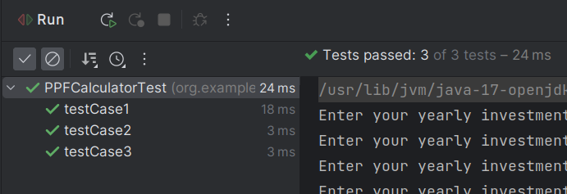

1. SIP Calculator Testing:

**Data Flow Graph**: The following is the data flow graph for the source code(refer the repo) and the corresponding def and du-path coverage.



| SIP Calculator | | | | |
| --- | --- | --- | --- | --- |
| Variables | Definitions | Uses | All Def Coverage | All DU Path Coverage |
| val | { 2, 5, 8 } | { (2, 1), (2, 3), 3, (5, 4), (5, 6), 6, (8, 7), (8, 9), 9 } | [0,1,2,3,4,5,6,7,8,9,10,11], [0,1,2,3,4,5,4,5,6,7,8,9,10,11], [0,1,2,3,4,5,6,7,8,7,8,9,10,11] | [0,1,2,3,4,5,6,7,8,9,10,11], [0,1,2,1,2,3,4,5,6,7,8,9,10,11], [0,1,2,3,4,5,4,5,6,7,8,9,10,11], [0,1,2,3,4,5,6,7,8,7,8,9,10,11], [0,1,2,3,4,5,6,7,8,9,10,11] |
| monthlyInvestment | { 3 } | { 10 } | [0,1,2,3,4,5,6,7,8,9,10,11] | [0,1,2,3,4,5,6,7,8,9,10,11] |
| expectedReturnRateInPercentage | { 6 } | { 10 } | [0,1,2,3,4,5,6,7,8,9,10,11] | [0,1,2,3,4,5,6,7,8,9,10,11] |
| timePeriodInYear | { 9 } | { 10 } | [0,1,2,3,4,5,6,7,8,9,10,11] | [0,1,2,3,4,5,6,7,8,9,10,11] |
| amount | { 10 } | { 11 } | [0,1,2,3,4,5,6,7,8,9,10,11] | [0,1,2,3,4,5,6,7,8,9,10,11] |

**Test Cases:**

Following are the test cases (passed) based on the above derived set of test paths.

package org.example;

import org.junit.Assert;

import org.junit.Test;

import java.io.ByteArrayInputStream;

public class SIPCalculatorTest {

String input1 = "3500\n5.5\n2\n"; // [0,1,2,3,4,5,6,7,8,9,10,11]

String input2 = "5000\n-5\n5.5\n2\n"; // [0,1,2,3,4,5,4,5,6,7,8,9,10,11]

String input3 = "5000\n5.5\n-2\n2\n"; // [0,1,2,3,4,5,6,7,8,7,8,9,10,11]

String input4 = "-10000\n5000\n5.5\n2\n"; // [0,1,2,1,2,3,4,5,6,7,8,9,10,11]

public void testing(String input, Long expectedTax){

ByteArrayInputStream byteArrayInputStream = new ByteArrayInputStream(input.getBytes());

System.*setIn*(byteArrayInputStream);

SIPCalculator sipCalculator = new SIPCalculator();

Long actual = sipCalculator.init();

Assert.*assertEquals*(expectedTax,actual);

}

@Test

public void testCase1(){

testing(input1, 88985L);

}

@Test

public void testCase2(){

testing(input2, 127122L);

}

@Test

public void testCase3(){

testing(input3, 127122L);

}

@Test

public void testCase4(){

testing(input4, 127122L);

}

}

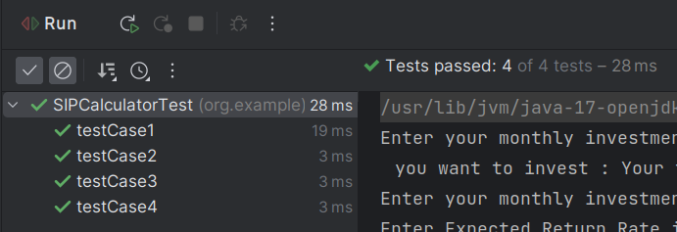

1. SWP Calculator Testing:

**Data Flow Graph**: The following is the data flow graph for the source code(refer the repo) and the corresponding def and du-path coverage.

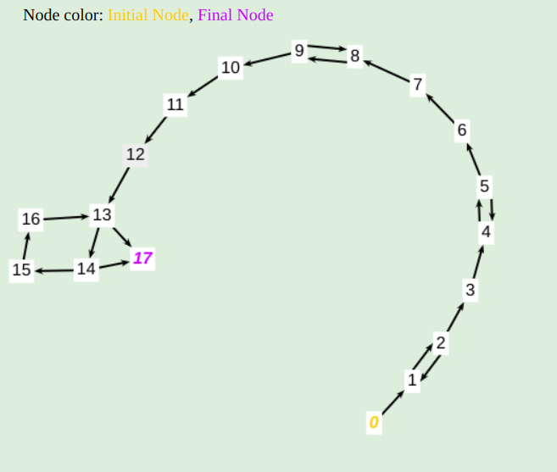

| SWP Calculator | | | | |
| --- | --- | --- | --- | --- |
| Variables | Definitions | Uses | All Def Coverage | All DU Path Coverage |
| val | { 2, 5, 7, 9 } | { (2, 1), (2, 3), 3, (5, 4), (5, 6), 6, 7, (9, 8), (9, 10), 10 } | [0,1,2,3,4,5,6,7,8,9,10,11,12,13,17], [0,1,2,3,4,5,4,5,6,7,8,9,10,11,12,13,17], [0,1,2,3,4,5,6,7,8,9,8,9,10,11,12,13,17] | [0,1,2,3,4,5,6,7,8,9,10,11,12,13,17], [0,1,2,1,2,3,4,5,6,7,8,9,10,11,12,13,17], [0,1,2,3,4,5,4,5,6,7,8,9,10,11,12,13,17], [0,1,2,3,4,5,6,7,8,9,10,11,12,13,17], [0,1,2,3,4,5,6,7,8,9,8,9,10,11,12,13,17] |
| totalInvestment | { 3 } | { 11 } | [0,1,2,3,4,5,6,7,8,9,10,11,12,13,17] | [0,1,2,3,4,5,6,7,8,9,10,11,12,13,17] |
| withdrawalAmount | { 6 } | { 11 } | [0,1,2,3,4,5,6,7,8,9,10,11,12,13,17] | [0,1,2,3,4,5,6,7,8,9,10,11,12,13,17] |
| expectedReturnRate | { 7 } | { 11 } | [0,1,2,3,4,5,6,7,8,9,10,11,12,13,17] | [0,1,2,3,4,5,6,7,8,9,10,11,12,13,17] |
| timePeriod | { 10 } | { 11 } | [0,1,2,3,4,5,6,7,8,9,10,11,12,13,17] | [0,1,2,3,4,5,6,7,8,9,10,11,12,13,17] |
| deduct | { 11 } | { 14 } | [0,1,2,3,4,5,6,7,8,9,10,11,12,13,14,17] | [0,1,2,3,4,5,6,7,8,9,10,11,12,13,14,17] |
| val1 | { 11, 14, 15 } | { 14, (14, 17), (14, 15), 15 } | [0,1,2,3,4,5,6,7,8,9,10,11,12,13,14,17], [0,1,2,3,4,5,6,7,8,9,10,11,12,13,14,15,16,13,17], [0,1,2,3,4,5,6,7,8,9,10,11,12,13,14,15,16,13,14,17] | [0,1,2,3,4,5,6,7,8,9,10,11,12,13,14,17], [0,1,2,3,4,5,6,7,8,9,10,11,12,13,14,15,16,13,17], [0,1,2,3,4,5,6,7,8,9,10,11,12,13,14,15,16,13,14,17] |
| gain | { 11, 15 } | { 15 } | [0,1,2,3,4,5,6,7,8,9,10,11,12,13,14,15,16,13,17], [0,1,2,3,4,5,6,7,8,9,10,11,12,13,14,15,16,13,14,15,16,13,17] | [0,1,2,3,4,5,6,7,8,9,10,11,12,13,14,15,16,13,17], [0,1,2,3,4,5,6,7,8,9,10,11,12,13,14,15,16,13,14,15,16,13,17] |
| n | { 11 } | { (13, 14), (13, 17) } | [0,1,2,3,4,5,6,7,8,9,10,11,12,13,14,17] | [0,1,2,3,4,5,6,7,8,9,10,11,12,13,14,17], [0,1,2,3,4,5,6,7,8,9,10,11,12,13,17] |
| i | { 12, 16 } | { (13, 14), (13, 17), 16 } | [0,1,2,3,4,5,6,7,8,9,10,11,12,13,14,17], [0,1,2,3,4,5,6,7,8,9,10,11,12,13,14,15,16,13,14,17] | [0,1,2,3,4,5,6,7,8,9,10,11,12,13,14,17], [0,1,2,3,4,5,6,7,8,9,10,11,12,13,17], [0,1,2,3,4,5,6,7,8,9,10,11,12,13,14,15,16,13,17], [0,1,2,3,4,5,6,7,8,9,10,11,12,13,14,15,16,13,14,17], [0,1,2,3,4,5,6,7,8,9,10,11,12,13,14,15,16,13,14,15,16,13,17] |
| returnAmnt | { 17 } | { 17 } | No Path needed | No Path needed |
| tmp | { 15 } | { 15 } | [0,1,2,3,4,5,6,7,8,9,10,11,12,13,14,15,16,13,14,15,16,13,17] | [0,1,2,3,4,5,6,7,8,9,10,11,12,13,14,15,16,13,14,15,16,13,17] |

**Test Cases:**

Following are the test cases (passed) based on the above derived set of test paths.

package org.example;

import org.junit.Assert;

import org.junit.Test;

import java.io.ByteArrayInputStream;

public class SWPCalculatorTest {

String input1 = "100000\n5000\n5.5\n0\n"; // [0,1,2,3,4,5,6,7,8,9,10,11,12,13,17]

String input2 = "100000\n-5000\n5000\n5.5\n3\n"; // [0,1,2,3,4,5,4,5,6,7,8,9,10,11,12,13,17]

String input3 = "100000\n5000\n5.5\n-2\n3\n"; // [0,1,2,3,4,5,6,7,8,9,8,9,10,11,12,13,17]

String input4 = "-3500\n100000\n5000\n5.5\n3\n"; // [0,1,2,1,2,3,4,5,6,7,8,9,10,11,12,13,17]

String input5 = "500000\n500000\n5.5\n2\n"; // [0,1,2,3,4,5,6,7,8,9,10,11,12,13,14,17]

String input6 = "500000\n250000\n5.5\n2\n"; // [0,1,2,3,4,5,6,7,8,9,10,11,12,13,14,15,16,13,14,17]

String input7 = "600000\n200000\n5.5\n2\n"; // [0,1,2,3,4,5,6,7,8,9,10,11,12,13,14,15,16,13,14,15,16,13,17]

public void testing(String input, Long expectedTax){

ByteArrayInputStream byteArrayInputStream = new ByteArrayInputStream(input.getBytes());

System.*setIn*(byteArrayInputStream);

SWPCalculator swpCalculator = new SWPCalculator();

Long actual = swpCalculator.init();

Assert.*assertEquals*(expectedTax,actual);

}

@Test

public void testCase1(){

testing(input1, 0L);

}

@Test

public void testCase2(){

testing(input2, 4621L);

}

@Test

public void testCase3(){

testing(input3, 4621L);

}

@Test

public void testCase4(){

testing(input4, 4621L);

}

@Test

public void testCase5(){

testing(input5, 4621L);

}

@Test

public void testCase6(){

testing(input6, 4621L);

}

@Test

public void testCase7(){

testing(input7, 4621L);

}

}

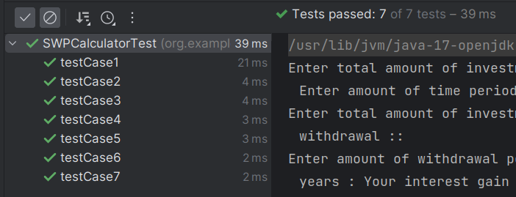

1. Income Tax Calculator:-

**Data Flow Graph**: The following is the data flow graph for the source code of income tax calculator (refer the repo) and the corresponding def and du-path coverage.

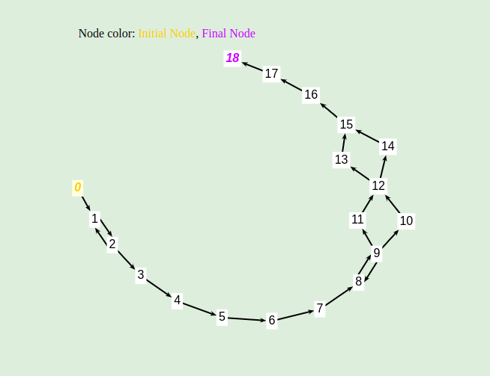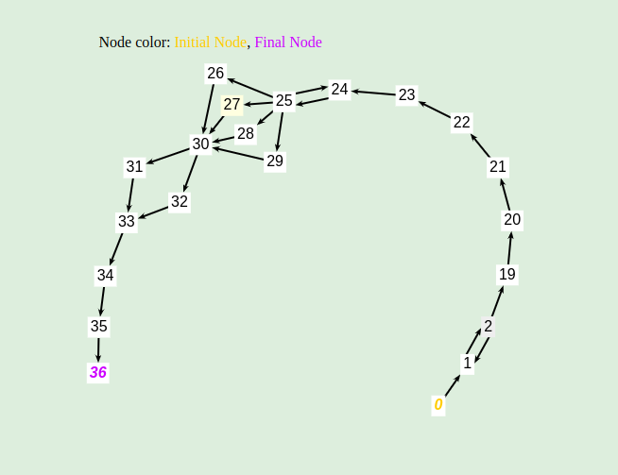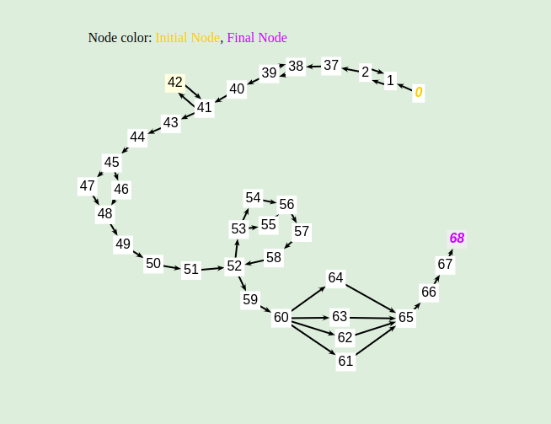

Text BoxShape Text Box Text Box

| Income Tax Calculator | | | | |
| --- | --- | --- | --- | --- |
| Variables | Definitions | Uses | All Def Coverage | All DU Path Coverage |
| slabs | { 51 } | { (52,52), (53,64), (53,55), 56 } | { [0,1,2,37,38,39,40,41,42,43,44,45,46,48,49,50,51,52,53,54,56,57,58,52,59,60,61,65,66,67,68], [0,1,2,37,38,39,40,41,42,43,44,45,46,48,49,50,51,52,53,55,56,57,58,52,59,60,61,65,66,67,68],    } | { [0,1,2,37,38,39,40,41,42,43,44,45,46,48,49,50,51,52,53,54,56,57,58,52,59,60,61,65,66,67,68], [0,1,2,37,38,39,40,41,42,43,44,45,46,48,49,50,51,52,53,55,56,57,58,52,59,60,61,65,66,67,68] } |
| slab | { 1 } | { 51 } | { [0,1,2,37,38,39,40,41,42,43,44,45,46,48,49,50,51,52,53,54,56,57,58,52,59,60,61,65,66,67,68]  } | { [0,1,2,37,38,39,40,41,42,43,44,45,46,48,49,50,51,52,53,54,56,57,58,52,59,60,61,65,66,67,68],  [0,1,2,37,38,39,40,41,42,43,44,45,47,48,49,50,51,52,53,54,56,57,58,52,59,60,61,65,66,67,68]  } |
| type | { 2 } | { (2,1), (2,3), (2,19), (2,37) } | { [0,1,2,37,38,39,40,41,42,43,44,45,46,48,49,50,51,52,53,54,56,57,58,52,59,60,61,65,66,67,68]  } | { [0,1,2,37,38,39,40,41,42,43,44,45,46,48,49,50,51,52,53,54,56,57,58,52,59,60,61,65,66,67,68] ,  [0,1,2],  [0,1,2,1,2,3,4,5,6,7,8,9,10,12,13,15,16,17,18],  [0,1,2,19,20,21,22,23,24,25,26,30,31,33,34,35,36]  } |
| income | { 3, 19, 44 } | { 4, 7, 20, 23, 50 } | { [0,1,2,1,2,3,4,5,6,7,8,9,10,12,13,15,16,17,18],  [0,1,2,19,20,21,22,23,24,25,26,30,31,33,34,35,36],  [0,1,2,37,38,39,40,41,42,43,44,45,46,48,49,50,51,52,53,54,56,57,58,52,59,60,61,65,66,67,68]  } | { [0,1,2,1,2,3,4,5,6,7,8,9,10,12,13,15,16,17,18],  [0,1,2,19,20,21,22,23,24,25,26,30,31,33,34,35,36],  [0,1,2,37,38,39,40,41,42,43,44,45,46,48,49,50,51,52,53,54,56,57,58,52,59,60,61,65,66,67,68],  [0,1,2,37,38,39,40,41,42,43,44,45,47,48,49,50,51,52,53,54,56,57,58,52,59,60,61,65,66,67,68]  } |
| ngoDonation | { 4, 20 } | { 5. 21 } | {  [0,1,2,1,2,3,4,5,6,7,8,9,10,12,13,15,16,17,18],  [0,1,2,19,20,21,22,23,24,25,26,30,31,33,34,35,36],  } | {  [0,1,2,1,2,3,4,5,6,7,8,9,10,12,13,15,16,17,18],  [0,1,2,19,20,21,22,23,24,25,26,30,31,33,34,35,36],  } |
| goDonation | { 4, 20 } | { 5. 21 } | {  [0,1,2,1,2,3,4,5,6,7,8,9,10,12,13,15,16,17,18],  [0,1,2,19,20,21,22,23,24,25,26,30,31,33,34,35,36],  } | {  [0,1,2,1,2,3,4,5,6,7,8,9,10,12,13,15,16,17,18],  [0,1,2,19,20,21,22,23,24,25,26,30,31,33,34,35,36],  } |
| netQualifyingLimit | { 4, 20 } | { 5. 21 } | {  [0,1,2,1,2,3,4,5,6,7,8,9,10,12,13,15,16,17,18],  [0,1,2,19,20,21,22,23,24,25,26,30,31,33,34,35,36],  } | {  [0,1,2,1,2,3,4,5,6,7,8,9,10,12,13,15,16,17,18],  [0,1,2,19,20,21,22,23,24,25,26,30,31,33,34,35,36],  } |
| deduction | { 5, 21, 48 } | { 6, 22, 49 } | {  [0,1,2,1,2,3,4,5,6,7,8,9,10,12,13,15,16,17,18],  [0,1,2,19,20,21,22,23,24,25,26,30,31,33,34,35,36],  [0,1,2,37,38,39,40,41,42,43,44,45,46,48,49,50,51,52,53,54,56,57,58,52,59,60,61,65,66,67,68]  } | {  [0,1,2,1,2,3,4,5,6,7,8,9,10,12,13,15,16,17,18],  [0,1,2,19,20,21,22,23,24,25,26,30,31,33,34,35,36],  [0,1,2,37,38,39,40,41,42,43,44,45,46,48,49,50,51,52,53,54,56,57,58,52,59,60,61,65,66,67,68]  } |
| deductedAmt | { 6, 22, 49 } | { 7, 23, 50 } | {  [0,1,2,1,2,3,4,5,6,7,8,9,10,12,13,15,16,17,18],  [0,1,2,19,20,21,22,23,24,25,26,30,31,33,34,35,36],  [0,1,2,37,38,39,40,41,42,43,44,45,46,48,49,50,51,52,53,54,56,57,58,52,59,60,61,65,66,67,68]  } | {  [0,1,2,1,2,3,4,5,6,7,8,9,10,12,13,15,16,17,18],  [0,1,2,19,20,21,22,23,24,25,26,30,31,33,34,35,36],  [0,1,2,37,38,39,40,41,42,43,44,45,46,48,49,50,51,52,53,54,56,57,58,52,59,60,61,65,66,67,68]  } |
| taxableAmt | { 7, 23, 50, 57 } | { 10, 11, (12,13), (12,14), 26, 27, 28, 29, (30,31), (30,32), (52,53), 54, 55, 57, (60,61), (60,62), (60,63), (60,64) } | { [0,1,2,37,38,39,40,41,42,43,44,45,46,48,49,50,51,52,53,54,56,57,58,52,53,54,56,57,58,52,59,60,61,65,66,67,68],  [0,1,2,19,20,21,22,23,24,25,26,30,31,33,34,35,36],  [0,1,2,1,2,3,4,5,6,7,8,9,11,12,13,15,16,17,18]  } | {[0,1,2,1,2,3,4,5,6,7,8,9,11,12,13,15,16,17,18], [0,1,2,1,2,3,4,5,6,7,8,9,10,12,13,15,16,17,18],  [0,1,2,1,2,3,4,5,6,7,8,9,11,12,14,15,16,17,18], [0,1,2,1,2,3,4,5,6,7,8,9,10,12,14,15,16,17,18],    [0,1,2,19,20,21,22,23,24,25,26,30,31,33,34,35,36],  [0,1,2,19,20,21,22,23,24,25,26,30,32,33,34,35,36],  [0,1,2,19,20,21,22,23,24,25,27,30,32,33,34,35,36],  [0,1,2,19,20,21,22,23,24,25,27,30,31,33,34,35,36],  [0,1,2,19,20,21,22,23,24,25,28,30,32,33,34,35,36],  [0,1,2,19,20,21,22,23,24,25,28,30,31,33,34,35,36], [0,1,2,19,20,21,22,23,24,25,29,30,32,33,34,35,36],  [0,1,2,19,20,21,22,23,24,25,29,30,31,33,34,35,36],    [0,1,2,37,38,39,40,41,42,43,44,45,46,48,49,50,51,52,53,54,56,57,58,52,53,54,56,57,58,52,59,60,61,65,66,67,68],  [0,1,2,37,38,39,40,41,42,43,44,45,46,48,49,50,51,52,53,55,56,57,58,52,53,54,56,57,58,52,59,60,62,65,66,67,68],  [0,1,2,37,38,39,40,41,42,43,44,45,46,48,49,50,51,52,53,55,56,57,58,52,53,54,56,57,58,52,59,60,63,65,66,67,68],  [0,1,2,37,38,39,40,41,42,43,44,45,46,48,49,50,51,52,53,55,56,57,58,52,53,54,56,57,58,52,59,60,64,65,66,67,68],    [0,1,2,37,38,39,40,41,42,43,44,45,46,48,49,50,51,52,59,60,64,65,66,67,68], [0,1,2,37,38,39,40,41,42,43,44,45,46,48,49,50,51,52,59,60,63,65,66,67,68], [0,1,2,37,38,39,40,41,42,43,44,45,46,48,49,50,51,52,59,60,62,65,66,67,68],  [0,1,2,37,38,39,40,41,42,43,44,45,46,48,49,50,51,52,59,60,61,65,66,67,68],    } |
| id | { 9, 25 } | { (9,8), (9,10), (9,11), (25,24), (25,26), (25,27), (25,28), (25,29) } | {  [0,1,2,3,4,5,6,7,8,9,10,12,13,15,16,17,18],  [0,1,2,19,20,21,22,23,24,25,26,30,31,33,34,35,36],  } | { [0,1,2,3,4,5,6,7,8,9,8,9,10,12,13,15,16,17,18],  [0,1,2,3,4,5,6,7,8,9,11,12,13,15,16,17,18],    [0,1,2,19,20,21,22,23,24,25,24,25,26,30,31,33,34,35,36],  [0,1,2,19,20,21,22,23,24,25,27,30,31,33,34,35,36],  [0,1,2,19,20,21,22,23,24,25,28,30,31,33,34,35,36],  [0,1,2,19,20,21,22,23,24,25,29,30,31,33,34,35,36]    } |
| ta | { 10, 11, 26, 27, 28, 29, 56 } | { 12, 30, 56, 59 } | {    [0,1,2,1,2,3,4,5,6,7,8,9,11,12,13,15,16,17,18],  [0,1,2,1,2,3,4,5,6,7,8,9,10,12,13,15,16,17,18]    [0,1,2,19,20,21,22,23,24,25,24,25,26,30,31,33,34,35,36],  [0,1,2,19,20,21,22,23,24,25,27,30,31,33,34,35,36],  [0,1,2,19,20,21,22,23,24,25,28,30,31,33,34,35,36],  [0,1,2,19,20,21,22,23,24,25,29,30,31,33,34,35,36]    [0,1,2,37,38,39,40,41,42,43,44,45,46,48,49,50,51,52,53,55,56,57,58,52,53,54,56,57,58,52,59,60,64,65,66,67,68]  } | { [0,1,2,1,2,3,4,5,6,7,8,9,11,12,13,15,16,17,18],  [0,1,2,1,2,3,4,5,6,7,8,9,10,12,13,15,16,17,18]    [0,1,2,19,20,21,22,23,24,25,24,25,26,30,31,33,34,35,36],  [0,1,2,19,20,21,22,23,24,25,27,30,31,33,34,35,36],  [0,1,2,19,20,21,22,23,24,25,28,30,31,33,34,35,36],  [0,1,2,19,20,21,22,23,24,25,29,30,31,33,34,35,36]    [0,1,2,37,38,39,40,41,42,43,44,45,46,48,49,50,51,52,53,55,56,57,58,52,53,54,56,57,58,52,59,60,64,65,66,67,68],  [0,1,2,37,38,39,40,41,42,43,44,45,46,48,49,50,51,52,53,55,56,57,58,52,53,55,56,57,58,52,59,60,64,65,66,67,68],  } |
| taxAmt | { 12, 30, 59 } | { 13, 14, 16, 18, 31, 32, 34, 36, 61, 62, 63, 64, 66, 68 } | {  [0,1,2,1,2,3,4,5,6,7,8,9,11,12,13,15,16,17,18],  [0,1,2,19,20,21,22,23,24,25,24,25,26,30,31,33,34,35,36],  [0,1,2,37,38,39,40,41,42,43,44,45,46,48,49,50,51,52,53,55,56,57,58,52,53,54,56,57,58,52,59,60,61,65,66,67,68]    } | { [0,1,2,1,2,3,4,5,6,7,8,9,11,12,13,15,16,17,18],  [0,1,2,1,2,3,4,5,6,7,8,9,11,12,14,15,16,17,18],    [0,1,2,19,20,21,22,23,24,25,24,25,26,30,31,33,34,35,36],  [0,1,2,19,20,21,22,23,24,25,24,25,26,30,32,33,34,35,36],      [0,1,2,37,38,39,40,41,42,43,44,45,46,48,49,50,51,52,53,55,56,57,58,52,53,54,56,57,58,52,59,60,61,65,66,67,68],  [0,1,2,37,38,39,40,41,42,43,44,45,46,48,49,50,51,52,53,55,56,57,58,52,53,54,56,57,58,52,59,60,62,65,66,67,68],  [0,1,2,37,38,39,40,41,42,43,44,45,46,48,49,50,51,52,53,55,56,57,58,52,53,54,56,57,58,52,59,60,63,65,66,67,68], [0,1,2,37,38,39,40,41,42,43,44,45,46,48,49,50,51,52,53,55,56,57,58,52,53,54,56,57,58,52,59,60,64,65,66,67,68],    } |
| Sc | { 13, 14, 61, 62, 63, 64, 31, 32 } | { 15, 33, 65 } | {  [0,1,2,1,2,3,4,5,6,7,8,9,11,12,13,15,16,17,18],  [0,1,2,1,2,3,4,5,6,7,8,9,11,12,14,15,16,17,18],    [0,1,2,19,20,21,22,23,24,25,24,25,26,30,31,33,34,35,36],  [0,1,2,19,20,21,22,23,24,25,24,25,26,30,32,33,34,35,36],    [0,1,2,37,38,39,40,41,42,43,44,45,46,48,49,50,51,52,53,55,56,57,58,52,53,54,56,57,58,52,59,60,61,65,66,67,68],  [0,1,2,37,38,39,40,41,42,43,44,45,46,48,49,50,51,52,53,55,56,57,58,52,53,54,56,57,58,52,59,60,62,65,66,67,68],  [0,1,2,37,38,39,40,41,42,43,44,45,46,48,49,50,51,52,53,55,56,57,58,52,53,54,56,57,58,52,59,60,63,65,66,67,68], [0,1,2,37,38,39,40,41,42,43,44,45,46,48,49,50,51,52,53,55,56,57,58,52,53,54,56,57,58,52,59,60,64,65,66,67,68]    } | {  [0,1,2,1,2,3,4,5,6,7,8,9,11,12,13,15,16,17,18],  [0,1,2,1,2,3,4,5,6,7,8,9,11,12,14,15,16,17,18],    [0,1,2,19,20,21,22,23,24,25,24,25,26,30,31,33,34,35,36],  [0,1,2,19,20,21,22,23,24,25,24,25,26,30,32,33,34,35,36],    [0,1,2,37,38,39,40,41,42,43,44,45,46,48,49,50,51,52,53,55,56,57,58,52,53,54,56,57,58,52,59,60,61,65,66,67,68],  [0,1,2,37,38,39,40,41,42,43,44,45,46,48,49,50,51,52,53,55,56,57,58,52,53,54,56,57,58,52,59,60,62,65,66,67,68],  [0,1,2,37,38,39,40,41,42,43,44,45,46,48,49,50,51,52,53,55,56,57,58,52,53,54,56,57,58,52,59,60,63,65,66,67,68], [0,1,2,37,38,39,40,41,42,43,44,45,46,48,49,50,51,52,53,55,56,57,58,52,53,54,56,57,58,52,59,60,64,65,66,67,68]    } |
| Surcharge | { 15,33,65 } | { 18, 36, 68 } | { [0,1,2,1,2,3,4,5,6,7,8,9,11,12,13,15,16,17,18],    [0,1,2,19,20,21,22,23,24,25,24,25,26,30,32,33,34,35,36],    [0,1,2,37,38,39,40,41,42,43,44,45,46,48,49,50,51,52,53,55,56,57,58,52,53,54,56,57,58,52,59,60,64,65,66,67,68]  } | { [0,1,2,1,2,3,4,5,6,7,8,9,11,12,13,15,16,17,18],    [0,1,2,19,20,21,22,23,24,25,24,25,26,30,32,33,34,35,36],    [0,1,2,37,38,39,40,41,42,43,44,45,46,48,49,50,51,52,53,55,56,57,58,52,53,54,56,57,58,52,59,60,64,65,66,67,68]  } |
| charge | { 16, 34, 60 } | { 17, 35, 67 } | { [0,1,2,1,2,3,4,5,6,7,8,9,11,12,13,15,16,17,18],    [0,1,2,19,20,21,22,23,24,25,24,25,26,30,32,33,34,35,36],    [0,1,2,37,38,39,40,41,42,43,44,45,46,48,49,50,51,52,53,55,56,57,58,52,53,54,56,57,58,52,59,60,64,65,66,67,68]  } | { [0,1,2,1,2,3,4,5,6,7,8,9,11,12,13,15,16,17,18],    [0,1,2,19,20,21,22,23,24,25,24,25,26,30,32,33,34,35,36],    [0,1,2,37,38,39,40,41,42,43,44,45,46,48,49,50,51,52,53,55,56,57,58,52,53,54,56,57,58,52,59,60,64,65,66,67,68]  } |
| healthAndEduCess | { 17, 35, 67 } | { 18, 36, 68 } | { [0,1,2,1,2,3,4,5,6,7,8,9,11,12,13,15,16,17,18],    [0,1,2,19,20,21,22,23,24,25,24,25,26,30,32,33,34,35,36],    [0,1,2,37,38,39,40,41,42,43,44,45,46,48,49,50,51,52,53,55,56,57,58,52,53,54,56,57,58,52,59,60,64,65,66,67,68]  } | { [0,1,2,1,2,3,4,5,6,7,8,9,11,12,13,15,16,17,18],    [0,1,2,19,20,21,22,23,24,25,24,25,26,30,32,33,34,35,36],    [0,1,2,37,38,39,40,41,42,43,44,45,46,48,49,50,51,52,53,55,56,57,58,52,53,54,56,57,58,52,59,60,64,65,66,67,68]  } |
| NetTax | { 18, 36, 68 } | { x,y,z } | { [0,1,2,1,2,3,4,5,6,7,8,9,11,12,13,15,16,17,18],    [0,1,2,19,20,21,22,23,24,25,24,25,26,30,32,33,34,35,36],    [0,1,2,37,38,39,40,41,42,43,44,45,46,48,49,50,51,52,53,55,56,57,58,52,53,54,56,57,58,52,59,60,64,65,66,67,68]  } | { [0,1,2,1,2,3,4,5,6,7,8,9,11,12,13,15,16,17,18],    [0,1,2,19,20,21,22,23,24,25,24,25,26,30,32,33,34,35,36],    [0,1,2,37,38,39,40,41,42,43,44,45,46,48,49,50,51,52,53,55,56,57,58,52,53,54,56,57,58,52,59,60,64,65,66,67,68]  } |
| schemeId | { 39 } | { (39,38), 40 } | { [0,1,2,37,38,39,38,39,40,41,42,43,44,45,46,48,49,50,51,52,53,55,56,57,58,52,53,54,56,57,58,52,59,60,64,65,66,67,68]  } | { [0,1,2,37,38,39,38,39,40,41,42,43,44,45,46,48,49,50,51,52,53,55,56,57,58,52,53,54,56,57,58,52,59,60,64,65,66,67,68]  } |
| regimeId | { 40 } | { (41,42), (45,46), (41,43), (45,47) } | { [0,1,2,37,38,39,40,41,42,43,44,45,46,48,49,50,51,52,53,55,56,57,58,52,53,54,56,57,58,52,59,60,64,65,66,67,68]  } | { [0,1,2,37,38,39,40,41,42,43,44,45,46,48,49,50,51,52,53,55,56,57,58,52,53,54,56,57,58,52,59,60,64,65,66,67,68],  [0,1,2,37,38,39,40,41,43,44,45,47,48,49,50,51,52,53,55,56,57,58,52,53,54,56,57,58,52,59,60,64,65,66,67,68]  } |
| ageGrp | { 40, 42 } | { (42,41), 43 } | {  [0,1,2,37,38,39,40,41,42,43,44,45,46,48,49,50,51,52,53,55,56,57,58,52,53,54,56,57,58,52,59,60,64,65,66,67,68],  [0,1,2,37,38,39,40,41,43,44,45,47,48,49,50,51,52,53,55,56,57,58,52,53,54,56,57,58,52,59,60,64,65,66,67,68]  } | {  [0,1,2,37,38,39,40,41,42,41,42,43,44,45,46,48,49,50,51,52,53,55,56,57,58,52,53,54,56,57,58,52,59,60,64,65,66,67,68],  [0,1,2,37,38,39,40,41,43,44,45,47,48,49,50,51,52,53,55,56,57,58,52,53,54,56,57,58,52,59,60,64,65,66,67,68]  } |
| ageGrpId | { 43 } | { 51 } | {  [0,1,2,37,38,39,40,41,42,43,44,45,46,48,49,50,51,52,53,55,56,57,58,52,53,54,56,57,58,52,59,60,64,65,66,67,68]  } | {  [0,1,2,37,38,39,40,41,42,43,44,45,46,48,49,50,51,52,53,55,56,57,58,52,53,54,56,57,58,52,59,60,64,65,66,67,68], [0,1,2,37,38,39,40,41,42,43,44,45,47,48,49,50,51,52,53,55,56,57,58,52,53,54,56,57,58,52,59,60,64,65,66,67,68],    } |
| 80c | { 45, 46 } | { 48 } | {  [0,1,2,37,38,39,40,41,42,43,44,45,46,48,49,50,51,52,53,55,56,57,58,52,53,54,56,57,58,52,59,60,64,65,66,67,68]  } | {  [0,1,2,37,38,39,40,41,42,43,44,45,46,48,49,50,51,52,53,55,56,57,58,52,53,54,56,57,58,52,59,60,64,65,66,67,68]  } |
| 80ccd1b | { 45, 46, 47 } | { 48 } | {  [0,1,2,37,38,39,40,41,42,43,44,45,46,48,49,50,51,52,53,55,56,57,58,52,53,54,56,57,58,52,59,60,64,65,66,67,68],  [0,1,2,37,38,39,40,41,42,43,44,45,47,48,49,50,51,52,53,55,56,57,58,52,53,54,56,57,58,52,59,60,64,65,66,67,68],  } | {  [0,1,2,37,38,39,40,41,42,43,44,45,46,48,49,50,51,52,53,55,56,57,58,52,53,54,56,57,58,52,59,60,64,65,66,67,68],  [0,1,2,37,38,39,40,41,42,43,44,45,47,48,49,50,51,52,53,55,56,57,58,52,53,54,56,57,58,52,59,60,64,65,66,67,68],  } |
| i | {51, 58} | {(52,53), (52,59), (53,54), (53,55), 55, 56, 58} | {  [0,1,2,37,38,39,40,41,42,43,44,45,46,48,49,50,51,52,53,55,56,57,58,52,53,55,56,57,58,52,59,60,64,65,66,67,68],  } | {  [0,1,2,37,38,39,40,41,42,43,44,45,46,48,49,50,51,52,53,55,56,57,58,52,53,55,56,57,58,52,59,60,64,65,66,67,68],    [0,1,2,37,38,39,40,41,42,43,44,45,46,48,49,50,51,52,59,60,64,65,66,67,68],    [0,1,2,37,38,39,40,41,42,43,44,45,46,48,49,50,51,52,53,54,56,57,58,52,53,54,56,57,58,52,59,60,64,65,66,67,68],    } |
| minA | {54, 55} | {56, 57} | {  [0,1,2,37,38,39,40,41,42,43,44,45,46,48,49,50,51,52,53,54,56,57,58,52,53,55,56,57,58,52,59,60,64,65,66,67,68]  } | {  [0,1,2,37,38,39,40,41,42,43,44,45,46,48,49,50,51,52,53,54,56,57,58,52,53,55,56,57,58,52,59,60,64,65,66,67,68]  } |

package org.example;

import org.junit.Assert;

import org.junit.Test;

import java.io.ByteArrayInputStream;

import java.util.Optional;

public class TaxCalculatorTest{

// [0,1,2,37,38,39,40,41,42,43,44,45,46,48,49,50,51,52,53,54,56,57,58,52,59,60,61,65,66,67,68]

String input1 = "1\n1\n1\n8000000\n10000\n25000\n1000\n2000\n6788\n";

// [0,1,2,37,38,39,40,41,42,43,44,45,46,48,49,50,51,52,53,55,56,57,58,52,59,60,61,65,66,67,68]

String input2 = "1\n1\n1\n8000000\n10000\n25000\n1000\n2000\n6788\n";

// [0,1,2,37,38,39,40,41,42,43,44,45,46,48,49,50,51,52,53,55,56,57,58,52,53,54,56,57,58,52,59,60,64,65,66,67,68]

String input3 = "1\n1\n1\n80000000\n10000\n25000\n1000\n2000\n6788\n";

// [0,1,2,37,38,39,40,41,42,43,44,45,46,48,49,50,51,52,53,55,56,57,58,52,53,54,56,57,58,52,59,60,61,65,66,67,68]

String input4 = "1\n1\n1\n8000000\n10000\n25000\n1000\n2000\n6788\n";

// [0,1,2,37,38,39,40,41,42,43,44,45,46,48,49,50,51,52,53,55,56,57,58,52,53,54,56,57,58,52,59,60,62,65,66,67,68]

String input5 = "1\n1\n1\n15000000\n10000\n25000\n1000\n2000\n6788\n";

// [0,1,2,37,38,39,40,41,42,43,44,45,46,48,49,50,51,52,53,55,56,57,58,52,53,54,56,57,58,52,59,60,63,65,66,67,68]

String input6 = "1\n1\n1\n40000000\n10000\n25000\n1000\n2000\n6788\n";

// [0,1,2,37,38,39,40,41,43,44,45,47,48,49,50,51,52,53,55,56,57,58,52,53,54,56,57,58,52,59,60,64,65,66,67,68]

String input7 = "1\n2\n80000000\n10000";

// [0,1,2,37,38,39,40,41,42,43,44,45,46,48,49,50,51,52,53,54,56,57,58,52,53,55,56,57,58,52,59,60,64,65,66,67,68]

String input8 = "1\n1\n1\n70000000\n10000\n25000\n1000\n2000\n6788\n";

// [0,1,2,37,38,39,40,41,42,41,42,43,44,45,46,48,49,50,51,52,53,55,56,57,58,52,53,54,56,57,58,52,59,60,64,65,66,67,68]

String input9 = "1\n1\n-1\n1\n70000000\n10000\n25000\n1000\n2000\n6788\n";

// Following test-paths are not possible practically based on business logic, although they are possible theoretically

// [0,1,2,37,38,39,40,41,42,43,44,45,46,48,49,50,51,52,53,54,56,57,58,52,53,54,56,57,58,52,59,60,64,65,66,67,68]

// [0,1,2,37,38,39,40,41,42,43,44,45,46,48,49,50,51,52,59,60,64,65,66,67,68]

// [0,1,2,37,38,39,40,41,42,43,44,45,46,48,49,50,51,52,59,60,64,65,66,67,68]

// [0,1,2,37,38,39,40,41,42,43,44,45,46,48,49,50,51,52,59,60,63,65,66,67,68]

// [0,1,2,37,38,39,40,41,42,43,44,45,46,48,49,50,51,52,59,60,62,65,66,67,68]

// [0,1,2,37,38,39,40,41,42,43,44,45,46,48,49,50,51,52,59,60,61,65,66,67,68]

// [0,1,2,1,2,3,4,5,6,7,8,9,10,12,13,15,16,17,18]

String input10 = "-1\n3\n80000000\n200000\n300000\n1\n";

// [0,1,2,1,2,3,4,5,6,7,8,9,11,12,13,15,16,17,18]

String input11 = "-1\n3\n80000000\n200000\n300000\n0\n";

// [0,1,2,3,4,5,6,7,8,9,10,12,13,15,16,17,18]

String input12 = "3\n80000000\n200000\n300000\n1\n";

// [0,1,2,3,4,5,6,7,8,9,8,9,10,12,13,15,16,17,18]

String input13 = "3\n80000000\n200000\n300000\n-1\n1\n";

// [0,1,2,3,4,5,6,7,8,9,11,12,13,15,16,17,18]

String input14 = "3\n80000000\n200000\n300000\n0\n";

// [0,1,2,1,2,3,4,5,6,7,8,9,11,12,14,15,16,17,18]

String input15 = "-1\n3\n150000000\n200000\n300000\n1\n";

// [0,1,2,1,2,3,4,5,6,7,8,9,10,12,14,15,16,17,18]

// [0,1,2,19,20,21,22,23,24,25,26,30,31,33,34,35,36]

String input16 = "2\n70000000\n200000\n300000\n1\n";

// [0,1,2,19,20,21,22,23,24,25,27,30,31,33,34,35,36]

String input17 = "2\n70000000\n200000\n300000\n2\n";

// [0,1,2,19,20,21,22,23,24,25,24,25,26,30,31,33,34,35,36]

String input18 = "2\n70000000\n200000\n300000\n-1\n1\n";

// [0,1,2,19,20,21,22,23,24,25,28,30,31,33,34,35,36]

String input19 = "2\n70000000\n200000\n300000\n3\n";

// [0,1,2,19,20,21,22,23,24,25,24,25,26,30,32,33,34,35,36]

String input20 = "2\n150000000\n200000\n300000\n-1\n1\n";

// [0,1,2,19,20,21,22,23,24,25,29,30,31,33,34,35,36]

String input21 = "2\n70000000\n200000\n300000\n4\n";

// [0,1,2,19,20,21,22,23,24,25,26,30,32,33,34,35,36]

String input22 = "2\n250000000\n200000\n300000\n1\n";

// [0,1,2,19,20,21,22,23,24,25,27,30,32,33,34,35,36]

String input23 = "2\n250000000\n200000\n300000\n2\n";

// [0,1,2,19,20,21,22,23,24,25,28,30,32,33,34,35,36]

String input24 = "2\n250000000\n200000\n300000\n3\n";

// [0,1,2,19,20,21,22,23,24,25,29,30,32,33,34,35,36]

String input25 = "2\n250000000\n200000\n300000\n4\n";

public void testing(String input, int expectedTax){

ByteArrayInputStream byteArrayInputStream = new ByteArrayInputStream(input.getBytes());

System.*setIn*(byteArrayInputStream);

TaxCalculator taxCalculator = new TaxCalculator();

int netTax = taxCalculator.init().intValue();

Assert.*assertEquals*(expectedTax,netTax);

}

@Test

public void testCase1(){

testing(input1, 2506932);

}

@Test

public void testCase2(){

testing(input2, 2506932);

}

@Test

public void testCase3(){

testing(input3, 33556679);

}

@Test

public void testCase4(){

testing(input4, 2506932);

}

@Test

public void testCase5(){

testing(input5, 5115885);

}

@Test

public void testCase6(){

testing(input6, 15220792);

}

@Test

public void testCase7(){

testing(input7, 33465645);

}

@Test

public void testCase8(){

testing(input8, 29326679);

}

@Test

public void testCase9(){

testing(input9, 29326679);

}

@Test

public void testCase10(){

testing(input10, 42135000);

}

@Test

public void testCase11(){

testing(input11, 33708000);

}

@Test

public void testCase12(){

testing(input12, 42135000);

}

@Test

public void testCase13(){

testing(input13, 42135000);

}

@Test

public void testCase14(){

testing(input14, 33708000);

}

@Test

public void testCase15(){

testing(input15, 81477500);

}

@Test

public void testCase16(){

testing(input16, 19286250);

}

@Test

public void testCase17(){

testing(input17, 16971900);

}

@Test

public void testCase18(){

testing(input18, 19286250);

}

@Test

public void testCase19(){

testing(input19, 11571750);

}

@Test

public void testCase20(){

testing(input20, 43355000);

}

@Test

public void testCase21(){

testing(input21, 23143500);

}

@Test

public void testCase22(){

testing(input22, 72355000);

}

@Test

public void testCase23(){

testing(input23, 63672400);

}

@Test

public void testCase24(){

testing(input24, 43413000);

}

@Test

public void testCase25(){

testing(input25, 86826000);

}

}

