Photo Gallery

# Project description:

We design and code a web app which acts as a Photo Gallery or cloud to be more precise and for doing so we have used MySQL as our project backend to store the user credentials for authentication and data dumping. Most of us use google drive we have a similar

Application where you can store your photo but not only that you can edit the photo without having to download it again and you can write a short story as a description for the photo

# Entities

* Admin.class

Here the work was divided as such Tianxin Zhen was assigned to work on the authentication module and Nikhil was assigned to work on the admin panel

And displaying the all user data for admin panel.

* Photo.class

Here the DAO and PDO agent were being assigned to Tianxin Zhen and Nikhil

Shah came up with the logic of CRUD for the photo list of a user that is logged

In currently through the session Which was partially done by both the members

* User.class

Here the DAO and PDO agent were being assigned to Tianxin Zhen and Nikhil

Shah was assigned to work on delete functionality of the User for

Admin and

* Page.class

Here Nikhil Shah created all the methods for various methods which are

Responsible for the page html and Tianxin Zhen was assigned to work on the

The login and registration handler.

# Group members

## **Responsibilities:-**

1. **Nikhil Shah (300311522)**

* will handle the database and code for photo entity of photo gallery.
* will do the documentation for the user model.
* Major UI enhancement.
* Exception and error handling.
* Dumped dummy inputs for testing
* Testing and validation

1. **Tianxin Zhen (300296818)**

* will handle the coding and database for user authentication.
* will do the documentation for the Photo model.
* Handling Sessions and UI enhancement.
* Work on the initial table design.
* Testing and validation

# Features

**Current:**

* A user can login or register for creating a new account.
* Password is encrypted by php password_hash method and is

Secured even from the admins as it is not being stored in the text

Format anywhere in code.

* Session are used to provide security to users and keep their data

Private and protected for them.

* Validation is done for all sorts input required while registration

To avoid a user to create account with any user errors.

To avoid repetitions in username SQL query is used to look

That if there is any existing user in a database.

* An admin panel is designed with 2 users (operators) who can

Search for a user (USING SQL LIKE Operator) and delete his entire

account this is useful Feature as nowadays we have a subscription

thing going on and If a user is not paying subscription and has cross

a desired period Admin has the interface to delete his account and data to free up some Space in database.

* Coming to photo_list panel it starts the session and get the username

And only displays the photos uploaded by that user only. Here the user

Can perform edit and delete on the photos and can also upload a new photo

NOTE (Only .jpg, .jpeg, .gif, .png formats allowed to a max size of 25 MB).

If a user is using a non-windows OS, make sure you have read/write access to

Inc/data/upload folder

There is a validation for file name of the photo must be unique which can

Be edited once uploaded through the photo_list UI.

* Used a SQL JOIN on photos and users table to show username and photo

Which is uploaded by that user to admin in admin panel.

* Remember admin is also a user so he can choose to sign in as the admin

Or sign in normally to upload his own photos.

# Class Diagram:

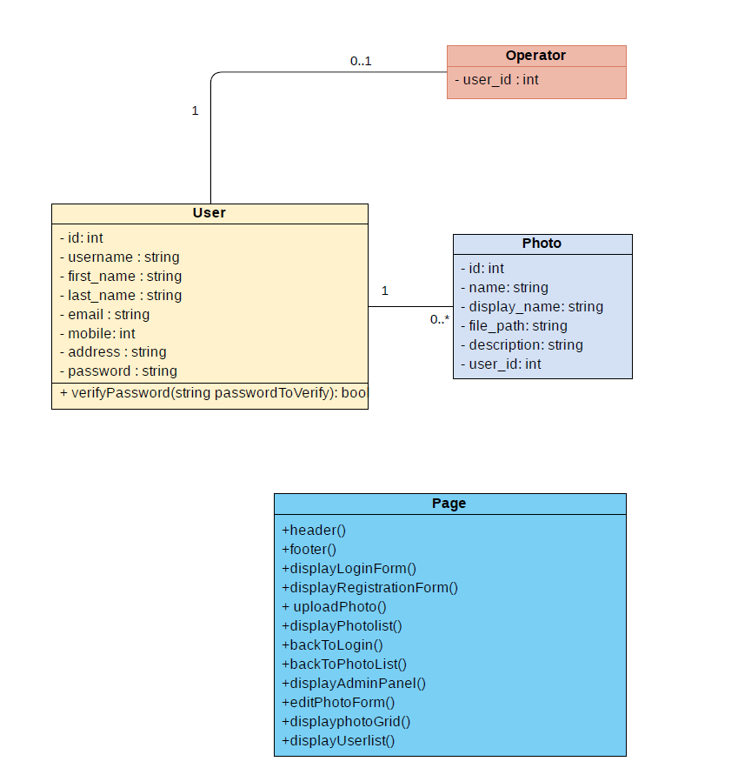

# Meeting Minutes:

Meeting minutes are recorded based on the time we start the meeting and is usually done every day when the meeting end one keeps track of the time spent for discussing what needs to be done? what was done before? how well are the members working ? and what all things will be done before next meeting.

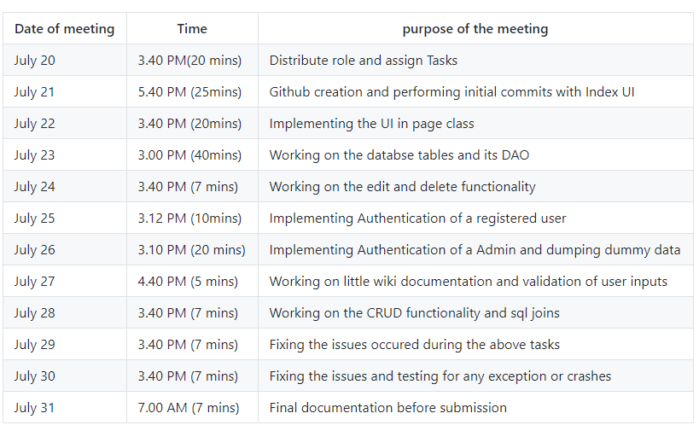

# Installation Manual (To be included)

1. Start the WAMP server and wait for it to turn **green**



**Make a folder name test in your c drive.**

1. Click on the wamp icon and go to **Apache->Alias directories->add alias**

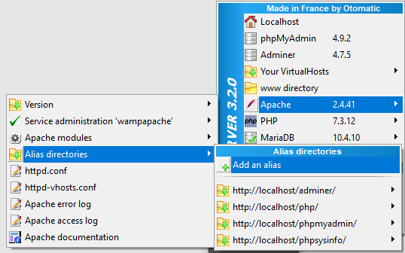

Write the name as test and give the patch of the test folder that your created above

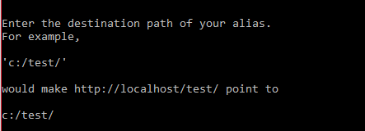

1. Download the project from the github <https://github.com/shahNikhil/photo_gallery_NSh11522_TZh96818.git>
2. Paste it in that test folder in your computer and go to wamp localhost

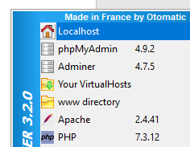

1. After that click on the alias you created in my case it is php instead of test

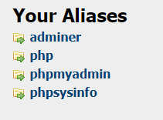

1. Click on your alias and open the project folder and don’t go to inc/sql/db.sql

After clicking it will download a sql file open it with any text editor like notepad.

Press ctrl + A and ctrl + C to copy the code

1. Now click on the wamp logo again and go the mysql->mysql command line

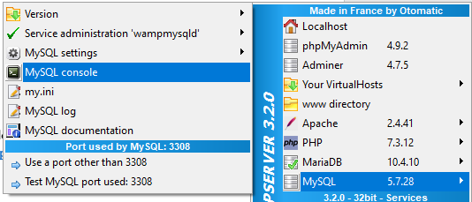

1. Now paste the copied sql and press enter Note you can also use source command

And specify the path/sqlfilename.sql to run it.

1. Now close the browser and visit localhost again go through step 5 and open the project folder and click on login.php if you see the below page you can either create a account or you can login with dummy username or the 2 admin account specified below and use **pass123** as the password

Username:

* nick, jzen (can be used to sign in as administrator or as normal users too)
* dummy, sunny, corona, CSIS (this are normal user only)

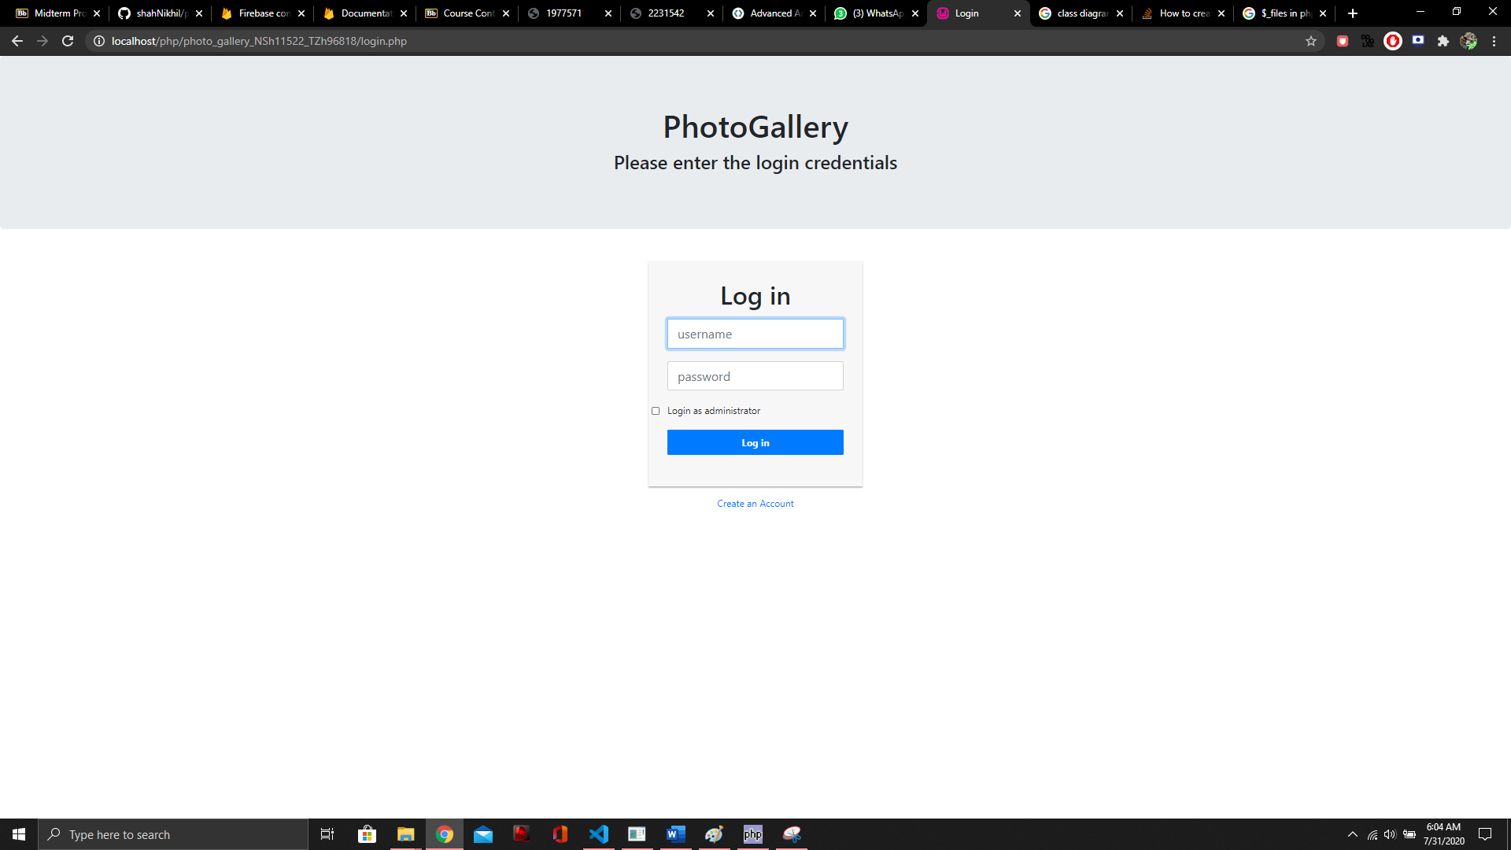

1. After logged in as normal user you have access to all the photos uploaded by you and

You can also upload new ones or delete or edit the present ones

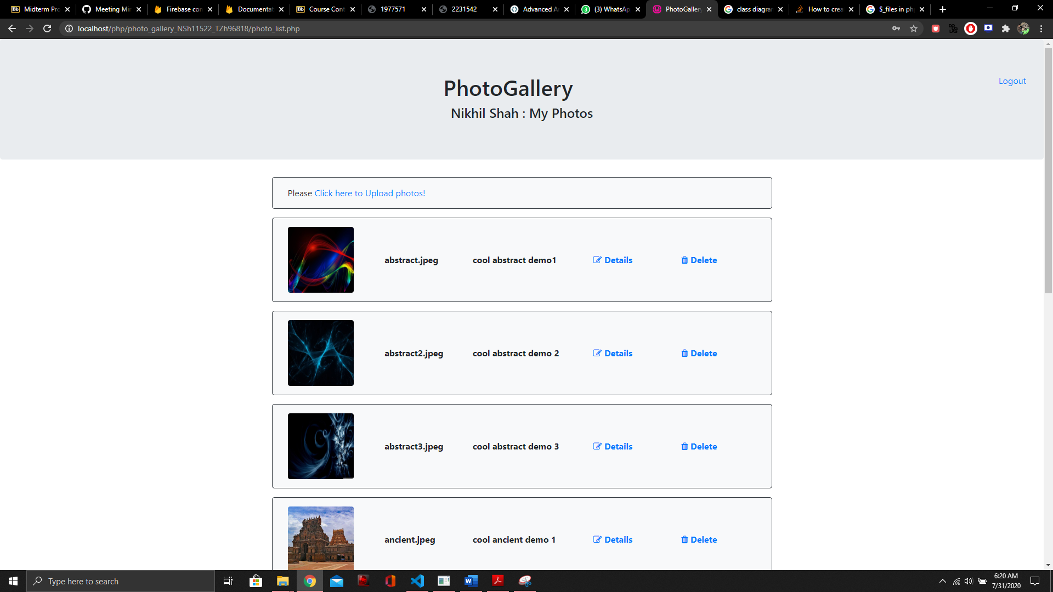

1. After performing CRUD here you can logout to close session and move to Admin Login

Here you can either view all users by pressing the button or you can search for a user by

Entering the begning characters of the user name and you can delete a entire user profile with his data just by pressing delete or you can also view all the user photos by pressing the view all photo button.

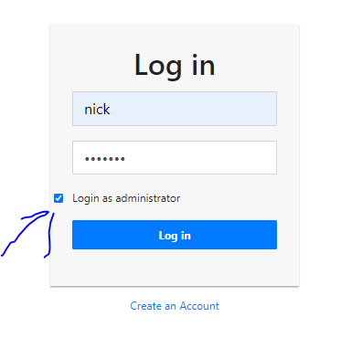

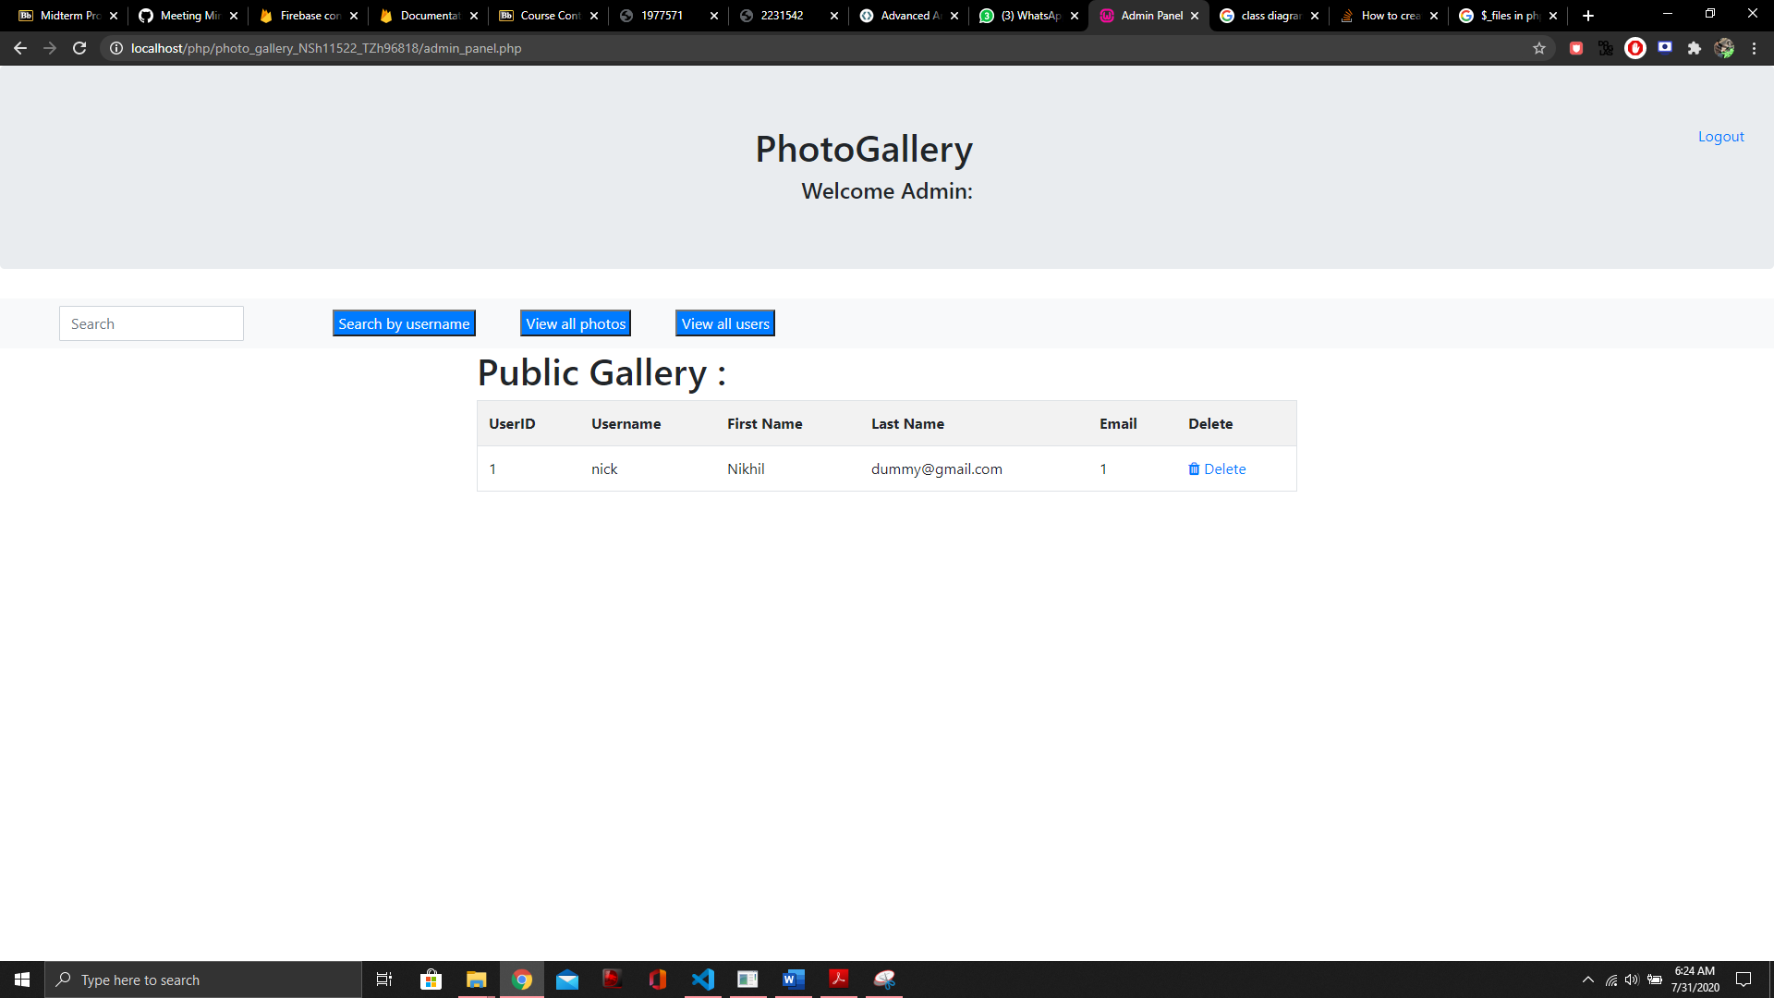

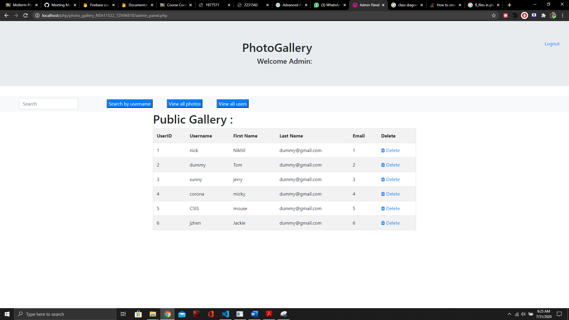

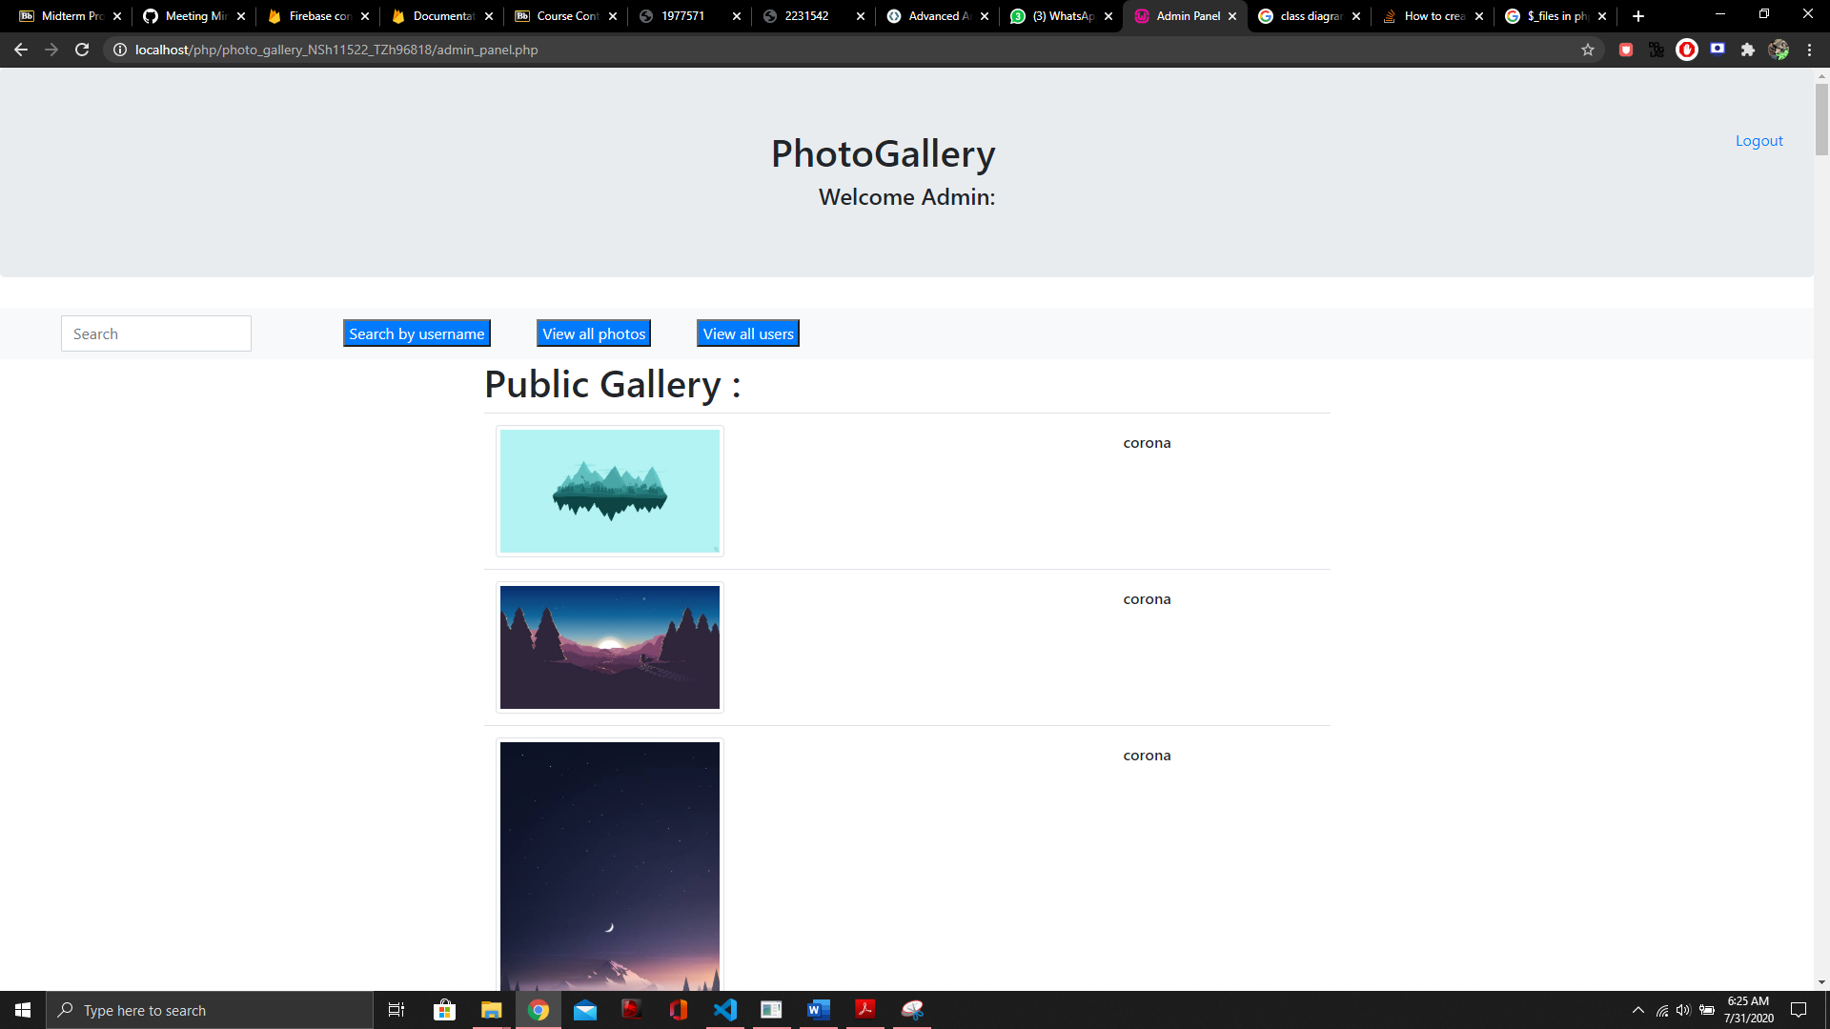

# Technical concepts

* PHP
* HTTP Request – POST/GET
* MySQL
* PDO
* DAO
* $_SESSION
* Image upload though $_Files

# Extended Technology used

* Bootstrap

# References:

**for getting idea about how to process image into local alias directory**

<https://www.tutorialrepublic.com/php-tutorial/php-file-upload.php>

**for using bootstrap and various css styles**

<https://www.w3schools.com/bootstrap4/>

**for PHP reference**

<https://www.php.net/manual/en/index.php>