Run 1:

K=10

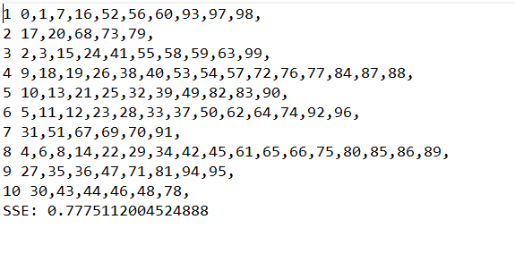

Run 2:

K=5

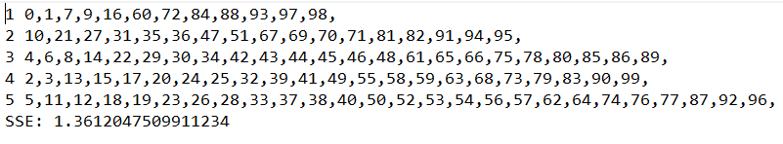

Run 3:

K=15

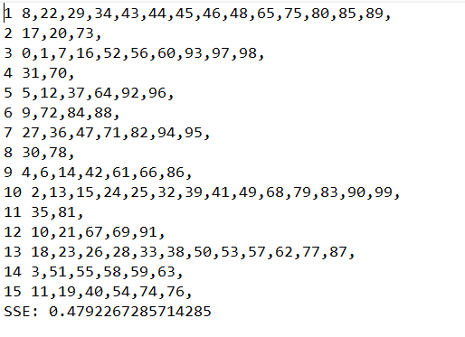

Run 4:

K=20

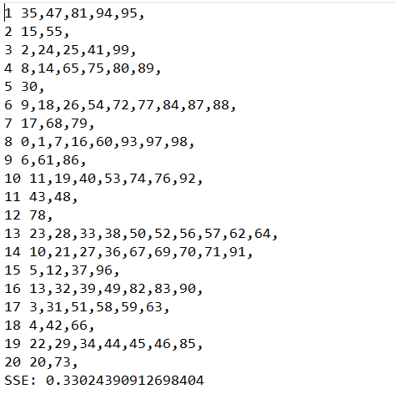

Run 5:

K=8

