C code for finding minimum:  
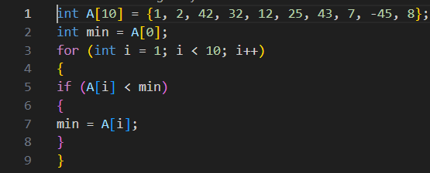

Assembly code of This function: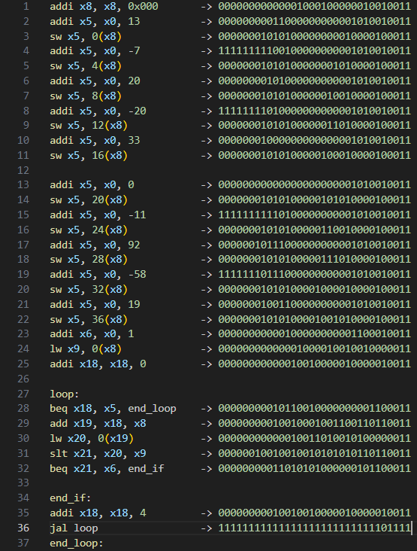

Datapath:

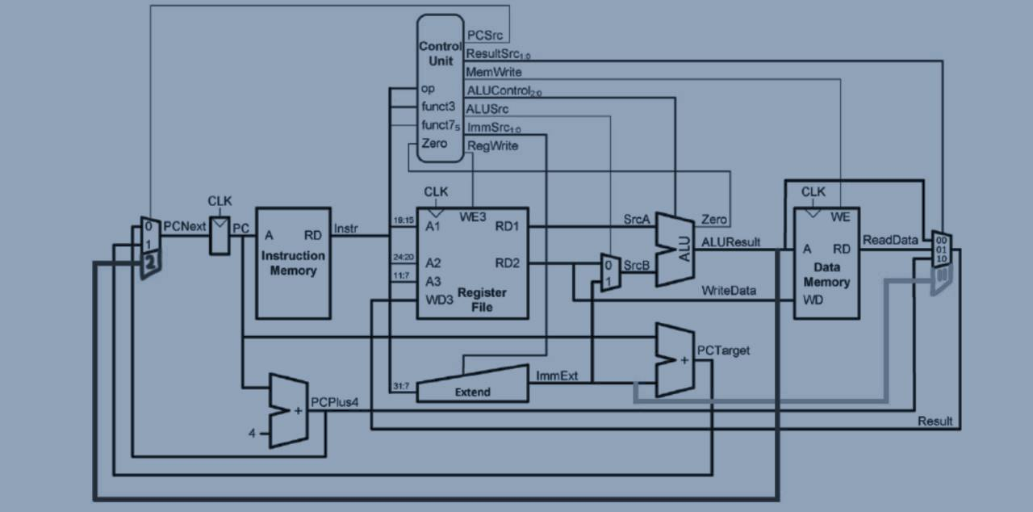

Controller:

|  |  |  |  |  |  |  |  |  |  |  |  |
| --- | --- | --- | --- | --- | --- | --- | --- | --- | --- | --- | --- |
| Type | Instruction | Pc src | Result src | Mem write | Alu cnt | Alu src | Imm src | Reg write | Alu op | Branch | Jump |
|  | Add | 00 | 00 | 0 | 000 | 0 | x | 1 | 0 | 0 | 00 |
|  | Sub | 00 | 00 | 0 | 001 | 0 | x | 1 | 10 | 0 | 00 |
| R-type | And | 00 | 00 | 0 | 010 | 0 | X | 1 | 10 | 0 | 00 |
|  | Or | 00 | 00 | 0 | 011 | 0 | X | 1 | 10 | 0 | 00 |
|  | Slt | 00 | 00 | 0 | 100 | 0 | X | 1 | 10 | 0 | 00 |
|  | Lw | 00 | 01 | 0 | 000 | 1 | 000 | 1 | 00 | 0 | 00 |
|  | Addi | 00 | 00 | 0 | 001 | 1 | 000 | 1 | 11 | 0 | 00 |
| I-type | Xori | 00 | 00 | 0 | 110 | 1 | 000 | 1 | 11 | 0 | 00 |
|  | Ori | 00 | 00 | 0 | 011 | 1 | 000 | 1 | 11 | 0 | 00 |
|  | Slti | 00 | 00 | 0 | 100 | 1 | 000 | 1 | 11 | 0 | 00 |
|  | Jalr | 10 | 11 | 0 | 000 | 1 | 000 | 1 | 00 | 0 | 01 |
| B-type | Beq | 01:00 | X | 0 | 001 | 0 | 011 | 0 | 01 | 1 | 00 |
|  | Bne | 00:01 | X | 0 | 001 | 0 | 011 | 0 | 01 | 1 | 00 |
| U-type | Lui | 00 | 01 | 0 | X | X | 100 | 1 | X | 0 | 00 |
| J-type | Jal | 00 | 01 | 0 | X | X | 100 | 1 | X | 0 | 10 |
| S-type | Sw | 00 | X | 1 | 000 | 1 | 001 | 0 | 00 | 0 | 00 |

Output:

