2025 Spring

Amir Naderi  
Shahaboddin Sheybani

[Document title]

[Document subtitle]

# Abstract

The Bergman model is a widely used nonlinear system that describes the dynamics of glucose-insulin interactions in the human body. Accurate control of this system is crucial for developing effective treatments for diabetes. The primary objective of this project is to linearize the nonlinear state equations of the Bergman model and design a controller in both time and frequency domain to regulate its output using MATLAB. This project focuses on the linearization and control of the Bergman model. The nonlinear state equations were linearized around an equilibrium point using Jacobian linearization, resulting in a state-space representation of the system. A state feedback controller was designed to regulate the system output, and its performance was evaluated through MATLAB simulations. The results demonstrate that the linearized model accurately approximates the nonlinear system, and the controller achieves stable regulation with minimal steady-state error. This work highlights the potential of linear control techniques for applications in biomedical systems, particularly in diabetes management.

# Introduction

Control systems are integral to managing dynamic processes across a wide range of applications, from industrial automation to biomedical engineering. In the context of biomedical systems, accurate modeling and control of physiological processes, such as glucose-insulin dynamics, are critical for developing effective treatment strategies for conditions like diabetes. The Bergman model, a well-known nonlinear system, has been widely used to describe glucose-insulin interactions. However, its nonlinear nature poses significant challenges for control design, necessitating the use of linearization techniques and advanced control strategies.

This project begins by exploring two additional models commonly used to describe glucose-insulin dynamics: the **Hovorka model** and the **Dalla Man Model**. These models are described in detail, and their state equations are derived to provide a comprehensive understanding of their structures and applications. By comparing these models with the Bergman model, we aim to highlight their similarities, differences, and suitability for control applications.

The primary focus of this project is then directed toward the **Bergman model**. The nonlinear state equations of the Bergman model are linearized around an equilibrium point using Jacobian linearization, resulting in a state-space representation suitable for control design. A state feedback controller is designed to regulate the system's output, and its performance is evaluated in both the **time domain** and **frequency domain** using MATLAB simulations. The time-domain analysis focuses on transient response, stability, and steady-state error, while the frequency-domain analysis examines characteristics such as bandwidth, gain margin, and phase margin.

The objectives of this project are threefold:

1. To describe and derive the equations of the Hovorka and Dalla Man models, providing a comparative analysis with the Bergman model.
2. To linearize the Bergman model and design a controller to regulate its output.
3. To analyze the controller's performance in both time and frequency domains, demonstrating its effectiveness in achieving stable and accurate control.

This report is structured as follows: Section 2 provides the theoretical background on the Bergman, Hovorka, and Minimal models, including their state equations and applications. Section 3 describes the methodology, including the linearization of the Bergman model and the design of the state feedback controller. Section 4 presents the results and discussion, focusing on the controller's performance in time and frequency domains. Finally, Section 5 concludes the report with key findings and suggestions for future work.

# **Heading**

**Bergman Model[1]**

The Bergman minimal model consists of a system of differential equations that describe the dynamics of glucose and insulin in the body. The model simplifies the glucose-insulin interaction into three main equations

• **Glucose Dynamics Equation**  
This equation models the rate of change in blood glucose concentration $G\left(t\right)$ over time:

$$\frac{dG\left(t\right)}{dt}=-p_{1}G\left(t\right)-X\left(t\right)G\left(t\right)+I_{g}$$ ( 1)

* $p_{1}$: The rate of glucose disappearance independent of insulin (basal glucose uptake).
* $X\left(t\right)$: Insulin action on glucose utilization.
* $I_{g}$ ​: Exogenous glucose infusion or intake.

• **Insulin Action Equation**  
This equation models the effect of insulin on glucose uptake by tissues:

$$\frac{dX\left(t\right)}{dt}=-p_{2}X\left(t\right)+p_{3}I\left(t\right)$$ ( 2)

* $p_{2}$ ​: The rate at which insulin action diminishes.
* $p_{3}$ ​: The sensitivity of glucose utilization to insulin.
* $I\left(t\right)$: Plasma insulin concentration.

• **Insulin Dynamics Equation** (optional in extended versions)  
This equation models the insulin secretion or infusion rate and its clearance from plasma. In cases of Type 1 diabetes, insulin is typically administered externally:

$$\frac{dI\left(t\right)}{dt}=-nI\left(t\right)+I_{inf}$$ ( 3)

* $n$: Insulin clearance rate.
* $I_{inf}$: Insulin infusion rate (e.g., via a pump or injection).

***Applications of the Bergman Model***

1. **Understanding Glucose Control:**
   * Helps in identifying how insulin impacts blood glucose regulation.
   * Analyzes insulin sensitivity and resistance in patients.
2. **Optimizing Insulin Therapy:**
   * Guides the design of insulin infusion protocols for Type 1 diabetes management.
   * Assists in the development of closed-loop systems like artificial pancreas devices.
3. **Simulation and Prediction:**
   * Simulates glucose-insulin dynamics under various conditions (e.g., fasting, meals, exercise).
   * Predicts blood glucose responses to insulin therapies.
4. **Clinical Research:**
   * Supports studies on beta-cell function and insulin resistance.
   * Provides a framework for evaluating new diabetes treatments.

***Limitations***

* **Simplifications:** The model assumes linear relationships and does not fully capture complexities like glucagon effects, stress, or meal composition.
* **Patient Variability:** Parameters such as $p_{1}$ ​, $p_{2}$ ​, and $p_{3}$ ​ differ among individuals, requiring customization.
* **Type 1 Diabetes Challenges:** Since Type 1 diabetes patients lack endogenous insulin production, the model often relies on external insulin infusion inputs.

Despite its limitations, the Bergman model remains a foundational tool in diabetes research and therapy optimization.

Apart from the **Bergman minimal model**, two other widely recognized alternatives for modeling glucose control in Type 1 diabetes patients are:

### ***1. Hovorka Model***

The Hovorka model is a more detailed physiological model compared to the Bergman model. It is particularly used for the development and optimization of closed-loop systems like artificial pancreas devices. It incorporates multiple compartments to simulate glucose-insulin dynamics more accurately.

### ***Hovorka Model Equations[2]***

The Hovorka model divides the glucose-insulin system into multiple compartments. It tracks glucose kinetics, insulin kinetics, and insulin action.

#### **Key Equations in the Hovorka Model**

1. **Glucose Dynamics**  
   The rate of change of blood glucose ($G$) is affected by:
   * Glucose intake from meals ($R_{a}$ ​).
   * Insulin-independent glucose utilization ($E_{GP}$ ​).
   * Insulin-dependent glucose utilization ($X$).
   * Endogenous glucose production ($G_{p}$ ​).

$$\frac{dG\left(t\right)}{dt}=-\left(E_{GP}+X\left(t\right)\right)G\left(t\right)+G_{p}\left(t\right)+R_{a}\left(t\right)$$

( 4)

* + ​: Insulin-independent glucose uptake rate.
  + $X\left(t\right)$: Insulin action on glucose uptake.
  + $G_{p}\left(t\right)$: Glucose production rate.
  + $R_{a}\left(t\right)$: Rate of glucose appearance from meals.

1. **Insulin Action on Glucose Uptake ($X\left(t\right)$)** Insulin action depends on the insulin concentration (III) in plasma:

$$\frac{dX\left(t\right)}{dt}=-p_{2}X\left(t\right)+p_{3}I\left(t\right)$$ ( 5)

* + ​: Rate of insulin action decay.
  + $p_{3}$: Insulin sensitivity.

1. **Insulin Kinetics** Insulin absorption and elimination are modeled as follows:

$$\frac{dI\left(t\right)}{dt}=-nI\left(t\right)+I_{inf}\left(t\right)$$

( 6)

* + : Insulin clearance rate.
  + $I_{inf}$: External insulin infusion rate.

1. **Rate of Glucose Appearance ($R_{a}$ ​)** The glucose appearance rate ($R_{a}$ ​) depends on meal intake and absorption:

$$R_{a}\left(t\right)=D\left(t\right)⋅k_{abs}$$

( 7) ​

* + : Meal glucose available for absorption.
  + $k_{abs}$ ​: Absorption rate constant.

#### **Key Features:**

1. **Multiple Compartments:**
   * The model separates glucose and insulin dynamics into different compartments:
     + **Glucose Subsystem:** Models glucose absorption, utilization, renal excretion, and endogenous production.
     + **Insulin Subsystem:** Models insulin kinetics, including subcutaneous absorption and action in different compartments.
   * Includes a compartment for glucose absorption from meals.
2. **Insulin Action:**
   * Distinguishes between three effects of insulin:
     + **Peripheral glucose uptake.**
     + **Suppression of endogenous glucose production.**
     + **Suppression of glucose renal excretion.**
3. **Physiological Inputs:**
   * Considers exogenous insulin (infusion or injection) and meal intake (carbohydrate absorption).

#### **Model Equations:**

The Hovorka model uses multiple differential equations for glucose and insulin kinetics:

* Glucose dynamics (rate of change in glucose concentration).
* Insulin kinetics (subcutaneous to plasma dynamics).
* Insulin action on glucose disposal and production.

#### **Applications:**

* Widely used in developing artificial pancreas systems.
* Suitable for clinical scenarios requiring detailed glucose-insulin modeling.
* Simulates postprandial (after meal) glucose and insulin responses.

#### **Limitations:**

* High complexity compared to simpler models like Bergman.
* Requires many physiological parameters, which might vary across patients.

### ***2. Dalla Man Model (Meal Model)[3]***

The Dalla Man model is another advanced physiological model explicitly designed to study glucose and insulin dynamics during meal ingestion. It is particularly useful for simulating postprandial glucose control and evaluating meal-related insulin dosing strategies.The Dalla Man model focuses on meal-related glucose dynamics and insulin kinetics. It introduces compartments for glucose absorption from the gut and insulin action.

#### **Key Equations in the Dalla Man Model**

1. **Glucose Absorption from the Gut** The gut glucose dynamics are modeled as two compartments:

$$\frac{dQ_{1}\left(t\right)}{dt}=-k_{21}Q_{1}\left(t\right)+D\left(t\right)$$

( 8)

$$\frac{dQ_{2}\left(t\right)}{dt}=k_{21}Q_{1}\left(t\right)-k_{abs}Q_{2}\left(t\right)$$

( 9)

* + : Glucose in the stomach.
  + $Q_{2}\left(t\right)$: Glucose in the intestine.
  + $k_{21}$ ​: Gastric emptying rate.
  + $k_{abs}$: Intestinal absorption rate.

1. **Rate of Glucose Appearance ($R_{a}$ ​)** After absorption, glucose appears in plasma:

$$R_{a}\left(t\right)=fQ_{2}\left(t\right)k_{abs}$$

( 10)

* + : Fraction of glucose that reaches plasma.

1. **Plasma Glucose Dynamics** The change in plasma glucose concentration ($G_{p}$ ​) is:

$$\frac{dG_{p}\left(t\right)}{dt}=R_{a}\left(t\right)-E\left(t\right)-G_{u}\left(t\right)$$

( 11)

* + : Rate of glucose appearance.
  + $E\left(t\right)$: Renal excretion rate.
  + $G_{u}\left(t\right)$: Glucose utilization rate.

1. **Insulin Kinetics** Insulin is tracked across subcutaneous and plasma compartments:

$$\frac{dI_{s}\left(t\right)}{dt}=-k_{e}I_{s}\left(t\right)+I_{inf}\left(t\right)$$

( 12)

$$\frac{dI_{p}\left(t\right)}{dt}=-nI_{p}\left(t\right)+k_{e}I_{s}\left(t\right)$$

( 13)

* + : Insulin in the subcutaneous compartment.
  + $I_{p}\left(t\right)$: Insulin in the plasma compartment.
  + $k_{e}$ ​: Subcutaneous to plasma transfer rate.
  + $n$: Insulin clearance rate.

1. **Insulin Action** Similar to the Hovorka model, insulin action is divided into:
   * Glucose uptake by tissues.
   * Suppression of glucose production.
   * Suppression of renal glucose excretion.

#### **Key Features:**

1. **Meal Simulation:**
   * Simulates glucose absorption from meals in detail, considering digestion, absorption rate, and carbohydrate type.
   * Includes a compartmental representation of the gastrointestinal system.
2. **Insulin Subsystem:**
   * Models subcutaneous insulin absorption and its action on glucose metabolism.
   * Divides insulin action into three pathways (similar to the Hovorka model):
     + Glucose uptake.
     + Suppression of endogenous glucose production.
     + Suppression of lipolysis (fat breakdown).
3. **Integration of Physiological Processes:**
   * Accounts for insulin-dependent and independent glucose uptake.
   * Includes hepatic glucose production and peripheral glucose utilization.

#### **Model Equations:**

The model uses detailed equations for:

* Carbohydrate absorption (with gastric emptying effects).
* Glucose and insulin dynamics in blood and interstitial fluid.
* Insulin action on glucose uptake and production.

#### **Applications:**

* Simulates meal-related glucose and insulin responses.
* Evaluates insulin dosing strategies for Type 1 diabetes patients.
* Supports the design of insulin pumps and artificial pancreas systems.

#### **Limitations:**

* Requires detailed input data, such as meal composition and timing.
* Computationally intensive compared to simpler models.

Table 1 Comparison of the Models

|  |  |  |  |
| --- | --- | --- | --- |
| Feature | Bergman Minimal Model | Hovorka Model | Dalla Man Model |
| Complexity | Low | High | Medium |
| Meal Handling | Not included (simplistic) | Detailed | Detailed |
| Insulin Absorption | Limited | Detailed | Detailed |
| Applications | Basic research, simple analysis | Artificial pancreas, advanced analysis | Postprandial control, dosing |
| Customizability | Limited | High | Medium |

# HEADING

Bergman equation is shown below :

$$\left\{\begin{aligned}\dot{G}=-P_{1}G-X\left(G+G_{b}\right)+D\left(t\right) \\ \dot{X}=-P_{2}X+P_{3}I \\ \dot{I}=-n\left(I+I_{b}\right)+\frac{U\left(t\right)}{V} \end{aligned} , \left\{y=G \right. →\left(\begin{aligned}\dot{G} \\ \dot{\begin{aligned}X \\ \dot{I}\end{aligned}}\end{aligned}\right)\right.=\left(\begin{aligned}f_{1}\left(G,X,I,U,D\right) \\ f_{2}\left(G,X,I,U,D\right) \\ f_{3}(G,X,I,U,D)\end{aligned}\right)$$

( 14)

And then solve the equations for equilibrium $(\dot{G=}\dot{X}=\dot{I}=0)$

$\left(\begin{aligned}0 \\ 0 \\ 0\end{aligned}\right)=\left(\begin{aligned}f_{1}\left(G,X,I,U,D\right) \\ f_{2}\left(G,X,I,U,D\right) \\ f_{3}(G,X,I,U,D)\end{aligned}\right)→ \left\{\begin{aligned}-X_{eq}\left(G_{eq}+G_{b}\right)=0 \\ P_{2}X_{eq}=P_{3}I_{eq} \\ -nI_{eq}+\frac{U_{eq}}{V}=0\end{aligned}\right\}→\left\{\begin{aligned}X_{eq}=I_{eq}=0,G_{eq}=G_{0} \\ G_{eq}=-G_{b} ,X_{eq}=X_{0},I_{eq}=\frac{P_{2}}{P_{3}}X_{0}\end{aligned}\right.$

To calculate the equilibrium points, we assume the input and disturbance to be zero. Additionally, we assume the value of $G_{eq}$ to be zero. This is because, according to the system, all three state variables are defined relative to a reference value, and our goal aligns with this assumption.

$\left\{\begin{aligned}G-G_{eq}=Z_{1} \\ X-X_{eq}=Z_{2} \\ I-I_{eq}=Z_{3}\end{aligned}\right. \underset{→}{linearization} \left\{\begin{aligned}{\dot{Z}}_{1}=\frac{∂f_{1}}{∂Z_{1}}Z_{1}+\frac{∂f_{1}}{∂Z_{2}}Z_{2}\text{+ }\frac{∂f_{1}}{∂Z_{3}}Z_{3}\text{+ }\frac{∂f_{1}}{∂U_{1}}U_{1}\text{+ }\frac{∂f_{1}}{∂U_{2}}U_{2} \\ {\dot{Z}}_{2}=\frac{∂f_{2}}{∂Z_{1}}Z_{1}+\frac{∂f_{2}}{∂Z_{2}}Z_{2}\text{+ }\frac{∂f_{2}}{∂Z_{3}}Z_{3}\text{+ }\frac{∂f_{2}}{∂U_{1}}U_{1}\text{+ }\frac{∂f_{2}}{∂U_{2}}U_{2} \\ {\dot{Z}}_{3}=\frac{∂f_{3}}{∂Z_{1}}Z_{1}+\frac{∂f_{3}}{∂Z_{2}}Z_{2}\text{+ }\frac{∂f_{3}}{∂Z_{3}}Z_{3}\text{+ }\frac{∂f_{3}}{∂U_{1}}U_{1}\text{+ }\frac{∂f_{3}}{∂U_{2}}U_{2} \end{aligned}\right\}$

Thus the linearized equation will be :

$$→\underline{\dot{Z}}=\left(\begin{matrix}-P_{1}-X_{eq} & -G_{eq}-G_{b} & 0 \\ 0 & -P_{2} & P_{3} \\ 0 & 0 & -n\end{matrix}\right)\underline{Z}+\left(\begin{matrix}1 & 0 \\ \begin{aligned}0 \\ 1\end{aligned} & \begin{aligned}0 \\ V^{-1}\end{aligned}\end{matrix}\right)\underline{U} , \underline{Y}=\left(1 0 0\right)\underline{Z} +\underline{0}×\underline{U}$$

( 15)

It’s time to calculate open loop transform function for input and disturbance:

$$G\left(s\right)=C{\left(sI_{n}-A\right)}^{-1}B=\left(1 0 0\right){\left[\left(\begin{matrix}s & 0 & 0 \\ 0 & s & 0 \\ 0 & 0 & s\end{matrix}\right)-\left(\begin{matrix}-P_{1}-X_{eq} & -G_{eq}-G_{b} & 0 \\ 0 & -P_{2} & P_{3} \\ 0 & 0 & -n\end{matrix}\right)\right]}^{-1}\left(\begin{matrix}1 & 0 \\ \begin{aligned}0 \\ 1\end{aligned} & \begin{aligned}0 \\ V^{-1}\end{aligned}\end{matrix}\right)$$

$$\underset{→}{sub}G\left(s\right)=\left(-\frac{4.875×{10}^{-6}}{s^{3}+{0.117333s}^{2}+0.00230833s} \frac{1}{s}\right)$$

( 16)

The numerator and denominator coefficients were extracted from Equation (16) and used to create the transfer function model. The MATLAB code is as follows:

Code 1

syms s;

[num_U, den_U] = ss2tf(A, B, C, D, 2);

[num_D, den_D] = ss2tf(A, B, C, D, 1);

G_open_loop_U = minreal(tf(num_U, den_U));

G_open_loop_D = minreal(tf(num_D, den_D));

numerator_U = poly2sym(num_U, s);

denominator_U = poly2sym(den_U, s);

[num_D_simplified, den_D_simplified] = tfdata( G_open_loop_D, 'v');

The root locus plot was used to analyze the stability of the system for different values of $K$ .The   
root locus shows the trajectories of the closed-loop poles as $K$ varies from 0 to infinity. The system is stable when all poles lie in the left half of the complex plane. For plotting root locus we use rlocus command. Here is root locus of open-loop transform function:

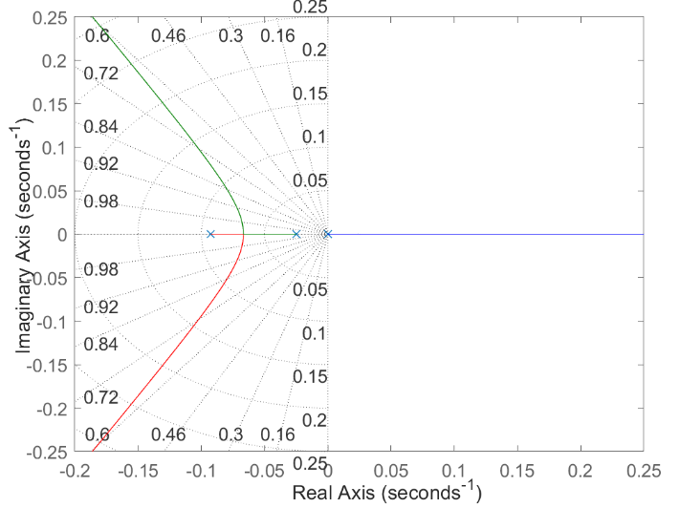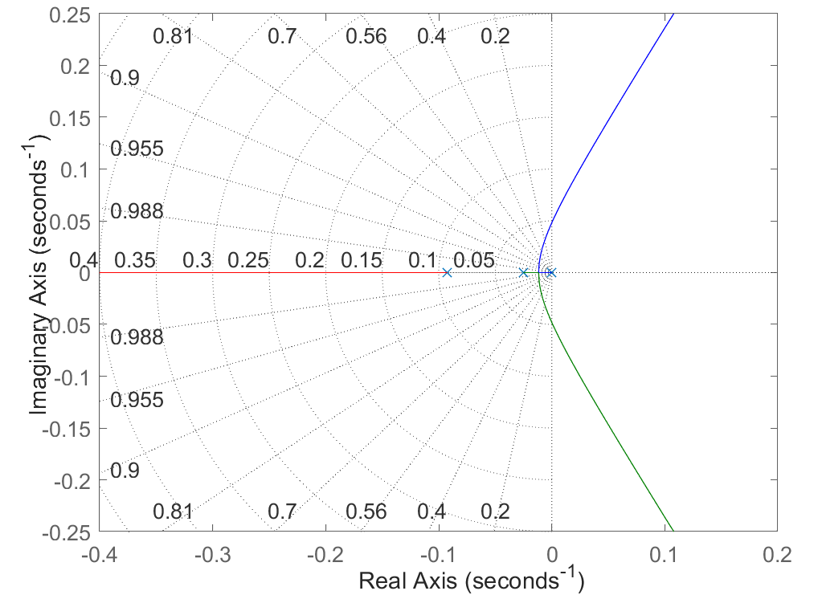

Figure 2 root locus for k>0

Figure 1 root locus for k<0

Since for positive values of $k$ it is always unstable we know that $k$ must be negative and for finding intervals we use MATLAB as it shown below :

Code 2

delta_closed_loop = @(K) den_U + K * [zeros(1, length(num_U) - length(den_U)), num_U];

K_values = linspace(-1000, 1000, 1000000);

for K = K_values

poles = roots(delta_closed_loop(K));

if any(abs(real(poles)) < 1e-5)

critical_gain = K;

break;

end

end

Thus, we find that for $-55.62<k<0$ system is stable.