**Project**

**Hotels booking**

This table has 119391 rows.

It has these columns:

Is canceled, Lead time, Arrival date, Aday, stays in weekend night, Adult, Children, Babies, Meal, Country, Market segment, distribution channel, is repeated guest, previous cancelation, previous booking, reserved room type, assigned room type, booking changes, deposit type, agent, company, days in waiting list, customer type, required car parking spaces, total special request, reservation status, reservation status date

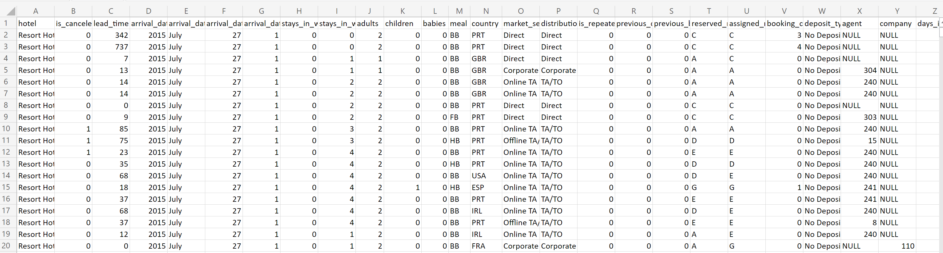

What is number of hotel reservation for last 5 months of year 2017?