Type 3 - Simulation (Performance) Study
Shahab Afshar (CprE 558)
CPR E 458/558 Real-Time Systems, Fall 2024
Department of Electrical and Computer Engineering
Iowa State University

Abstract
This project implements and evaluates server-based scheduling algorithms for mixed periodic-aperiodic real-time workloads. A comprehensive discrete-event simulator was developed in Python/Streamlit, implementing four server-based algorithms (Polling Server, Deferrable Server, Sporadic Server, and Background Scheduler) along with foundational scheduling algorithms (RMS, EDF, DMS, LLF). The simulator provides interactive Gantt chart visualizations, schedulability analysis, and performance metrics including CPU utilization, context switches, deadline misses, and aperiodic response times. Evaluation using deterministic benchmark scenarios demonstrates correct implementation of server capacity management policies: Polling Server loses unused capacity, Deferrable Server preserves capacity within periods, and Sporadic Server provides dynamic replenishment for optimal aperiodic response times. The simulator serves as both an educational tool for understanding real-time scheduling concepts and a platform for comparative algorithm analysis.

1. Introduction
Real-time systems must satisfy timing constraints in addition to functional correctness. When designing mixed periodic-aperiodic workloads, engineers face a critical decision: selecting the appropriate server-based scheduling algorithm and configuring its parameters (capacity Cₛ and period Pₛ). While theoretical schedulability analysis provides utilization bounds, it does not reveal the temporal behavior of schedules—when tasks actually execute, how server capacity is consumed and replenished, and how aperiodic response times vary with different configurations.
The Gap: Manual schedule construction is tedious and error-prone. Testing algorithms on actual RTOS hardware requires significant development effort and may not be feasible during early design phases. Engineers need a way to explore algorithm behavior before committing to implementation decisions.
Practical Use Cases for Simulation:
- Pre-implementation design decisions: Test different Cₛ/Pₛ combinations to find configurations that meet aperiodic response time requirements without compromising periodic schedulability
- What-if analysis: Explore the impact of adding new tasks, changing computation times, or modifying deadlines before deploying changes to production systems
- Algorithm selection justification: Generate Gantt chart visualizations and performance metrics to support design documentation and stakeholder reviews
- Workload characterization: Identify utilization bottlenecks and determine the maximum aperiodic load the system can handle while maintaining deadline guarantees
This project addresses these needs by implementing a discrete-event simulator for four server-based scheduling algorithms from the real-time systems literature:
- Polling Server [2] - Checks for aperiodic tasks periodically; unused capacity is lost
- Deferrable Server [2] - Preserves unused capacity within the same period
- Sporadic Server [1] - Dynamic replenishment provides best aperiodic response time
- Background Scheduler - Baseline that serves aperiodic tasks only during CPU idle time
The simulator provides interactive visualization, allowing users to observe capacity management behavior directly and compare algorithm performance under identical conditions.

2. Project Objectives & Scope

2.1. System Model
The system model considers a uniprocessor real-time system with:
- Periodic tasks: Tasks τᵢ with parameters (Cᵢ, Pᵢ, Dᵢ) representing computation time, period, and deadline
- Aperiodic tasks: Tasks with parameters (rᵢ, Cᵢ, dᵢ) representing arrival time, computation time, and deadline
- Server: A virtual periodic task with capacity Cₛ and period Pₛ that services aperiodic requests
This model appears in embedded systems, RTOS environments, and any application requiring deterministic timing guarantees while handling event-driven workloads.
Figure 1: System Model
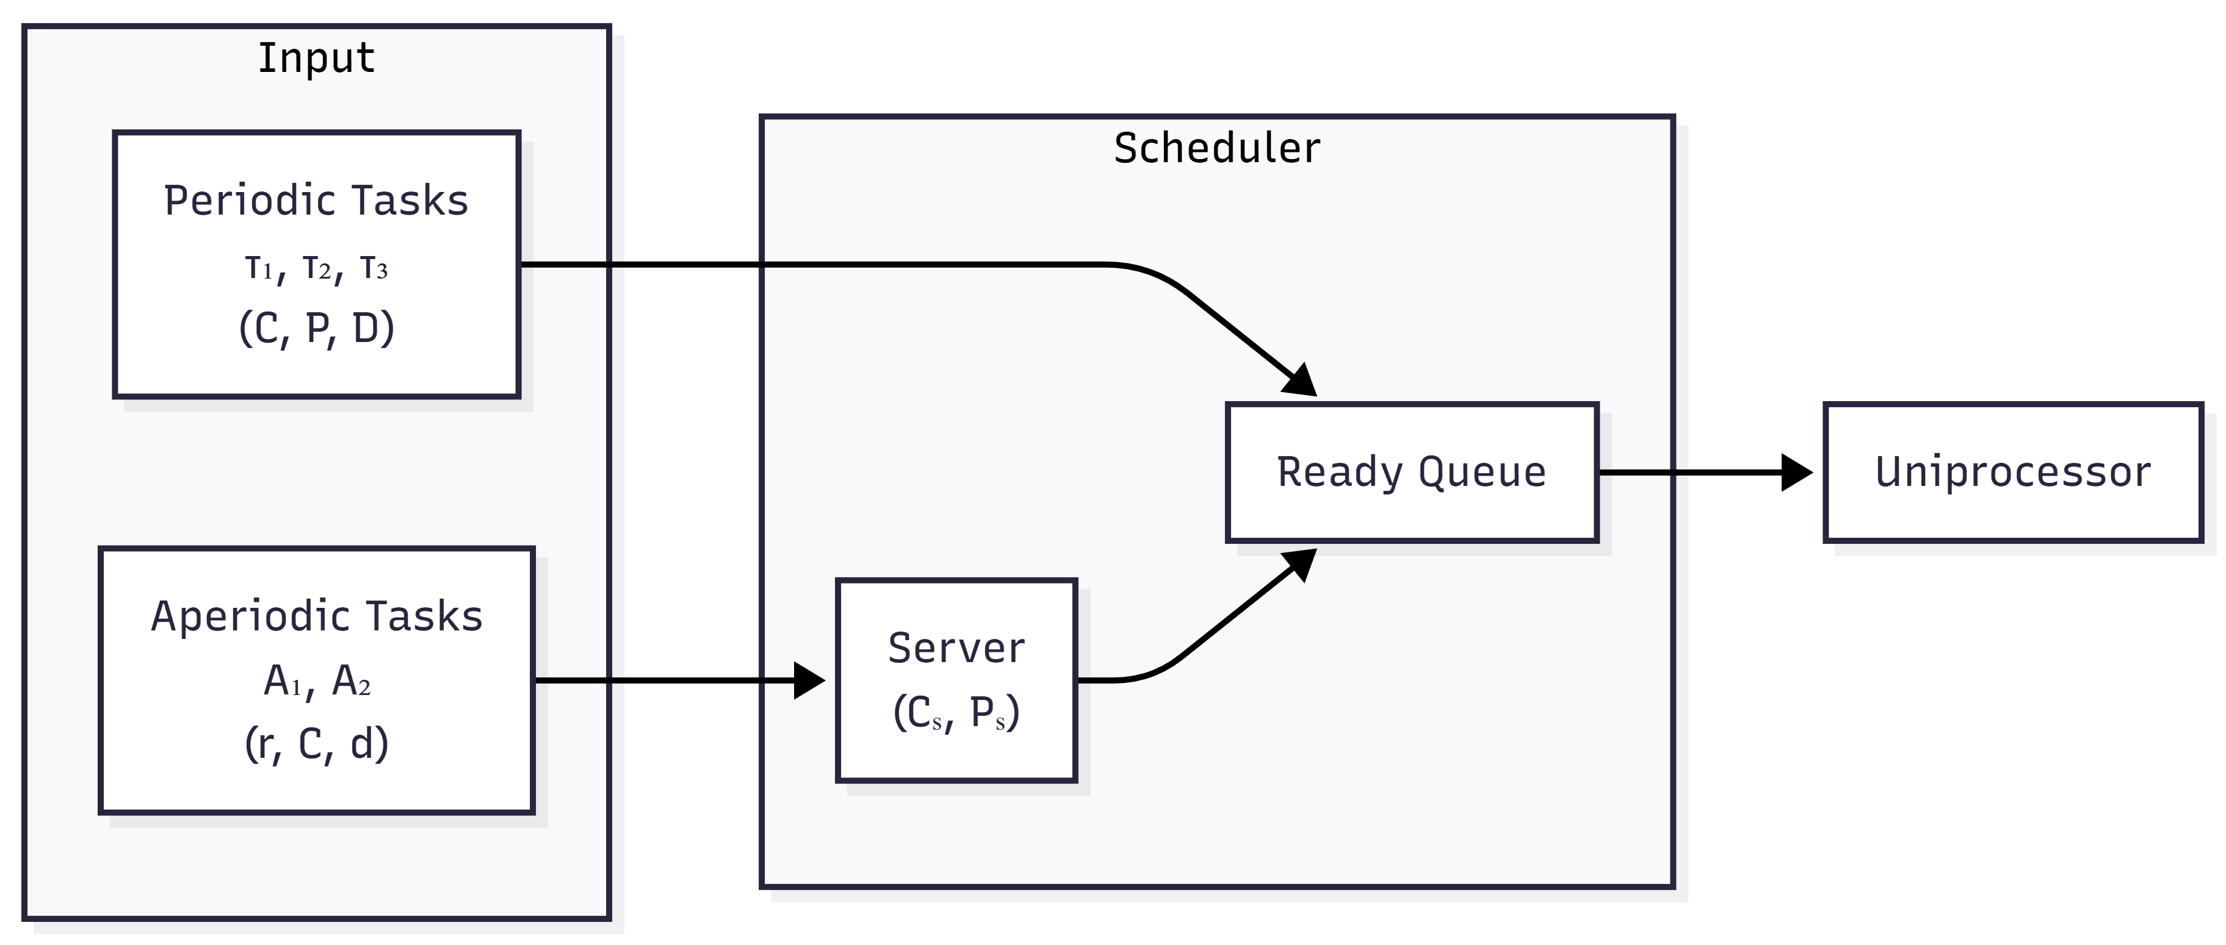
System Model

2.2. Problem Statement
Engineers designing mixed periodic-aperiodic systems must choose between server algorithms and configure parameters, but theoretical formulas alone do not show temporal behavior, and testing on actual RTOS requires significant development effort.
The core problem is: How do different server capacity management policies affect aperiodic task response times while maintaining periodic task schedulability?
Research Questions:
- RQ1: Can a discrete-event simulator faithfully implement server capacity management policies as described in the literature?
- RQ2: Does interactive visualization help users understand the differences between server algorithms?
- RQ3: Can parameter exploration (varying Cₛ/Pₛ) reveal optimal configurations for specific workloads?

2.3. Objectives and Scope
Primary Objectives: 1. Implement four server-based scheduling algorithms with correct capacity management 2. Develop an interactive visualization tool for schedule analysis 3. Compare algorithm behavior through deterministic test scenarios 4. Provide educational demonstrations of server scheduling concepts
Scope: - Uniprocessor scheduling (no multiprocessor considerations) - Discrete-time simulation with unit time steps - Focus on server algorithms under RMS priority assignment - Interactive web-based UI for exploration and analysis

3. Solution Methodology / Approach
Our approach is to build a discrete-event simulator that implements server-based algorithms exactly as described in the seminal literature [1-3], allowing rapid comparison of algorithm behavior under identical workload conditions. The simulator provides interactive Gantt chart visualization so users can directly observe capacity management behavior—when capacity is consumed, when it is replenished, and how these dynamics affect aperiodic response times.

3.1. Algorithms / Protocols / Architectures

3.1.1. Rate Monotonic Scheduling (RMS)
The foundation for server-based scheduling, as proven by Liu and Layland [4]. Tasks are assigned static priorities based on period: shorter period = higher priority. The utilization bound for n tasks is:
$$U=\sum_{i=1}^{n}{\frac{C_{i}}{P_{i}}}≤n(2^{1/n}−1)$$

3.1.2. Polling Server
Introduced by Lehoczky et al. [2], the Polling Server provides a simple mechanism for aperiodic task handling.
Mechanism: The server is a periodic task with capacity Cₛ and period Pₛ. At each server invocation: - If aperiodic tasks are waiting: serve them using available capacity - If no aperiodic tasks: capacity is lost
Characteristics: - Simple implementation - Non-bandwidth-preserving - Worst aperiodic response time among server algorithms - Maintains RMS schedulability analysis
Implementation: (scheduler/core/algorithms/combined.py, class PollingServerScheduler)
def _execute_server_slot(self, t: int) -> bool:
if self.aperiodic_queue and self.server_remaining > 0:
# Service aperiodic task
apt = self.aperiodic_queue[0]
work_done = min(1.0, self.server_remaining, self.aperiodic_remaining[apt.id])
self.server_remaining -= work_done
self.aperiodic_remaining[apt.id] -= work_done
return True
else:
# NO APERIODIC TASKS → CAPACITY LOST
self.server_remaining = 0
return False

3.1.3. Deferrable Server
Also introduced by Lehoczky et al. [2], the Deferrable Server improves upon Polling by preserving unused capacity.
Mechanism: Unlike Polling, the server preserves its capacity when no aperiodic tasks are available. Capacity can be used at any time during the period.
Characteristics: - Bandwidth-preserving - Better aperiodic response time than Polling - Capacity replenished at period boundaries - May interfere with lower-priority periodic tasks
Key difference from Polling:
def _execute_server_slot(self, t: int) -> bool:
if self.aperiodic_queue and self.server_remaining > 0:
# Service aperiodic task (same as Polling)
# ...
return True
else:
# CAPACITY PRESERVED (Deferrable behavior)
# Server defers - does NOT run, keeps capacity for later
return False # Let periodic tasks run

3.1.4. Sporadic Server
Proposed by Sprunt, Sha, and Lehoczky [1], the Sporadic Server provides optimal aperiodic responsiveness while maintaining RMS schedulability guarantees.
Mechanism: Capacity consumed at time t is replenished at time t + Pₛ. This dynamic replenishment provides the best aperiodic response times.
Characteristics: - Bandwidth-preserving - Best response time among server algorithms - Maintains RMS utilization bound - Most complex implementation (requires replenishment queue)
Replenishment Logic:
def _consume_capacity(self, amount: float, t: int) -> None:
self.server_remaining -= amount
# Schedule replenishment at t + Ps
replenish_time = t + self.server_period
self.replenishment_queue.append((replenish_time, amount))

3.1.5. Background Scheduler
Mechanism: Aperiodic tasks execute only when the CPU is idle (no periodic tasks ready). This represents the worst-case baseline for aperiodic service.
Characteristics: - Simplest implementation - No interference with periodic tasks - Worst aperiodic response times - Useful as a baseline for comparison

3.1.6. Server Algorithm Comparison Summary
The key difference between server algorithms is how they handle unused capacity:
Algorithm | When No Aperiodic Tasks | Capacity Behavior
Polling | Capacity lost | Non-preserving
Deferrable | Capacity kept until period end | Preserving
Sporadic | Capacity kept, replenish at t+Pₛ | Preserving + Dynamic
Background | N/A (no server concept) | Runs during idle only
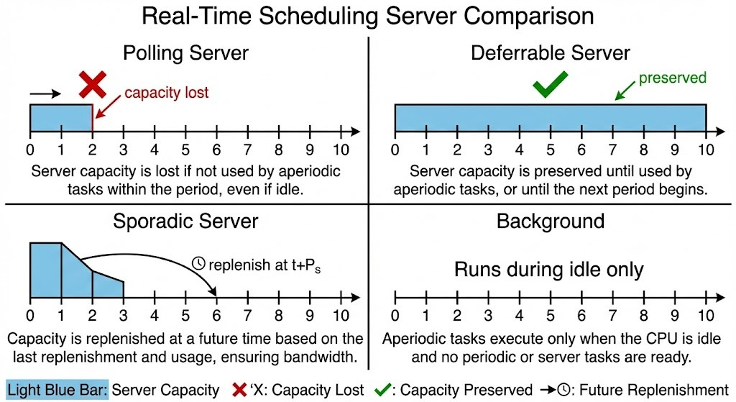
Server Algorithm Comparison
Figure 2: Visual comparison of server capacity management strategies

3.2. Illustrative Example
Consider the following workload:
Periodic Tasks: - P1: C=1, P=10, D=10 (10% utilization) - P2: C=1, P=15, D=15 (6.7% utilization)
Aperiodic Tasks: - A1: arrives at t=0, C=8, deadline=50
Server: Cₛ=2, Pₛ=5
Expected Behavior:
Server Type | A1 Completion Time | Explanation
Polling (Cₛ=2) | ~t=17 | Needs 4 replenishments, capacity lost when A1 not ready
Polling (Cₛ=4) | ~t=9 | Needs 2 replenishments
Polling (Cₛ=8) | ~t=8 | Single replenishment sufficient
Deferrable | Faster than Polling | Capacity preserved for immediate use
Sporadic | Fastest | Dynamic replenishment optimizes response
Background | Slowest | Must wait for CPU idle time
This demonstrates how server capacity directly impacts aperiodic task completion time.

4. Implementation/Simulation Architecture

4.1. Software Architecture
The simulator follows a layered architecture with clear separation of concerns:
Figure 3: Layered Architecture
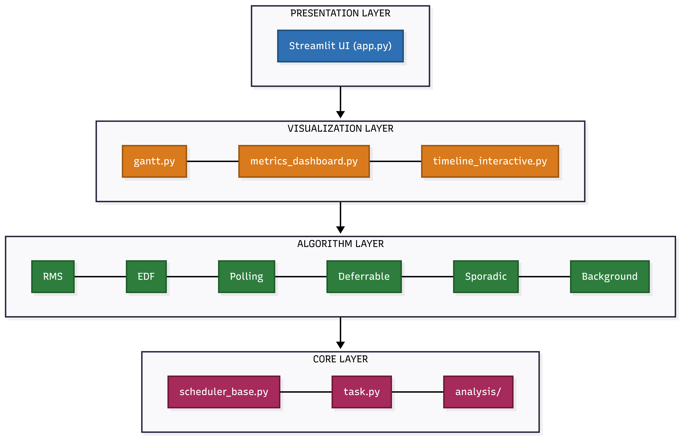
Layered Architecture
Directory Structure:
scheduler/
├── core/
│ ├── task.py # Task data models
│ ├── scheduler_base.py # Abstract base class
│ ├── algorithms/ # RMS, EDF, Polling, Deferrable, Sporadic, Background
│ └── analysis/ # Schedulability tests
├── visualization/ # Gantt charts, metrics dashboard
├── configs.py # 21 preset configurations
└── app.py # Streamlit web UI

4.2. Design Pattern: Template Method
The core design uses the Template Method pattern. SchedulerBase implements the complete simulation loop, while concrete schedulers only implement:
class SchedulerBase(ABC):
@abstractmethod
def assign_priorities(self) -> None:
"""How to assign priorities to tasks"""
@abstractmethod
def get_next_task(self, ready_queue) -> Optional[TaskInstance]:
"""Which task to run next from ready queue"""
def simulate(self) -> ScheduleResult:
"""Complete simulation loop (implemented in base)"""
Server schedulers extend this with custom simulate() that handles capacity management:
class ServerScheduler(SchedulerBase):
@abstractmethod
def _handle_replenishment(self, t: int) -> None:
"""Server-specific replenishment policy"""
@abstractmethod
def _execute_server_slot(self, t: int) -> bool:
"""Server-specific capacity usage policy"""
Figure 4: Class Hierarchy (Template Method Pattern)
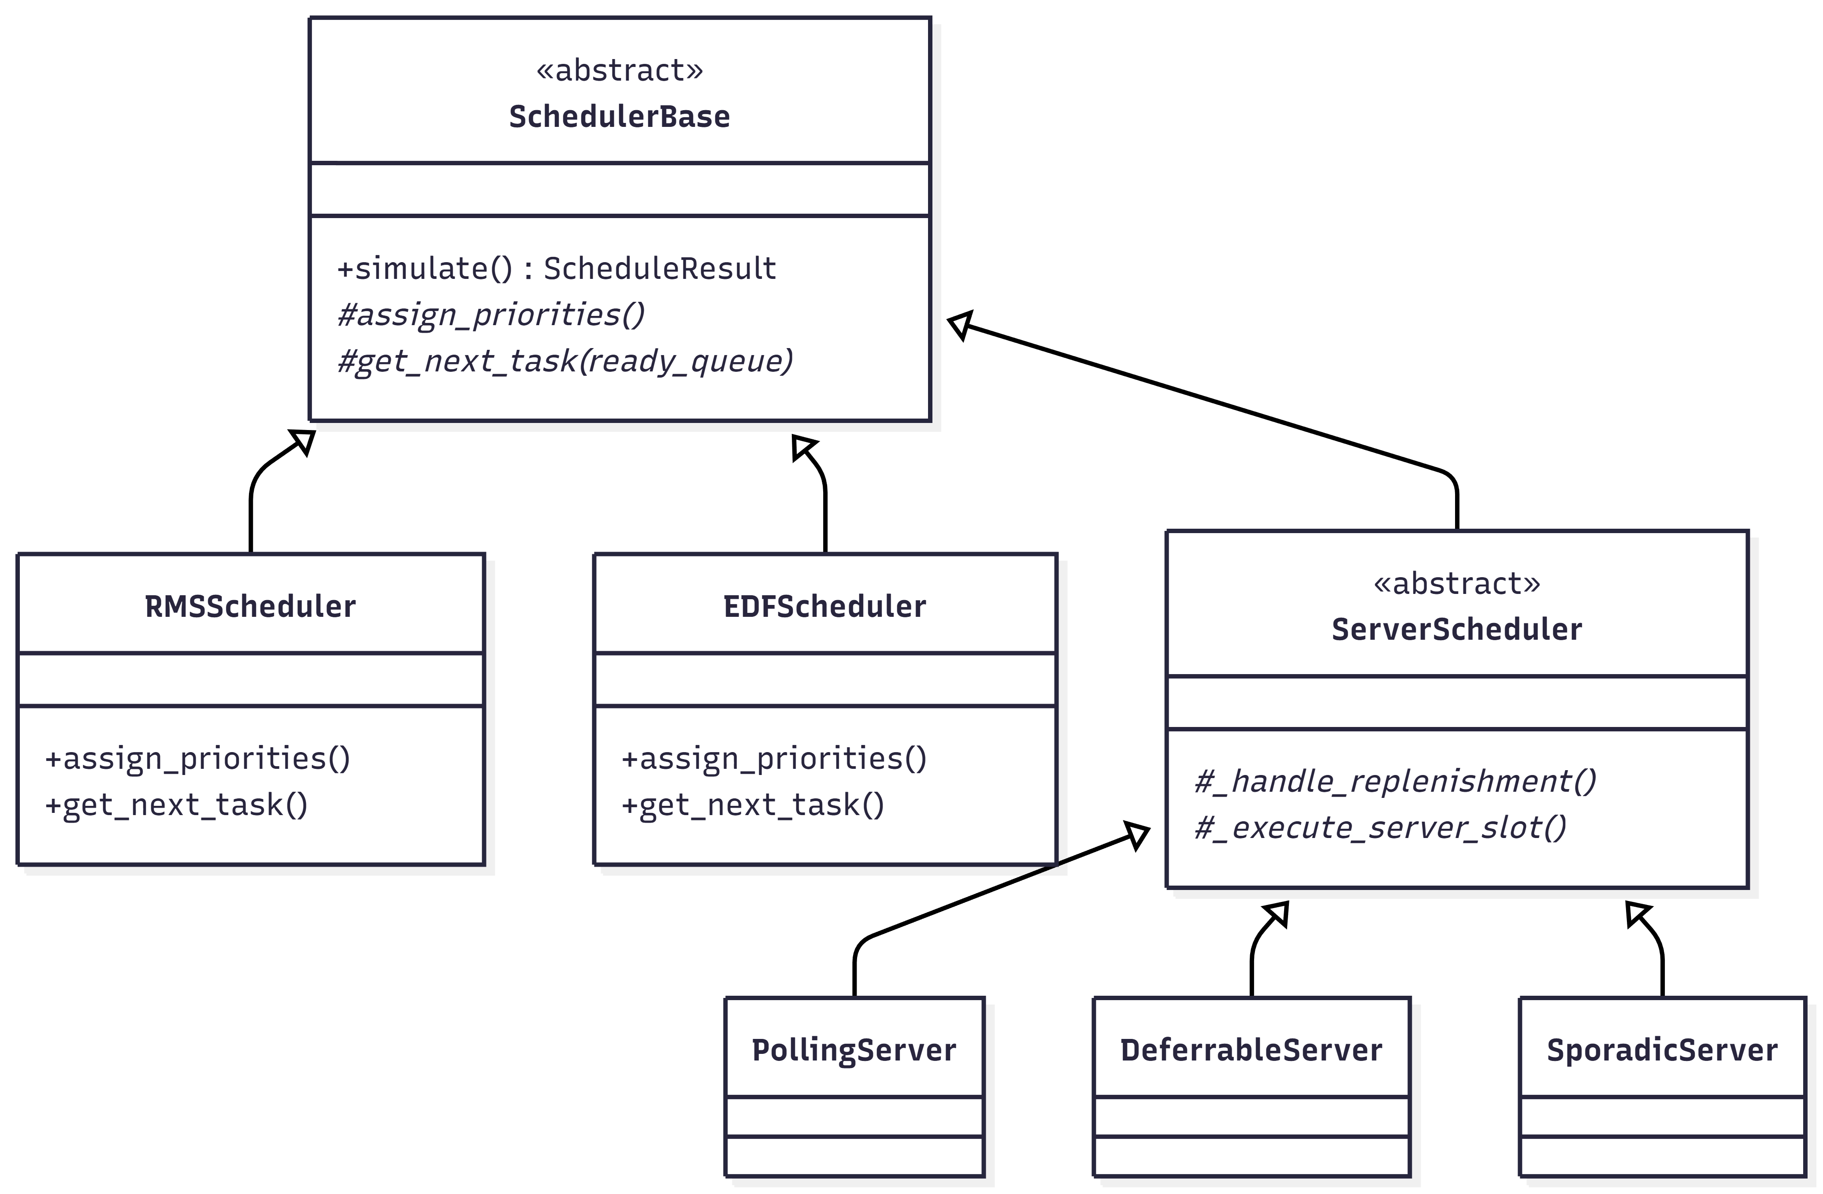
Class Hierarchy

4.3. Technology Stack
Component | Technology | Purpose
Core Logic | Python 3.10+ | Simulation engine, data models
Web UI | Streamlit | Interactive dashboard
Visualization | Plotly | Interactive Gantt charts, metrics
Data Handling | Pandas | Task tables, data export
Analysis | NumPy | Numerical computations

4.4. Key Data Structures
TaskInstance - Represents a single instance of a periodic task:
@dataclass
class TaskInstance:
task_id: str
instance_number: int
arrival_time: float
deadline: float
remaining_time: float
completed: bool = False
ScheduleEvent - Records simulation events:
@dataclass
class ScheduleEvent:
time: float
task_id: str
event_type: str # 'start', 'complete', 'preempt', 'deadline_miss', 'replenish'
details: Optional[Dict] = None
ScheduleResult - Complete simulation output:
@dataclass
class ScheduleResult:
events: List[ScheduleEvent]
deadline_misses: List[ScheduleEvent]
cpu_utilization: float
context_switches: int

4.5. UI Features
The Streamlit-based UI provides:
- Algorithm Selection: Category-based organization (Basic, Server-Based, Precedence, Overload, Aperiodic)
- Task Configuration: Editable data grid for task parameters
- Server Configuration: Capacity (Cₛ) and Period (Pₛ) sliders
- Preset Library: 21 curated test scenarios from literature examples
- Schedulability Analysis: Real-time utilization tests with pass/fail indicators
- Interactive Gantt Chart: Hover for event details, zoom/pan support
- Metrics Dashboard: CPU utilization, context switches, deadline statistics

5. Evaluation

5.1. Validation Approach
Since this is a simulation study (Type 3), evaluation focuses on validating that the simulator correctly implements the algorithms rather than measuring real-world performance:
- Correctness: Do the algorithms produce the expected capacity management behavior as described in the literature?
- Observability: Can users clearly see the differences between server algorithms through visualization?
- Parameter Sensitivity: Does varying Cₛ/Pₛ produce the expected effects on aperiodic response time?
Test Environment: - Windows 11, Python 3.11 - Streamlit 1.28+, Plotly 5.18+ - Discrete-event simulation with unit time steps

5.2. Correctness Validation
The following behaviors were verified against the algorithm descriptions in [1-3]:
Server Type | Expected Behavior | Verified?
Polling Server | Capacity lost when no aperiodic tasks pending | ✓ (capacity_lost events observed)
Deferrable Server | Capacity preserved within period | ✓ (deferred events observed)
Sporadic Server | Replenishment scheduled at t + Pₛ | ✓ (replenish events at correct times)
Background | Aperiodic runs only during CPU idle | ✓ (no preemption of periodic tasks)
Performance Metrics Collected:
Metric | Definition
CPU Utilization | (Busy time / Duration) × 100%
Context Switches | Count of task execution start events
Deadline Misses | Count of tasks completing after deadline
Aperiodic Response Time | Completion time - Arrival time

5.3. Parameter Sensitivity Results

5.3.1. Server Capacity Effect (RQ3)
Workload: P1(C=1,P=10), P2(C=1,P=15), A1(C=8, arrives t=0)
Cₛ | Pₛ | A1 Response Time | Server Replenishments
2 | 5 | 17 | 4
4 | 5 | 9 | 2
8 | 5 | 8 | 1
Finding: Server capacity directly impacts aperiodic response time. Larger Cₛ reduces the number of replenishment cycles needed, demonstrating that parameter exploration (RQ3) reveals optimal configurations.

5.3.2. Server Algorithm Comparison (RQ1, RQ2)
Workload: Basic Server Example (SERVER_EXAMPLE_1) - Periodic: P1(C=2,P=10), P2(C=1,P=8) - Aperiodic: A1(t=3,C=2), A2(t=8,C=1), A3(t=15,C=2) - Server: Cₛ=2, Pₛ=5
Algorithm | Avg Response Time | Observable Behavior
Polling | Moderate | Gantt shows capacity_lost events when A1 not ready
Deferrable | Good | Gantt shows capacity preserved via deferred events
Sporadic | Best | Gantt shows dynamic replenish events
Background | Worst | Aperiodic task runs only in gaps between periodic tasks
Finding: Interactive visualization clearly shows the behavioral differences between server types (RQ2), and the simulator faithfully implements the capacity management policies (RQ1).

5.3.3. Schedulability Analysis Validation
RMS Utilization Test: - Task set: T1(C=2,P=4), T2(C=1,P=8) - U = 2/4 + 1/8 = 0.625 - Bound (n=2): 2(2^0.5 - 1) = 0.828 - Result: SCHEDULABLE (0.625 ≤ 0.828) ✓
EDF Utilization Test: - Task set: T1(C=1,P=3), T2(C=4,P=6) - U = 1/3 + 4/6 = 1.0 - Result: SCHEDULABLE (U ≤ 1.0) ✓

5.4. Reproducibility
To reproduce these results:
- Start the simulator: streamlit run scheduler/app.py
- Load preset: Select “Server Capacity Demo” from the preset dropdown
- Run simulation: Click “Run Simulation” button
- Vary parameters: Adjust Cₛ slider to 2, 4, or 8 and re-run
- Observe Gantt chart: Note the aperiodic task completion time changes
All presets and configurations are stored in scheduler/configs.py for reproducibility.
[Screenshot: See figures/gantt_server_demo.png for example Gantt chart output]

6. Conclusions

6.1. Contributions
This project delivers the following contributions:
- Open-source simulator: Python/Streamlit implementation of four server-based scheduling algorithms (Polling, Deferrable, Sporadic, Background) with correct capacity management behavior
- Interactive visualization: Plotly-based Gantt charts that display capacity events (replenish, deferred, capacity_lost) so users can observe algorithm differences directly
- Preset library: 21 curated task sets from literature examples for experimentation and validation
- Parameter exploration: Users can modify Cₛ/Pₛ via sliders and immediately observe the effect on aperiodic response times
- Schedulability analysis: Built-in utilization tests for RMS, EDF, and DMS with pass/fail indicators

6.2. Research Question Answers
RQ1: Can a discrete-event simulator faithfully implement server capacity management policies?
Yes. The simulator correctly implements capacity management as verified by observing the expected events: Polling Server generates capacity_lost events when no aperiodic tasks are pending, Deferrable Server preserves capacity via deferred events, and Sporadic Server schedules replenishments at t + Pₛ.
RQ2: Does interactive visualization help users understand algorithm differences?
Yes. Gantt charts clearly show when capacity is lost versus preserved. Users can visually compare how the same workload behaves under different server algorithms by switching between them and observing the timeline changes.
RQ3: Can parameter exploration reveal optimal configurations?
Yes. Varying Cₛ from 2 to 8 with the Server Capacity Demo preset shows that larger capacity reduces aperiodic response time (17 → 8 time units). This enables users to find configurations that meet response time requirements without trial-and-error on real systems.

6.3. Recommendations for Future Work
- Total Bandwidth Server (TBS): EDF-based server with dynamic deadline assignment [3]
- Multi-Server Configurations: Multiple servers with different priorities
- Statistical Analysis: Random task generation using UUniFast algorithm [6]
- Resource Protocols: Integration of Priority Inheritance/Ceiling protocols

6.4. Limitations
- Discrete-time simulation: Unit time steps may not capture fine-grained continuous-time behavior; results are valid for discrete workloads only
- No overhead modeling: Context switch costs and scheduler overhead are not simulated
- Deterministic workloads only: Random/stochastic task generation is not implemented; all task sets are manually defined
- Single processor: Multiprocessor scheduling is outside the scope of this project
- No hardware validation: Results are simulation-based and have not been validated against an actual RTOS implementation

Self-Assessment of Project Completion
Project Learning Objectives | Status | Pointers
Self-contained description of project goal, scope, and requirements | Fully Completed | Section 2, pages 2-3
Self-contained description of solutions (algorithms/protocols) | Fully Completed | Section 3, pages 3-6
Adequate description of implementation details | Fully Completed | Section 4, pages 6-8
Testing and evaluation - test cases, metrics, results | Fully Completed | Section 5, pages 8-10
Overall Project Success Assessment | Fully Successful

7. References
[1] B. Sprunt, L. Sha, and J. P. Lehoczky, “Aperiodic task scheduling for hard-real-time systems,” Real-Time Systems, vol. 1, no. 1, pp. 27-60, 1989.
[2] J. P. Lehoczky, L. Sha, and J. K. Strosnider, “Enhanced aperiodic responsiveness in hard real-time environments,” in Proc. IEEE Real-Time Systems Symposium, 1987, pp. 261-270.
[3] M. Spuri and G. C. Buttazzo, “Scheduling aperiodic tasks in dynamic priority systems,” Real-Time Systems, vol. 10, no. 2, pp. 179-210, 1996.
[4] C. L. Liu and J. W. Layland, “Scheduling algorithms for multiprogramming in a hard-real-time environment,” Journal of the ACM, vol. 20, no. 1, pp. 46-61, 1973.
[5] G. C. Buttazzo, Hard Real-Time Computing Systems: Predictable Scheduling Algorithms and Applications, 3rd ed. New York: Springer, 2011.
[6] E. Bini and G. C. Buttazzo, “Measuring the performance of schedulability tests,” Real-Time Systems, vol. 30, no. 1-2, pp. 129-154, 2005.

Prepared by: Shahab Afshar Date: December 2024 Instructor: Dr. G. Manimaran Department: Electrical and Computer Engineering, Iowa State University

