**Changin Site Heading Title**

**Goto your project ‘urls.py’**

admin.site.site_header ='Admin Title'

admin.site.site_title ='Admin Title'

admin.site.index_title ='Admin Title'

**Admin List**

**Goto app/models.py**

class Product(models.Model):

    title       = models.CharField(max_length=22)

    description = models.CharField(max_length=333)

    price       = models.CharField(max_length=10)

    def __str__(self):

        return self.title

**Add Multiple Field at Admin**

**Goto app/models.py**

from django.contrib import admin

from application.models import Product

class ProductAdmin(admin.ModelAdmin):

    list_display=['title','description','price']

admin.site.register(Product,ProductAdmin)

**Layout**

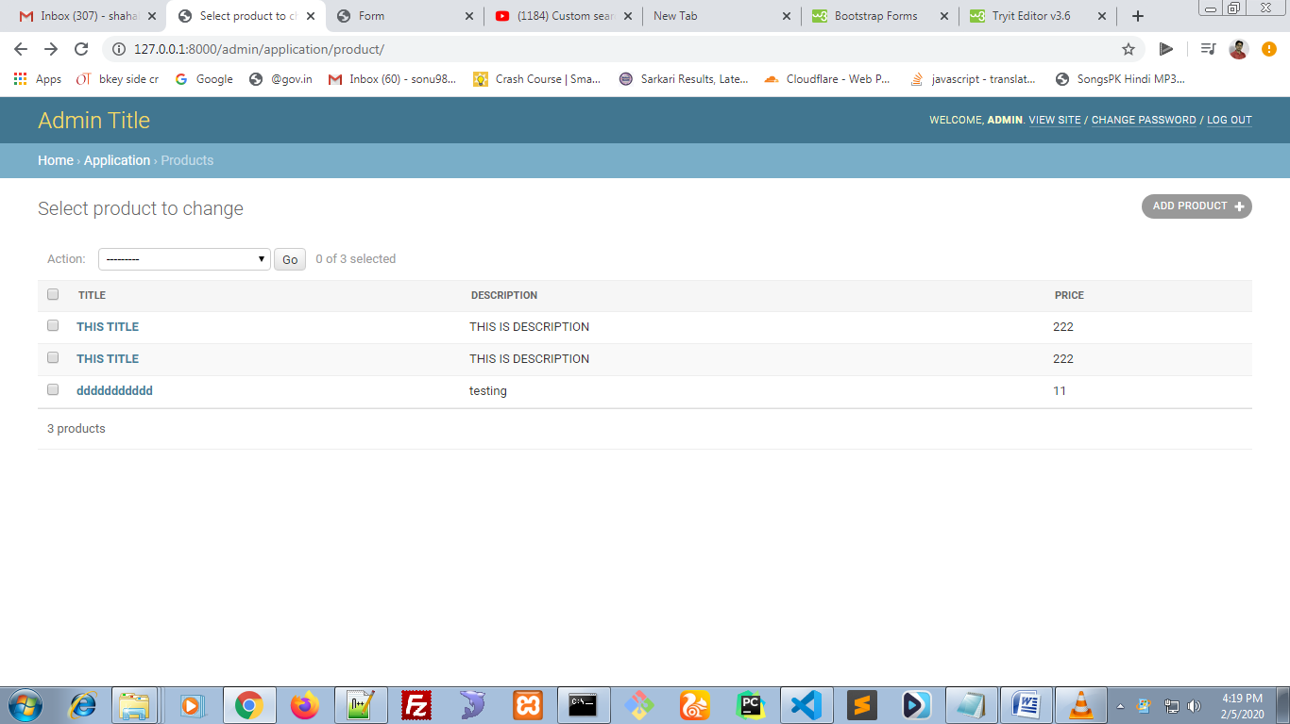

**Custom Search**

from django.contrib import admin

from application.models import Product

class ProductAdmin(admin.ModelAdmin):

    list_display=['title','description','price']

    search_fields=['title']

admin.site.register(Product,ProductAdmin)

**Layout**

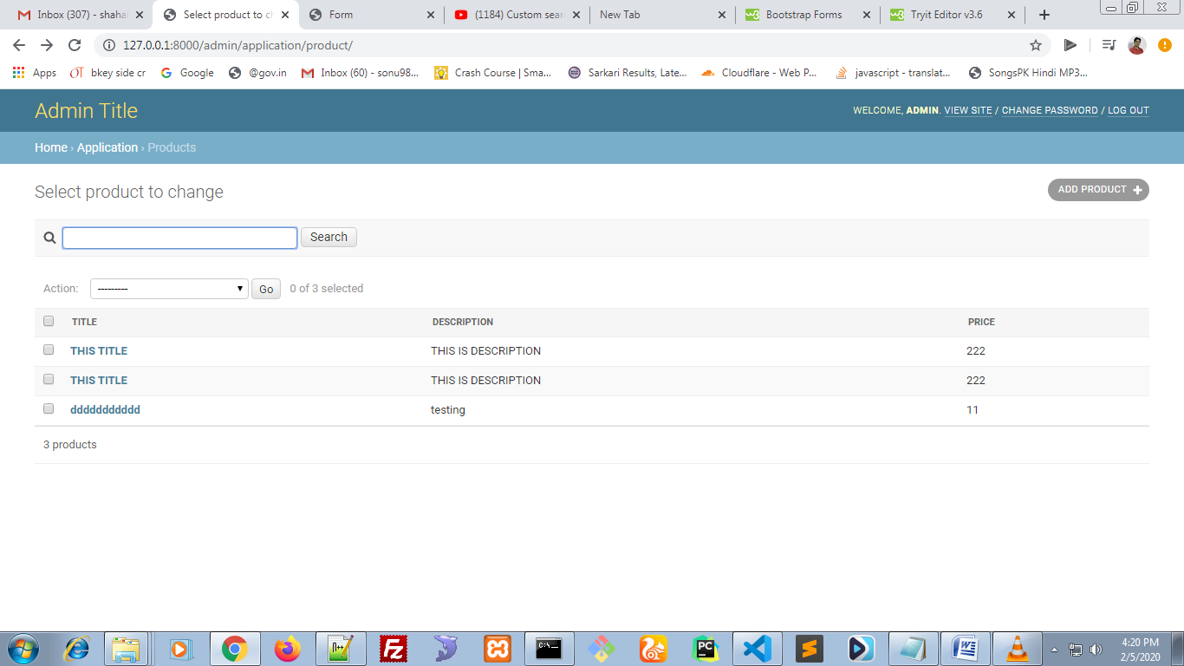

**Adding List Filter**

from django.contrib import admin

from application.models import Product

class ProductAdmin(admin.ModelAdmin):

    list_display=['title','description','price']

    search_fields=['title']

    list_filter =['title']

admin.site.register(Product,ProductAdmin)

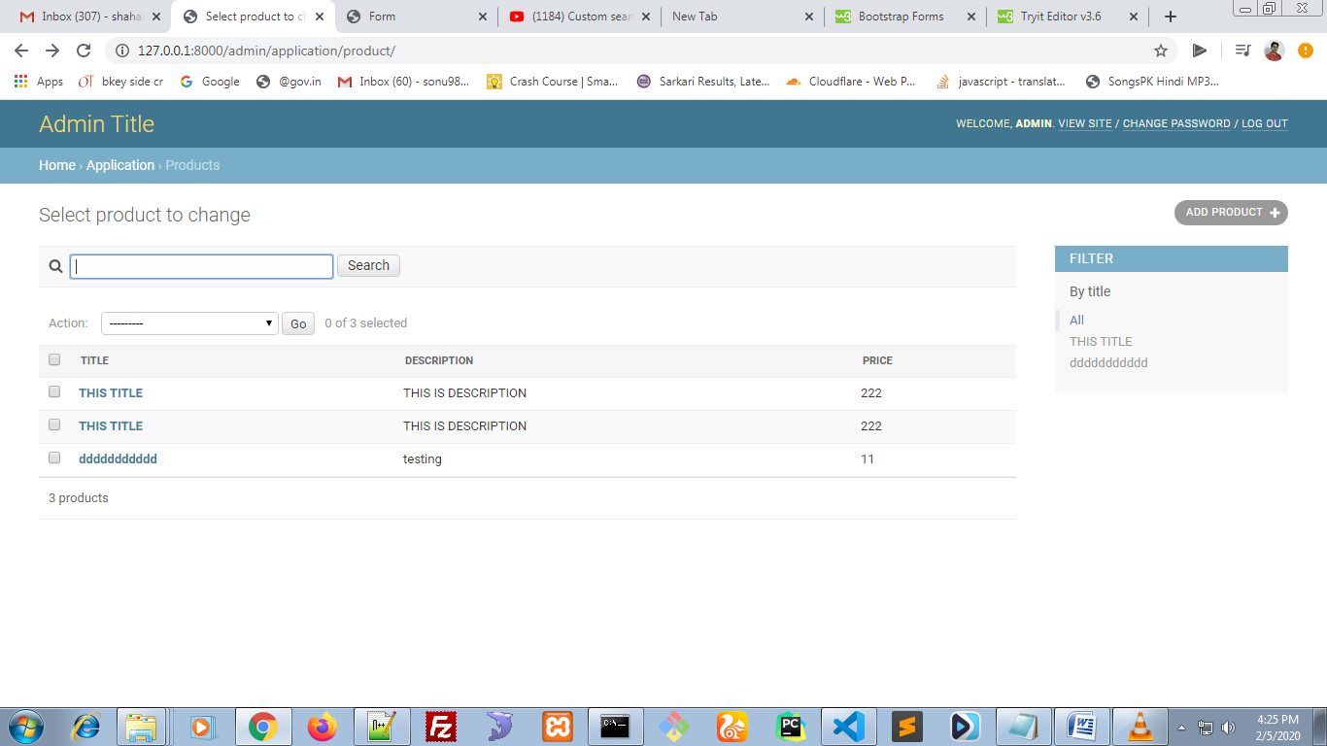

**Paasing data from view to html**

data=Student.objects.all()#fetch all record from table

    return render(request,'index.html',{'data': data}) #passing data to views

**Passing form data using from action**

<form action="{% url 'fetch' %}" method="POST">

**Passing user id in url**

<td><a href="{% url 'delete' %}userid={{ get.id }}">Delete</a></td>

<td><a href="/delete?id={{ get.id }}">Delete</a></td>

<td><a href="/delete?id={{ get.id }}&action=delete">Delete</a></td>