DOCUMENTATION

25/04/2025

1. To print the first 3 fields in syslog

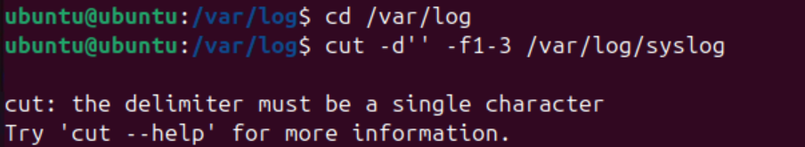

We tried to print the first 3 data from the syslog, but we encountered a error because of a delimiter error .

We now added a delimiter “,” and got the log

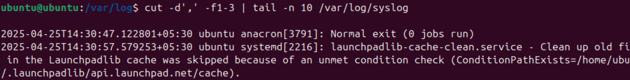

1. Tried to view syslog

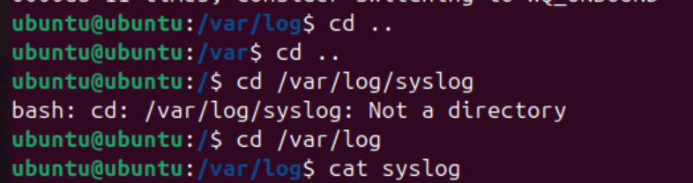

We tried to view syslog by using the cd command .

Since syslog is a file we needed to use cat command to view syslog

1. To view date and time of syslog file



After running we got other values



After changing it to $1,$2,$3,we got the time and date.

1. List the last 5 logs in syslog

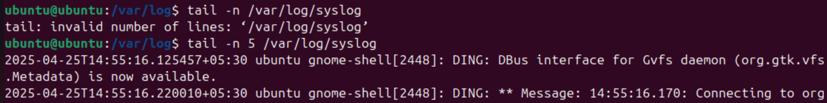

First we used -n without declaring a limit.Then we added 5 to it and corrected the command.