**Installation Guide**

Instructions for setting up XAMPP on a Windows PC

These instructions are for a Windows 7 computer. The process is very similar in Windows XP, Windows

Vista, and Windows 8.

Part I – Installing XAMPP

1. Download XAMPP for windows.

a. Visit this URL - [http://www.apachefriends.org/en/xampp-windows.htm](http://www.apachefriends.org/en/xampp-windows.html)l b. Scroll down the page and download the installer (as pictured below)

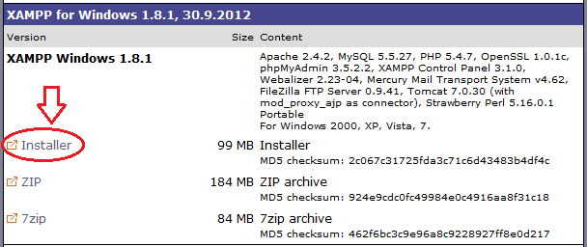

2. After xampp-win32-1.8.1-VC9-installer.exe has been downloaded, run it.

3. Screen shots follow. Click OK and next to proceed through this installation. The most important thing is where XAMPP get’s installed. Any future documentation will assume that you chose the default installation location “c:\XAMPP”. Click “Finish” at the end.

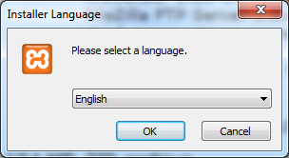

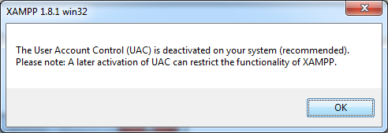

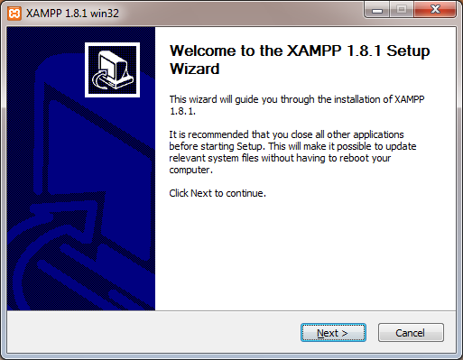

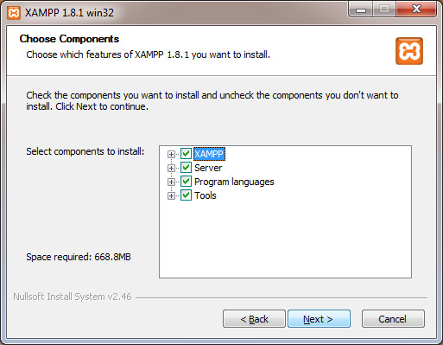

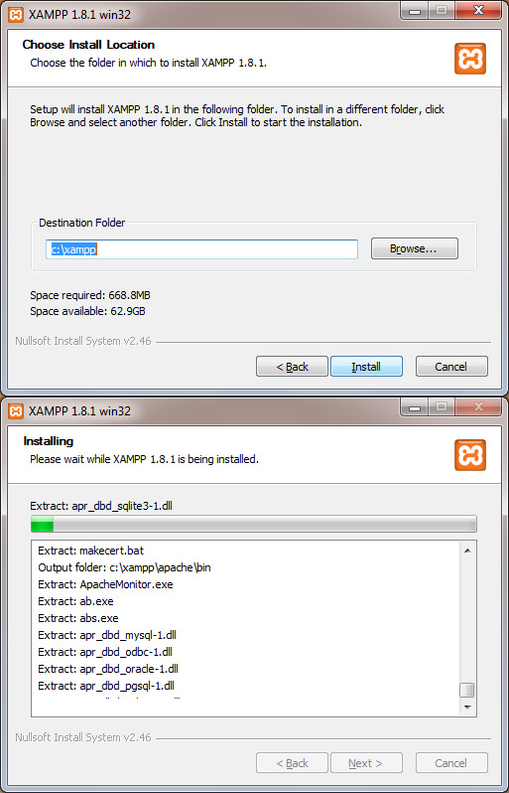

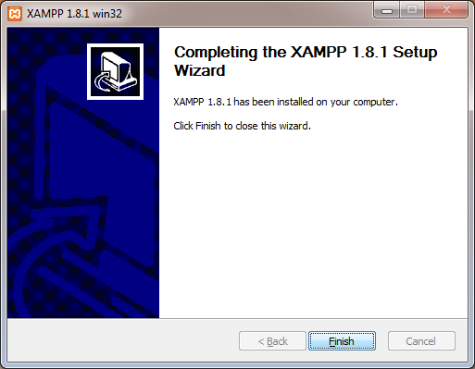

4. After you click “Finish” you will be asked if you want to start the XAMPP control panel. Click

“No.” We will start the control panel using the shortcut that was placed on your desktop.

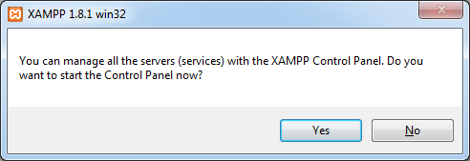

Part II – Running XAMPP

You’ve installed XAMPP. Now you have an icon for the XAMPP control center on your desktop.

1. Double click on it!

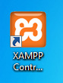

2. Using the XAMPP Control Panel, start the Apache Web Service on your computer.

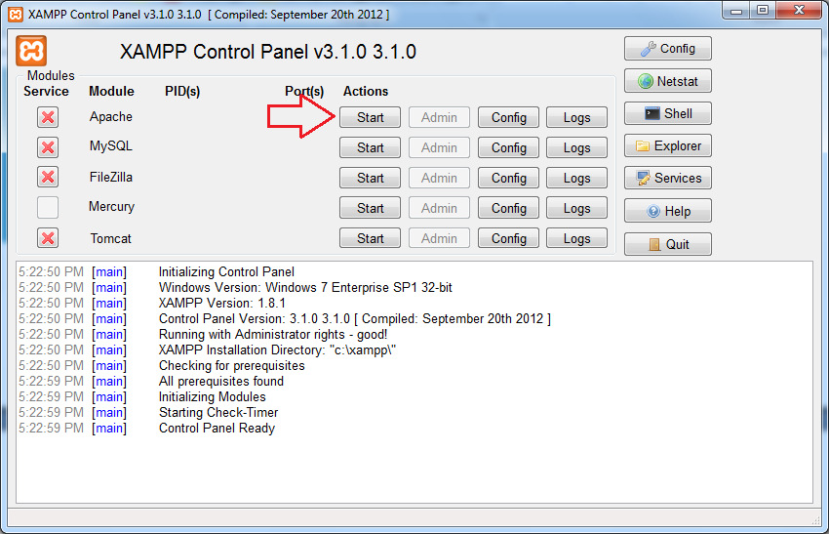

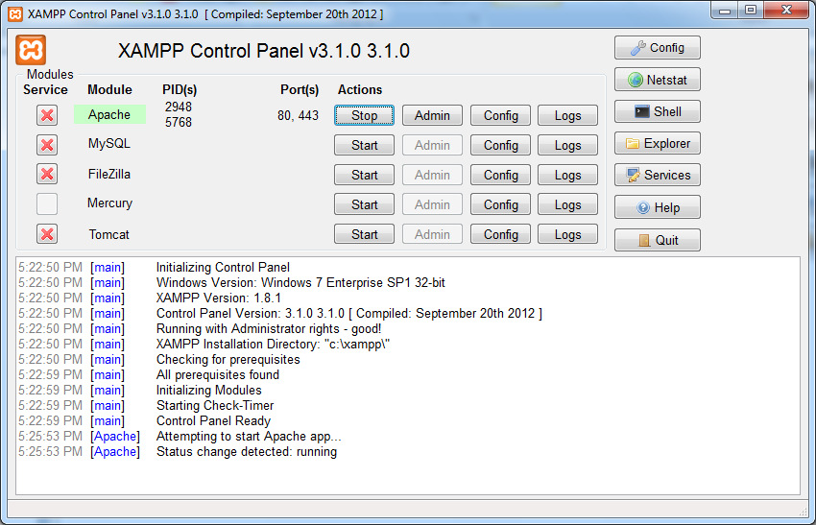

3. Using the XAMPP Control Panel, start the MySQL Database Service on your computer.

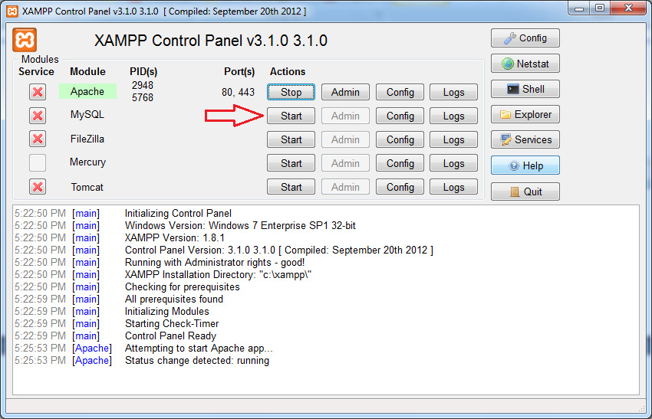

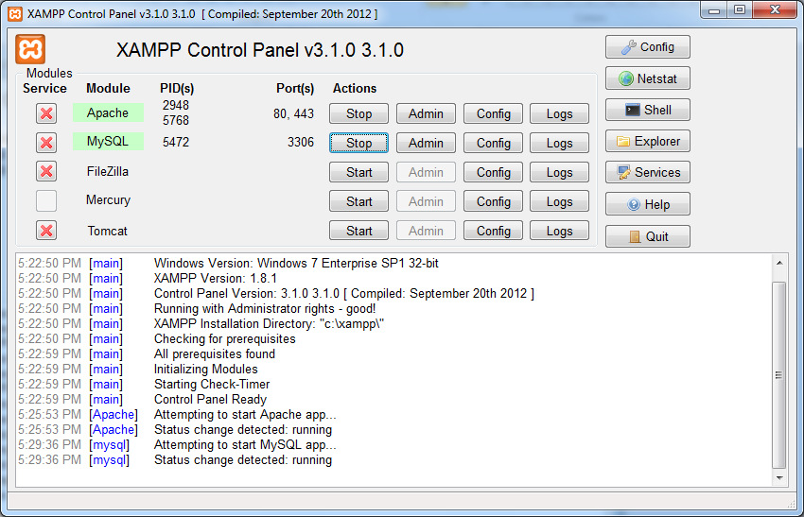

Part III – Checking your work

You now have Apache and MySQL running on your computer. You are ready to move on to the next set of instructions. “Using Notepad++ on a PC to create a PHP file.”

But, before you do, you should check and make sure XAMPP is running OK. To do that, open up a browser and go to the following URL:

[http://localhos](http://localhost)t

You should see a web page like this:

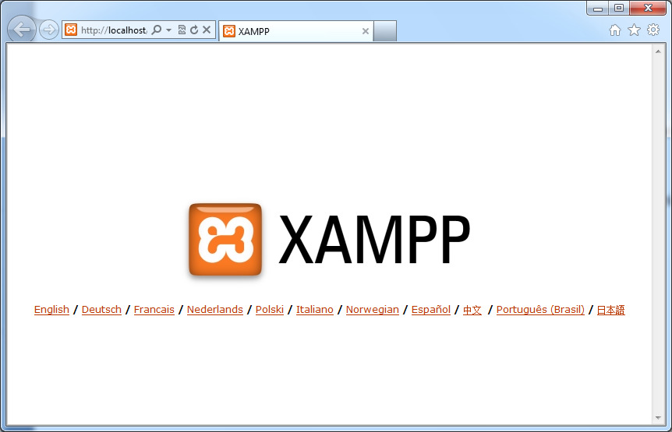

Additional Links:

<http://make.wordpress.org/core/handbook/installing-a-local-server/installing-xampp/>