# CONTENTS

About Interest Navigator

Controls and Basics

### Controls

### Options

### Menu

# Amortization Schedule

# Common Calculations

# 

# Interest Navigator

Interest Navigator is a stand-alone web site and as such it can be deployed without a web server or even a connection to the Internet. It is installed by copying the files to a folder inside of the target device, while maintaining the directory structure, and then creating a bookmark to the application’s main page (in.html). The date picker built into Interest Navigator is derived – with minimal change, from one written by Chris Hulbert (MIT License). At the time of this writing (September 2018) the original can be found at http://www.splinter.com.au/javascript-date-picker-that-doesnt-sucktm/.

**PLEASE NOTE: Interest Navigator should be considered pre-beta and as such the author does not claim it to be useful for any purpose nor does the author accept liability for any harm that may come due to hosting, running or relying on its results. You may host and or distribute Interest Navigator only if this disclaimer is included and made prominent to the end user.**

# Controls and Basics

At its most basic level, Interest Navigator is operated by selecting a calculator, entering known values in the input fields and then pressing one of the target buttons to calculate the value for the unknown field. The message panel indicates if the values are valid and consistent.

Items on the Options Panel can be cycled through by clicking on each item individually. Changing the value of any of the options causes the current calculation to be invalidated.

## Controls

•         **Title Bar** is where the name appears for the current calculation or “New Calculation” if one has not been assigned yet. Keep in mind that the calculation name is not necessarily the same as the file name to which it is saved.

•         Click the **Menu Widget** to perform file operations, change settings and get help.

•          **Calculator Widget** is a dropdown list to pick the type of calculator desired.

•          **Start Dates Widget** displays a dialog to modify Critical Start Dates: Start, Payment begins and Interest charge begins. In most cases, all three dates are the same. A date picker can be displayed by clicking of the icon to the right of the date entry field. If all three fields are not the same, a small red light on top of the widget is turned on.

•         Clicking a **Target Button** causes the value of that item to be calculated and displayed in the adjacent field. Message Panel text changes to show validity of the data entered.

o   No. of Payments/Deposits is not always the same as the number of compounding periods if all dates are not the same.

o   Interest Rate is the percentage interest charged per year. Negative interest rates are accepted, in light of recent economic events. It is up to the user to make sure the interest rate makes sense.

o   Principal / Beginning Balance is the amount of initial investment or loan.

o   Labels change according to the calculator selected.

•         **Command Buttons**

o   Clear Button causes the field values to be cleared, options set to defaults and all dates set to the system date. Calculation name remains the same. To clear out the calculation name and start a new calculation, pick New from the menu.

o   Schedule Button creates a new page or tab, depending on your browser, displaying the calculation’s time schedule table.

o   Default Options command button is where you change the value of options given to new calculations.

•         **Input Fields**

o   No. Deposits/No. of Payments is the same as number of compound periods only when all start dates are the same – which is the usual case.

o   Even if the Payment Amount/Deposit Amount is 0$, there still is a No. Deposits/No. Payments greater than 1.

o   If Payment Amount/Deposit Amount is 0, then enter 0 for the value – do not leave blank.

## Options Panel

This is where payment frequency, payment timing and amortization method are selected. Values can be circulated through by repeatedly clicking on the relevant item or applying from the Default Options Dialog. When a new calculation is selected from the menu or the Clear command button is clicked, the values for this panel are set to the saved default.

•         Payment frequency indicates how often a loan payment or an investment deposit is made. The possible values are: Monthly, Bimonthly, Quarterly, Semiannual, Annual or Daily. It can be cycled through by clicking on it.

•         Payment timing in Advance or Arrears, whether a payment is made at the beginning or end of a period.

•         Amortization Method refers to the way the balance of a loan or investment is calculated. It can be either compound interest or Rule of 78s.

o   Rule of 78s only applies to loans, not investments.

o   Interest Rate % target button changes to Finance Charge $.

o   There can be only one Start Date for Rule of 78s.

o   Interest Navigator does not check legality of any loan - it only applies a formula to the entries made.

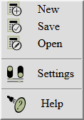

## Menu

The menu can be displayed by clicking on the menu widget.

•         **New**, clears the input fields, options are set to the default values and the title bar is changed to “New Calculation”. Make sure you save the existing calculation first, if you want to return to it at a later time.

•         **Save**, if the values are consistent, saves the current calculation to the client’s (local) file system. Prompts for a name to give to the calculation and then calls on the browser to save the values. Once it is saved locally, it can be treated like any other file: deleted, emailed, renamed etc. Renaming of the file does not change the calculation name.

•         **Open**, calls on the browser to fetch an existing calculation from the client’s file system. The Open function checks for the calculation’s consistency and since in most cases there are rounding errors between what’s been saved and the displayed values, it is like that the message panel may show inconsistent values, even though the calculation was consistent when saved.  Click any of the target buttons to verify consistency.

•         **Settings**, displays the Settings Dialog where the preferences are set. As of this writing only the date picker and the dates display format are set. The format can be modified only if Interest Navigator’s built-in date picker is picked, otherwise it is determined by the browser.

•         **Help**, opens this document.

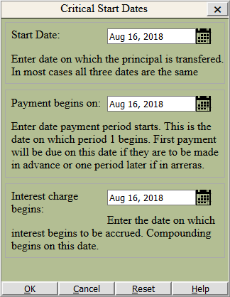

## Critical Start Dates

In most cases all dates are the same and this dialog need not be used. But if interest is not charged for a number of periods and payments are made anyway or no payments are made for a number of periods but interest is charged anyway, then this is where you enter the start dates.

Dialog commands:

•         **OK -** save the dates and dismiss the dialog

•         **Cancel –** any values entered are ignored and the dialog is dismissed.

•         **Reset** – all dates are set to the date on the main form (the calculator).

•         **Help** – this text.

Note that if all three dates are not the same and the values are saved by clicking OK, once the Critical Start Dates is dismissed, a red light appears on the Start Dates selection widget on the calculator, indicating that start dates are not all the same.

If the date picker provided by Interest Navigator is being used, a date can be picked by clicking on the calendar icon next to the date input box. You can choose to use the browser’s date picker or Interest Navigator’s from the Settings option of the menu.

## Default Options Dialog

Use this dialog to set the options values for all new calculations or when the current calculation is cleared. Values for the current calculation can be picked from the Options Panel also.

Command buttons:

•         **Apply** – applies the selected values to the current calculation but is not saved for future calculations. It is an alternate method to picking from the Options Panel.

•         **Save** – saves the selected values for future calculations, whenever the current calculation is cleared or a new one is picked from the menu.

•         **Exit** – dismisses the dialog. Prompts to save the selected values if they were changed and not saved.

## Application Settings Dialog

It can be opened by choosing Settings from the menu. Currently the only settings options relate to how dates are picked and formatted.

•         **Use date piker -** Whether to use the browser’s internal date picker, if one is available or to use the date picker built in to Interest Navigator.

•         **Dates format** - If Interest Navigator’s date picker is used, the order in which day, month and year appear is selected.

•         **Month format** – If Interest Navigator’s date picker is used, Month format drop-down lets you can pick numeric or named and capital or lower case and abbreviated or full month name.

# Amortization Schedule

Clicking on the Schedule command button opens a new browser tab displaying the amortization schedule.

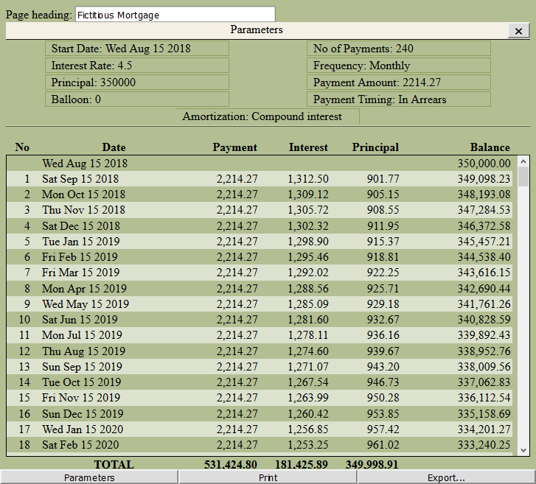

•         **Page heading**, defaults to the name given when the calculation was saved. If the calculation was not saved before the schedule was generated, it defaults to “Schedule”. It can be overwritten with any text desired.

•         **Parameters command button** is used to toggle visibility of the parameters at the top.

•         **Print command button** invokes the browser’s printing facilities to print the displayed data. Selection of a printer, page format, etc., is handled by the browser.

•         **Export command button** opens the Export Options dialog.

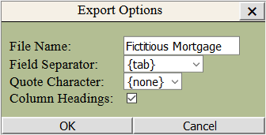o   **File Name** defaults to the page heading but no extension is added. Once OK is clicked, it is handed over to the browser at which time the location can be decided.

o   **Field Separator** can be either a tab or a comma. It is used to separate data columns.

o   **Quote Character** is not mandatory but it can be either a single or double quote character. If comma has been picked for field separator, it is highly advisable to pick a quote character as the receiving application may get confused as to which commas are thousands separators and which are used to separate the columns.

o   **Column Headings** check mark should be set if it is desired for the first row/record of the file to contain the field names.

`

Please be aware that if you click the browser’s reload button and the values entered in the calculator have changed, the schedule will update to reflect the new values. If the corresponding calculator tab has been closed since, the result is not defined and is browser dependent.

# Common Calculations

The following examples are for demonstrating how to use the calculators and not necessarily real world examples. In reality, considerations may have to be made for taxes, fees and etc., which are beyond the scope of these examples.

Note that it is not necessary to clear a calculation before starting a new one. After a calculation is performed, any input field can be modified and a new target button clicked, thereby examining what-if scenarios. Also, after each calculation, a new schedule may be produced for comparison.

## 30 Year Fixed Mortgage

Fixed 30 year (360 months) amortization at 4.5% with initial borrowing of $350,000. Enter the values for No. of Payments, Interest Rate, Principal and then click Payment Amount $.

## 10 Year Fixed, 30 Year Amortization

Same mortgage as before except the balance is due after ten years. You would like to know how much needs to be refinanced at the end of ten years.

1.    Proceed following the previous example’s instructions to get the figure for the payments amount.

2.    Change No. of Payments to 120 (10 years) and then click Balloon to get the amount needed to refinance or payoff the loan after 10 years.

## Simple Future Value

An investment of $100,000 that pays 4.5%, compounded monthly for 10 years, interest and principal paid at the end of the term.

1.    Select the Savings and Investments Calculator

2.    Enter 120 (10 years) No of Deposits, although only one initial investment is made.

3.    Enter 4.5 for the Interest Rate.

4.    Enter100,000 in the Beginning Balance field.

5.    Enter 0 for deposit amount, to indicate no periodic payments or draws are made. Note that a blank and 0 are not the same.

6.    Click Future Value.

## Monthly Savings for Future Value

Bank savings account pays an interest of 2%. The goal is to have accumulated $200,000 in ten years and there is a 50,000 initial investment. To calculate additional monthly deposits needed:

1.    Select the Savings and Investments Calculator

2.    Enter 120 (10 years) for No of Deposits

3.    Enter 2 for Interest Rate

4.    Enter 50000 for Beginning Balance

5.    Enter 200000 for Future Value

6.    Click Deposit Amount.