

DATABASE MANAGEMENT SYSTEM (CE431)

PROJECT REPORT

Group Members:

Khizar Hayat Khan (2016194)

Muhammad Shahab (2016353)

Niaz Ahmad (2016387)

Assumptions:

We have the following assumptions in our database project:

1. Since, there is no student view in our database project. So we have assumed that the student has enrolled the course offered by department.
2. When the instructor enter the marks of the students obtained in the course. We have assumed that the exam has taken place and instructor will enter the marks of the student in each activity.
3. There is no option for adding a new instructor in the department view. We will enter it in the database manually.
4. An instructor will work for only one department and one department will have many instructor.
5. A program will be associated with only one department.
6. A department can have many programs.
7. We have also assumed student is enrolled in a program. A program will have many students and each student can be enrolled in only one program.

Conceptual Diagram:

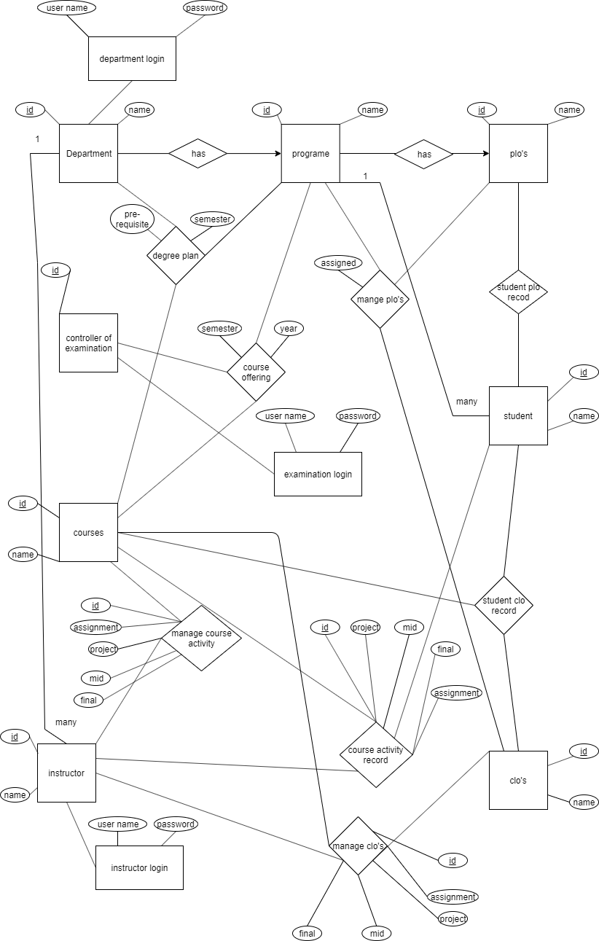

Logical Diagram:

