**Assignment 1:**

**Code :**

alpha=1/2;

R=3;

ts=0.125;

sim('lab4problem1');

dftY=fft(simout);

fs=1/ts;

n=length(dftY);

f=linspace(0,fs,n);

subplot(2,2,1);

plot(f,abs(dftY));

title('Amplitude response for alpha=1/2, R=3');

subplot(2,2,2);

plot(f,angle(dftY));

title('Phase response for alpha=1/2' );

**simulink model :**

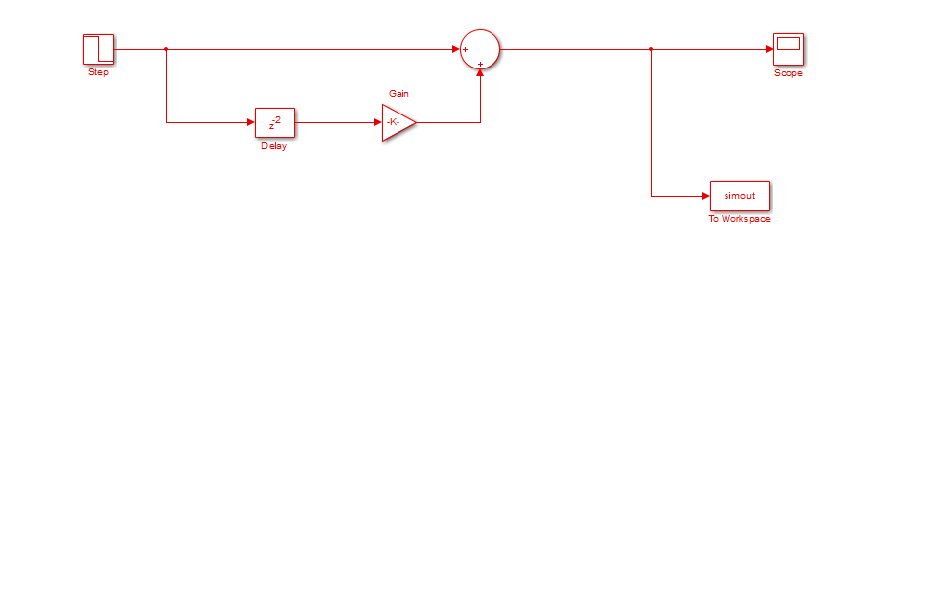

**Graphs**



**ii) alpha = 1**

alpha=1;

R=3;

ts=0.125;

sim('lab4problem1');

dftY=fft(simout);

fs=1/ts;

n=length(dftY);

f=linspace(0,fs,n);

subplot(2,2,1);

plot(f,abs(dftY));

title('Amplitude response for alpha=1, R=3');

subplot(2,2,2);

plot(f,angle(dftY));

title('Phase response for alpha=1' );

