IE4-DS Lab Session #1: Lecture Preparation
Surname, First Name | Group Team
- all of us  2.  3. | 1 ◻ A B C D E F  2 ◻  3 ◻
This preparation sheet must be filled and uploaded to EMIL by every student before the lab session. Cooperation within the lab team (of 2-3 students) is possible (same solution). However, no cooperation across lab teams.

TAsk
Design a digital module ADCDAC_TOP in VHDL that reads data from an ADS7947 (http://www.ti.com/lit/ds/symlink/ads7947.pdf). The communication to the FPGA (Virtex 7 FPGA on an Xilinx ML507 board) is accomplished by a 3-wire synchronous serial transmission (SCLK, SDO, -CS).
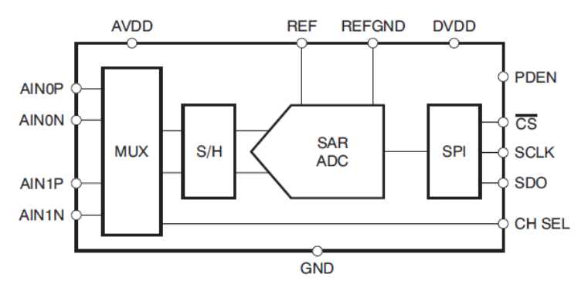
The timing of the three signals is as follows (to read a 12-bit ADC value).
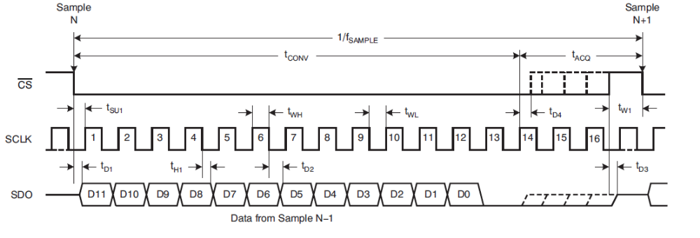
The FPGA module ADCDAC_TOP shall have the following blocks:
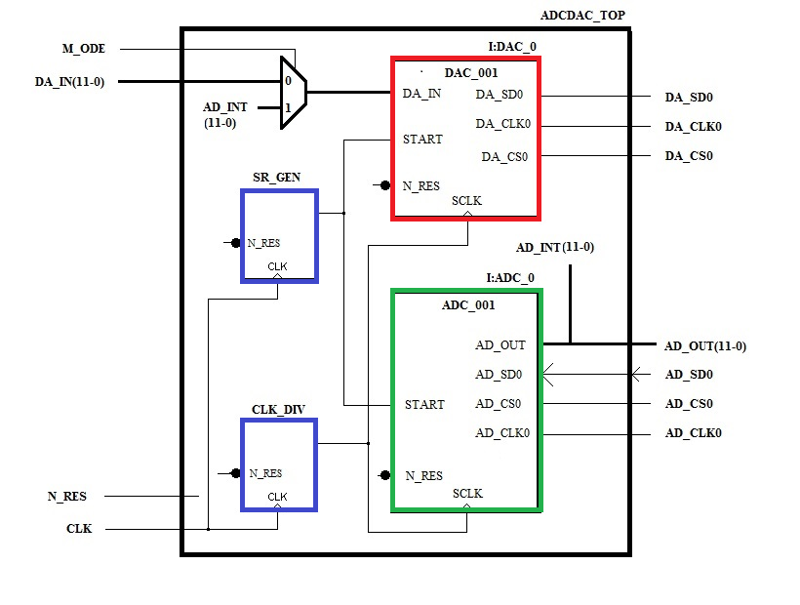
The module ADC_001 that reads data from the ADC and converts them into a parallel 12bit word AD_OUT(11:0), a clock divider CLK_DIV for that generates a 3.125 MHz clock signal (which is clock speed of FPGA 100MHz / 32) and a sample rate generator module SR_GEN that generates every 1/48 kHz a START pulse that triggers a new reading of the external ADC. The DAC module will be done by yourself during prep of the lab.

TASK 1: Design of the clock divider CLK_DIV
Write a VHDL module CLK_DIV with a clock divider and simulate the module.

specification (VERBALLY)
- the clock divider shall generate SCLK with 3.125MHz generated from a global CLK with 100MHz
- a modulo-32 (5bit) counter shall be used of which the MSB is the SCLK output
- the module shall be reset by a an active low asynchronous reset

Simulation TEST cASES (VERBALLY)
- verify for a least 3 periods that a 3.125 MHz output is generated
- verify that the reset is asynchronous by applying a reset not aligned to clock edges and that it is active low and that the CLK_CNT value is “00000” when reset
- verify that CLK_CNT increments correctly

VHDL model
library IEEE;
use IEEE.std_logic_1164.ALL;
use IEEE.std_logic_unsigned.ALL;

entity CLK_DIV is
port ( CLK, N_RES: in bit; -- 100 MHz; async, active low reset
SCLK : out bit); -- 3.125 MHz clk out
end CLK_DIV;

architecture BEHAVIOUR of CLK_DIV is

signal CLK_CNT : std_logic_vector(4 downto 0);

begin

-- clock divider
CLK_DIV : process(N_RES,CLK)
begin
if N_RES ='0' then
CLK_CNT <= (others =>'0');
elsif CLK = '1' and CLK'event then
CLK_CNT <= CLK_CNT + '1' ;
end if;
end process CLK_DIV;

SCLK <= to_bit(CLK_CNT(4)) ;

end BEHAVIOUR ;

TEST BENCH
# show input signals
add wave -divider -height 32 Inputs
add wave -height 30 -radix default N_RES
add wave -height 30 -radix default CLK

# show internal signals
add wave -height 30 -radix default CLK_CNT

# show output signals
add wave -height 30 -radix default SCLK

# generate input stimuli
force CLK 0 0ns, 1 5ns -r 10ns
force N_RES 1 0ns, 0 33ns, 1 57ns
run 1000ns

SIMULATION RESULTS
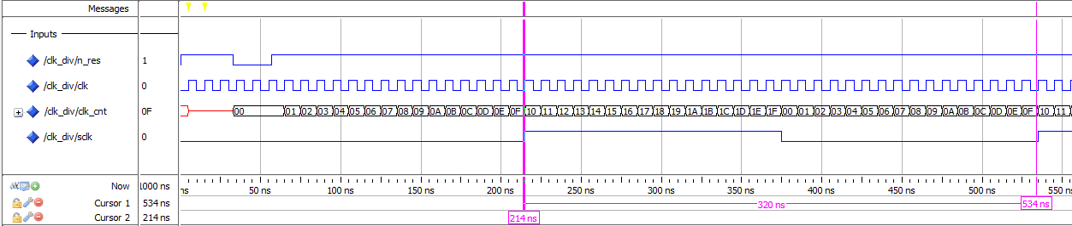

TASK 2: Design of the sampling rate genrator SR_GEN
Write a VHDL module SR_GEN that generates the START_TE pulse at a rate of 48kHz and simulate the module.

specification (VERBALLY)
- sample rate generator shall generate a START pulse of 320ns duration (32/100MHz) at a frequency of 48 kHz
- a counter shall be used to generate period and duty cycle of START signal
- the module shall be reset by an active low asynchronous reset

Simulation TEST cASES (VERBALLY)
- verify for a least 3 periods that a pulse every 1/48kHz =20.8333…µs is generated
- verify that the reset is asynchronous by applying a reset not aligned to clock edges and that it is active low and that the CLK_CNT value is “00000” when reset
- verify that CLK_CNT increments correctly

VHDL model
library IEEE;
use IEEE.std_logic_1164.ALL;
use IEEE.std_logic_unsigned.ALL;

entity SR_GEN is
port ( CLK, N_RES : in bit; -- 100MHz; async, active low reset
START_TE : out bit);
end SR_GEN;

architecture BEHAVIOUR of SR_GEN is

signal SCNT : std_logic_vector(11 downto 0);

begin

SR_GEN:process(N_RES,CLK)
begin
if N_RES ='0' then
SCNT <= (others=>'0');
elsif CLK = '1' and CLK'event then
if SCNT = "100000100010" then -- 100MHz/48kHz=2083.33
-- range 0...2082
SCNT <= (others=>'0');
else
SCNT <= SCNT + '1' ;
end if;
end if;
end process SR_GEN;
START_TE <= '1' when SCNT < "000000100000" else '0' after 5 ns;

end BEHAVIOUR ;

TEST BENCH
# show input signals
add wave -divider -height 32 Inputs
add wave -height 30 -radix default N_RES
add wave -height 30 -radix default CLK

# show internal signals
add wave -divider -height 32 Internals
add wave -height 30 -radix default SCNT

# show output signals
add wave -divider -height 32 Outputs
add wave -height 30 -radix default START_TE

# generate input stimuli
force CLK 0 0ns, 1 5ns -r 10ns
force N_RES 1 0ns, 0 33ns, 1 57ns
run 70000ns

SIMULATION RESULTS
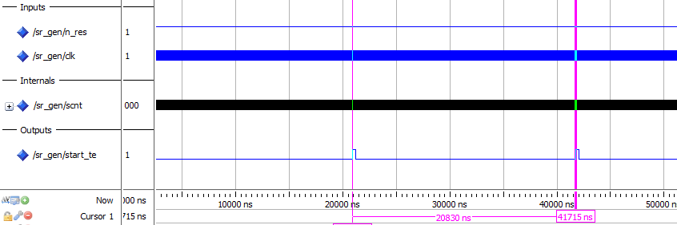
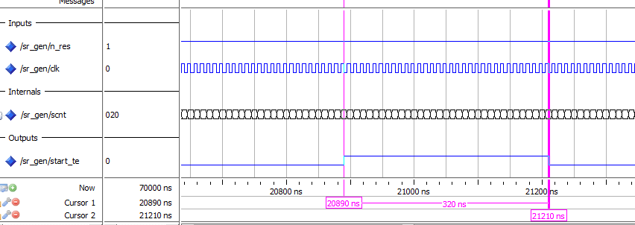

TASK 3: Design of the ADC communication module
Write a VHDL module ADC_001 that that controls AD_CLK0 and AD_CS0 of the ADC and receives data AD_SD0. The module shall convert the serial bit stream from the ADC into a parallel 12bit data word.

Specification (VERBALLY)
- The serial bit stream is initiated and read by an FSM and a counter BIT_CNT
- When the FSM is in AD_IDLE it waits for a next sampling point (START=’1’)
- After START=’1’, -CS is pulled low and 16 bits are read in (12 data bits plus 4 zeros for acquisition phase) in state Shift_AD
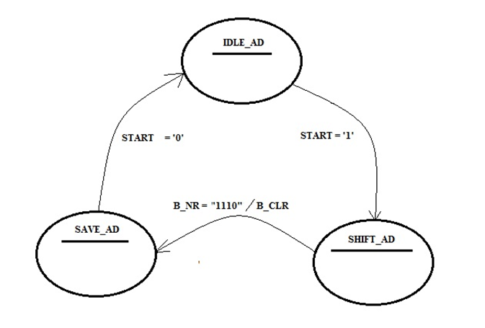
- Received values are shifted into shift register AD0_SR (MSB first)
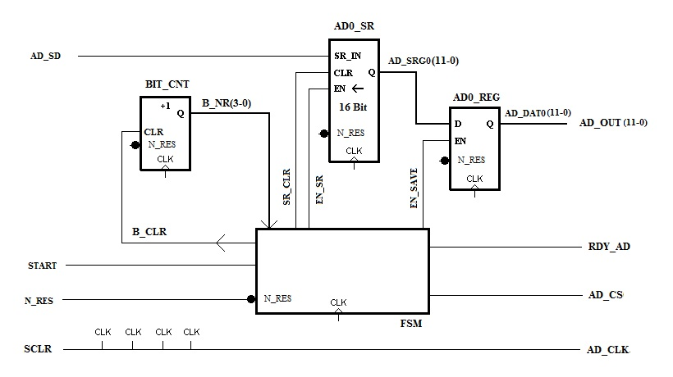

- -CS is pulled high afterwards and contents of shift register is copied to AD0_REG (highest 12 bits) in state SAVE_AD
- SR_CLR clears the shift register
- Shifting is done when EN_SR=1

Simulation TEST cASES (VERBALLY)

VHDL model
library IEEE;
use IEEE.std_logic_1164.ALL;
use IEEE.NUMERIC_STD.ALL;

entity ADC_001 is
port ( SCLK, N_RES : in bit;
AD_OUT : out bit_vector(11 downto 0);
START : in bit; -- start signal
RDY_AD : out bit ; -- ready flag
AD_SD : in bit ;
AD_CS : out bit ;
AD_CLK : out bit );
end ADC_001 ;

architecture BEHAVIOUR of ADC_001 is
-- bit counter
signal B_NR : unsigned(3 downto 0):= "0000" ;
signal B_CLR : bit ;

--Control Signals ADC
signal SR_CLR : bit; -- clear shift reg
signal EN_SR : bit; -- enable shift reg
signal EN_SAVE : bit; -- store

-- registers for ADC data
signal AD_SRG0 : bit_vector(15 downto 0):= (others => '0') ; -- shift reg
signal AD_DAT0 : bit_vector(11 downto 0):= (others => '0') ; -- save reg

type State_Type_AD is (IDLE_AD,SHIFT_AD,SAVE_AD);
-- states of ADC communication module
signal AD_STATE : State_Type_AD;
signal AD_NEXTSTATE : State_Type_AD;

begin

AD_OUT <= AD_DAT0;

-- clock to ADC
AD_CLK <= not SCLK;

-- counter for serial bits -------------------------------
BIT_CNT: process(SCLK)
begin
if SCLK = '1' and SCLK'event then
if B_CLR = '1' then
B_NR <= "0000" after 5 ns ;
else
B_NR <= B_NR + 1 after 5 ns ;
end if ;
end if ;
end process BIT_CNT;

---------ADC0 - shift / save regs -----------------------------
AD0_SR: process(SCLK, N_RES)
begin
if N_RES ='0' then
AD_SRG0 <= (others=>'0') after 5 ns ;
elsif SCLK = '1' and SCLK'event then
if SR_CLR = '1' then
AD_SRG0 <= (others=>'0') after 5 ns ;
elsif EN_SR = '1' then
AD_SRG0 <= AD_SRG0(14 downto 0) & AD_SD after 5 ns ;
end if;
end if ;
end process AD0_SR;

AD0_REG: process(SCLK, N_RES)
begin
if N_RES ='0' then
AD_DAT0 <= (others=>'0') after 5 ns ;
elsif SCLK = '1' and SCLK'event then
if EN_SAVE = '1' then
AD_DAT0 <= AD_SRG0(15 downto 4) after 5 ns ;
end if;
end if ;
end process AD0_REG;

-- FSM_ADC comm module -----------------------------------------
FSM_AD_REG : process(SCLK , N_RES)
begin
if N_RES ='0' then
AD_STATE <= IDLE_AD after 5 ns ;
elsif SCLK = '1' and SCLK 'event then
AD_STATE <= AD_NEXTSTATE after 5 ns ;
end if ;
end process ;

FSM_AD_SN : process(AD_STATE,B_NR,START)
begin
AD_NEXTSTATE <= AD_STATE after 5 ns ;
AD_CS <= '1' after 5 ns ;
EN_SR <= '0' after 5 ns ;
SR_CLR <= '0' after 5 ns ;
EN_SAVE <= '0' after 5 ns ;
RDY_AD <= '0' after 5 ns ;
B_CLR <= '1' after 5 ns ;
case AD_STATE is
when IDLE_AD => SR_CLR <= '1' after 5 ns ;
RDY_AD <= '1' after 5 ns ;
if START = '1' then
AD_NEXTSTATE <= SHIFT_AD after 5 ns ;
end if ;
when SHIFT_AD => AD_CS <= '0' after 5 ns ; -- 15 states
EN_SR <= '1' after 5 ns ;
B_CLR <= '0' after 5 ns ;
if B_NR = "1111" then
B_CLR <= '1' after 5 ns ;
AD_NEXTSTATE <= SAVE_AD after 5 ns ;
end if;
when SAVE_AD => EN_SAVE <= '1' after 5 ns ;
if START = '0' then
AD_NEXTSTATE <= IDLE_AD after 5 ns ;
end if;
end case;
end process;

end BEHAVIOUR ;

TEST BENCH
Does not cover all relevant cases (!)
# --- compilation
vlib work
vcom -93 -work work ADC_001.vhd
vsim ADC_001
# --- simulation
# view signal wave forms
view wave
# number format is hex
radix hex

# show input signals
add wave -divider -height 32 Inputs
add wave -height 30 -radix default N_RES
add wave -height 30 -radix default SCLK
add wave -height 30 -radix default START

# show reg signals
add wave -divider -height 32 Reg
add wave -height 30 -radix default AD_SRG0
add wave -height 30 -radix default AD_DAT0

# show ADC signals
add wave -divider -height 32 ADC_signals
add wave -height 30 -radix default AD_CS
add wave -height 30 -radix default AD_CLK
add wave -height 30 -radix default AD_SD

# show output of register
add wave -divider -height 32 Reg_output
add wave -height 30 -radix default AD_OUT

# generate input stimuli
force SCLK 0 0ns, 1 160ns -r 320ns
force N_RES 1 0ns, 0 33ns, 1 57ns
force START 0 0ns, 1 1000ns, 0 1320ns
force AD_SD 0 0ns, 1 1320ns, 0 1640ns, 1 1960ns, 0 2600ns, 1 2920ns, 0 3240ns
run 8000ns

SIMULATION RESULTS
