IE4-DS Lab Session #1
Surname, First Name | Group Team
2.  3. | 1 ◻ A B C D E F  2 ◻  3 ◻
This preparation sheet must be filled and uploaded to EMIL by every student before the lab session. Cooperation within the lab team (of 2-3 students) is possible (same solution). However, no cooperation across lab teams.
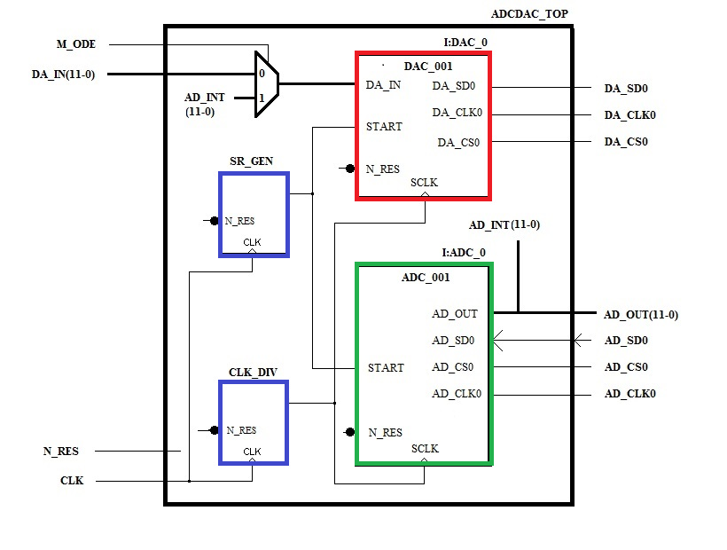

PREP TASK 1.1
PREP TASK 1.1: Design the module DAC_001 that communicates with the DAC8801. Use an FSM that sends the bits serially to the DAC after the START=1 pulse occurred. The bits are read from a 16bit shift register SR_DAC0.

specification (VERBALLY)

Simulation TEST cASES (VERBALLY)

VHDL model

TEST BENCH

SIMULATION RESULTS

Prep TASK 1.2
PREP TASK 1.2: Create an entity ADCDAC_TOP that instantiates the module DAC_001 SR_GEN and adds the sample rate generator and the clock divider.

specification (VERBALLY)

Simulation TEST cASES (VERBALLY)

VHDL model

TEST BENCH

SIMULATION RESULTS

Simulation TEST cASES (VERBALLY)

VHDL model

TEST BENCH

SIMULATION RESULTS

