UNIVERSITY CAMPUS NETWORK USING CISCO PACKET TRACER
Network Design, Configuration, Simulation and Testing — Final Report
Field | Details
Simulation Platform | Cisco Packet Tracer 9.0.0
Project File | University_Campus_Network_Premier_University.pkt

Contents

(Right-click the table and choose Update Field in Microsoft Word to refresh page numbers.)

1. Abstract
This report documents the design, configuration and testing of a simulated smart university campus network for Premier University, Chittagong, built directly in Cisco Packet Tracer 9.0. The network contains 31 devices: a simulated ISP and Internet server, a Cisco 2911 edge router, two Catalyst 3650 multilayer distribution switches, five Catalyst 2960 access switches, four data-centre servers, seven PCs, a WPA2 access point with two wireless clients, and four IoT devices. Nine VLANs are addressed from 10.10.0.0/16 with VLSM, routed with OSPFv2 (IPv4) and OSPFv3 (IPv6), served by a central DHCP/DNS server through DHCP relay, protected by three named extended ACLs, an SSH-only management policy and NAT/PAT, and extended with an IoT registration server that switches classroom lighting by occupancy. Of 31 planned tests, 23 passed, 2 failed and 6 were not run; every result is reported as observed, with screenshots captured from the running simulation.

2. Introduction
University campuses combine user groups with very different needs — students, registrar and administrative staff, faculty, researchers, facilities and IT — on one shared infrastructure. The project brief for CSE 3568 asks for a comprehensive network that demonstrates multi-zone routing, VLAN segmentation, VLSM and IPv6 addressing, wireless access, ACL and NAT security, and an IoT automation function. The smart-city scenario in the course template was adapted to a smart campus, as described in the approved-for-review proposal. All campus segments are simulated; they are not a description of the university's real infrastructure.

3. Problem Statement
Design and build, in Cisco Packet Tracer, a campus network in which: (i) every authorised segment can reach the services it needs; (ii) students cannot reach administrative, management or IoT segments; (iii) clients are addressed automatically from a central server; (iv) the campus reaches a simulated Internet through a single translated public address while only the web portal is published inward; (v) at least one segment runs IPv6 end to end; (vi) students can connect over secured Wi-Fi; and (vii) a smart-campus automation rule reacts to a sensor condition.

4. Objectives
- Build a routed two-block campus with OSPF adjacencies reaching FULL state between all Layer-3 devices.
- Implement a non-overlapping VLSM plan for nine VLANs and three /30 links, plus dual-stack IPv6 on the library and server VLANs.
- Enforce an inter-zone security policy with named ACLs, an SSH-only management ACL and NAT/PAT, verified by permit and deny tests.
- Provide WPA2-AES student Wi-Fi and centralised DHCP/DNS through DHCP relay.
- Demonstrate occupancy-based lighting and temperature-based ventilation rules on a central IoT server.

5. Scope and Assumptions
- All segments, addresses and services are simulated; public addresses use RFC 5737 (203.0.113.0/29, 198.51.100.0/24) and IPv6 uses the RFC 3849 documentation prefix 2001:DB8::/32.
- The two building blocks are joined by routed links in one OSPF area; there are no WAN serial links between campuses.
- IPv6 is internal only (VLAN 50, VLAN 60 and link L3); no IPv6 Internet service is simulated.
- Lab-only credentials (netadmin / PULab2026, Wi-Fi PUStudent2026, IoT iotadmin / PUIoT2026) are used for demonstration and must be changed before any reuse.
- Packet Tracer feature support defines the limits of the design; differences from the proposal are listed in Section 22.

6. Requirements
ID | Requirement | Status
FR1 | Inter-zone routing with OSPF and a redundant inter-block path | Implemented; adjacencies verified (failover not tested)
FR2 | VLAN segmentation, 802.1Q trunks with native VLAN 999, SVI inter-VLAN routing | Implemented and verified by DHCP/ping tests
FR3 | Central DHCP (relay) and DNS | Implemented and verified
FR4 | WPA2-AES student wireless in VLAN 40 | Implemented; association and DHCP verified
FR5 | ACLs, SSH-only management, NAT/PAT and static NAT | Implemented and verified (some negative tests not run)
FR6 | Dual-stack IPv6 with OSPFv3; IoT automation | Implemented; IPv6 ping and motion rule verified; temperature rule not triggered

7. Network Architecture
The design is a collapsed core/distribution hierarchy in two blocks. R-EDGE (Cisco 2911) is the only Internet boundary and performs NAT/PAT and inbound filtering. Two Catalyst 3650-24PS multilayer switches act as the distribution and inter-VLAN routing layer for the Academic & Library block (DSW-ACAD) and the Administration & Data Center block (DSW-ADMIN). The three Layer-3 devices form a triangle of routed /30 links (L1, L2, L3) in OSPF Area 0, so traffic between blocks normally uses L3 and can fall back through R-EDGE. VLANs are local to each block, which keeps every spanning-tree domain small. Access is provided by five Catalyst 2960-24TT switches.
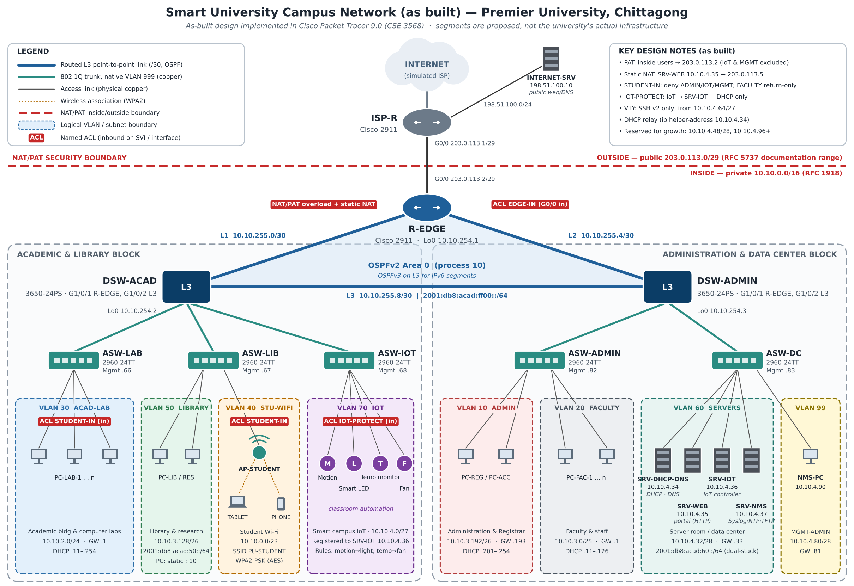
Figure 1. As-built logical design (diagram drawn from the implemented configuration).

8. Actual Packet Tracer Topology
Figure 2 is a screenshot of the logical workspace of the saved project file. Device labels match the configured hostnames; port labels show the cabling used.
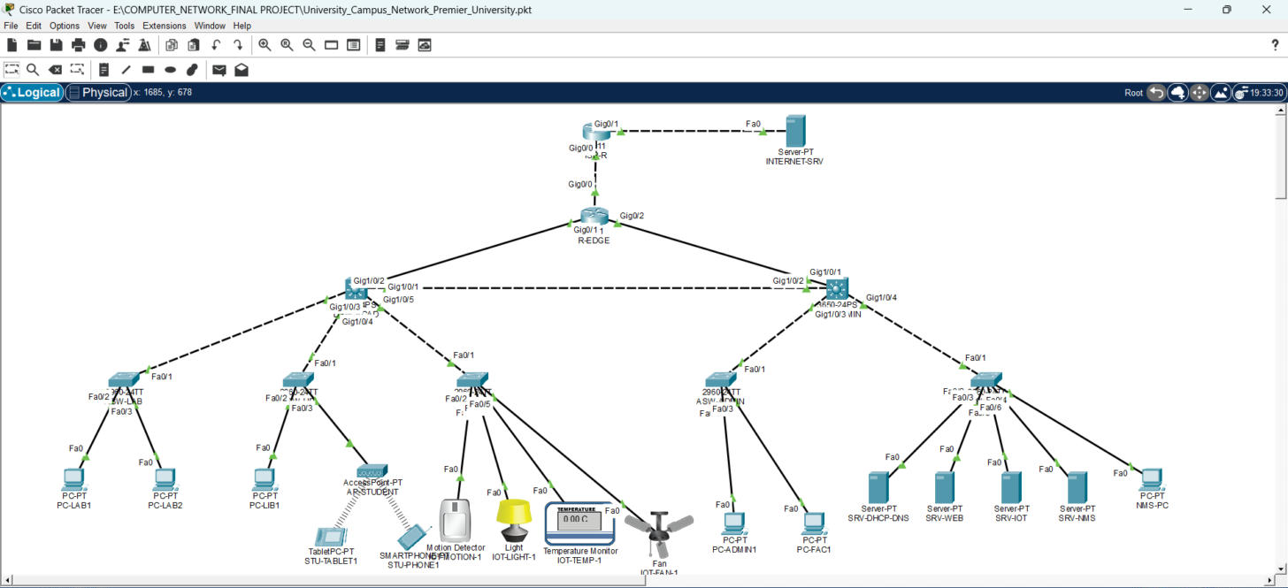
Figure 2. Logical topology in Cisco Packet Tracer 9.0 (screenshot of the saved project).

9. Device Inventory
Device | Model | Role | Key interfaces / address
ISP-R | Cisco 2911 | Simulated ISP | G0/0 203.0.113.1/29, G0/1 198.51.100.1/24
INTERNET-SRV | Server-PT | Simulated Internet web server | 198.51.100.10/24
R-EDGE | Cisco 2911 | Edge router, NAT/PAT, EDGE-IN ACL, OSPF ASBR | G0/0 203.0.113.2/29, G0/1 10.10.255.1/30, G0/2 10.10.255.5/30, Lo0 10.10.254.1
DSW-ACAD | Catalyst 3650-24PS | Distribution, SVIs 30/40/50/70/98 | G1/0/1 10.10.255.2, G1/0/2 10.10.255.9, trunks G1/0/3-5
DSW-ADMIN | Catalyst 3650-24PS | Distribution, SVIs 10/20/60/99 | G1/0/1 10.10.255.6, G1/0/2 10.10.255.10, trunks G1/0/3-4
ASW-LAB / ASW-LIB / ASW-IOT | Catalyst 2960-24TT | Access (academic block) | Fa0/1 trunk; mgmt 10.10.4.66/.67/.68
ASW-ADMIN / ASW-DC | Catalyst 2960-24TT | Access (admin block) | Fa0/1 trunk; mgmt 10.10.4.82/.83
SRV-DHCP-DNS / SRV-WEB / SRV-IOT / SRV-NMS | Server-PT | DHCP+DNS / portal / IoT controller / syslog | 10.10.4.34 / .35 / .36 / .37
AP-STUDENT | AccessPoint-PT | WPA2-AES SSID PU-STUDENT | ASW-LIB Fa0/3, VLAN 40
PC-LAB1, PC-LAB2, PC-LIB1, PC-ADMIN1, PC-FAC1, NMS-PC | PC-PT | Representative users | DHCP (NMS-PC static 10.10.4.90)
STU-TABLET1, STU-PHONE1 | TabletPC-PT, Smartphone-PT | Wireless clients | DHCP 10.10.0.11, 10.10.0.13
IOT-MOTION-1, IOT-LIGHT-1, IOT-TEMP-1, IOT-FAN-1 | Home IoT devices | Sensors and actuators | Wired adapter PT-IOT-NM-1CFE, VLAN 70

10. VLAN Table
VLAN | Name | Purpose | Switches | Gateway (SVI)
10 | ADMIN | Administration & Registrar | DSW-ADMIN, ASW-ADMIN | 10.10.3.193
20 | FACULTY | Faculty & staff | DSW-ADMIN, ASW-ADMIN | 10.10.3.1
30 | ACAD-LAB | Computer labs | DSW-ACAD, ASW-LAB | 10.10.2.1
40 | STU-WIFI | Student wireless | DSW-ACAD, ASW-LIB | 10.10.0.1
50 | LIBRARY | Library & research (dual-stack) | DSW-ACAD, ASW-LIB | 10.10.3.129
60 | SERVERS | Data centre (dual-stack) | DSW-ADMIN, ASW-DC | 10.10.4.33
70 | IOT | Smart campus devices | DSW-ACAD, ASW-IOT | 10.10.4.1
98 | MGMT-ACAD | Switch management (academic) | DSW-ACAD + academic ASWs | 10.10.4.65
99 | MGMT-ADMIN | Switch management + NMS-PC | DSW-ADMIN + admin ASWs | 10.10.4.81
998 | PARKING | Unused, shut-down ports | All switches | —
999 | NATIVE | Unused native VLAN on trunks | All trunks | —

11. IPv4 and VLSM Addressing Table
Subnets were allocated largest first from 10.10.0.0/16. Every subnet was checked by script for overlap and DHCP-scope containment before configuration. VLANs 98 and 99 occupy one aligned /27 (10.10.4.64/27), so one ACL wildcard (0.0.0.31) matches both management VLANs. 10.10.4.96 – 10.10.253.255 remains free.
VLAN/Link | Name | Network | Prefix | Subnet mask | First usable | Last usable | Broadcast | DHCP range
10 | ADMIN (Administration & Registrar) | 10.10.3.192 | /26 | 255.255.255.192 | 10.10.3.193 | 10.10.3.254 | 10.10.3.255 | 10.10.3.201-10.10.3.254
20 | FACULTY (Faculty & Staff) | 10.10.3.0 | /25 | 255.255.255.128 | 10.10.3.1 | 10.10.3.126 | 10.10.3.127 | 10.10.3.11-10.10.3.126
30 | ACAD-LAB (Academic Bldg & Computer Labs) | 10.10.2.0 | /24 | 255.255.255.0 | 10.10.2.1 | 10.10.2.254 | 10.10.2.255 | 10.10.2.11-10.10.2.254
40 | STU-WIFI (Student Wi-Fi) | 10.10.0.0 | /23 | 255.255.254.0 | 10.10.0.1 | 10.10.1.254 | 10.10.1.255 | 10.10.0.11-10.10.1.254
50 | LIBRARY (Library & Research) | 10.10.3.128 | /26 | 255.255.255.192 | 10.10.3.129 | 10.10.3.190 | 10.10.3.191 | 10.10.3.136-10.10.3.190
60 | SERVERS (Server Room / Data Center) | 10.10.4.32 | /28 | 255.255.255.240 | 10.10.4.33 | 10.10.4.46 | 10.10.4.47 | static
70 | IOT (Smart Campus IoT) | 10.10.4.0 | /27 | 255.255.255.224 | 10.10.4.1 | 10.10.4.30 | 10.10.4.31 | 10.10.4.11-10.10.4.30
98 | MGMT-ACAD (Network Mgmt (Academic block)) | 10.10.4.64 | /28 | 255.255.255.240 | 10.10.4.65 | 10.10.4.78 | 10.10.4.79 | static
99 | MGMT-ADMIN (Network Mgmt & Security) | 10.10.4.80 | /28 | 255.255.255.240 | 10.10.4.81 | 10.10.4.94 | 10.10.4.95 | static
L1 | R-EDGE G0/1 ↔ DSW-ACAD G1/0/1 | 10.10.255.0 | /30 | 255.255.255.252 | 10.10.255.1 | 10.10.255.2 | 10.10.255.3 | -
L2 | R-EDGE G0/2 ↔ DSW-ADMIN G1/0/1 | 10.10.255.4 | /30 | 255.255.255.252 | 10.10.255.5 | 10.10.255.6 | 10.10.255.7 | -
L3 | DSW-ACAD G1/0/2 ↔ DSW-ADMIN G1/0/2 | 10.10.255.8 | /30 | 255.255.255.252 | 10.10.255.9 | 10.10.255.10 | 10.10.255.11 | -
Lo0 | OSPF router-IDs | 10.10.254.1-3 | /32 | 255.255.255.255 |  |  |  | -
WAN | R-EDGE G0/0 - ISP-R G0/0 | 203.0.113.0 | /29 | 255.255.255.248 | 203.0.113.1 | 203.0.113.6 | 203.0.113.7 | -
ISP LAN | Simulated Internet | 198.51.100.0 | /24 | 255.255.255.0 | 198.51.100.1 | 198.51.100.254 | 198.51.100.255 | -
Reserved | Future DMZ / server growth | 10.10.4.48 | /28 | 255.255.255.240

12. IPv6 Configuration
Segment | Prefix | Router address | Host
VLAN 50 Library | 2001:DB8:ACAD:50::/64 | DSW-ACAD SVI ::1, link-local FE80::1 | PC-LIB1 2001:DB8:ACAD:50::10 (static), gateway FE80::1
VLAN 60 Servers | 2001:DB8:ACAD:60::/64 | DSW-ADMIN SVI ::1, link-local FE80::1 | SRV-WEB 2001:DB8:ACAD:60::35, gateway FE80::1
Link L3 | 2001:DB8:ACAD:FF00::/64 | DSW-ACAD ::1, DSW-ADMIN ::2 | —
ipv6 unicast-routing and OSPFv3 process 10 (Area 0) run on both 3650 switches. The OSPFv3 adjacency reached FULL and DSW-ACAD learned 2001:DB8:ACAD:60::/64 (Figure 9a). PC-LIB1 did not obtain a global address by SLAAC, so a static address was configured; the IPv6 ping to the web server then succeeded (Figure 15).
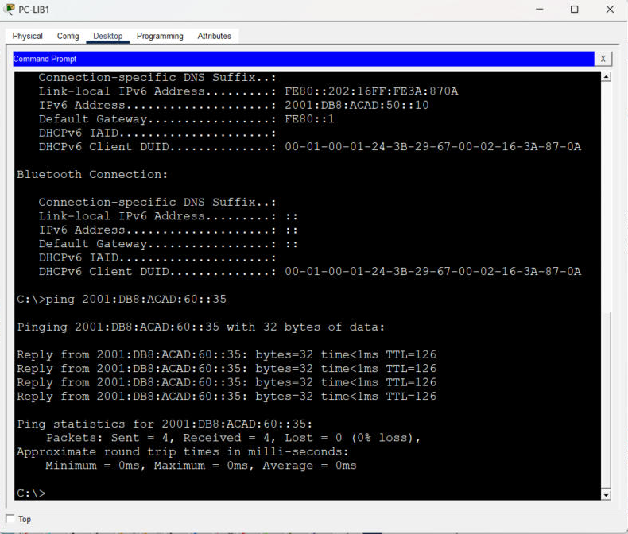
Figure 15. PC-LIB1: static IPv6 address and 0% loss ping to SRV-WEB 2001:DB8:ACAD:60::35.

13. Routing Design
OSPFv2 process 10 runs in a single Area 0 with loopback router-IDs 10.10.254.1–3. On the 3650s, passive-interface default is used and only the two routed uplinks are made active, so SVI subnets are advertised without forming adjacencies toward users. R-EDGE holds a static default route to the ISP and advertises it with default-information originate. OSPF was chosen over EIGRP (vendor-specific) and RIP (hop-count metric, slow convergence). The ISP router intentionally has no route to 10.10.0.0/16, so Internet replies can return only through NAT.
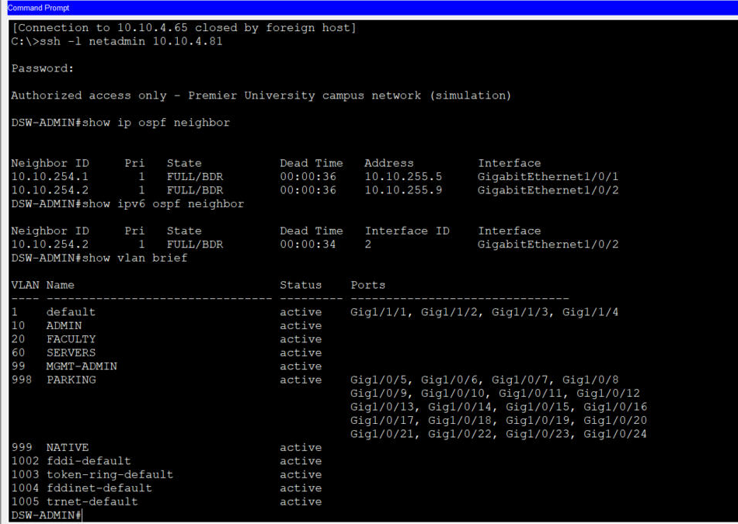
Figure 3. DSW-ADMIN: OSPFv2 neighbours (R-EDGE, DSW-ACAD) and OSPFv3 neighbour FULL; block VLANs.
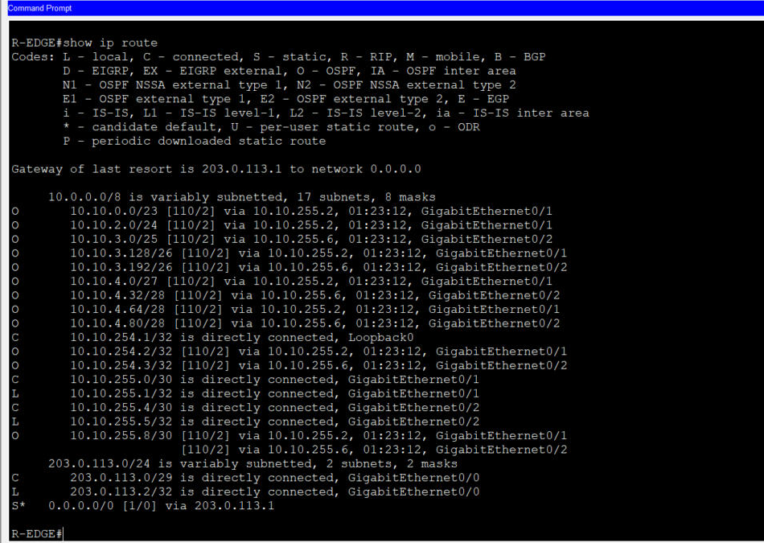
Figure 4. R-EDGE routing table: every campus subnet learned by OSPF, and the static default route.

14. DHCP and DNS
SRV-DHCP-DNS (10.10.4.34) holds one pool per client VLAN (10, 20, 30, 40, 50, 70). Each SVI forwards DHCP broadcasts with ip helper-address 10.10.4.34, and the server selects the pool that matches the relay address. DNS A records point portal.pu.internal, iot.pu.internal and nms.pu.internal at the servers, and an AAAA record (portal6.pu.internal) holds the portal's IPv6 address. Observed leases: PC-LAB1 10.10.2.11, PC-LAB2 10.10.2.12, PC-ADMIN1 10.10.3.201, PC-FAC1 10.10.3.11, PC-LIB1 10.10.3.136, tablet 10.10.0.12 (10.10.0.11 after re-lease), phone 10.10.0.13, motion detector 10.10.4.11.
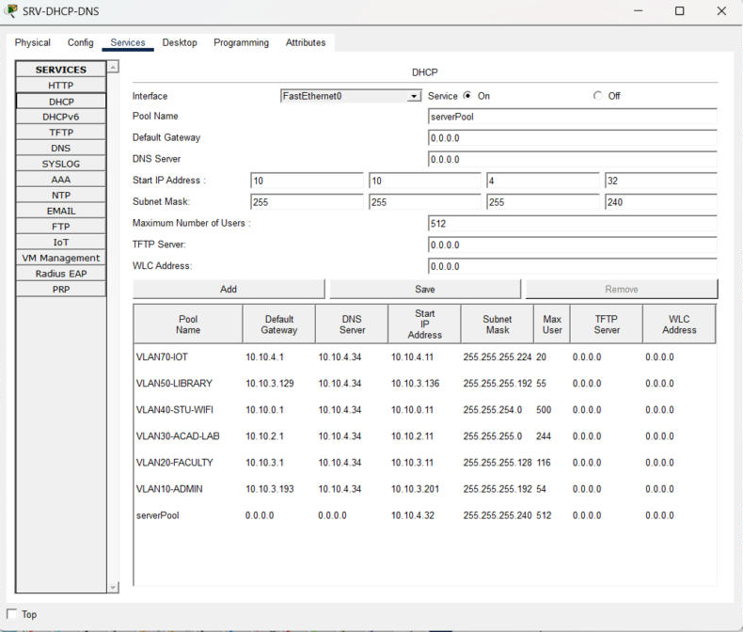
Figure 5a. DHCP pools on SRV-DHCP-DNS.
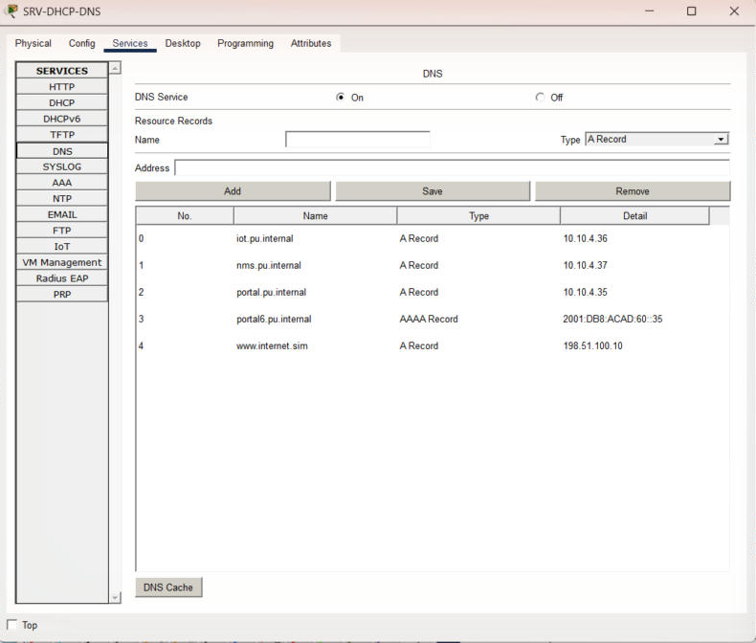
Figure 5b. DNS resource records.
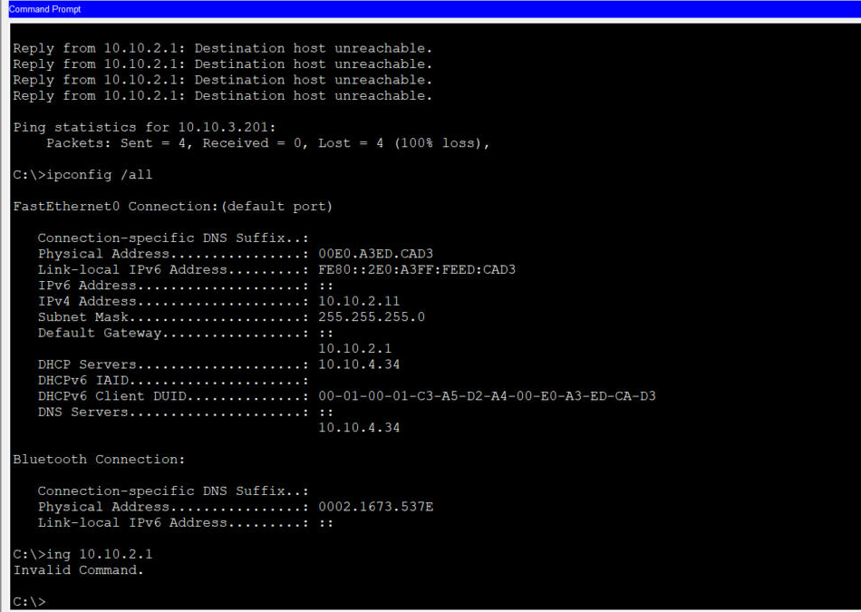
Figure 6. PC-LAB1 lease from the central server (10.10.4.34) through DHCP relay.

15. Server Configuration
SRV-WEB serves a campus portal page over HTTP on 10.10.4.35 and 2001:DB8:ACAD:60::35, and is published to the outside as 203.0.113.5 by static NAT. SRV-IOT runs the IoT registration service. SRV-NMS has its syslog service enabled; no network device has yet been configured to send logs to it (logging host is a recommended next step). INTERNET-SRV (198.51.100.10) represents a public website behind ISP-R.
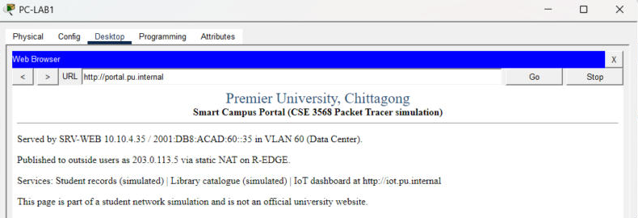
Figure 7. Campus portal opened by name from PC-LAB1 (DNS + inter-VLAN routing + HTTP).

16. ACL and NAT/PAT
Policy | Applied | Rules (summary)
STUDENT-IN (extended) | DSW-ACAD SVI 30 and SVI 40, inbound | Permit DHCP; permit established TCP and echo-replies to faculty; deny faculty, admin (10.10.3.192/26), IoT (10.10.4.0/27), management (10.10.4.64/27); permit everything else
IOT-PROTECT (extended) | DSW-ACAD SVI 70, inbound | Permit DHCP; permit IoT → SRV-IOT 10.10.4.36; permit echo-replies to management; deny all else
EDGE-IN (extended) | R-EDGE G0/0, inbound | Permit HTTP to 203.0.113.5; permit established TCP, DNS replies, echo-reply, unreachable; deny all else
MGMT-ONLY (standard) | access-class on VTY lines of all 8 network devices | Permit 10.10.4.64/27 only; VTY accepts SSH v2 only, local login
NAT-USERS + PAT | R-EDGE inside G0/1-2, outside G0/0 | Deny IoT and management subnets; permit 10.10.0.0/16; overload on G0/0 (203.0.113.2)
Static NAT | R-EDGE | 10.10.4.35 ↔ 203.0.113.5
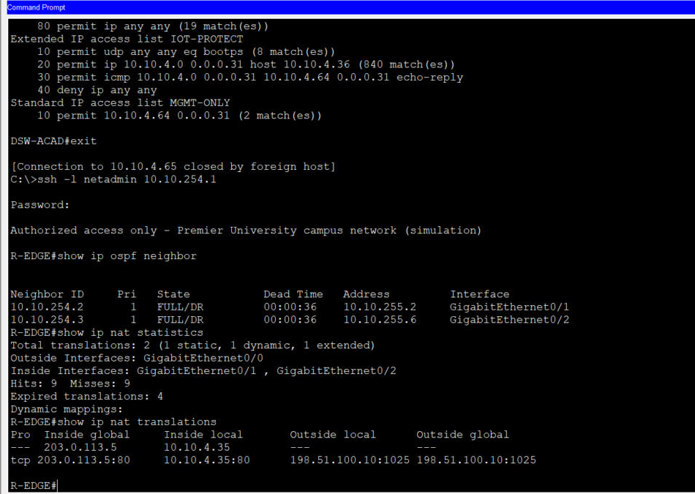
Figure 8a. R-EDGE (SSH from NMS-PC): OSPF neighbours, NAT statistics and translations.
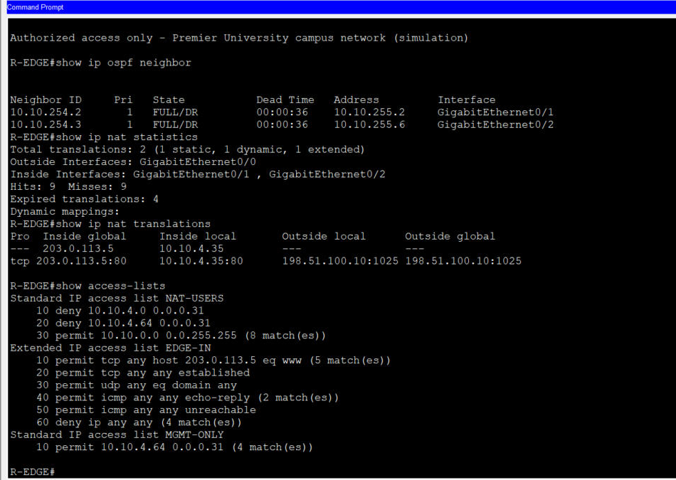
Figure 8b. R-EDGE: NAT-USERS, EDGE-IN and MGMT-ONLY hit counters.
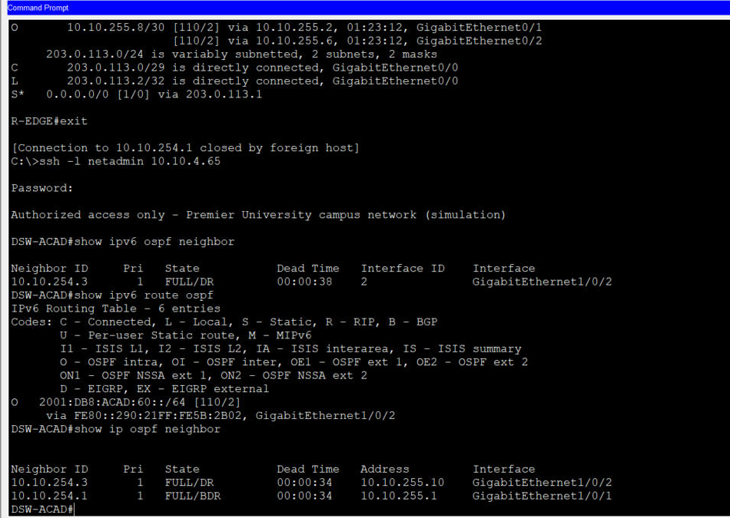
Figure 9a. DSW-ACAD: OSPFv3 neighbour, IPv6 OSPF route and OSPFv2 neighbours.
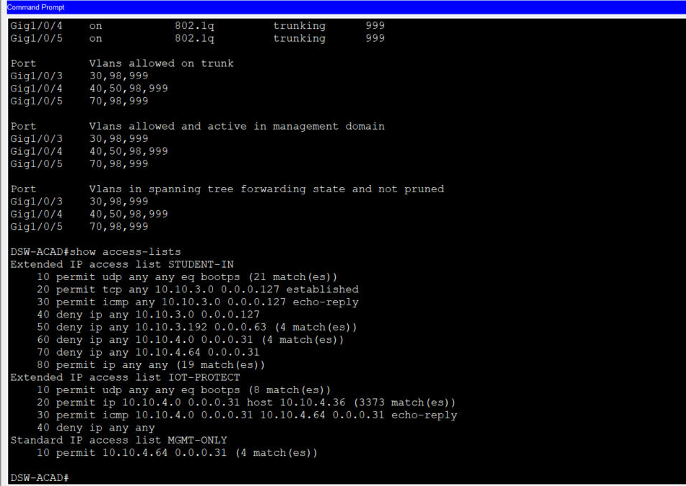
Figure 9b. DSW-ACAD: STUDENT-IN and IOT-PROTECT hit counters.
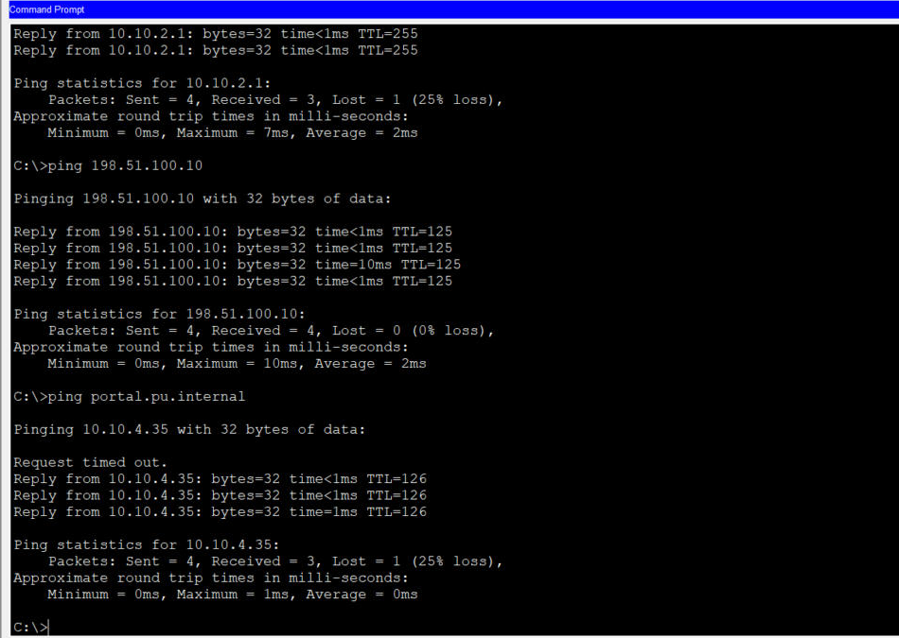
Figure 10a. PC-LAB1: gateway, Internet (through PAT) and portal-by-name reachable.
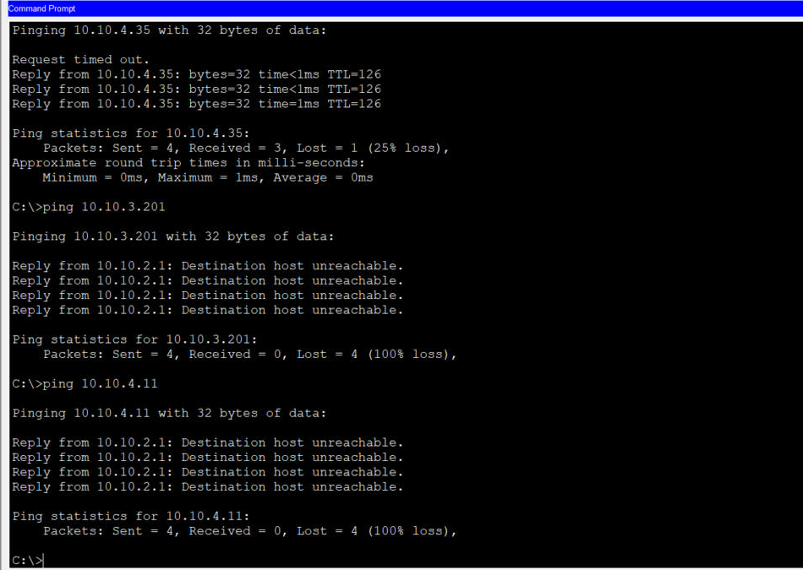
Figure 10b. PC-LAB1: registrar and IoT subnets blocked by STUDENT-IN.
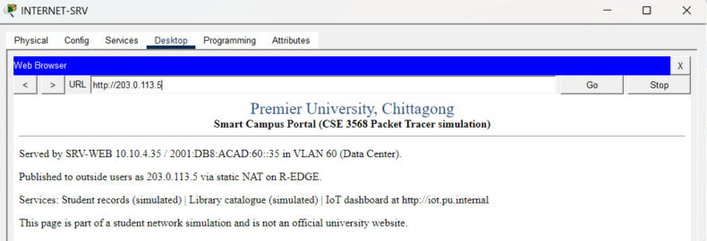
Figure 11a. INTERNET-SRV opens the portal through static NAT (203.0.113.5).
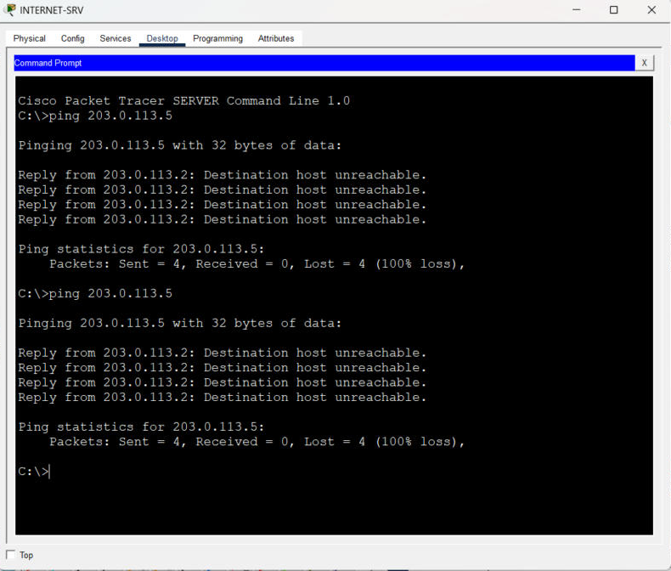
Figure 11b. INTERNET-SRV ping to 203.0.113.5 dropped by EDGE-IN.

17. Wireless Network
AP-STUDENT (AccessPoint-PT) is connected to ASW-LIB Fa0/3 in VLAN 40 and broadcasts SSID PU-STUDENT with WPA2-PSK and AES. A tablet and a smartphone were configured with the same SSID and passphrase; both associated and leased addresses from the /23 student pool. STUDENT-IN applies to them exactly as to lab PCs. A tablet was used instead of the proposed laptop because it has a built-in wireless adapter.
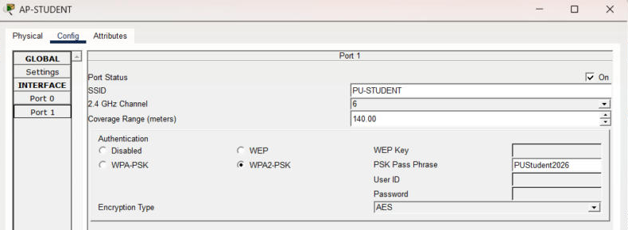
Figure 12a. AP-STUDENT security settings.
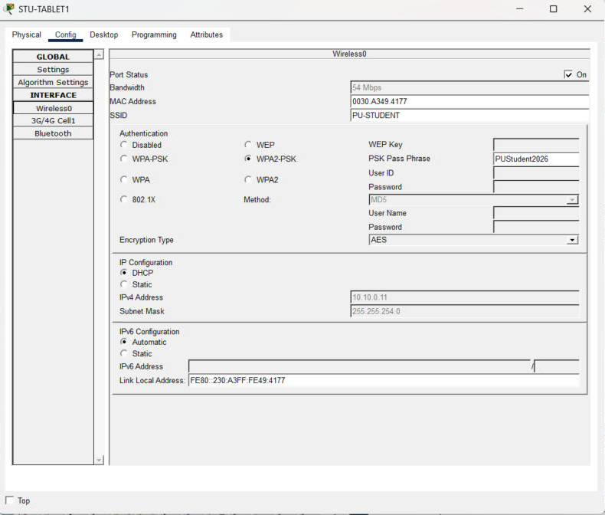
Figure 12b. STU-TABLET1 associated with WPA2-PSK/AES and leased an address from 10.10.0.0/23.
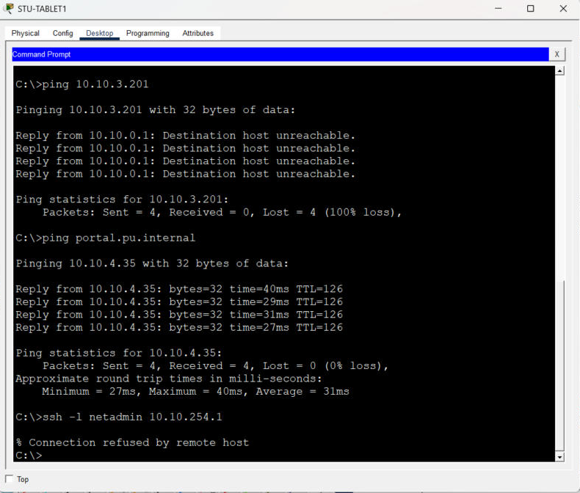
Figure 12c. STU-TABLET1: portal reachable over Wi-Fi; registrar and SSH to R-EDGE blocked.

18. IoT Automation
The four Home IoT devices were switched to the wired PT-IOT-NM-1CFE adapter, cabled to ASW-IOT (VLAN 70), addressed by DHCP and registered with SRV-IOT as remote server. An account was created on the registration server from NMS-PC, and four rules were added: R1-Lights-On / R1-Lights-Off (motion detector controls the light) and R2-Fan-High / R2-Fan-Off (temperature above 30 °C sets the fan to High; below 26 °C turns it off, the gap preventing rapid cycling). Triggering the motion detector (Alt+click) switched the light from Off to On. The temperature rule is configured but was not triggered, because the simulated ambient temperature was not changed.
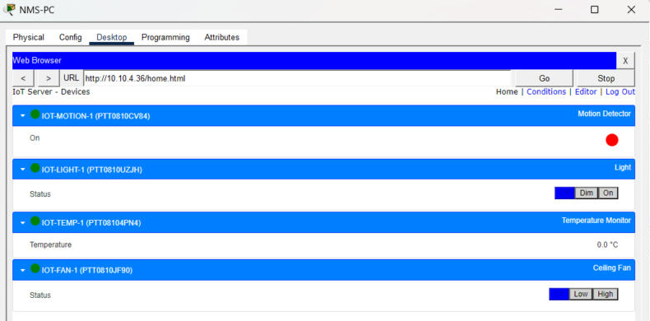
Figure 13a. All four IoT devices online on the SRV-IOT dashboard (motion detector On).
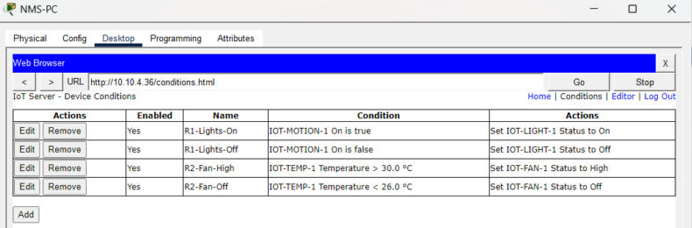
Figure 13b. Automation rules on SRV-IOT.
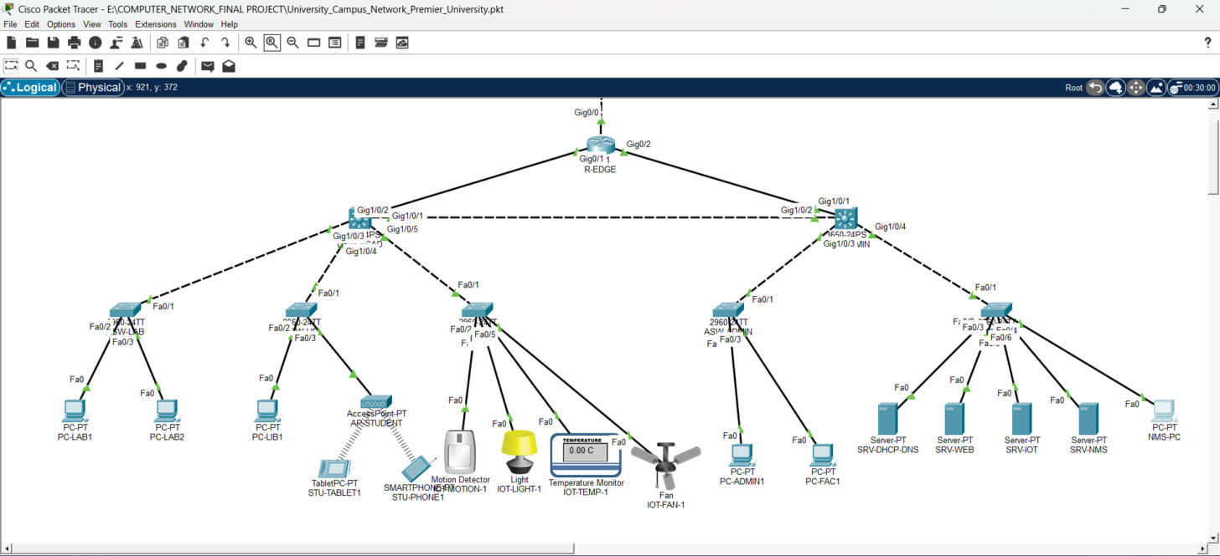
Figure 13c. After the motion trigger the smart light is on (topology view).

19. Testing Matrix
Thirty-one tests were planned against the functional requirements. Each was run in the simulation unless marked NOT TESTED. Screenshot numbers refer to files in the Screenshots folder.
ID | Area | Test | Expected | Result
T01 | Routing | OSPF adjacencies — R-EDGE: show ip ospf neighbor | FULL with 10.10.254.2 and 10.10.254.3 | PASS
T02 | Routing | All campus subnets learned — R-EDGE: show ip route | O routes for every VLAN subnet + S* default | PASS
T03 | IPv6 | OSPFv3 adjacency and route — DSW-ACAD: show ipv6 ospf neighbor / show ipv6 route ospf | Neighbour FULL; 2001:DB8:ACAD:60::/64 learned | PASS
T04 | IPv6 | End-to-end IPv6 — PC-LIB1: ping 2001:DB8:ACAD:60::35 | Replies | PASS
T05 | IPv6 | SLAAC on VLAN 50 — PC-LIB1 IPv6 = Automatic | Global address from RA | FAIL
T06 | DHCP | Relay to VLAN 30 — PC-LAB1: ipconfig /all | 10.10.2.x/24 from 10.10.4.34 | PASS
T07 | DHCP | Relay to VLANs 10/20/50 — PC-ADMIN1, PC-FAC1, PC-LIB1 DHCP | Address in own VLAN | PASS
T08 | DHCP | Relay to IoT VLAN 70 through IOT-PROTECT — IOT-MOTION-1 DHCP | 10.10.4.x/27 | PASS
T09 | VLAN/Trunk | VLANs and 802.1Q trunks — show vlan brief / show interfaces trunk (DSW-ACAD, DSW-ADMIN, ASW-DC) | Correct VLANs; trunks native 999, pruned lists | PASS
T10 | Connectivity | Default gateway — PC-LAB1: ping 10.10.2.1 | Replies | PASS
T11 | DNS/Inter-VLAN | Name resolution + server reach — PC-LAB1: ping portal.pu.internal | Resolves to 10.10.4.35, replies | PASS
T12 | Web | Campus portal — PC-LAB1 browser http://portal.pu.internal | Portal page | PASS
T13 | ACL | Student -> Registrar blocked — PC-LAB1: ping 10.10.3.201 | Fail | PASS
T14 | ACL | Student -> IoT blocked — PC-LAB1: ping 10.10.4.11 | Fail | PASS
T15 | NAT/PAT | Inside user to Internet — PC-LAB1: ping 198.51.100.10 | Replies (ISP has no route to 10.10.0.0/16) | PASS
T16 | Static NAT | Outside access to portal — INTERNET-SRV browser http://203.0.113.5 | Portal page | PASS
T17 | ACL | Unsolicited inbound ICMP blocked — INTERNET-SRV: ping 203.0.113.5 | Fail | PASS
T18 | Wireless | WPA2-AES association + DHCP — STU-TABLET1 / STU-PHONE1 | Associate, lease 10.10.0.x | PASS
T19 | Wireless | Wi-Fi client reaches services; ACL applies — STU-TABLET1: ping portal.pu.internal, ping 10.10.3.201 | Portal replies; registrar blocked | PASS
T20 | Wireless | Wrong passphrase rejected — Client with wrong key | No association | NOT TESTED
T21 | Management | SSH v2 from management VLAN — NMS-PC: ssh -l netadmin to R-EDGE, DSW-ACAD, DSW-ADMIN, ASW-DC | Login | PASS
T22 | Management | SSH from non-management host blocked — STU-TABLET1: ssh -l netadmin 10.10.254.1 | Refused | PASS
T23 | Management | Console enable on R-EDGE — R-EDGE CLI tab: enable | Prompt accepts secret | FAIL
T24 | IoT | Devices registered — SRV-IOT dashboard from NMS-PC | 4 devices online | PASS
T25 | IoT | Motion -> light rule — Alt+click IOT-MOTION-1 | Light turns On | PASS
T26 | IoT | Temperature -> fan rule — Raise ambient temperature above 30 C | Fan High | NOT TESTED
T27 | Routing | Failover when L3 is shut — shutdown G1/0/2 on DSW-ACAD, traceroute | Traffic via R-EDGE | NOT TESTED
T28 | ACL | Faculty-initiated session to lab allowed — PC-FAC1 ping PC-LAB1 | Replies | NOT TESTED
T29 | Switching | Port-security / BPDU Guard — Connect extra device / switch | Port err-disabled | NOT TESTED
T30 | File | Native .pkt saved — File > Save / Save As | .pkt written by Packet Tracer | PASS
T31 | File | Reopen .pkt and re-test — File > Open | Topology and configs persist | NOT TESTED

20. Actual Test Results
ID | Observed result | Evidence
T01 | Both FULL; DSW-ACAD and DSW-ADMIN each also show 2 FULL neighbours | 02, 05, 08
T02 | O routes for 10.10.0.0/23 ... 10.10.4.80/28; S* 0.0.0.0/0 via 203.0.113.1 | 04
T03 | 10.10.254.3 FULL on G1/0/2; O 2001:DB8:ACAD:60::/64 [110/2] | 05
T04 | 4/4 replies, 0% loss | 16
T05 | No global address obtained; static 2001:DB8:ACAD:50::10 used instead | 16
T06 | 10.10.2.11 /24, gw 10.10.2.1, DHCP server 10.10.4.34, DNS 10.10.4.34 | 12
T07 | 10.10.3.201 /26, 10.10.3.11 /25, 10.10.3.136 /26 | 10
T08 | 10.10.4.11 /27; IOT-PROTECT bootps entry matches | 07
T09 | All VLANs active; trunks on, 802.1q, native 999, allowed lists as designed | 06, 08, 09
T10 | 3/4 replies (first lost to ARP) | 13
T11 | Resolved; 3/4 replies (first lost to ARP) | 13
T12 | Page displayed | 15
T13 | Destination host unreachable from 10.10.2.1; STUDENT-IN deny 10.10.3.192 matches | 14, 07
T14 | Destination host unreachable; STUDENT-IN deny 10.10.4.0 matches | 14, 07
T15 | 4/4 replies; NAT-USERS permit 8 matches; 4 expired dynamic translations | 13, 02, 03
T16 | Page displayed; translation tcp 203.0.113.5:80 <-> 10.10.4.35:80 listed | 23, 02
T17 | Destination host unreachable from 203.0.113.2; EDGE-IN deny matches | 24, 03
T18 | Tablet 10.10.0.11 /23 (re-leased; earlier .12), phone 10.10.0.13 /23 | 17, 18
T19 | Portal 4/4 replies; registrar blocked by 10.10.0.1 | 19
T20 | Not run | -
T21 | Logged in to all four | 02, 05, 08, 09
T22 | % Connection refused by remote host | 19
T23 | Secret rejected 3x when typed through the remote-control session; same secret works over SSH. Cause not determined. | -
T24 | IOT-MOTION-1, IOT-LIGHT-1, IOT-TEMP-1, IOT-FAN-1 online | 20
T25 | Light changed from Off to On; dashboard shows motion On | 20, 22
T26 | Rule configured; ambient temperature not changed | 21
T27 | Not run | -
T28 | Not run | -
T29 | Configured only | -
T30 | Binary project file saved to E:\COMPUTER_NETWORK_FINAL PROJECT | -
T31 | Not run (file was re-saved after this session's checks) | -
Summary: 23 PASS, 2 FAIL, 6 NOT TESTED. The first lost ping in T10 and T11 is ARP resolution on first contact, not packet loss on an established path.

21. Screenshots and Evidence
All screenshots were captured at full screen resolution from the running Packet Tracer application (CLI font set to 12 pt for legibility) and are stored in the Screenshots folder; they are cropped to the relevant window but otherwise unedited:
- 01_Topology_Logical_View.png
- 02_R-EDGE_OSPF_Neighbors_and_NAT.png
- 03_R-EDGE_Access_Lists_Counters.png
- 04_R-EDGE_Routing_Table.png
- 05_DSW-ACAD_OSPFv2_OSPFv3_Neighbors_IPv6_Route.png
- 06_DSW-ACAD_VLANs_and_Trunks.png
- 07_DSW-ACAD_ACL_Counters.png
- 08_DSW-ADMIN_OSPF_Neighbors_and_VLANs.png
- 09_ASW-DC_VLANs_and_Trunk.png
- 10_SRV-DHCP-DNS_DHCP_Pools.png
- 11_SRV-DHCP-DNS_DNS_Records.png
- 12_PC-LAB1_ipconfig_DHCP_Lease.png
- 13_PC-LAB1_Gateway_Internet_DNS_Ping.png
- 14_PC-LAB1_ACL_Blocks_Registrar_and_IoT.png
- 15_PC-LAB1_Campus_Portal_by_Name.png
- 16_PC-LIB1_IPv6_Ping_to_SRV-WEB.png
- 17_AP-STUDENT_WPA2_AES.png
- 18_STU-TABLET1_Wireless_DHCP.png
- 19_STU-TABLET1_Portal_OK_ACL_and_SSH_Blocked.png
- 20_IoT_Dashboard_Devices_Live_State.png
- 21_IoT_Automation_Rules.png
- 22_IoT_Motion_Light_On_Topology.png
- 23_INTERNET-SRV_Static_NAT_Portal.png
- 24_INTERNET-SRV_Ping_Blocked_by_EDGE-IN.png
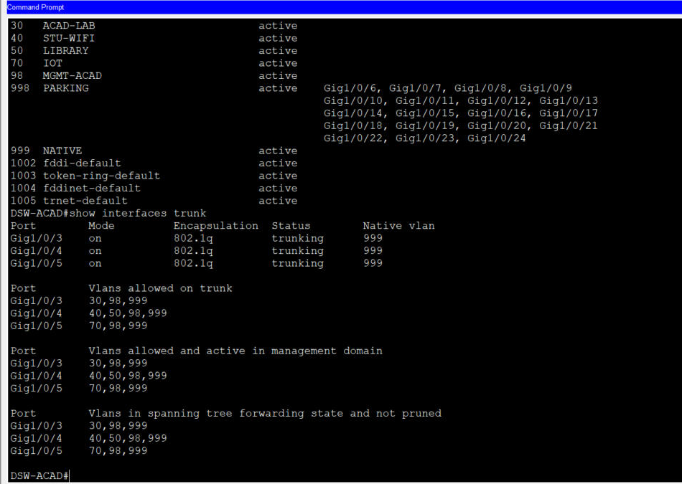
Figure 14a. DSW-ACAD: VLANs and 802.1Q trunks (native 999).
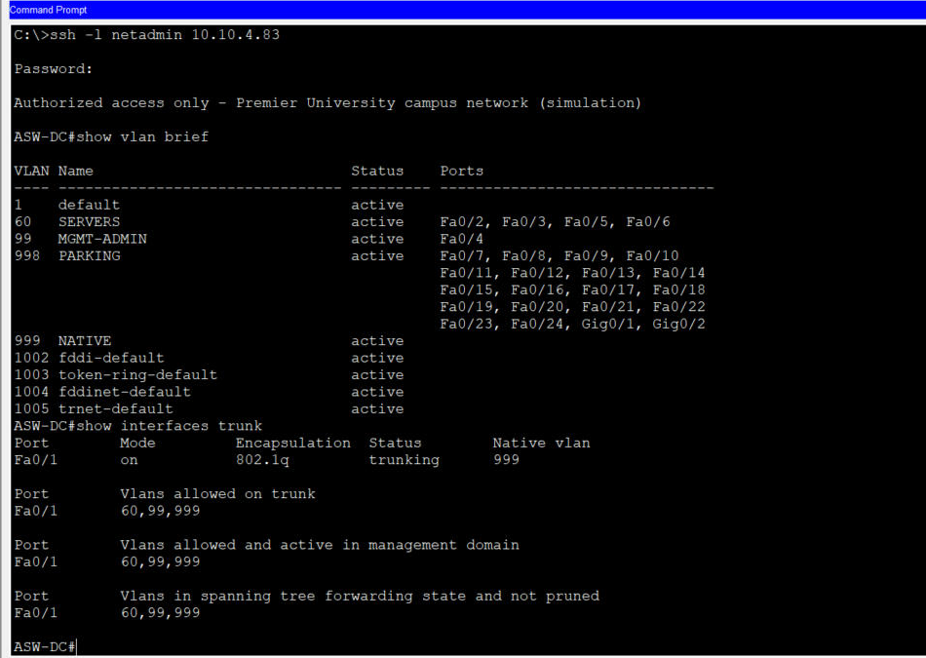
Figure 14b. ASW-DC: VLAN port membership and trunk.

22. Limitations and Deviations from the Proposal
- Edge router changed from ISR4331 to Cisco 2911: in Packet Tracer 9.0 the ISR4331's third port (G0/0/2) is SFP-only and refused the copper link to DSW-ADMIN.
- Actual ports differ from the proposal: routed links use G0/1, G0/2 on R-EDGE and G1/0/1 (uplink), G1/0/2 (L3) on the 3650s; access-switch uplinks are 2960 Fa0/1 (100 Mbps).
- PC-LIB1 did not receive an IPv6 address by SLAAC; a static IPv6 address was used (T05 FAIL). The cause (e.g. Router Advertisement behaviour of the 3650 SVI in Packet Tracer) was not investigated further.
- The R-EDGE console rejected the enable secret three times when typed through the remote-control session, although the identical secret worked over SSH (T23 FAIL). Verification on R-EDGE was therefore done over SSH from NMS-PC.
- The ICMP keyword time-exceeded is not supported by Packet Tracer 9.0, so traceroute replies from outside are not explicitly permitted by EDGE-IN.
- Not tested: OSPF failover, Wi-Fi wrong-key rejection, faculty-to-lab reachability, port-security/BPDU-guard violations, the temperature/fan rule, and reopening the saved file.
- SRV-NMS syslog/NTP is enabled but no device points at it yet; WPA2-Enterprise was not attempted.
- Device configurations in Device_Configurations are the scripts that were applied, not show running-config exports.

23. Conclusion
The project produced a working Packet Tracer model of a segmented, dual-stack smart campus network. OSPF and OSPFv3 converged across a redundant three-node routed core; DHCP relay and DNS served every client VLAN from one server; the security policy blocked students from administrative and IoT segments while keeping shared services and the Internet reachable through PAT; the portal was published safely through static NAT; WPA2 Wi-Fi clients joined the student VLAN; and an IoT rule switched classroom lighting on occupancy. The failed and untested items listed above are the natural next steps, starting with SLAAC on VLAN 50, an OSPF failover test and triggering the ventilation rule.

24. References
[1] Cisco Networking Academy, “Cisco Packet Tracer,” Cisco Systems. https://www.netacad.com/cisco-packet-tracer
[2] Cisco Systems, Cisco IOS configuration guides: OSPF, NAT, Access Control Lists, IPv6. https://www.cisco.com
[3] Y. Rekhter et al., “Address Allocation for Private Internets,” RFC 1918, IETF, 1996.
[4] J. Moy, “OSPF Version 2,” RFC 2328, IETF, 1998.
[5] R. Coltun, D. Ferguson, J. Moy and A. Lindem, “OSPF for IPv6,” RFC 5340, IETF, 2008.
[6] G. Huston, A. Lord and P. Smith, “IPv6 Address Prefix Reserved for Documentation,” RFC 3849, IETF, 2004.
[7] J. Arkko, M. Cotton and L. Vegoda, “IPv4 Address Blocks Reserved for Documentation,” RFC 5737, IETF, 2010.
[8] P. Srisuresh and K. Egevang, “Traditional IP Network Address Translator,” RFC 3022, IETF, 2001.
[9] R. Droms, “Dynamic Host Configuration Protocol,” RFC 2131, IETF, 1997.
[10] IEEE Std 802.1Q-2022; IEEE Std 802.11-2020.

25. Appendix: Device Configurations
The applied configuration scripts follow. Lab-only credentials are shown because they are part of the simulation; change them before any reuse.

ISP-R
! ISP-R - configuration script applied through the Packet Tracer IOS CLI (Paste) on 29 Oct 2026.
! This is the script that was entered, not a 'show running-config' export. Lab-only credentials: change before reuse.
!
enable
configure terminal
hostname ISP-R
no ip domain-lookup
banner motd #Simulated ISP router - CSE 3568 campus network project#
interface GigabitEthernet0/0
description WAN link to campus R-EDGE G0/0
ip address 203.0.113.1 255.255.255.248
no shutdown
interface GigabitEthernet0/1
description Simulated Internet server LAN
ip address 198.51.100.1 255.255.255.0
no shutdown
end
write memory

R-EDGE
! R-EDGE - configuration script applied through the Packet Tracer IOS CLI (Paste) on 29 Oct 2026.
! This is the script that was entered, not a 'show running-config' export. Lab-only credentials: change before reuse.
!
enable
configure terminal
hostname R-EDGE
no ip domain-lookup
ip domain-name pu.internal
service password-encryption
enable secret PULab2026
username netadmin privilege 15 secret PULab2026
banner motd #Authorized access only - Premier University campus network (simulation)#
interface Loopback0
description OSPF router-ID
ip address 10.10.254.1 255.255.255.255
interface GigabitEthernet0/0
description WAN to ISP-R G0/0 (NAT outside)
ip address 203.0.113.2 255.255.255.248
ip nat outside
no shutdown
interface GigabitEthernet0/1
description L1 to DSW-ACAD G1/0/1
ip address 10.10.255.1 255.255.255.252
ip nat inside
no shutdown
interface GigabitEthernet0/2
description L2 to DSW-ADMIN G1/0/1
ip address 10.10.255.5 255.255.255.252
ip nat inside
no shutdown
router ospf 10
router-id 10.10.254.1
network 10.10.255.0 0.0.0.3 area 0
network 10.10.255.4 0.0.0.3 area 0
network 10.10.254.1 0.0.0.0 area 0
default-information originate
ip route 0.0.0.0 0.0.0.0 203.0.113.1
ip access-list standard NAT-USERS
deny 10.10.4.0 0.0.0.31
deny 10.10.4.64 0.0.0.31
permit 10.10.0.0 0.0.255.255
ip nat inside source list NAT-USERS interface GigabitEthernet0/0 overload
ip nat inside source static 10.10.4.35 203.0.113.5
ip access-list extended EDGE-IN
permit tcp any host 203.0.113.5 eq www
permit tcp any any established
permit udp any eq domain any
permit icmp any any echo-reply
permit icmp any any unreachable
! "permit icmp any any time-exceeded" was rejected by Packet Tracer 9.0 (keyword not supported) and is NOT in the running config
deny ip any any
interface GigabitEthernet0/0
ip access-group EDGE-IN in
ip access-list standard MGMT-ONLY
permit 10.10.4.64 0.0.0.31
line con 0
logging synchronous
line vty 0 4
access-class MGMT-ONLY in
login local
transport input ssh
exit
crypto key generate rsa general-keys modulus 1024
ip ssh version 2
end
write memory

DSW-ACAD
! DSW-ACAD - configuration script applied through the Packet Tracer IOS CLI (Paste) on 29 Oct 2026.
! This is the script that was entered, not a 'show running-config' export. Lab-only credentials: change before reuse.
!
enable
configure terminal
hostname DSW-ACAD
no ip domain-lookup
ip domain-name pu.internal
service password-encryption
enable secret PULab2026
username netadmin privilege 15 secret PULab2026
banner motd #Authorized access only - Premier University campus network (simulation)#
ip routing
ipv6 unicast-routing
ipv6 router ospf 10
router-id 10.10.254.2
exit
vlan 30
name ACAD-LAB
vlan 40
name STU-WIFI
vlan 50
name LIBRARY
vlan 70
name IOT
vlan 98
name MGMT-ACAD
vlan 998
name PARKING
vlan 999
name NATIVE
exit
interface Loopback0
description OSPF router-ID
ip address 10.10.254.2 255.255.255.255
interface GigabitEthernet1/0/1
description L1 to R-EDGE G0/1
no switchport
ip address 10.10.255.2 255.255.255.252
no shutdown
interface GigabitEthernet1/0/2
description L3 inter-block link
no switchport
ip address 10.10.255.9 255.255.255.252
ipv6 address 2001:DB8:ACAD:FF00::1/64
ipv6 ospf 10 area 0
no shutdown
interface range GigabitEthernet1/0/3 - 5
switchport mode trunk
switchport trunk native vlan 999
switchport nonegotiate
no shutdown
interface GigabitEthernet1/0/3
description Trunk to ASW-LAB Fa0/1
switchport trunk allowed vlan 30,98,999
interface GigabitEthernet1/0/4
description Trunk to ASW-LIB Fa0/1
switchport trunk allowed vlan 40,50,98,999
interface GigabitEthernet1/0/5
description Trunk to ASW-IOT Fa0/1
switchport trunk allowed vlan 70,98,999
interface range GigabitEthernet1/0/6 - 24
switchport mode access
switchport access vlan 998
shutdown
ip access-list extended STUDENT-IN
permit udp any any eq bootps
permit tcp any 10.10.3.0 0.0.0.127 established
permit icmp any 10.10.3.0 0.0.0.127 echo-reply
deny ip any 10.10.3.0 0.0.0.127
deny ip any 10.10.3.192 0.0.0.63
deny ip any 10.10.4.0 0.0.0.31
deny ip any 10.10.4.64 0.0.0.31
permit ip any any
ip access-list extended IOT-PROTECT
permit udp any any eq bootps
permit ip 10.10.4.0 0.0.0.31 host 10.10.4.36
permit icmp 10.10.4.0 0.0.0.31 10.10.4.64 0.0.0.31 echo-reply
deny ip any any
interface Vlan30
description Gateway ACAD-LAB
ip address 10.10.2.1 255.255.255.0
ip helper-address 10.10.4.34
ip access-group STUDENT-IN in
no shutdown
interface Vlan40
description Gateway STU-WIFI
ip address 10.10.0.1 255.255.254.0
ip helper-address 10.10.4.34
ip access-group STUDENT-IN in
no shutdown
interface Vlan50
description Gateway LIBRARY dual-stack
ip address 10.10.3.129 255.255.255.192
ip helper-address 10.10.4.34
ipv6 address FE80::1 link-local
ipv6 address 2001:DB8:ACAD:50::1/64
ipv6 ospf 10 area 0
no shutdown
interface Vlan70
description Gateway IOT
ip address 10.10.4.1 255.255.255.224
ip helper-address 10.10.4.34
ip access-group IOT-PROTECT in
no shutdown
interface Vlan98
description Management ACAD block
ip address 10.10.4.65 255.255.255.240
no shutdown
router ospf 10
router-id 10.10.254.2
passive-interface default
no passive-interface GigabitEthernet1/0/1
no passive-interface GigabitEthernet1/0/2
network 10.10.0.0 0.0.255.255 area 0
ip access-list standard MGMT-ONLY
permit 10.10.4.64 0.0.0.31
line con 0
logging synchronous
line vty 0 4
access-class MGMT-ONLY in
login local
transport input ssh
exit
crypto key generate rsa general-keys modulus 1024
ip ssh version 2
end
write memory

DSW-ADMIN
! DSW-ADMIN - configuration script applied through the Packet Tracer IOS CLI (Paste) on 29 Oct 2026.
! This is the script that was entered, not a 'show running-config' export. Lab-only credentials: change before reuse.
!
enable
configure terminal
hostname DSW-ADMIN
no ip domain-lookup
ip domain-name pu.internal
service password-encryption
enable secret PULab2026
username netadmin privilege 15 secret PULab2026
banner motd #Authorized access only - Premier University campus network (simulation)#
ip routing
ipv6 unicast-routing
ipv6 router ospf 10
router-id 10.10.254.3
exit
vlan 10
name ADMIN
vlan 20
name FACULTY
vlan 60
name SERVERS
vlan 99
name MGMT-ADMIN
vlan 998
name PARKING
vlan 999
name NATIVE
exit
interface Loopback0
description OSPF router-ID
ip address 10.10.254.3 255.255.255.255
interface GigabitEthernet1/0/1
description L2 to R-EDGE G0/2
no switchport
ip address 10.10.255.6 255.255.255.252
no shutdown
interface GigabitEthernet1/0/2
description L3 inter-block link
no switchport
ip address 10.10.255.10 255.255.255.252
ipv6 address 2001:DB8:ACAD:FF00::2/64
ipv6 ospf 10 area 0
no shutdown
interface range GigabitEthernet1/0/3 - 4
switchport mode trunk
switchport trunk native vlan 999
switchport nonegotiate
no shutdown
interface GigabitEthernet1/0/3
description Trunk to ASW-ADMIN Fa0/1
switchport trunk allowed vlan 10,20,99,999
interface GigabitEthernet1/0/4
description Trunk to ASW-DC Fa0/1
switchport trunk allowed vlan 60,99,999
interface range GigabitEthernet1/0/5 - 24
switchport mode access
switchport access vlan 998
shutdown
interface Vlan10
description Gateway ADMIN-REGISTRAR
ip address 10.10.3.193 255.255.255.192
ip helper-address 10.10.4.34
no shutdown
interface Vlan20
description Gateway FACULTY
ip address 10.10.3.1 255.255.255.128
ip helper-address 10.10.4.34
no shutdown
interface Vlan60
description Gateway SERVERS dual-stack
ip address 10.10.4.33 255.255.255.240
ipv6 address FE80::1 link-local
ipv6 address 2001:DB8:ACAD:60::1/64
ipv6 ospf 10 area 0
no shutdown
interface Vlan99
description Management ADMIN block
ip address 10.10.4.81 255.255.255.240
no shutdown
router ospf 10
router-id 10.10.254.3
passive-interface default
no passive-interface GigabitEthernet1/0/1
no passive-interface GigabitEthernet1/0/2
network 10.10.0.0 0.0.255.255 area 0
ip access-list standard MGMT-ONLY
permit 10.10.4.64 0.0.0.31
line con 0
logging synchronous
line vty 0 4
access-class MGMT-ONLY in
login local
transport input ssh
exit
crypto key generate rsa general-keys modulus 1024
ip ssh version 2
end
write memory

ASW-LAB
! ASW-LAB - configuration script applied through the Packet Tracer IOS CLI (Paste) on 29 Oct 2026.
! This is the script that was entered, not a 'show running-config' export. Lab-only credentials: change before reuse.
!
enable
configure terminal
hostname ASW-LAB
no ip domain-lookup
ip domain-name pu.internal
service password-encryption
enable secret PULab2026
username netadmin privilege 15 secret PULab2026
banner motd #Authorized access only - Premier University campus network (simulation)#
vlan 30
name ACAD-LAB
vlan 98
name MGMT-ACAD
vlan 998
name PARKING
vlan 999
name NATIVE
exit
interface FastEthernet0/1
description Trunk to DSW-ACAD G1/0/3
switchport mode trunk
switchport trunk native vlan 999
switchport trunk allowed vlan 30,98,999
switchport nonegotiate
interface range FastEthernet0/2 - 3
description Computer lab PCs
switchport mode access
switchport access vlan 30
switchport port-security
switchport port-security maximum 2
switchport port-security mac-address sticky
spanning-tree portfast
spanning-tree bpduguard enable
interface range FastEthernet0/4 - 24 , GigabitEthernet0/1 - 2
switchport mode access
switchport access vlan 998
shutdown
interface Vlan1
shutdown
interface Vlan98
ip address 10.10.4.66 255.255.255.240
no shutdown
ip default-gateway 10.10.4.65
ip access-list standard MGMT-ONLY
permit 10.10.4.64 0.0.0.31
line con 0
logging synchronous
line vty 0 15
access-class MGMT-ONLY in
login local
transport input ssh
exit
crypto key generate rsa general-keys modulus 1024
ip ssh version 2
end
write memory

ASW-LIB
! ASW-LIB - configuration script applied through the Packet Tracer IOS CLI (Paste) on 29 Oct 2026.
! This is the script that was entered, not a 'show running-config' export. Lab-only credentials: change before reuse.
!
enable
configure terminal
hostname ASW-LIB
no ip domain-lookup
ip domain-name pu.internal
service password-encryption
enable secret PULab2026
username netadmin privilege 15 secret PULab2026
banner motd #Authorized access only - Premier University campus network (simulation)#
vlan 40
name STU-WIFI
vlan 50
name LIBRARY
vlan 98
name MGMT-ACAD
vlan 998
name PARKING
vlan 999
name NATIVE
exit
interface FastEthernet0/1
description Trunk to DSW-ACAD G1/0/4
switchport mode trunk
switchport trunk native vlan 999
switchport trunk allowed vlan 40,50,98,999
switchport nonegotiate
interface FastEthernet0/2
description Library research PC
switchport mode access
switchport access vlan 50
switchport port-security
switchport port-security maximum 2
switchport port-security mac-address sticky
spanning-tree portfast
spanning-tree bpduguard enable
interface FastEthernet0/3
description AP-STUDENT (SSID PU-STUDENT)
switchport mode access
switchport access vlan 40
spanning-tree portfast
interface range FastEthernet0/4 - 24 , GigabitEthernet0/1 - 2
switchport mode access
switchport access vlan 998
shutdown
interface Vlan1
shutdown
interface Vlan98
ip address 10.10.4.67 255.255.255.240
no shutdown
ip default-gateway 10.10.4.65
ip access-list standard MGMT-ONLY
permit 10.10.4.64 0.0.0.31
line con 0
logging synchronous
line vty 0 15
access-class MGMT-ONLY in
login local
transport input ssh
exit
crypto key generate rsa general-keys modulus 1024
ip ssh version 2
end
write memory

ASW-IOT
! ASW-IOT - configuration script applied through the Packet Tracer IOS CLI (Paste) on 29 Oct 2026.
! This is the script that was entered, not a 'show running-config' export. Lab-only credentials: change before reuse.
!
enable
configure terminal
hostname ASW-IOT
no ip domain-lookup
ip domain-name pu.internal
service password-encryption
enable secret PULab2026
username netadmin privilege 15 secret PULab2026
banner motd #Authorized access only - Premier University campus network (simulation)#
vlan 70
name IOT
vlan 98
name MGMT-ACAD
vlan 998
name PARKING
vlan 999
name NATIVE
exit
interface FastEthernet0/1
description Trunk to DSW-ACAD G1/0/5
switchport mode trunk
switchport trunk native vlan 999
switchport trunk allowed vlan 70,98,999
switchport nonegotiate
interface range FastEthernet0/2 - 5
description Smart campus IoT devices
switchport mode access
switchport access vlan 70
switchport port-security
switchport port-security maximum 1
switchport port-security mac-address sticky
spanning-tree portfast
spanning-tree bpduguard enable
interface range FastEthernet0/6 - 24 , GigabitEthernet0/1 - 2
switchport mode access
switchport access vlan 998
shutdown
interface Vlan1
shutdown
interface Vlan98
ip address 10.10.4.68 255.255.255.240
no shutdown
ip default-gateway 10.10.4.65
ip access-list standard MGMT-ONLY
permit 10.10.4.64 0.0.0.31
line con 0
logging synchronous
line vty 0 15
access-class MGMT-ONLY in
login local
transport input ssh
exit
crypto key generate rsa general-keys modulus 1024
ip ssh version 2
end
write memory

ASW-ADMIN
! ASW-ADMIN - configuration script applied through the Packet Tracer IOS CLI (Paste) on 29 Oct 2026.
! This is the script that was entered, not a 'show running-config' export. Lab-only credentials: change before reuse.
!
enable
configure terminal
hostname ASW-ADMIN
no ip domain-lookup
ip domain-name pu.internal
service password-encryption
enable secret PULab2026
username netadmin privilege 15 secret PULab2026
banner motd #Authorized access only - Premier University campus network (simulation)#
vlan 10
name ADMIN
vlan 20
name FACULTY
vlan 99
name MGMT-ADMIN
vlan 998
name PARKING
vlan 999
name NATIVE
exit
interface FastEthernet0/1
description Trunk to DSW-ADMIN G1/0/3
switchport mode trunk
switchport trunk native vlan 999
switchport trunk allowed vlan 10,20,99,999
switchport nonegotiate
interface FastEthernet0/2
description Registrar office PC
switchport mode access
switchport access vlan 10
interface FastEthernet0/3
description Faculty PC
switchport mode access
switchport access vlan 20
interface range FastEthernet0/2 - 3
switchport port-security
switchport port-security maximum 2
switchport port-security mac-address sticky
spanning-tree portfast
spanning-tree bpduguard enable
interface range FastEthernet0/4 - 24 , GigabitEthernet0/1 - 2
switchport mode access
switchport access vlan 998
shutdown
interface Vlan1
shutdown
interface Vlan99
ip address 10.10.4.82 255.255.255.240
no shutdown
ip default-gateway 10.10.4.81
ip access-list standard MGMT-ONLY
permit 10.10.4.64 0.0.0.31
line con 0
logging synchronous
line vty 0 15
access-class MGMT-ONLY in
login local
transport input ssh
exit
crypto key generate rsa general-keys modulus 1024
ip ssh version 2
end
write memory

ASW-DC
! ASW-DC - configuration script applied through the Packet Tracer IOS CLI (Paste) on 29 Oct 2026.
! This is the script that was entered, not a 'show running-config' export. Lab-only credentials: change before reuse.
!
enable
configure terminal
hostname ASW-DC
no ip domain-lookup
ip domain-name pu.internal
service password-encryption
enable secret PULab2026
username netadmin privilege 15 secret PULab2026
banner motd #Authorized access only - Premier University campus network (simulation)#
vlan 60
name SERVERS
vlan 99
name MGMT-ADMIN
vlan 998
name PARKING
vlan 999
name NATIVE
exit
interface FastEthernet0/1
description Trunk to DSW-ADMIN G1/0/4
switchport mode trunk
switchport trunk native vlan 999
switchport trunk allowed vlan 60,99,999
switchport nonegotiate
interface range FastEthernet0/2 - 3 , FastEthernet0/5 - 6
description Data center servers
switchport mode access
switchport access vlan 60
spanning-tree portfast
spanning-tree bpduguard enable
interface FastEthernet0/4
description NMS-PC network management workstation
switchport mode access
switchport access vlan 99
spanning-tree portfast
spanning-tree bpduguard enable
interface range FastEthernet0/7 - 24 , GigabitEthernet0/1 - 2
switchport mode access
switchport access vlan 998
shutdown
interface Vlan1
shutdown
interface Vlan99
ip address 10.10.4.83 255.255.255.240
no shutdown
ip default-gateway 10.10.4.81
ip access-list standard MGMT-ONLY
permit 10.10.4.64 0.0.0.31
line con 0
logging synchronous
line vty 0 15
access-class MGMT-ONLY in
login local
transport input ssh
exit
crypto key generate rsa general-keys modulus 1024
ip ssh version 2
end
write memory

End devices and services
End devices and services configured through the Packet Tracer GUI (Config / Services / Desktop tabs)
=====================================================================================================
SRV-DHCP-DNS 10.10.4.34/28 GW 10.10.4.33 DNS 10.10.4.34
DHCP (service ON). Pools: VLAN10-ADMIN gw 10.10.3.193 start 10.10.3.201 /26 max 54
VLAN20-FACULTY gw 10.10.3.1 start 10.10.3.11 /25 max 116
VLAN30-ACAD-LAB gw 10.10.2.1 start 10.10.2.11 /24 max 244
VLAN40-STU-WIFI gw 10.10.0.1 start 10.10.0.11 /23 max 500
VLAN50-LIBRARY gw 10.10.3.129 start 10.10.3.136 /26 max 55
VLAN70-IOT gw 10.10.4.1 start 10.10.4.11 /27 max 20
(default serverPool left in place; unused because no DHCP clients exist in VLAN 60)
DNS (service ON): portal.pu.internal A 10.10.4.35 | iot.pu.internal A 10.10.4.36 | nms.pu.internal A 10.10.4.37
www.internet.sim A 198.51.100.10 | portal6.pu.internal AAAA 2001:DB8:ACAD:60::35
SRV-WEB 10.10.4.35/28 GW 10.10.4.33 | 2001:DB8:ACAD:60::35/64 GW FE80::1 | HTTP index.html = campus portal page
SRV-IOT 10.10.4.36/28 GW 10.10.4.33 | IoT registration service ON | account iotadmin / PUIoT2026 (lab only)
Rules: R1-Lights-On IF IOT-MOTION-1 On = true THEN IOT-LIGHT-1 Status = On
R1-Lights-Off IF IOT-MOTION-1 On = false THEN IOT-LIGHT-1 Status = Off
R2-Fan-High IF IOT-TEMP-1 Temperature > 30 C THEN IOT-FAN-1 Status = High
R2-Fan-Off IF IOT-TEMP-1 Temperature < 26 C THEN IOT-FAN-1 Status = Off
SRV-NMS 10.10.4.37/28 GW 10.10.4.33 | Syslog service ON (no device has been pointed at it yet)
INTERNET-SRV 198.51.100.10/24 GW 198.51.100.1 | HTTP test page
NMS-PC 10.10.4.90/28 GW 10.10.4.81 DNS 10.10.4.34 (static)
PC-LAB1, PC-LAB2, PC-ADMIN1, PC-FAC1: DHCP (leases observed 10.10.2.11, 10.10.2.12, 10.10.3.201, 10.10.3.11)
PC-LIB1 DHCP IPv4 (10.10.3.136) + static IPv6 2001:DB8:ACAD:50::10/64, gateway FE80::1
AP-STUDENT Port 1: SSID PU-STUDENT, WPA2-PSK, AES, passphrase PUStudent2026 (lab only)
STU-TABLET1, STU-PHONE1: SSID PU-STUDENT WPA2-PSK AES, DHCP (leases 10.10.0.12, 10.10.0.13)
IoT devices (IOT-MOTION-1, IOT-LIGHT-1, IOT-TEMP-1, IOT-FAN-1): adapter changed to PT-IOT-NM-1CFE (wired),
DHCP, IoT Server = Remote Server 10.10.4.36 (iotadmin). IOT-MOTION-1 leased 10.10.4.11.

