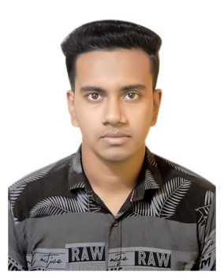**CURRICULAM VITAE**

**Shahadat Ahmed Mahi**

Web Designer

Contact No : +8801834782001

Email : [shahadatmahi567@gmail.com](mailto:shahadatmahi567@gmail.com)

**CAREER OBJECTIVE**

Enthusiastic and hard working web designer seeking a position with smart solutions where I can satisfy my clients and customers with my services.

**EXTRA CURRICULAR ACTIVITIES**

* Writing, Poetize
* Poem Recitation
* Indoor and Outdoor games

**EDUCATIONAL QUALIFICATIONS**

**Secondary School Certificate**

Group : Science

Institute : Govt. MC (Mohammed Chowdhury) Academy

Board : Sylhet

Passing Year : 2020

Result : GPA 5.00 out of 5.00

**Junior School Certificate**

Institute : Jahir Tahir Memorial High School

Board : Sylhet

Passing Year : 2017

Result : GPA 4.71 out of 5.00

**Primary Education Certificate**

Institute : Metrocity Pre-Cadet Academy

Board : Sylhet

Passing Year : 2014

Result : GPA 5.00 out of 5.00

**LANGUAGE PROFICIENCY**

|  |  |  |  |  |
| --- | --- | --- | --- | --- |
| **Language** | **Reading** | **Writing** | **Speaking** | **Listening** |
| English | Excellent | Excellent | Excellent | Excellent |
| Bengali | Excellent | Excellent | Excellent | Excellent |

**PERSONAL INFORMATION**

Full Name : Shahadat Ahmed Mahi

Father’s Name : Faruk Ahmed

Mother’s Name : Halima Begum

Date of Birth : 5 September 2003

Marital Status : Unmarried

Religion : Islam

Present Address :

Village : Kuchai Post-office : Kadamtaly

Station-house : Moglabazar

Union : Kuchai District : Sylhet

Permanent Address :

Village : Khalagram, Mollapara Post-office : Ranaping

Station-house : Beanibazar

Union : 1 no. Alinagar District : Sylhet

Shahadat Ahmed Mahi