SENG205 – Software Engineering
Assessment 3 – Complete Project Documentation
SmartClinic+
Group 07
Abu Bakkar Siddiquey – K250482
Mohammad Shahadat Hossen – K250578
Aadarsha Shrestha – K250653
Anayat Ahmed Monna – K250420
Lecturer: Danish Abbasi

1. Introduction
SmartClinic+ is a digital clinic management system designed to make regular healthcare processes faster, clearer, and more organised. The idea comes from common clinic problems such as long queues, scattered patient information, manual paperwork, scheduling conflicts, and communication gaps between staff and patients. This report develops the SmartClinic+ concept into detailed project documentation by refining the requirements, system design, prototype, project management, and testing activities. The aim is to present a realistic system blueprint that can guide future implementation while clearly separating the work that has already been demonstrated in the prototype from technical functions that still require full development.

1.1 SmartClinic+ Project Background
SmartClinic+ was envisioned as a modern solution to everyday problems faced in outpatient clinics. Traditional processes can slow service delivery when appointment information, patient records, laboratory results, and staff activities are handled separately. SmartClinic+ brings the main clinic functions into one proposed digital environment. The project focuses on appointment management, smart queueing, automated notifications, clinical and staff management, Electronic Health Records (EHRs), laboratory integration, analytics, and patient engagement. By supporting patients and clinic staff through one system, SmartClinic+ is intended to improve coordination, reduce avoidable delays, and provide clearer access to relevant information.

1.2 Purpose and Scope of Assessment 3
The purpose of this report is to provide complete project documentation for SmartClinic+. It includes detailed requirements, stakeholder analysis, prioritisation, UML diagrams, high-level and component design, a Hi-Fidelity Figma prototype, project-management evidence, testing and QA, a detailed timeline, and a budget. The current work demonstrates the interface and its navigation through the Figma prototype. Server-side database, security, and concurrency functions are treated as proposed implementation requirements rather than completed functionality.

2. Detailed Requirements Elicitation & Analysis

2.1 Stakeholders
SmartClinic+ has several stakeholders with different needs. Patients need simple appointment booking, queue information, access to relevant medical information, and timely notifications. Doctors require patient histories, consultation information, schedules, prescriptions, and laboratory results. Nurses and other clinical staff need information that supports patient coordination and clinical workflow. Administrative staff manage registration, appointments, records, and daily clinic operations. Clinic managers need operational information and reporting, while IT support is responsible for future system maintenance, security, access control, and technical reliability.

2.2 Requirements Elicitation Approach
The requirements were developed by reviewing the SmartClinic+ project outline, the previously identified project requirements, and the expected workflows of patients and clinic staff. Scenario-based analysis was also used to consider how activities such as booking an appointment, viewing queue status, accessing patient information, and managing clinical work should operate. The requirements were then reviewed against the project scope and prioritised so that essential clinical and patient functions remain the main focus. This approach keeps the requirements consistent with the supplied SmartClinic+ scenario without claiming stakeholder interviews or surveys that were not actually conducted.

2.3 Detailed Functional Requirements
ID | Requirement | Description
FR-01 | Appointment Management | Patients can book, reschedule, or cancel appointments using available doctor and time-slot information.
FR-02 | Smart Queueing | The system provides queue information based on patient check-in, delays, and clinic activity.
FR-03 | Automated Notifications | Patients can receive appointment confirmations, reminders, and relevant follow-up notifications.
FR-04 | Clinical & Staff Management | Clinic staff can manage schedules, consultations, and assigned clinical activities.
FR-05 | Electronic Health Records | Authorised users can access and manage patient health information.
FR-06 | Laboratory Integration | Laboratory or test results can be associated with the correct patient and consultation.
FR-07 | Analytics | Operational information can support reporting such as waiting times and clinician workload.
FR-08 | Patient Engagement | The system can support patient-facing information and engagement features.
Table 2.1: SmartClinic+ Functional Requirements

2.4 Detailed Non-Functional Requirements
The main non-functional requirements are security and privacy, data integrity, concurrency, efficiency, and accuracy. Sensitive patient information must only be available to authorised users and should be protected using appropriate authentication, access control, and encryption in a complete implementation. Data must remain consistent when records are created or updated. Concurrency is especially important for appointment booking because two patients should not be able to reserve the same doctor and time slot. The system should also respond efficiently and display accurate appointment, queue, and clinical information.

2.5 Technical Requirements & Constraints
The proposed technical design can use an appropriate application language such as Java or Python together with a relational database such as MySQL or PostgreSQL. Transaction management would be required for operations such as appointment booking, while encryption and role-based access would support security. The current project does not implement the full server and database environment; these technologies are part of the proposed architecture and future implementation scope.

3. Use Case Design

3.1 SmartClinic+ Use Case Diagram
The Use Case Diagram summarises the main interactions between SmartClinic+ and its users. It places the system functions inside a clear system boundary and shows which roles are expected to perform each activity.
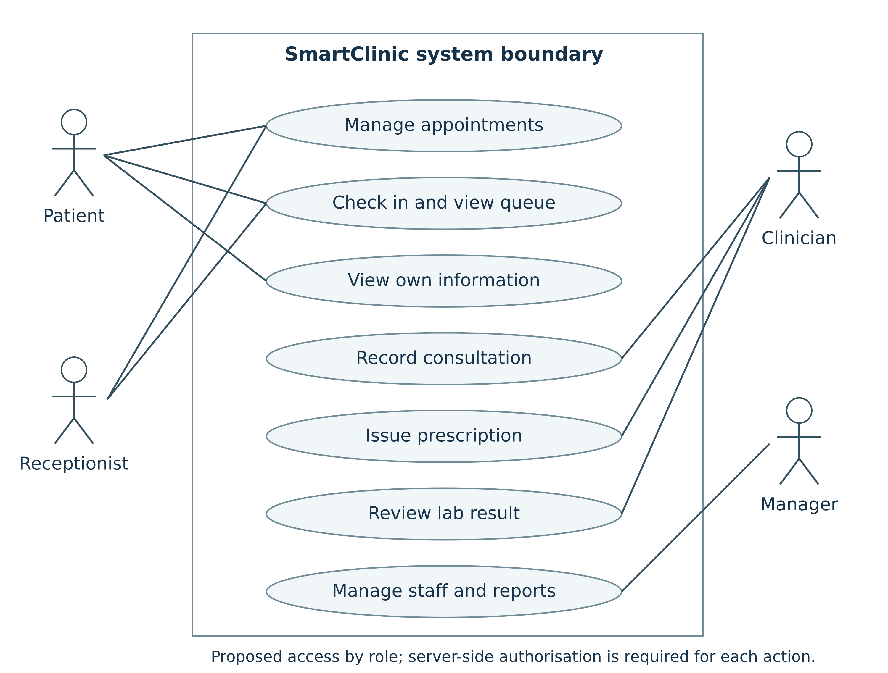
Figure 3.1: SmartClinic+ Use Case Diagram

3.2 Actors & Main Use Cases
The main actors shown are Patient, Receptionist, Clinician, and Manager. Patients manage appointments, check in or view queue information, and view their own information. Reception staff support appointment and queue activities. Clinicians record consultations, issue prescriptions, and review laboratory results. Managers are associated with staff and reporting activities.

3.3 Diagram Explanation
The diagram provides a high-level view of access by role. In a complete implementation, every action involving clinical or patient information would still require server-side authorisation. The diagram therefore supports the functional requirements while also connecting with the security and privacy requirements.

4. Requirements Classification & Prioritisation

4.1 Requirements Classification
The requirements for SmartClinic+ can be classified as functional, non-functional, and technical requirements. The functional requirements specify what services will be provided by the application, such as appointment management, smart queueing, automatic notifications, clinical and staff management, Electronic Health Records (EHRs), laboratory connectivity, analytics, and patient engagement. The non-functional requirements relate to the quality and behaviour of the system and include security and privacy, data integrity, concurrency, efficiency, and accuracy aspects. Finally, technical requirements can help in supporting those functionalities with the use of proper programming languages, a relational database (for example, MySQL), transaction management, and encryption.

4.2 MoSCoW Prioritisation
The MoSCoW technique is used to categorise the requirements of SmartClinic+ in accordance with their priority level. The Must Have requirements consist of appointment management, clinical & staff operations, EHR, laboratory connectivity, security and privacy, data integrity, and concurrency. These components are vital for the support of core clinical operations as well as for ensuring the safety of personal patient data. The Should Have requirements include a smart queue system, automatic notification service, and operational analytics. These functionalities provide additional efficiency and improve the patient experience, although they are not as crucial as the core functionalities. The Could Have requirements include patient engagement tools and predictive insights since the application is capable of performing its main operations even without these features. Functionalities that do not fall into the current scope of SmartClinic+ are included in the Won’t Have category.
Priority | SmartClinic+ Requirements
Must Have | Appointment management; clinical & staff operations; EHR; laboratory integration; security/privacy; data integrity; concurrency
Should Have | Smart queue; automated notifications; operational analytics
Could Have | Patient engagement tools; predictive insights
Won’t Have | Features outside the current SmartClinic+ scope
Table 4.1: MoSCoW Prioritisation

4.3 Priority Justification
Must Have requirements receive the highest priority because the system cannot safely support its core clinic purpose without appointment management, clinical information, data protection, and prevention of conflicting bookings. Should Have requirements improve efficiency and patient experience but do not stop the basic clinic workflow if they are delayed. Could Have features provide additional value and can be considered after the essential functions are stable.

4.4 Advantages & Limitations of MoSCoW
The MoSCoW technique is suitable for SmartClinic+ since it is simple to prioritise the requirements using this approach. It assists the team in structuring the Product Backlog and focusing development on vital features. However, prioritisation can become subjective when team members or stakeholders disagree about which requirements are essential. Another drawback is that too many requirements can be categorised as Must Have. This means that the team may need to re-prioritise during Scrum meetings.

5. Sequence Design

5.1 SmartClinic+ Sequence Diagram
The sequence diagram represents the interaction involved in making an appointment, which is one of the basic requirements of SmartClinic+. The main participants include the Patient, SmartClinic+ Interface, Appointment System, Database, and Notification System. The process starts when the patient logs in and selects the appointment option. The appointment system checks the database for available doctors and time slots and presents those options to the patient.
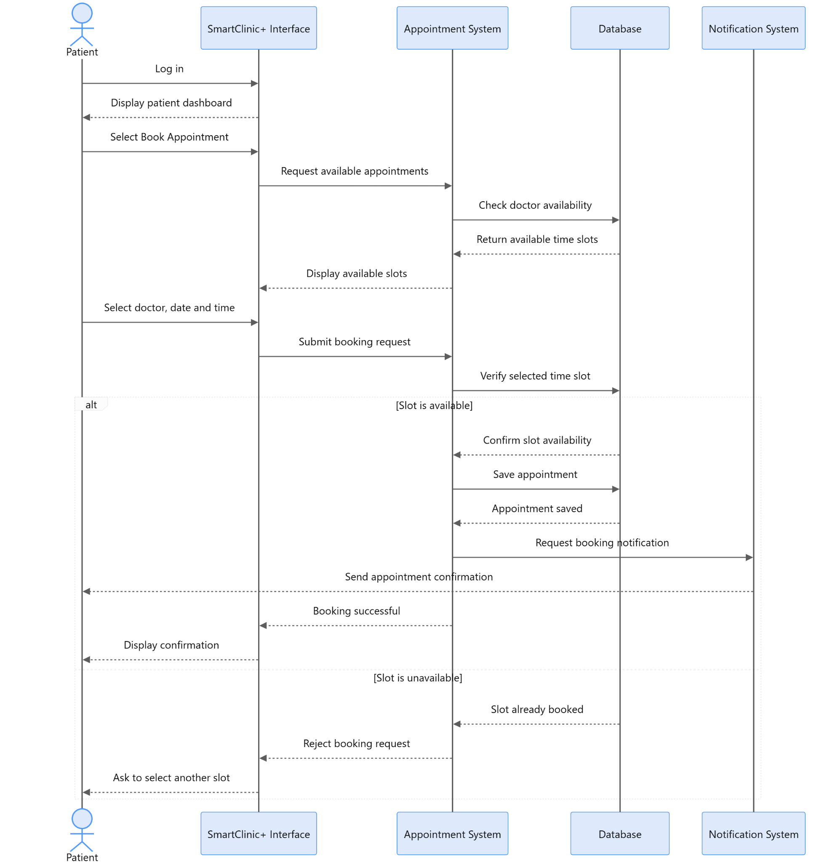
Figure 5.1: SmartClinic+ Appointment Booking Sequence Diagram

5.2 System/Database Interaction
After the patient selects a doctor, date, and time, the booking request is submitted to the Appointment System. The selected slot is verified with the database before the appointment is saved. If the slot is available, the appointment is stored and the Notification System sends confirmation. If the slot has already been booked, the request is rejected and the patient is asked to select another available slot.

5.3 Data Flow Explanation
This flow is important because the database check occurs before the appointment is stored. It demonstrates how the proposed system can support the concurrency requirement and reduce the risk of double booking. The sequence also connects appointment management with automated notification functionality.

6. Software Development Methodology & Modern Tools

6.1 Agile Scrum
Agile Scrum is the selected development approach for SmartClinic+. There are several modules that are appropriate for gradual development and analysis within this project, such as appointment scheduling, EHR, laboratory, and analytics modules. Short sprints allow the group to work on specific functionalities without having to wait until the whole system is created. The approach also supports regular review and re-prioritisation of Product Backlog items (Schwaber & Sutherland 2020).

6.2 Justification for SmartClinic+
Scrum suits SmartClinic+ because the project contains several connected features that can be designed and reviewed in smaller parts. Requirements such as appointment booking, queueing, patient records, and laboratory information can be handled as separate backlog items while still contributing to the same system. Feedback from each stage can then be used to improve later work.

6.3 Modern Development Tools
Modern tools support both development and teamwork. Git and GitHub are appropriate for version control during future source-code implementation. A project board can manage Product Backlog items using To Do, In Progress, and Done categories. Figma was used for the Hi-Fidelity SmartClinic+ prototype, while draw.io/Mermaid was used for UML design work.

6.4 Tool Selection & Appropriate Use
The tools were selected according to the type of project activity. Figma is suitable for demonstrating and testing user navigation before a complete application is built. UML tools are useful for showing system behaviour and interactions. Git-based version control becomes most useful when source-code implementation begins; therefore, this report does not present unverified Git commits or branches as completed evidence.

7. High-Level & Detailed System Design

7.1 Architecture Overview
The architecture of SmartClinic+ is a three-layer structure: browser interface, application services, and a MySQL database. Java is suggested for the core clinic functions and Python for analytics. Having these duties separated allows for easier changes. The current prototype covers the interface; the server architecture shown in the system design is a proposed design for future implementation.

7.2 Main System Components
The main components manage appointments, patient records, staff schedules, queues, reminders, and laboratory results. These components are designed to work together to support the main activities of SmartClinic+. Authorised aggregated data could also be used by analytics to provide information such as waiting time and clinician workload.

7.3 Component Interaction
A booking request is taken from the interface to the appointment service. In a complete implementation, the service would check the required information and communicate with the database to check availability and save the selected slot. This design also supports the prevention of double bookings.

7.4 Database & Data Management
The core entities are Patient, Staff, Appointment, Consultation, Prescription, and LabResult. Each booking, consultation, and result is related to the right person through primary and foreign keys. A unique active clinician-slot reservation can be used to ensure that double bookings do not occur in a complete implementation.
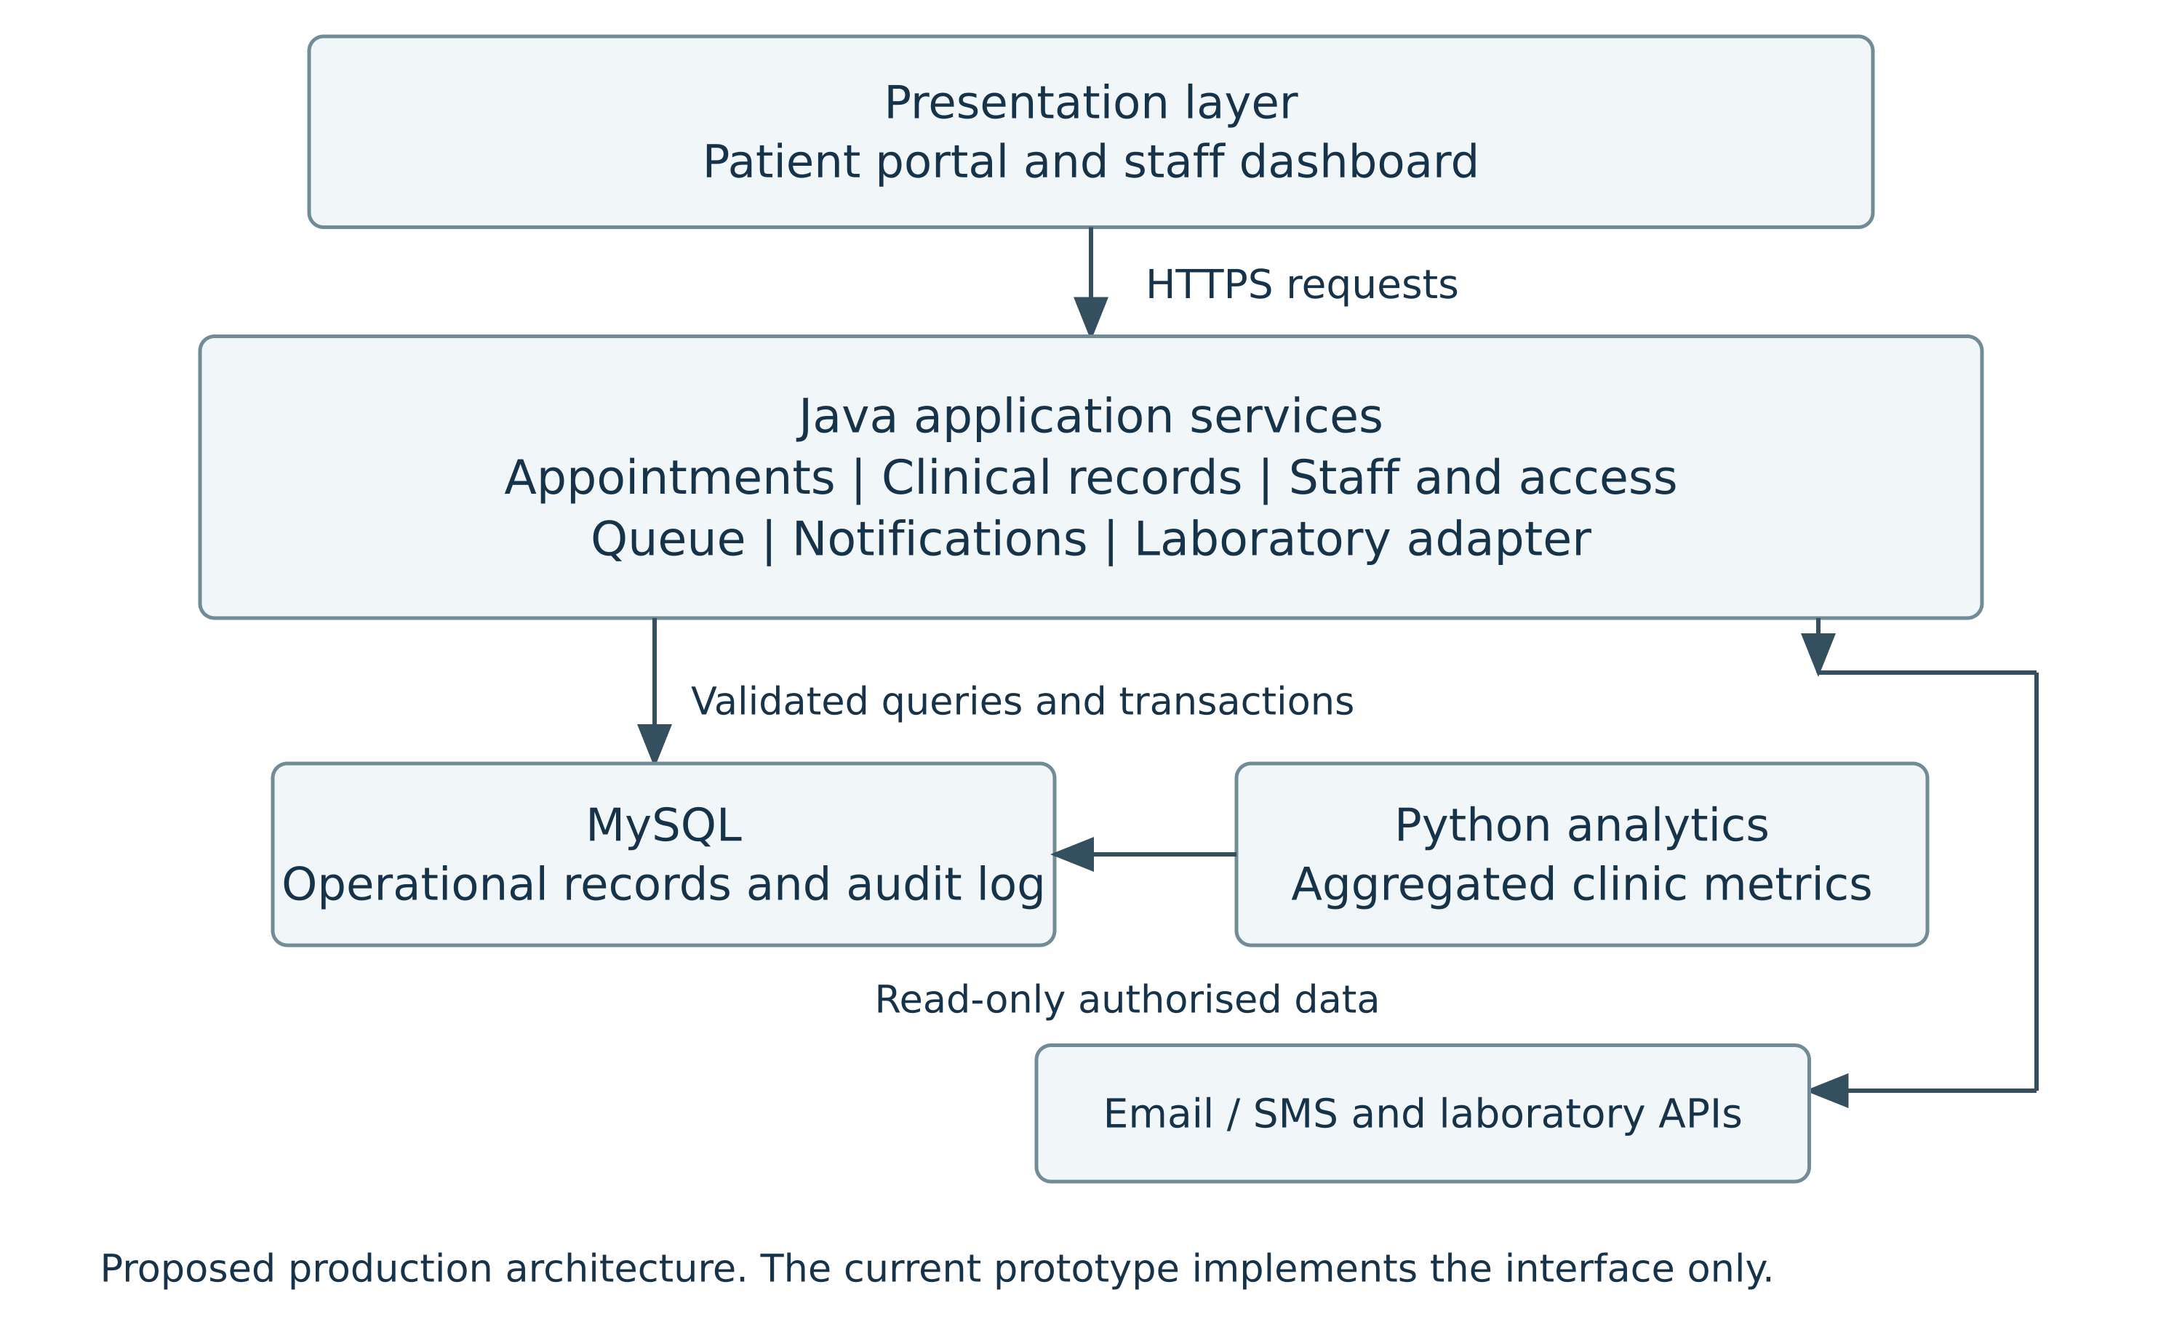
Figure 7.1: Proposed SmartClinic+ System Architecture
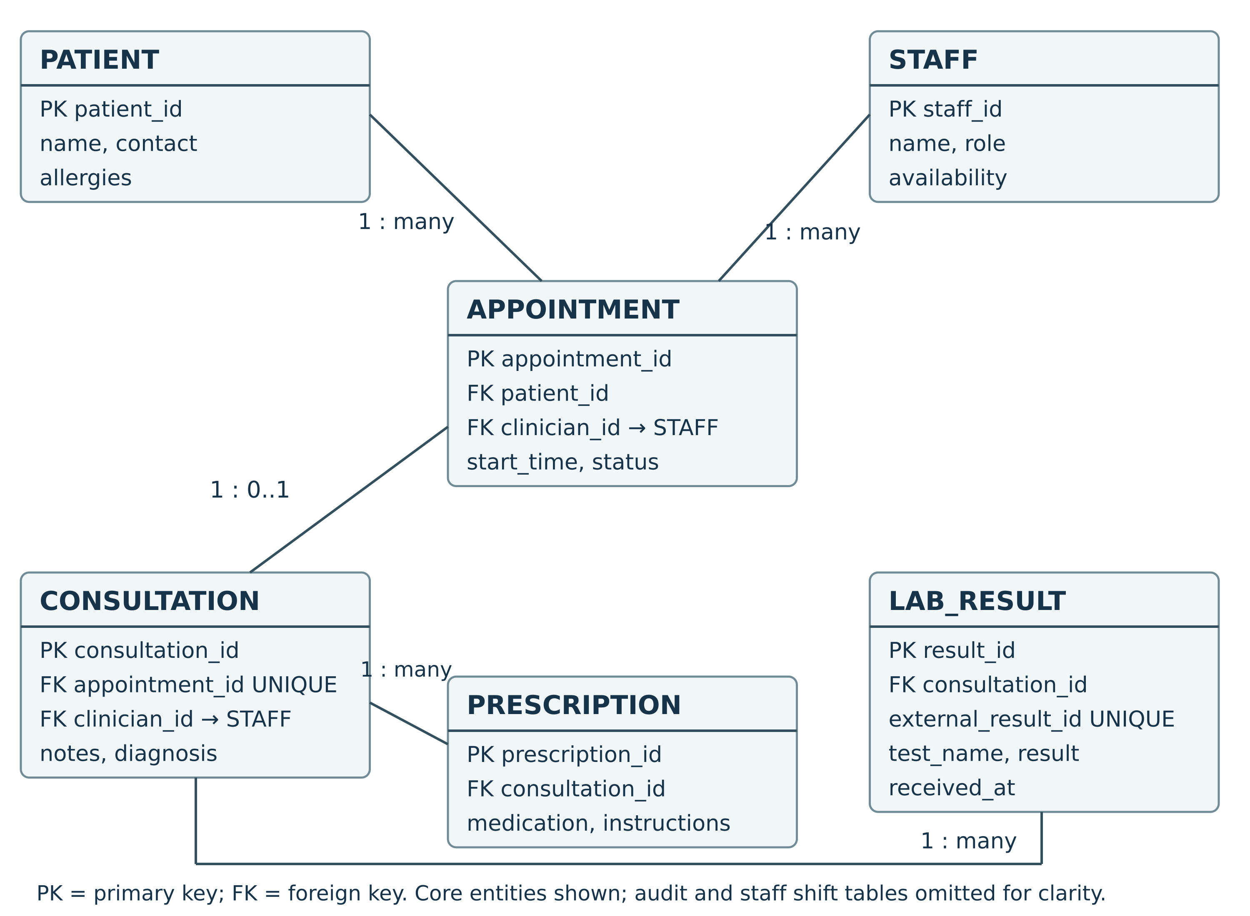
Figure 7.2: SmartClinic+ Database Design

8. Hi-Fidelity Prototype

8.1 Prototype Overview
The Figma prototype is clickable and shows how the patient can work with the main SmartClinic+ functions using sample information. It includes the main patient screens, with navigation and appointment interactions connected between the screens.

8.2 Main Interface Screens
The main interface includes Login, Patient Dashboard, Book Appointment, Appointment Confirmation, and Queue Status. The dashboard displays the upcoming appointment and provides access to booking and queue information.

8.3 Navigation & User Flow
A patient logs in and enters the dashboard. From there, the patient can click Book Appointment, choose the appointment information, and confirm the booking. The confirmation screen then allows the patient to return to the dashboard. The patient can also open Queue Status and return to the dashboard. These navigation interactions were tested in Figma Present Mode.

8.4 Design Principles & Usability
Consistently formatted headings, buttons, and labelled fields help with step-by-step navigation across the screens. The confirmation screen provides information about what has occurred after booking. The same colours and layout style are used throughout the prototype to keep the interface simple and consistent.
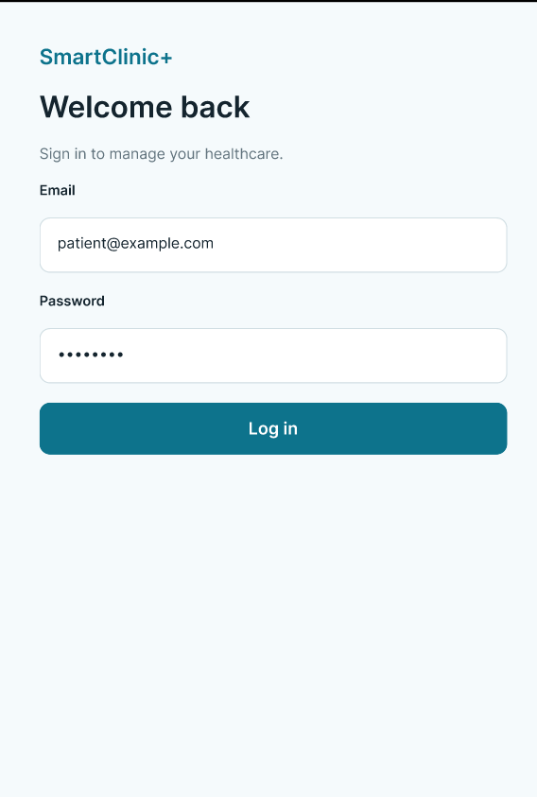 | 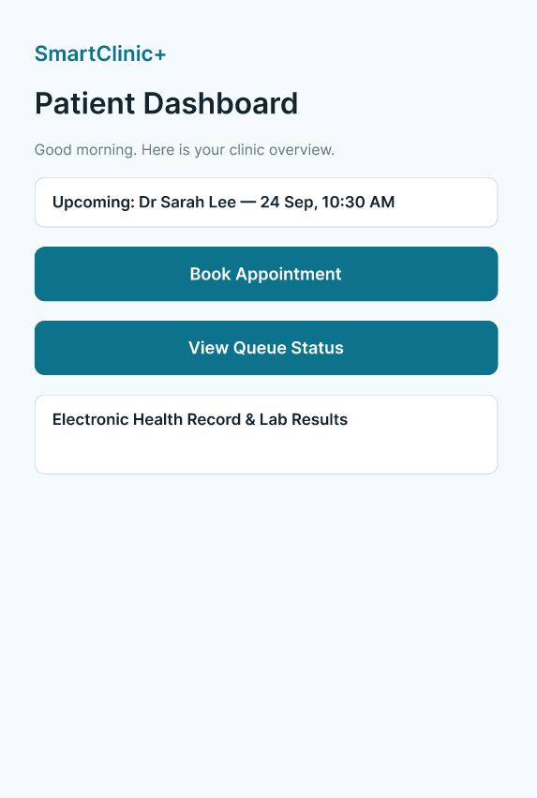 | 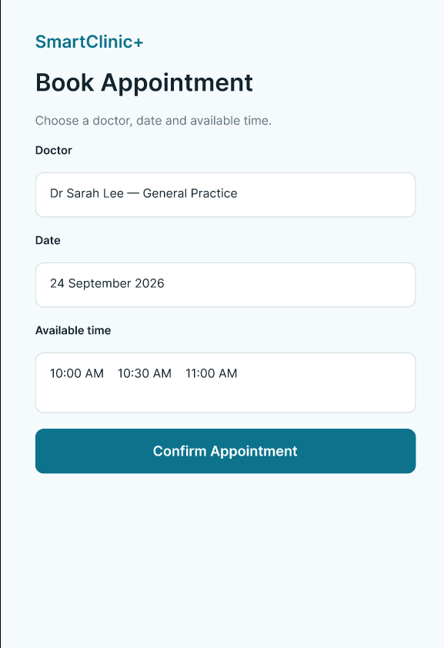
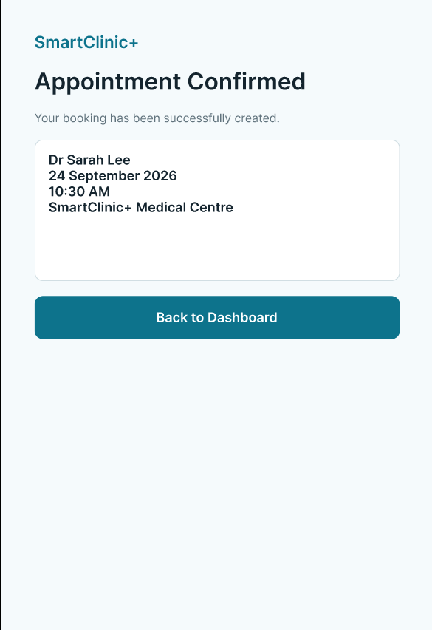 | 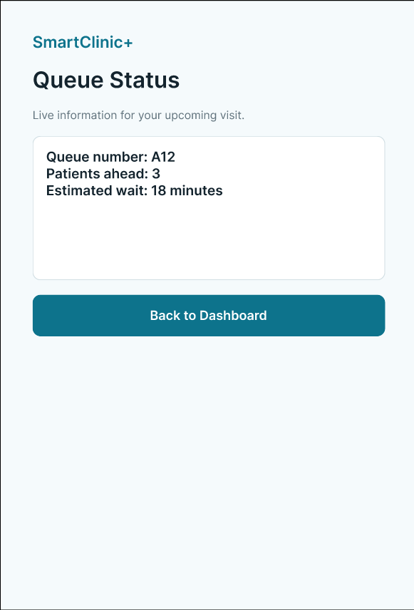 | 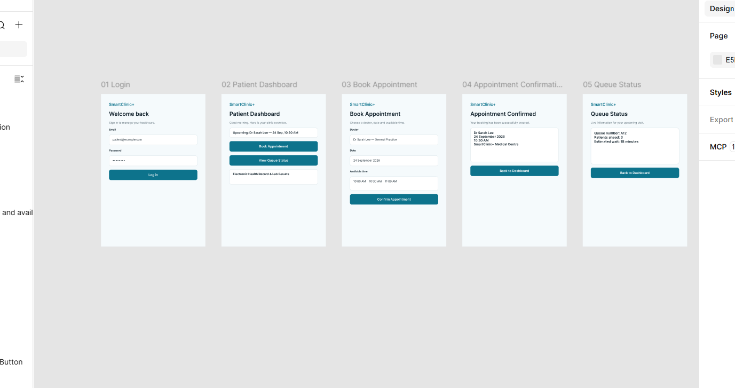  Prototype Overview
Figure 8.1: SmartClinic+ Hi-Fidelity Prototype Screens

9. Code Repository & Project Management

9.1 Project File Organisation
The SmartClinic+ project materials are organised into requirements, design documents, UML diagrams, prototype screens, testing evidence, and final documentation. Keeping these materials organised provides the group with a clear basis for combining and reviewing the final project work.

9.2 Version Control
A complete SmartClinic+ application has not been implemented at this stage, so Git commits, branches, and release versions are not presented as completed evidence. Version control would be useful during future implementation because it can keep the history of source-code changes and support work by different group members.

9.3 Product Backlog & Task Management
The task register represents the main activities involved in project management and shows the assigned work and completion status. The project work includes requirements analysis, UML diagrams, system design, the Hi-Fidelity prototype, testing and QA, timeline, budget, and final documentation. This makes it easier for the group to review what has been completed and what still needs to be finished.
ID | Task | Assigned Member | Status
SC-01 | Requirements elicitation & Use Case Diagram | Abu Bakkar Siddiquey | Done
SC-02 | Requirements prioritisation & Sequence Diagram | Mohammad Shahadat Hossen | Done
SC-03 | System architecture & database design | Aadarsha Shrestha | Done
SC-04 | Hi-Fidelity Figma prototype | Group work | Done
SC-05 | Prototype navigation testing & QA evidence | Group work | Done
SC-06 | Testing, timeline & budget | Anayet Ahmed Monna | Done
SC-07 | Combine and format final report | Mohammad Shahadat Hossen | In Progress
SC-08 | Final group review | All Members | To Do
Table 9.1: SmartClinic+ Project Task Register
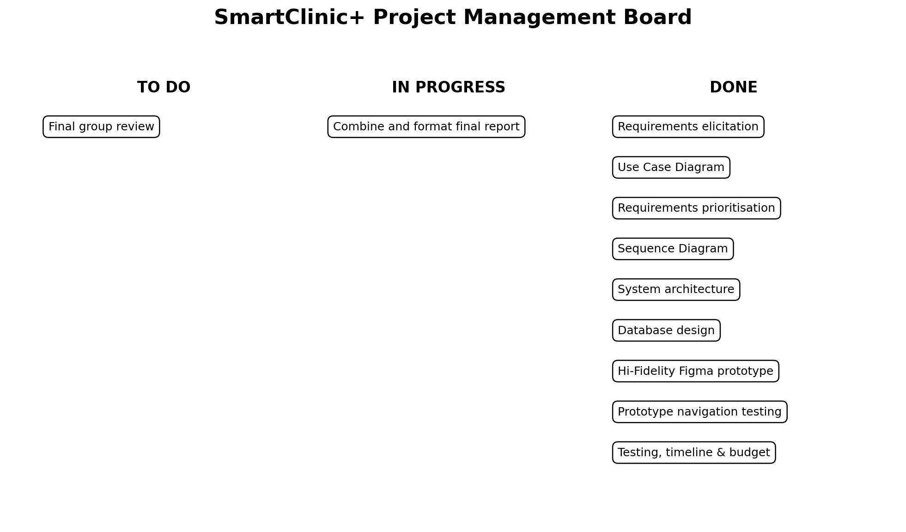
Figure 9.1: SmartClinic+ Project Management Board

9.4 Team Collaboration
Team members worked on their assigned sections and shared the project information needed to combine the work. Common requirements and design decisions were followed to keep the SmartClinic+ report consistent. The completed Figma prototype was also used for testing and QA activities, linking the prototype work with the testing section. Final report formatting and the final group review are completed as part of the submission process.

10. Testing & Quality Assurance

10.1 Testing Strategy
Testing is very important for SmartClinic+, since it is responsible for managing appointments, patient data and other healthcare-related services. The testing approach includes both functional and non-functional testing in order to validate the requirements. A high-fidelity prototype in Figma was tested for primary navigation and workflow. Test cases were mapped to respective requirements when possible.

10.2 Functional Testing
Functional testing tests if SmartClinic+ basic functionalities function as intended. Testing of the interactive prototype was done along the primary patient journey, which includes Login > Dashboard > Book Appointment > Confirmation > Dashboard and Dashboard > Queue Status > Dashboard. All navigations of the interactive prototype were found to be working as intended.
System-based functions, like database interactions and simultaneous appointments, need a complete system to test.

10.3 Non-Functional Testing
Non-functional testing includes security/privacy, data integrity, concurrency, efficiency, and accuracy. Concurrency testing is one of the most important future tests, where two different patients cannot book the same doctor and time. Access to patient information must be limited to only authorised people. All these technical tests are included in the test plan but cannot be marked as passed because they cannot be tested using the Figma prototype.

10.4 QA Activities & Evidence
QA consisted of analysing the SmartClinic+ prototype and verifying its interactive navigation features. Patient flow navigation and queue status navigation were verified in Figma Present Mode. All links tested functioned well and allowed for screen transitions as desired.
A screen recording was created to demonstrate the working SmartClinic+ prototype and its main navigation flow.
https://drive.google.com/file/d/1RJbitL4_qjvni2Oo3s5A5l5Vak-u9xtQ/view?usp=drive_link

11. Detailed Test Plan

11.1 Test Objectives & Scope
The test plan seeks to confirm that the basic functionality of SmartClinic+ works properly. Prototype testing currently includes login, navigation through the dashboard, appointment booking process, and queue status navigation. Future testing will include technical testing of security, concurrency, and database functionality.

11.2 Test Cases
Test ID | Req. | Test Activity | Expected Result | Actual Result | Status
QA-01 | FR-01 | Login -> Dashboard | Dashboard should open | Dashboard opened correctly | Pass
QA-02 | FR-01 | Dashboard -> Book Appointment | Booking screen should open | Booking screen opened correctly | Pass
QA-03 | FR-01 | Book Appointment -> Confirmation | Confirmation screen should appear | Confirmation screen displayed correctly | Pass
QA-04 | FR-01 | Confirmation -> Dashboard | User should return to Dashboard | Dashboard opened correctly | Pass
QA-05 | FR-02 | Dashboard -> Queue Status -> Dashboard | Queue screen should open and allow return | Navigation worked correctly | Pass
TC-01 | NFR-03 | Attempt double booking | Second booking should be rejected | Not tested | Pending
TC-02 | NFR-01 | Unauthorised EHR access | Access should be denied | Not tested | Pending
Table 11.1: SmartClinic+ Test Cases

11.3 Expected/Actual Results
The expected navigation results in the created prototype tests have been achieved. All five interactions were performed successfully. Tests that include database, security or backend features have not been done yet because they cannot be tested using the Figma prototype.

11.4 Pass/Fail Criteria
Pass tests are those where the actual result is equal to the expected result. Tests where the actual result is not equal to the expected result are termed as failures. Unexecuted tests are marked as Pending.

11.5 Requirements Traceability
Prototype testing is mostly focused on appointment management and patient interaction functionalities. The test table links each activity to the relevant functional or non-functional requirement ID. Access control and concurrency tests remain Pending until the backend and database functions are implemented. This provides clear traceability without marking unexecuted technical tests as completed.

12. Detailed Project Timeline

12.1 Activities & Schedule
Weeks | Activity
1-2 | Planning and requirements analysis
3-4 | System and database design
5-10 | Scrum development, prototype and project activities
11-12 | Integration, testing, QA and security review
13 | Final evaluation, documentation and presentation
Table 12.1: SmartClinic+ Detailed Project Timeline

12.2 Milestones & Deliverables
Major deliverables include completed requirements, UML diagrams, a high-fidelity prototype, project-management evidence, testing and quality assurance results, and project documentation. The 13-week schedule allows requirements and design work to be completed before the main prototype, testing, and final documentation activities.

13. Detailed Budget Breakdown
Budget Category | Estimated Cost (AUD)
Development & Personnel | $15,000
Technology, Database & Hosting | $2,500
Testing & Security | $2,500
Maintenance & Support | $2,500
Contingency | $2,500
Total | $25,000
Table 13.1: SmartClinic+ Detailed Budget
A significant amount of money goes toward development and staffing, since there is a great deal of work involved in the development process. The rest of the budget goes toward infrastructure, testing, security, maintenance, and contingency costs for the project. The budget represents the proposed cost of a full SmartClinic+ development rather than money already spent on the Figma prototype.

14. Conclusion & Recommendations
SmartClinic+ provides an integrated approach to managing appointments, clinical processes, patient information, queue status, and related clinic activities. The high-fidelity prototype was successfully tested and demonstrated the main patient appointment and queue navigation flows. The system architecture, database design, UML models, task management, test plan, timeline, and budget provide a clear basis for future development. Future work should focus on implementing and evaluating the database, access control, concurrency, security, and data-integrity functions before full deployment.

15. References
de Carvalho Junior, MA & Bandiera-Paiva, P 2018, ‘Health information system role-based access control current security trends and challenges’, Journal of Healthcare Engineering, vol. 2018.
Fernández-Alemán, JL, Señor, IC, Lozoya, PÁO & Toval, A 2013, ‘Security and privacy in electronic health records: A systematic literature review’, Journal of Biomedical Informatics, vol. 46, no. 3, pp. 541–562.
Ramesh, B, Cao, L & Baskerville, R 2010, ‘Agile requirements engineering practices and challenges: an empirical study’, Information Systems Journal, vol. 20, no. 5, pp. 449–480.
Rezaeibagha, F, Win, KT & Susilo, W 2015, ‘A systematic literature review on security and privacy of electronic health record systems: technical perspectives’, Health Information Management Journal, vol. 44, no. 3, pp. 23–38.
Schwaber, K & Sutherland, J 2020, The Scrum Guide: The Definitive Guide to Scrum, Scrum.org.
Sommerville, I 2016, Software Engineering, 10th edn, Pearson, Harlow.

