Abstract - Real and Fake Face Detection Using Deep Learning Technologies
Shahad AL Qasmi – 22F22736 – AI and DL (Dr. Jayakumari Chitathukattle) - A

The advancement of artificial intelligence and deep learning as technologies for resolving image classification issues is well documented. In this study, an effort will be made to identify real face images from fake face images using deep learning algorithms. Two models will be suggested, one being an in-house built Convolutional Neural Network (CNN) model and the other being a pre-trained MobileNetV2 model. These models will be tested for their capability of classifying the facial images into either the real category or the fake category. For this purpose, a data set collected from Kaggle will be pre-processed first before training the models. Different performance evaluation metrics will be considered. This project focuses on measuring the efficiency of deep learning and transfer learning for face authentication.

Index Terms—Real and Fake Faces, Deep Learning, Convolutional Neural Network (CNN), MobileNetV2, and Binary Image Classification.

INTRODUCTION
Deep learning is an important area of artificial intelligence where machines automatically learn from a large amount of data. Deep learning has found widespread use in many different practical applications such as medical diagnosis, facial recognition systems, image recognition, self-driving cars, and cybersecurity. In deep learning algorithms, convolutional neural network (CNN) algorithms are particularly effective for image classification applications because they can automatically extract features from images. With the rapid growth of artificial intelligence technology, new methods of image processing and generation such as "deepfakes" are emerging on the market. These face images are potentially dangerous and can be used for phishing, deception, and various security threats. Classifying images of real and fake faces is one of the difficult tasks faced by researchers in the field of deep learning and computer vision. In this project, two CNN architectures were proposed and tested in order to recognize fake faces based on deep learning algorithms. The custom CNN and the pre-trained MobileNetV2 model are compared through several evaluation metrics. The main objective of this project is to evaluate the efficiency of deep learning in the context of real-world problems.

Literature review
Multiple research papers apply deep learning solutions for solving image classification problems and detecting fake faces. Various convolutional neural network (CNN) architectures and deep learning transfer learning models can be applied for improving the accuracy of face classification and decreasing the classification error rates. For example, in one study, the authors use deep learning models based on CNN for recognizing fake faces created with the help of deepfake technologies. In particular, the authors prove the effectiveness of using deep learning and CNN models in extracting meaningful visual information from images and recognizing manipulated facial patterns. High classification accuracy is attained during testing the CNN model on datasets with multiple facial images. However, as a result, the authors note the impact of improper data sets, variations in facial features, and poor illumination on the accuracy and reliability of CNN-based classification algorithms. Another similar research paper explores how pre-trained deep learning models such as MobileNetV2 and ResNet50 work for the purpose of fake face detection. According to the results obtained by the authors, transfer learning models are more accurate and efficient for the given task compared to traditional CNNs because of pre-training on large-scale datasets and better feature extraction ability of pre-trained models. In addition, the authors found out that the MobileNetV2 algorithm requires fewer computational resources, which makes it suitable for practical implementation.
Similarly to the above-mentioned literature sources, this project will explore the potential of using deep learning methods for the purpose of detecting fake faces. Specifically, in this case, a custom CNN model will be implemented along with a pre-trained MobileNetV2 model to compare the effectiveness of different approaches in solving the given problem. Several metrics such as accuracy, precision, and F1 score will be utilized to compare the performance of models.

problem statement
The swift pace of technological advancements regarding the use of deep learning face manipulation algorithms has resulted in serious security and privacy problems. Fake face images that can be generated through deepfakes and other presentation attacks like photographs and videos can be created and used for bypassing facial recognition techniques. The dangers associated with biometric verification systems are numerous, such as identity thefts, financial crimes, misinformation, or cybersecurity threats. With the current level of visual sophistication of fake images, differentiating between a fake and a real one becomes more difficult by means of conventional techniques. Thus, there is an urgent need for developing an efficient automated system based on deep learning for fake face image detection.

data
The data set used in this experiment was downloaded from Kaggle and contains authentic as well as synthetic face pictures, which can be used for binary image classification purposes. There are only two classes available in this data set: the first one consists of real faces, while the second class represents faces generated using face manipulation and deepfake techniques. A number of preprocessing techniques were used before the training process was started. First, all images were resized to make them match the required dimensionality for deep learning algorithms. In addition, normalization of images was performed to improve the efficiency of deep learning algorithms. Moreover, the data set was divided into train and test sets to evaluate the models. Such data set will be useful in assessing the deep learning algorithms because it contains a variety of patterns, lighting conditions, and other variables.

methods
This project was created using Python language in Jupyter notebook environment. The key objective of this project is to clarify whether the face image presented is a real one or not using deep learning models. The dataset utilized in this project was acquired from Kaggle and contained two classes - face images labeled as 'real' and fake face images. This dataset had about 1081 real faces and 960 fake faces. Prior to training the models, images in the dataset were first preprocessed. Resizing was performed for each image to make them uniformly of 128x128 in shape. Then normalization was carried out by rescaling the pixel values to (1/255). Moreover, the dataset was separated into training data and validation data in an 80% - 20% ratio. Two deep learning models have been applied in this experiment. The first one was the CNN model, which consisted of convolutional, max-pooling, dense, and dropout layers. The hidden layers had Rectified Linear Units (ReLU) as their activation functions, whereas the output layer made use of Sigmoid activation function, which helped classify the images into categories as real or fake. Another deep learning model applied to carry out image classification was the MobileNetV2, which was a pre-trained deep learning model. Its purpose was to improve feature extraction and compare its performance to that of the CNN model. The two models were trained for 10 epochs using the Adam optimization algorithm and binary cross entropy loss function. The performance of the models was measured using accuracy, precision, recall, F1-score, confusion matrix, and loss measures.

result evaluation
Both DL models' performances were assessed based on accuracy, precision, recall, F1-score, and loss evaluation metrics. The findings of the experiment proved that both models had the potential to classify face images into real or fake categories, but their performance level was relatively moderate. First, the proposed CNN model produced a validation accuracy of 51.7%, together with a loss value of 0.731. According to the results provided by the classification report, this model had a balanced performance, which involved weighted precision, recall, and F1-score, all equaling 0.50. Therefore, it could perform feature extraction of the images and classify an acceptable number of them. At the same time, the MobileNetV2 model produced slightly higher validation accuracy, equaling 53.6%, although the loss value was higher – 1.176. In particular, the F1-score was also slightly lower and amounted to 0.48. Although this model enjoyed transfer learning with the use of pre-trained ImageNet weights, its advantages did not play much of a role. It was clear from the accuracy and loss curves that both neural networks underwent learning during the training process, but the results obtained were not highly reliable due to the drawbacks of the used datasets and overfitting. In addition, the confusion matrix and classification report analysis revealed that certain fake and real images were misclassified.

Table I. Performance Comparison of CNN and MobileNetV2 Models

Model | Accuracy | Loss | Precision | Recall | F1-Score (%)
CNN | 51% | 73% | 0.50 | 0.51 | 0.50
MobileNetV2 | 53% | 1.17 | 0.49 | 0.50 | 0.48

In summary, both the CNN and MobileNetV2 models can be applied for identifying fake faces from real faces. Despite the higher accuracy attained by MobileNetV2, the CNN model provided relatively more balanced evaluation metrics for this experiment. Some improvements to these models would come through having a larger database, implementing data augmentation, and more training iterations.

conclusion
In this project, a deep learning solution for detection of fake and real face images was proposed through CNN and MobileNetV2 approaches. Based on experimental analysis, both networks were able to learn facial image data and perform binary image classification. As can be seen from the comparison results, MobileNetV2 provided better classification accuracy, whereas CNN provided more balanced results during evaluation according to some criteria. The relevance of the use of transfer learning approaches in image classification tasks was also shown. While the classification accuracy obtained was not high, the project has succeeded in showing how the deep learning algorithms can be applied for fake face detection using such tools as Python, TensorFlow, and Jupyter Notebook. Possible improvements of this work might include increasing the number of training images, using image augmentation, training for more epochs.
References

Kaggle, “Real and Fake Face Detection Dataset.” Available: https://www.kaggle.com/datasets/ciplab/real-and-fake-face-detection

TensorFlow Documentation. Available: https://www.tensorflow.org/

Keras Documentation. Available: https://keras.io/

M. Sandler et al., “MobileNetV2: Inverted Residuals and Linear Bottlenecks,” Proceedings of the IEEE Conference on Computer Vision and Pattern Recognition (CVPR), 2018.

GitHub link
https://github.com/21f21512/Football_Vs_Rugby/blob/main/football_vs_rugby.ipynb

Import Required Libraries:
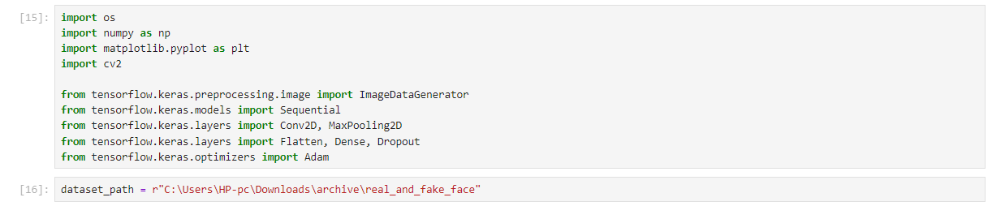
Display Number of Images:

The number of real and synthetic faces was displayed to gain insight into the dataset distribution and make sure that the images were loaded successfully.
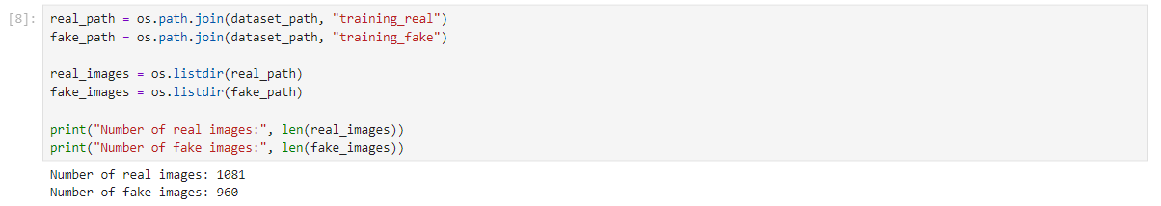
Display Sample Images ( Real / Fake):

The images of both the classes were shown to distinguish between real and fake face images prior to starting the training process.
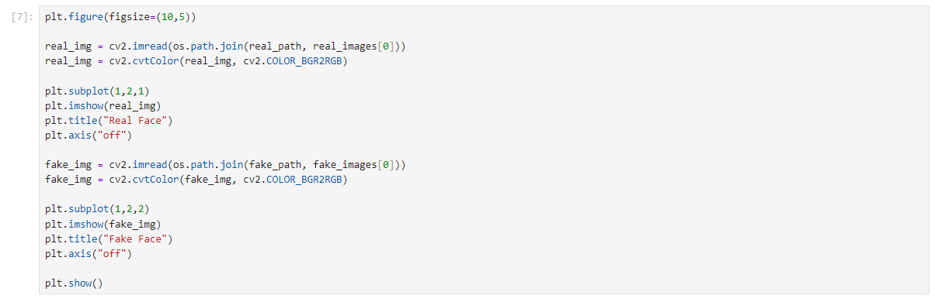

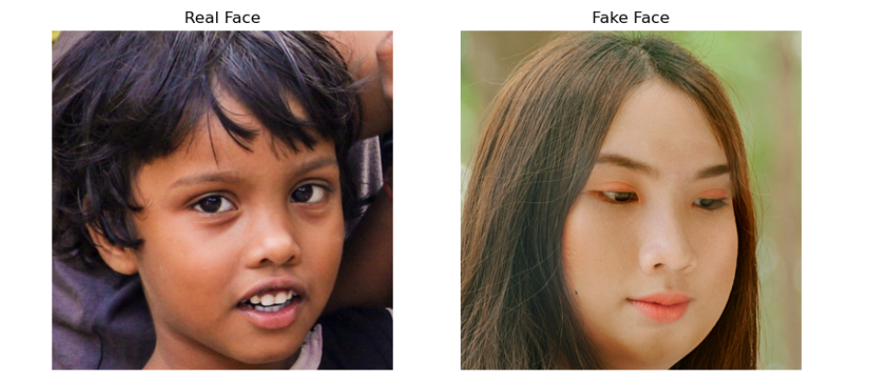
Data Preprocessing:

Pre-processing of data was carried out prior to model training. Image normalization was conducted through ImageDataGenerator where pixel values were scaled between 0 and 1. Moreover, splitting of the data into training and validation sets took place.
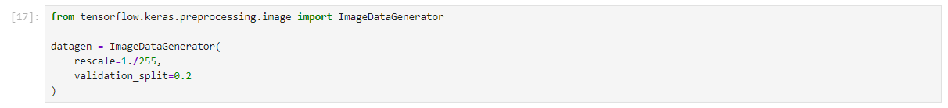
Create Training and Validation Datasets:

The dataset was split into training and validation data with a ratio of 80% and 20%. The images were then reduced to 128×128 pixels and fed into the network in batches.
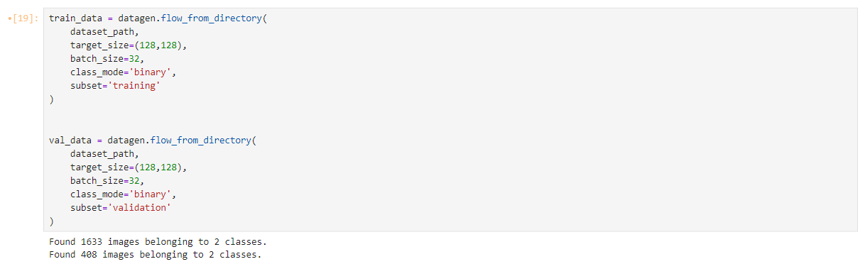

Build CNN Model:

A customized model of CNN has been created that could help in classifying images. The CNN model includes convolution layers, max-pooling layers, flatten layers, dense layers, and dropout layers.
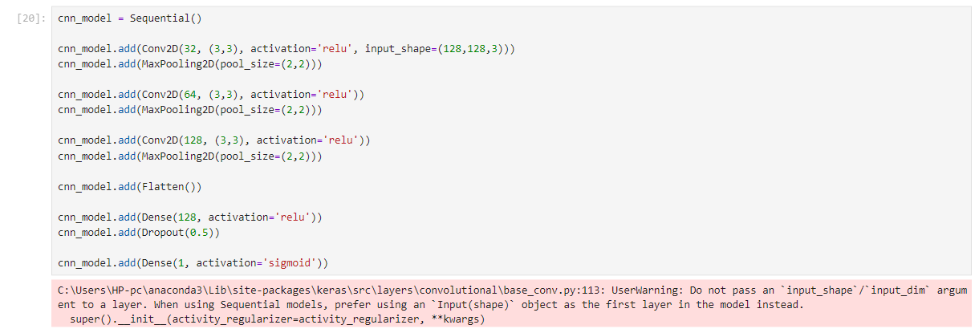
Compile CNN Model;

CNN model was trained by utilizing Adam optimization and binary cross entropy as the loss function. The accuracy was used as the evaluation metric when training the model.
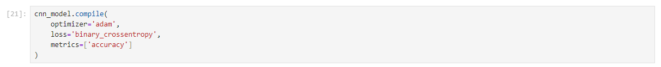
Train CNN Model:

The CNN model was trained using the training dataset for 10 epochs. In addition, validation data was used during training to evaluate model performance and minimize overfitting.
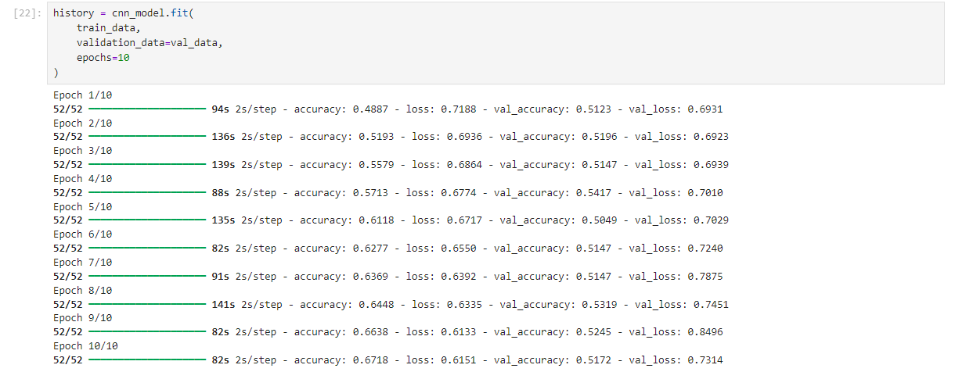
CNN Accuracy Graph:

The graph representing the accuracy demonstrates the training and validation accuracies of the CNN model for each epoch. The graph allows assessing the learning capability of the model.
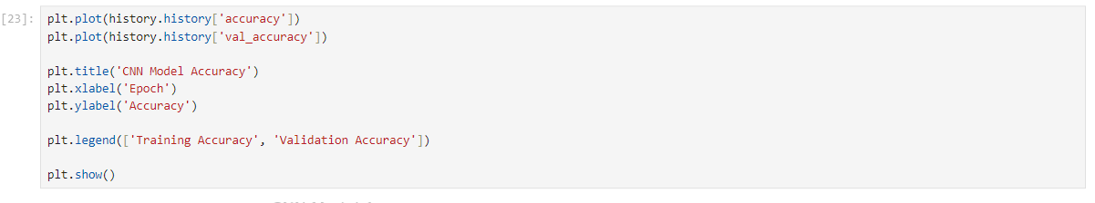
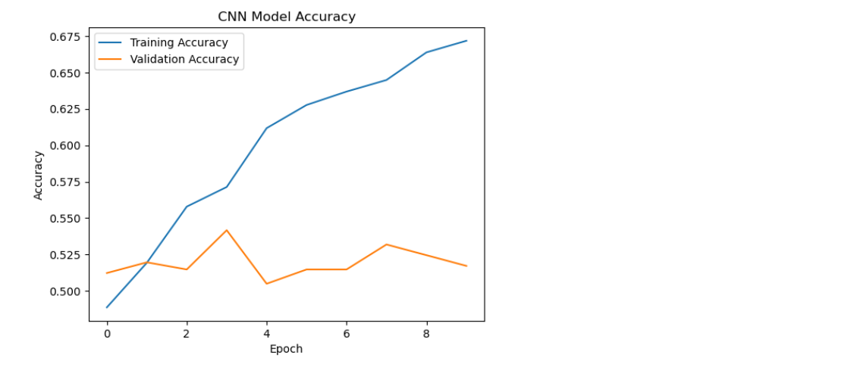
Loss Graph:

The loss plot illustrates the training and validation loss at various points during training. The loss plot was used for analyzing the model learning and performance behavior.
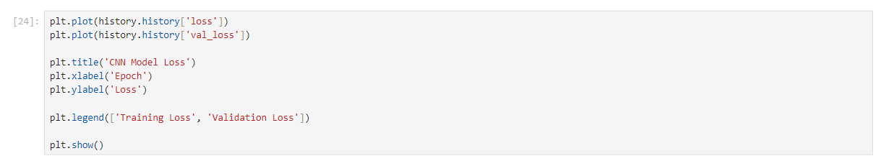

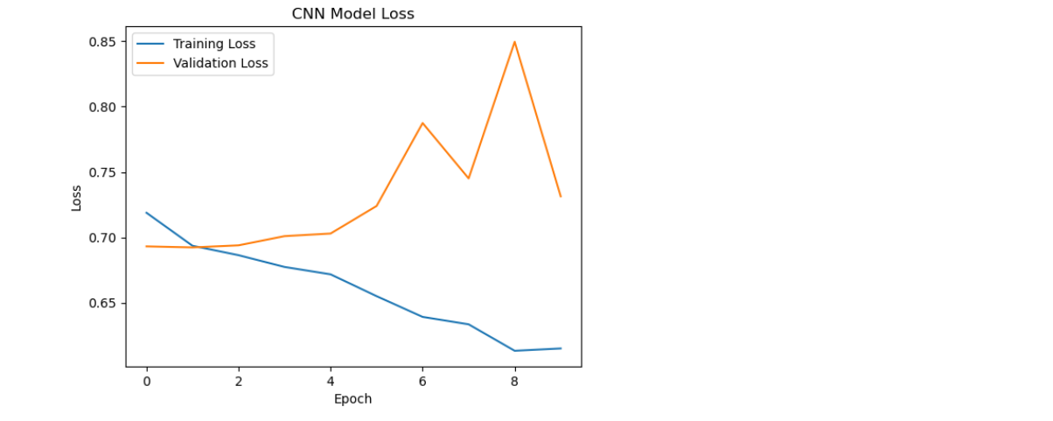
Evaluate CNN Model:

Final values for loss and accuracy were obtained by testing the trained CNN model with the validation dataset.
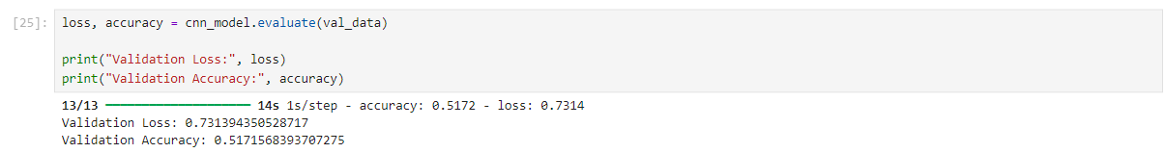
Predict Validation Data:

CNN model predictions for classifying validation image data as real or fake were produced through the trained CNN model.

Classification Report:

Classification report was developed to measure the performance of the CNN model in terms of precision, recall, f1-score, and accuracy.
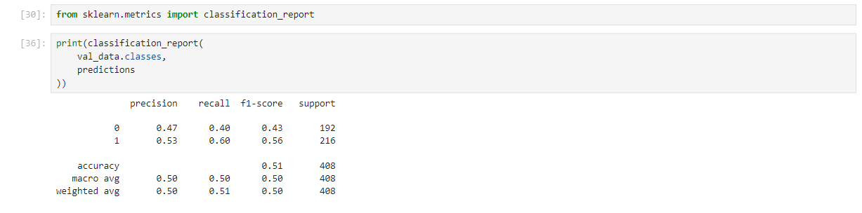
Confusion Matrix:

The confusion matrix was employed to demonstrate the number of correct classifications as well as incorrect classifications in terms of both real faces and fake faces.
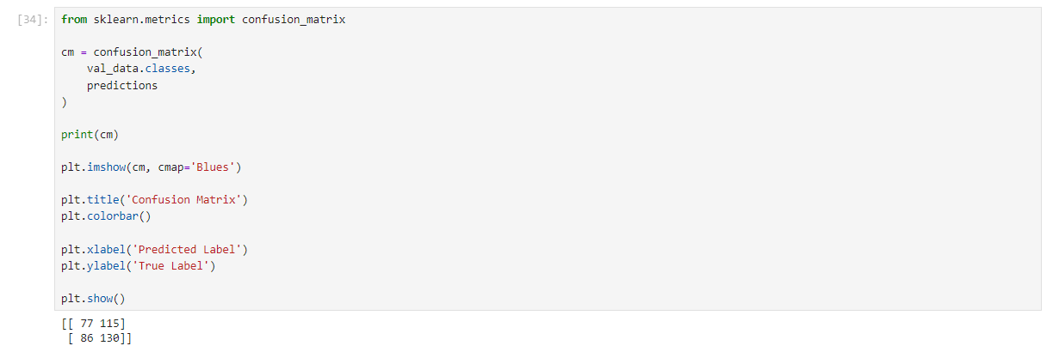
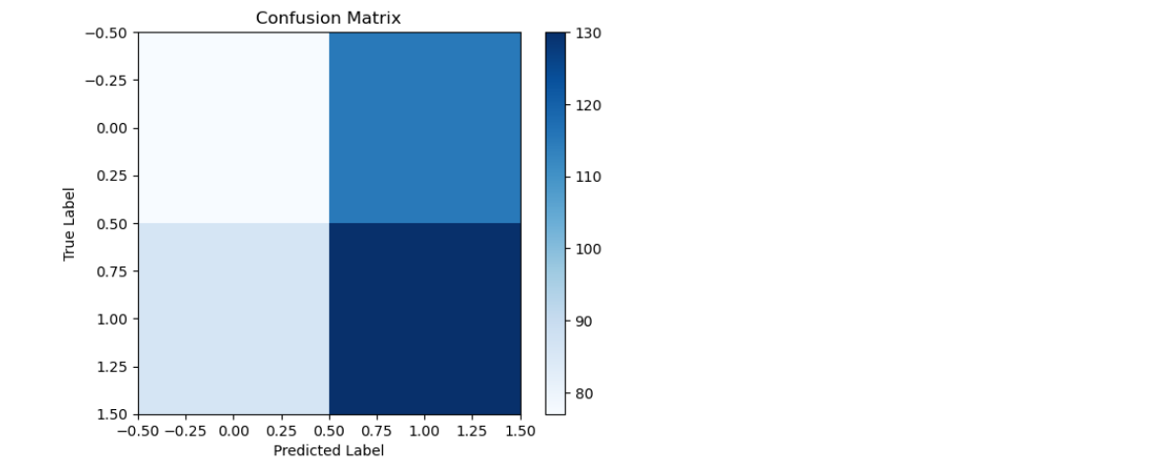

Import MobileNet2 Libraries:

In this section, the libraries that are essential for building the MobileNetV2 model are imported.

Load Pre-trained MobileNet2 Model:

MobileNetV2 model pretrained on ImageNet weights was used for our project. The top classification layers were omitted since the model was being customized for binary classification purposes (real faces/fake faces).
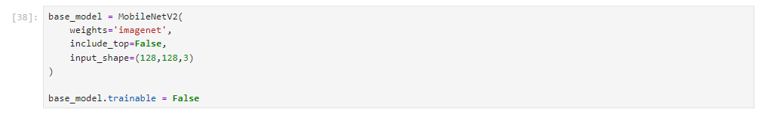
Freeze Pre-trained Layers:

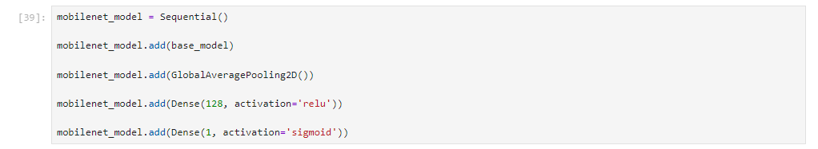
Build MobileNet2 Classification Model:

other layers including GlobalAveragePooling2D and Dense layers were introduced into the MobileNetV2 architecture to help in classifying the images of faces as either real or fake.
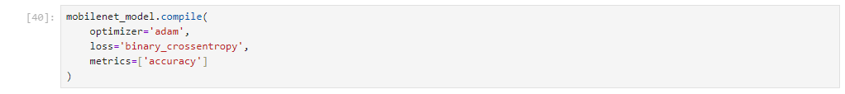
Train MobileNet2 Model:

MobileNetV2 model training was done using the training dataset for 10 epochs. The validation dataset was also included in the training process to check model performance.
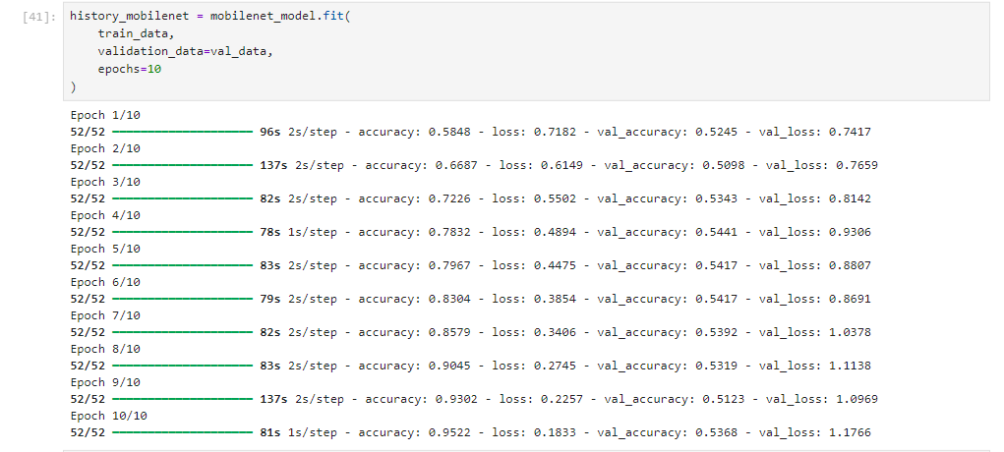

MobileNet2 Accuracy Graph:

The accuracy plot shows the accuracy of the training and validation sets at each epoch for the MobileNetV2 model.
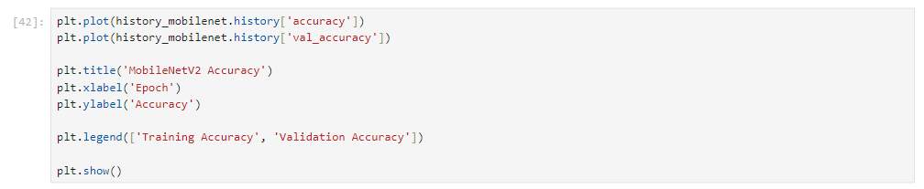
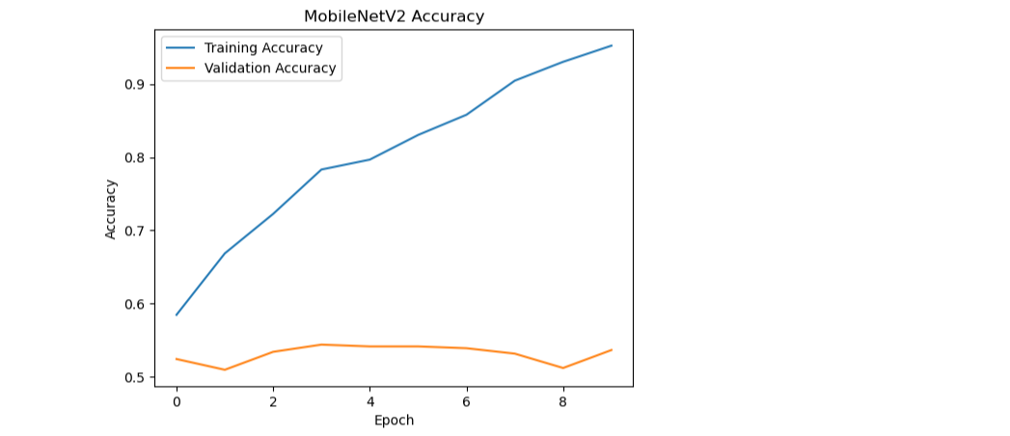

MobileNet2 Loss Graph:

Loss graph is one that displays the training loss and validation loss throughout the training process and can help assess the learning performance of the model.
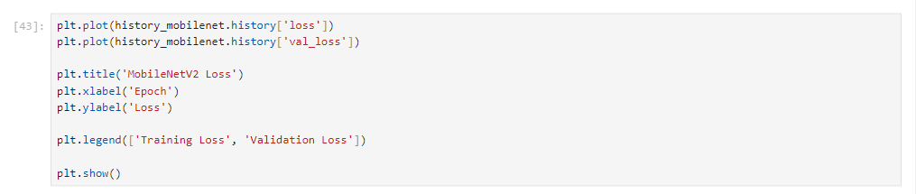

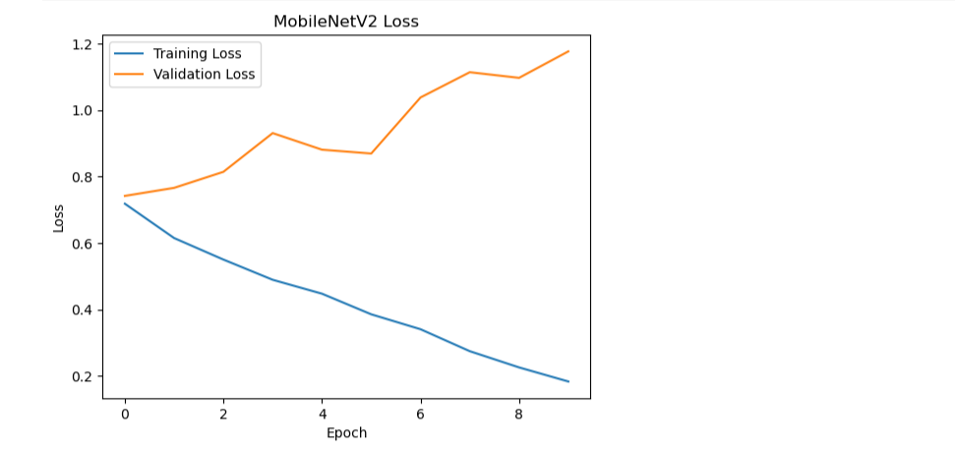
Evaluate MobileNet2 Model:

The training of MobileNetV2 was assessed using the validation data set for calculating the final loss and accuracy.
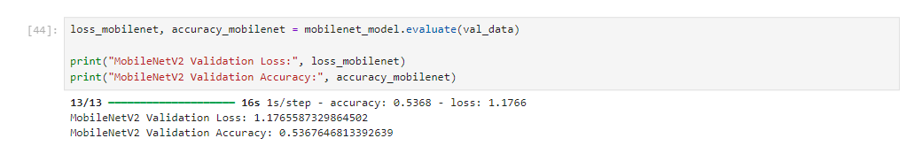
Predict Validation Images:

Classifications for validation images as either real or fake were made using the trained MobileNetV2 model.

MobileNet2 Classification Report:

This classification report was created for testing the MobileNetV2 model using various measures such as precision, recall, F1 score, and accuracy.
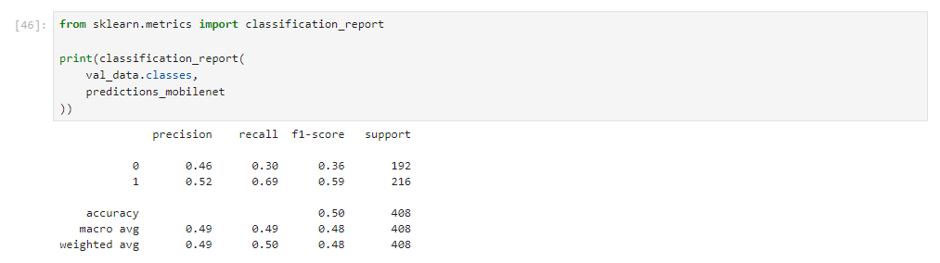
MobileNet2 Confusion Matrix:

The confusion matrix was created to visualize how many images were classified as correct and incorrect using the MobileNetV2 model.


 

