

American International University-Bangladesh (AIUB)  
**Department of Computer Science  
Faculty of Science &Technology (FST)  
Spring 21_22**

**Section: I  
Group No: 6**

**Centralized Medical Application - CMA**

A software Engineering project submitted

By

|  |  |  |  |  |
| --- | --- | --- | --- | --- |
| S/N | Student Name | Student ID | Contribution (%) | Individual Marks |
| 07 | Md Shahadot Hossain Shakib | 20-42385-1 | 20% |  |
| 08 | Shadril Hassan Shifat | 20-42451-1 | 20% |  |
| 09 | Abu Shaleh Md Kaium | 20-42475-1 | 20% |  |
| 10 | Gourob Kumar Das | 20-42482-1 | 20% |  |
| 11 | Ummee Zinat Refaiat | 20-42487-1 | 20% |  |

The project will be Evaluated for the following Course Outcomes

|  |  |
| --- | --- |
| Your Project will be Evaluated based on the following marking criteria | Total Marks |
|  |
| Requirements Analysis (functional, quality, and project requirements) [5Marks] |  |
| System Design (UI/UX design) & Test case [5Marks] |  |
| Project Management Planning [5Marks] |  |
| Submission, Completeness, Spelling, Grammar and Organization [5Marks] |  |

Submission Date: 7 August, 2022

Description of Student’s Contribution in the Project work

|  |
| --- |
| Student Name: Md Shahadot Hossain Shakib  Student ID: 20-42385-1  Contribution in Percentage (%): 20  Contribution in the Project:   * Quality Attributes * System test plan   ___________________  Signature of the Student |
| Student Name: Shadril Hassan Shifat  Student ID: 20-42451-1  Contribution in Percentage (%): 20  Contribution in the Project:   * System Features * Project Requirements * UI Design * Project Scheduling   _________________________  ___________________  Signature of the Student |
| Student Name: Abu Shaleh Md Kaium  Student ID: 20-42475-1  Contribution in Percentage (%): 20  Contribution in the Project:   * System Test Plan * Project Scheduling * Quality Attributes   ___________________  Signature of the Student |
| Student Name: Gourob Kumar Das  Student ID: 20-42482-1  Contribution in Percentage (%): 20  Contribution in the Project:   * Risk Analysis * System Test Plan   ___________________  Signature of the Student |
| Student Name: Ummee Zinat Refaiat  Student ID: 20-42487-1  Contribution in Percentage (%): 20  Contribution in the Project:   * Risk Analysis * System Test Plan   ___________________  Signature of the Student |

# PRODUCT AND PROJECT DESCRIPTION

## System Features

# 1. Software Registration

**Functional Requirements:**

* 1. Every time a user clicks "Register" on the homepage, the registration procedure must start.
  2. In order to register, the user must give some personal information (Name, NID number, Date of Birth, Location, Cellphone number, Gender, Blood Group and Mail address) using the Sign-Up form.
  3. Additionally, the user must create a secure password and re-enter it to validate password in the form.
  4. Once the user has completed the required Manual Registration information, he/she needs to click 'Register' to initiate registration validation and completion.

**Priority Level:** High

**Precondition:** The user must accurately enter all required information and choose a secure password.

**Cross-reference:** 2.4, 4.1,4.2, 4.3, 4.4

**2. Doctor Appointment**

**Functional Requirements:**

2.1 The system will provide doctor recommendation to the user based on their disease prediction.

2.2 Additionally, a user can manually search for doctors by name.

2.3 The user will then be able to view the doctor's name, as well as their degree, specialty, and

appointment time.

2.4 The user may book any doctor by clicking the 'Book' button next to the doctor's name.

2.5 Here, the user may also find out about various hospitals and their doctors.

**Priority Level:** High

**Precondition:** To book an appointment, the user must log in with their valid email and password.

**Cross-reference:** 1.1, 1.2, 1.3, 1.4, 3.4, 4.1,4.2, 4.3, 4.4

**3. Disease Prediction**

**Functional Requirements:**

3.1 User inputs such as blood pressure and pulse are required for disease prediction.

3.2 The user must check the box near the disease symptoms in the checkbox.

3.3 The user is required to provide information for the 'Duration' and 'Disease State' columns for any

symptoms that have been checked in the checkbox.

3.4 Last, the user needs to click ‘Submit’ for disease prediction and after that he/she will be suggested

doctors according to disease prediction.

**Priority Level:** High

**Precondition:** The user must accurately enter all required information.

**Cross-reference:** 2.3, 2.4, 2.5

**4. Custom Exercise Guide to Patients**

**Functional Requirements:**

4.1 In this option, the doctor may recommend exercises to the patient.

4.2 The doctor can provide the required documents or videos for the patient.

4.3 The patients are able to download or view the documents or videos.

4.4 Additionally, the user is able to communicate with the doctor in real time through live chat, and

the doctor is able to monitor the patient's progress.

**Priority Level:** High

**Precondition:** The user must log in with their valid email and password and must have doctor’s

consultation subscription.

**Cross-reference:** 1.1, 1.2, 1.3, 1.4, 2.3, 2.4, 2.5

## System Quality Attributes

**QA 1- Availability:** The system must be 99% available between 8.00 a.m. and 8:00 p.m. local time, and 97% available during the rest hours.

**Priority Level:** High

**Precondition:** The users must have enough internet connection.

**Cross-reference:** N/A

**QA 2- Testability:** Software should be able to detect when a system is at risk of failing. The

maximum cyclomatic complexity should not be more than 15.

**Priority Level:** High

**Precondition:** N/A

**Cross-reference:** QA1**,** QA-4, QA-5

**QA 3- Portability**: The system shall run on the web-based platform. The user may access the system

using a web browser on any device.

**Priority Level:** Medium

**Precondition:** N/A

**Cross-reference:** QA-2, QA-4, QA-5

**QA 4 – Maintainability:** It shouldn't take more than two hours for a maintenance programmer to

make changes to an existing form. The maintenance programmers must be able to resolve any system

issue in under three hours of manual effort in order to successfully fix the issue.

**Priority Level:** High

**Precondition:** The system should detect any errors.

**Cross-reference:** QA-1, QA-2, QA-5

**QA 5–Flexibility:**This system is going to be simple and straightforward to use. If anything has to be

added or updated, a maintenance programmer may work on the software and produce a new version,

including code modifications and testing, in less than 3-4 hours of effort.

**Priority Level:** High  
 **Precondition:** System should identify an error.  
**Cross-reference:** QA-2, QA-3

## Project Requirements

**Time:** It is estimated that it will take four months to finish the whole project.

**Budget:** In order to develop this system, we will need approximately 2.5 lakhs BDT as overall budget.

**Human Resources**: For the development of this system, we need a group of nine persons: one administrator, four software engineers, one software taster, one domain expert, and two members from the management team.

**Internet Resources:** A connection with a broadband speed of minimum 1 Mbps is required for the system to operate successfully.

**Device Resources:** Laptop, Desktop, Smartphone, Tablet.

**Software Resources:** HTML, CSS, Oracle Database, PHP, JavaScript.

**User Interface Design:** Pencil Desktop Application.

**Environment:** Adaptive Environment.

# SYSTEM DESIGN SPECIFICATION

## UI/UX Design

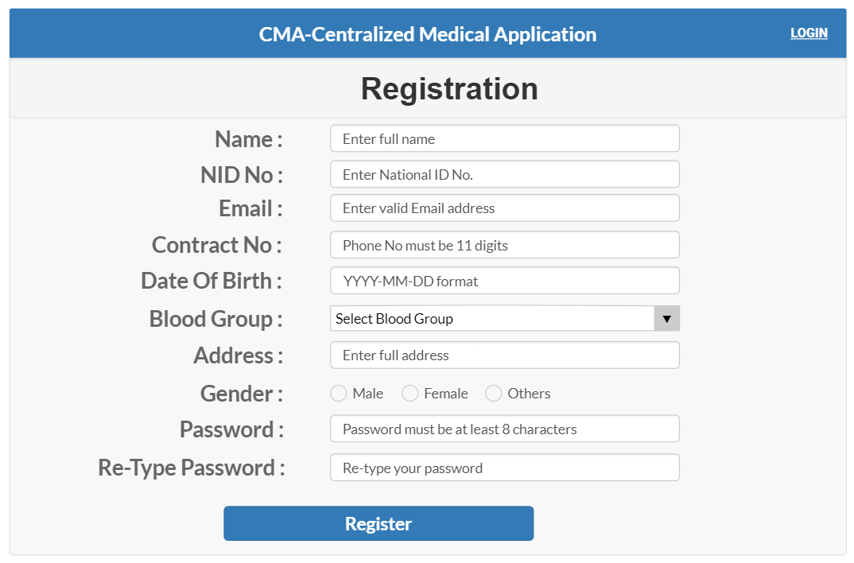

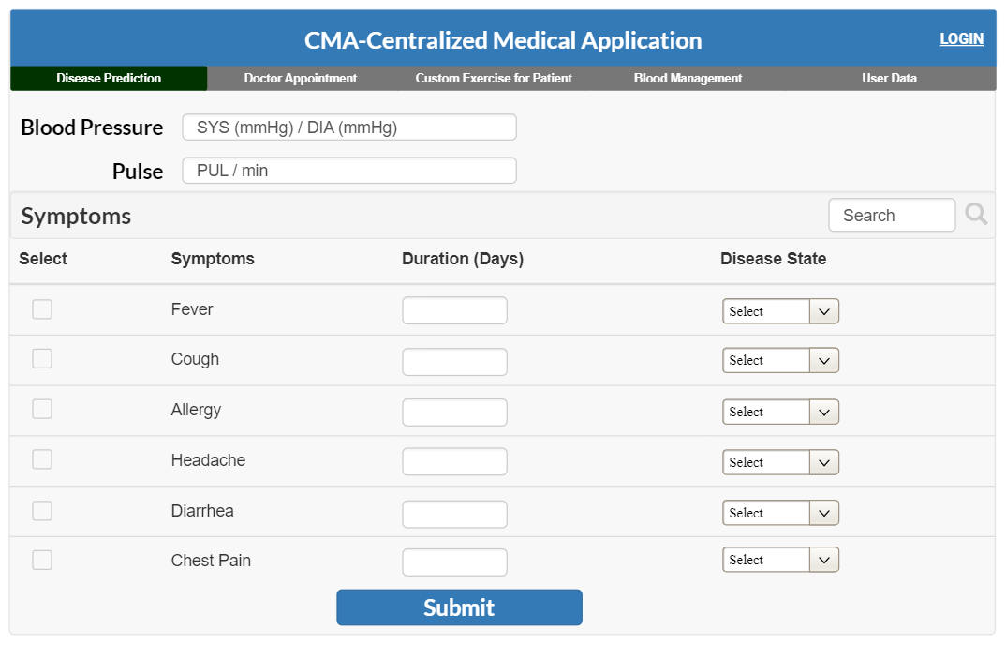

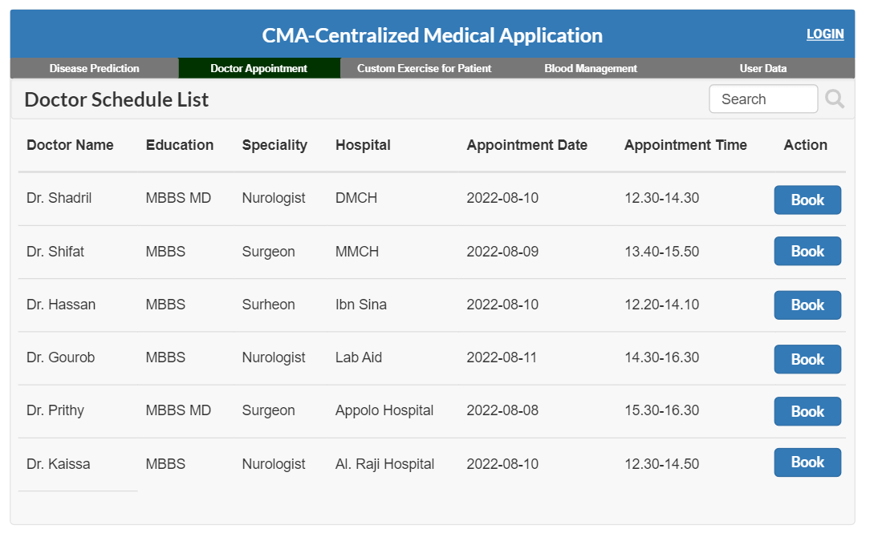

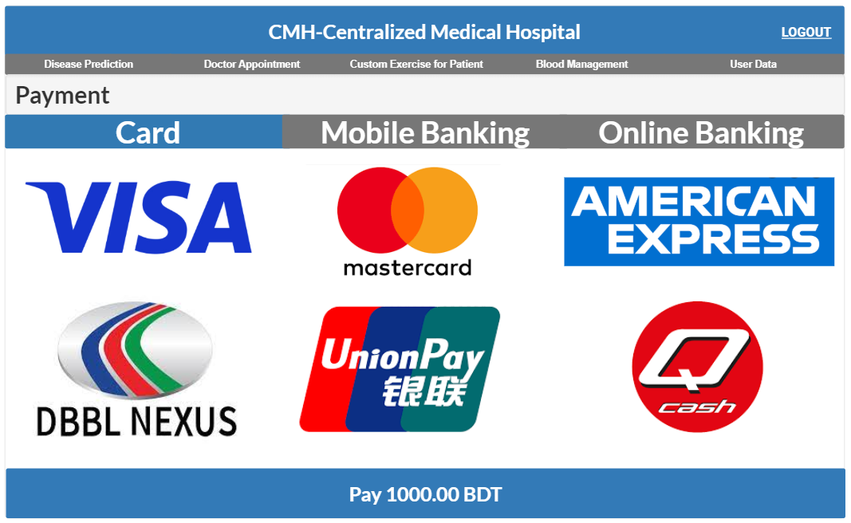

# SYSTEM TEST PLAN

|  |  |  |  |  |
| --- | --- | --- | --- | --- |
| Project Name: Centralized Medical Application - CMA | | Test Designed by: Abu Shaleh Md. Kaium | | |
| Test Case ID: FR_2 | | Test Designed date: 06-Aug-22 | | |
| Test Priority: Medium | | Test Executed by: | | |
| Module Name: Doctor Appointment | | Test Execution date: | | |
| Test Title: Verify Doctor Appointment | | | | |
| Description: Test web Doctor Appointment | | | | |
| Precondition: The user needs to log in to the system. | | | | |
| Test Steps | Test Data | Expected Results | Actual Results | Status (Pass/Fail) |
| 1. Go to website and click on doctor appointment.  2. Click on search option.  3. Type a doctor’s name or select from suggested doctors list.  4. Check doctors name, specialty, appointment date, hospital name, available time.  5. Click on book option. | **For search option-**  Doctor’s name: Dr. Shadril  Specialty : Neurologist  Action: **Click on Book** | Go to payment option successfully. |  |  |
| Post Condition: This user's time slot will be reserved on database. | | | | |

|  |  |  |  |  |
| --- | --- | --- | --- | --- |
| Project Name: Centralized Medical Application -CMA | | Test Designed by: Md Shahadot Hossain Shakib | | |
| Test Case ID: FR_1 | | Test Designed date: 06-Apr-2022 | | |
| Test Priority : High | | Test Executed by: | | |
| Module Name: Disease prediction | | Test Execution date: | | |
| Test Title: Verify diseases prediction by suggesting doctor. | | | | |
| Description: Test website disease prediction page. | | | | |
| Precondition: The user must accurately enter all required information in the disease prediction page. | | | | |
| Test Steps | Test Data | Expected Results | Actual Results | Status (Pass/Fail) |
| 1. Go to the diseases   prediction option.   1. Enter Blood pressure and pulse. 2. Check option of symptoms. 3. Enter duration days. 4. Enter disease state. 5. Click on submit. | Blood pressure:120/80  Pulse: 70  Symptoms: Check Fever  Duration: 7  Disease state: High | The interface should suggest some doctors for that disease. |  |  |

|  |  |  |  |  |
| --- | --- | --- | --- | --- |
| Project Name: Centralized Medical Application - CMA | | Test Designed by: Abu Shaleh Md. Kaium | | |
| Test Case ID: NFR_1 | | Test Designed date: 06-Aug-22 | | |
| Test Priority: High | | Test Executed by: | | |
| Module Name: Maintainability | | Test Execution date: | | |
| Test Title: Verify the responsiveness of System to solve problem within 3 hours | | | | |
| Description: Test if system can solve the problem within 3 hours. | | | | |
| Precondition: User must Login with valid username and password. | | | | |
| Test Steps | Test Data | Expected Results | Actual Results | Status (Pass/Fail) |
| 1.Go to the application and login.  2.Click on Doctor’s appointment.  3. click on Book for taking appointment of a doctor. | **For search option-**  Doctor’s name: Dr. Shadril  Speciality : Nurologist  Action: **Click on Book** | Doctor’s appoinment problem should be solved within 2 hours or less. |  |  |
| Postcondition: N/A | | | | |

|  |  |  |  |  |
| --- | --- | --- | --- | --- |
| Project Name: Centralized Medical Application- CMA | | Test Designed by: Abu Shaleh Md. Kaium | | |
| Test Case ID: NFR_2 | | Test Designed date: 06-Apr-2022 | | |
| Test Priority: High | | Test Executed by: | | |
| Module Name: Availability | | Test Execution date: | | |
| Test Title: Verify the availability of the system | | | | |
| Description: Test the availability of the system between 8:00 a.m. to 8:00 p.m. | | | | |
| Precondition: User must login to the system | | | | |
| Test Steps | Test Data | Expected Results | Actual Results | Status (Pass/Fail) |
| 1. Go to the website and click on disease prediction. 2. Use the system from 8:00 a.m. to 8:00 p.m. For 10000 times with automated software. | Blood pressure:120/80mmHg  Pulse: 70  Symptoms: Fever  Duration: 7  Disease state: Medium  (Use different data on every test) | The system must be 99% available between 8.00 a.m. and 8:00 p.m. local time |  |  |

# PROJECT MANAGEMENT PLAN

## Project Scheduling

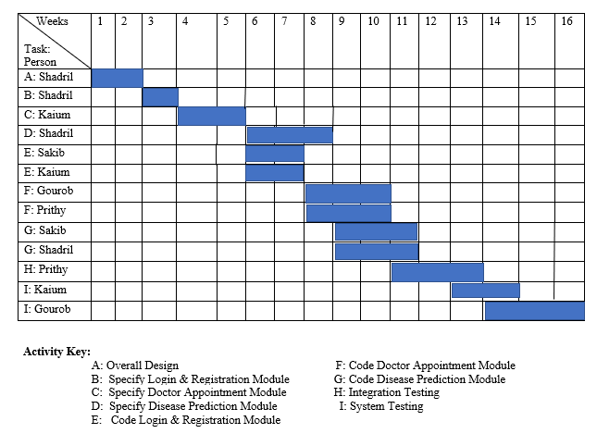

## Risk Analysis

