home assignment #1

The work was written by

Shahaf Zohar 205978000

1. Our code:

#include <stdio.h>

#include <stdlib.h>

#include <time.h>

#include "mpi.h"

#include <math.h>

int main(int argc, char *argv[])

{

int myid,numprocs,i,namelen,n,flag=0;

int totalPoints = 0;

int pointsInsideCircle = 0;

double x,y,pi,mypi,Stime,pi_estimate;

char processor_name[MPI_MAX_PROCESSOR_NAME];

MPI_Init(&argc,&argv);

MPI_Comm_size(MPI_COMM_WORLD, &numprocs);

MPI_Comm_rank(MPI_COMM_WORLD, &myid);

MPI_Get_processor_name(processor_name, &namelen);

while(!flag){

if(myid ==0){

if (totalPoints == 0) totalPoints=10000000; else totalPoints=0;

Stime = MPI_Wtime();

}

MPI_Bcast(&totalPoints, 1, MPI_INT,0, MPI_COMM_WORLD);

if (totalPoints == 0) flag = 1;

else{

for(i = myid+1; i < totalPoints; i+=numprocs){

x = (double)rand() / RAND_MAX; // Random number between 0 and 1

y = (double)rand() / RAND_MAX; // Random number between 0 and 1

// Check if the point (x, y) is inside the unit circle

if(x*x + y*y <= 1){

pointsInsideCircle++;

}

}

// Estimate pi using the Monte carlo method

pi_estimate = 4.0 * pointsInsideCircle/totalPoints;

MPI_Reduce(&pi_estimate,&pi,1,MPI_DOUBLE,MPI_SUM,0,MPI_COMM_WORLD);

if(myid == 0){

printf("Estimated value of pi: %.6f\nThe clock time %f.\n",pi ,MPI_Wtime()-Stime);

fflush(stdout);

}

}

}

MPI_Finalize();

return 0;

}

1. A brief explanation of how to run the code:

Compilation of the program:

mpicc hw1.c -o a

Running the program after compiling and selecting several processes:

mpirun -np <number_of_processes> ./a

Using Scalasca

A performance analysis tool for parallel programs:

scalasca -instrument mpicc -o cpi_scalasca ./hw1.c

Running the program with Scalasca and several processes can be added:

scalasca -analyze mpirun -np <number_of_processes> ./cpi_scalasca

After running the previous command, a Scalasca file is created. This command runs the Scalasca file:

scalasca -examine ./scorep_cpi_scalasca_<number_of_processes>_sum

Using jumpshot:

Compilation of the program:

tau_cc.sh -o test_tau ./test.c

Running the program after compiling and selecting several processes:

mpirun -np <number_of_processes> ./test2_tau

Run paraprof

paraprof

close and run this command to prompt jumpshot

tau_treemerge.pl

tau2slog2 tau.trc tau.edf

jumpshot ./tau.slog2

1. The plots that are requested in item D above:

Plot without Scalasca

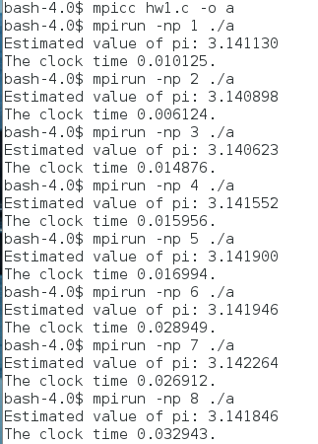

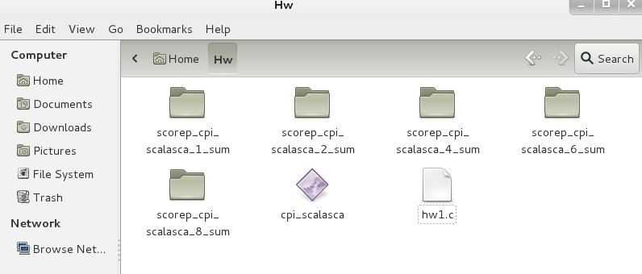After running the Scalasca commands the following files were created:

For one process:

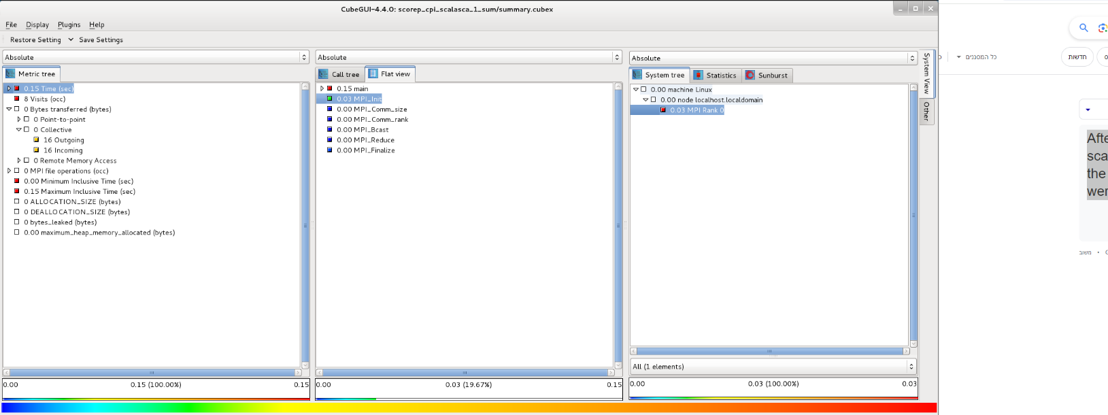

For two processes:

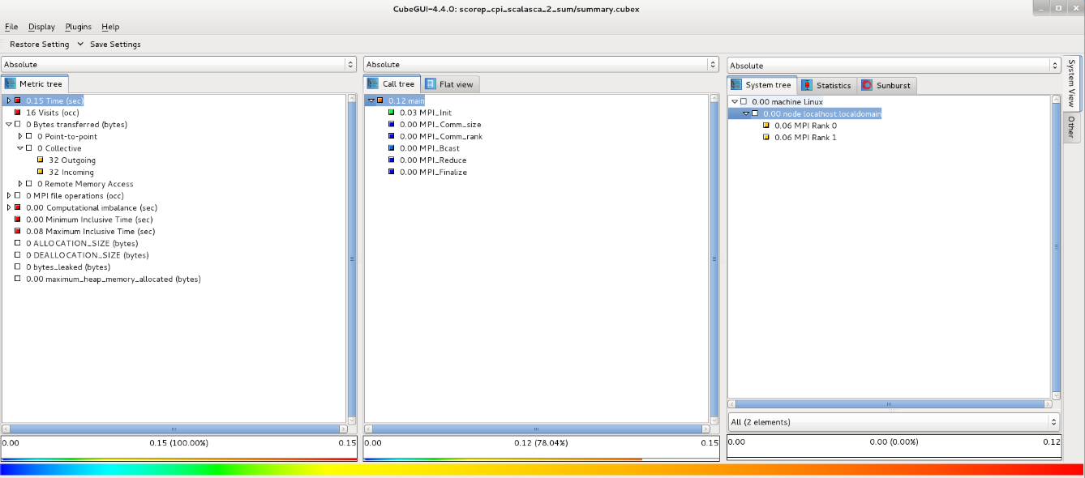

for four processes:

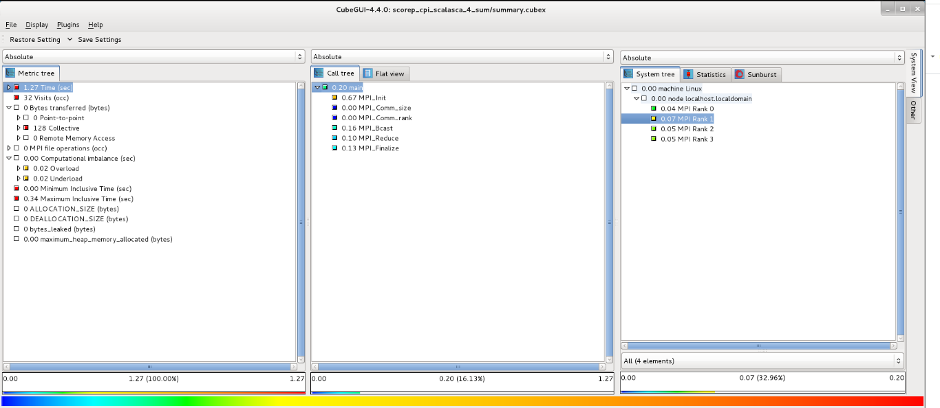

For six processes:

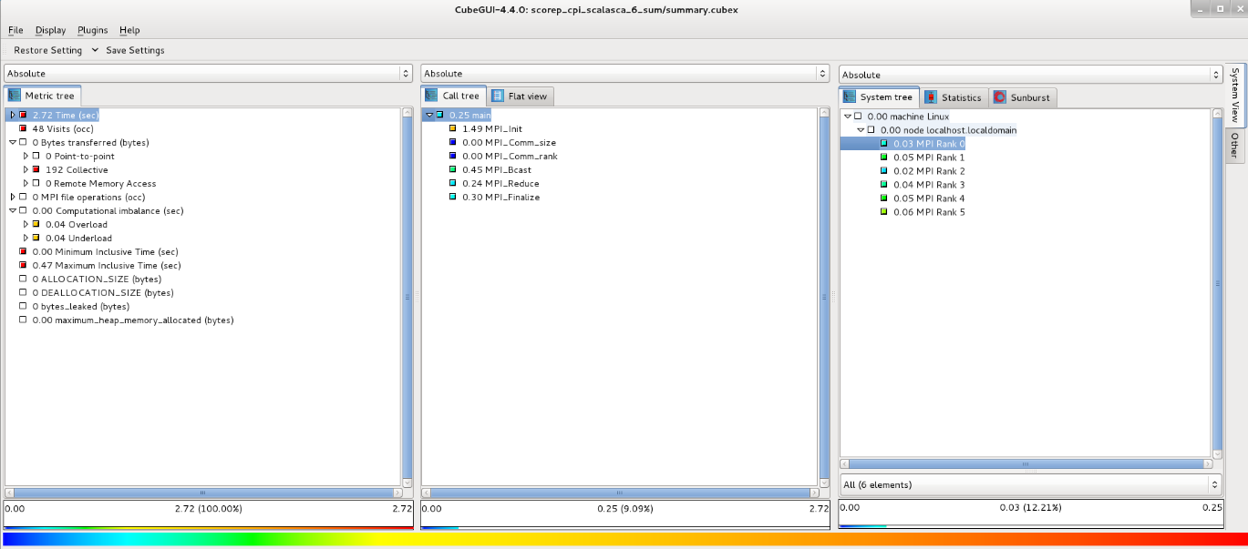

For eight processes:

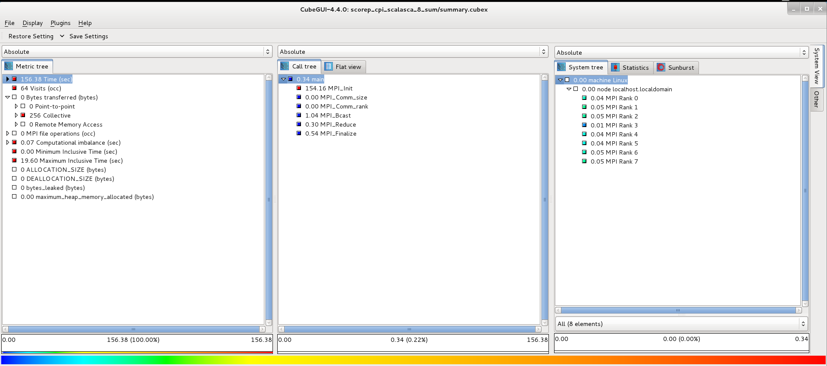

An example that can be given for each of the processors:

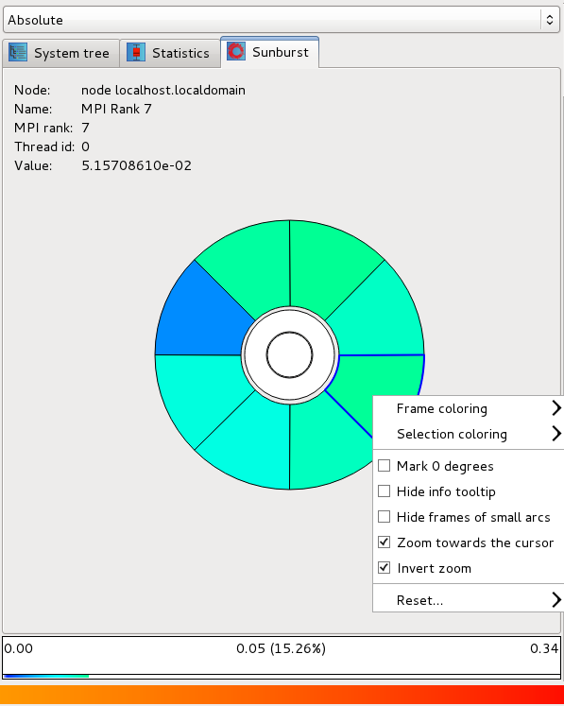

1. 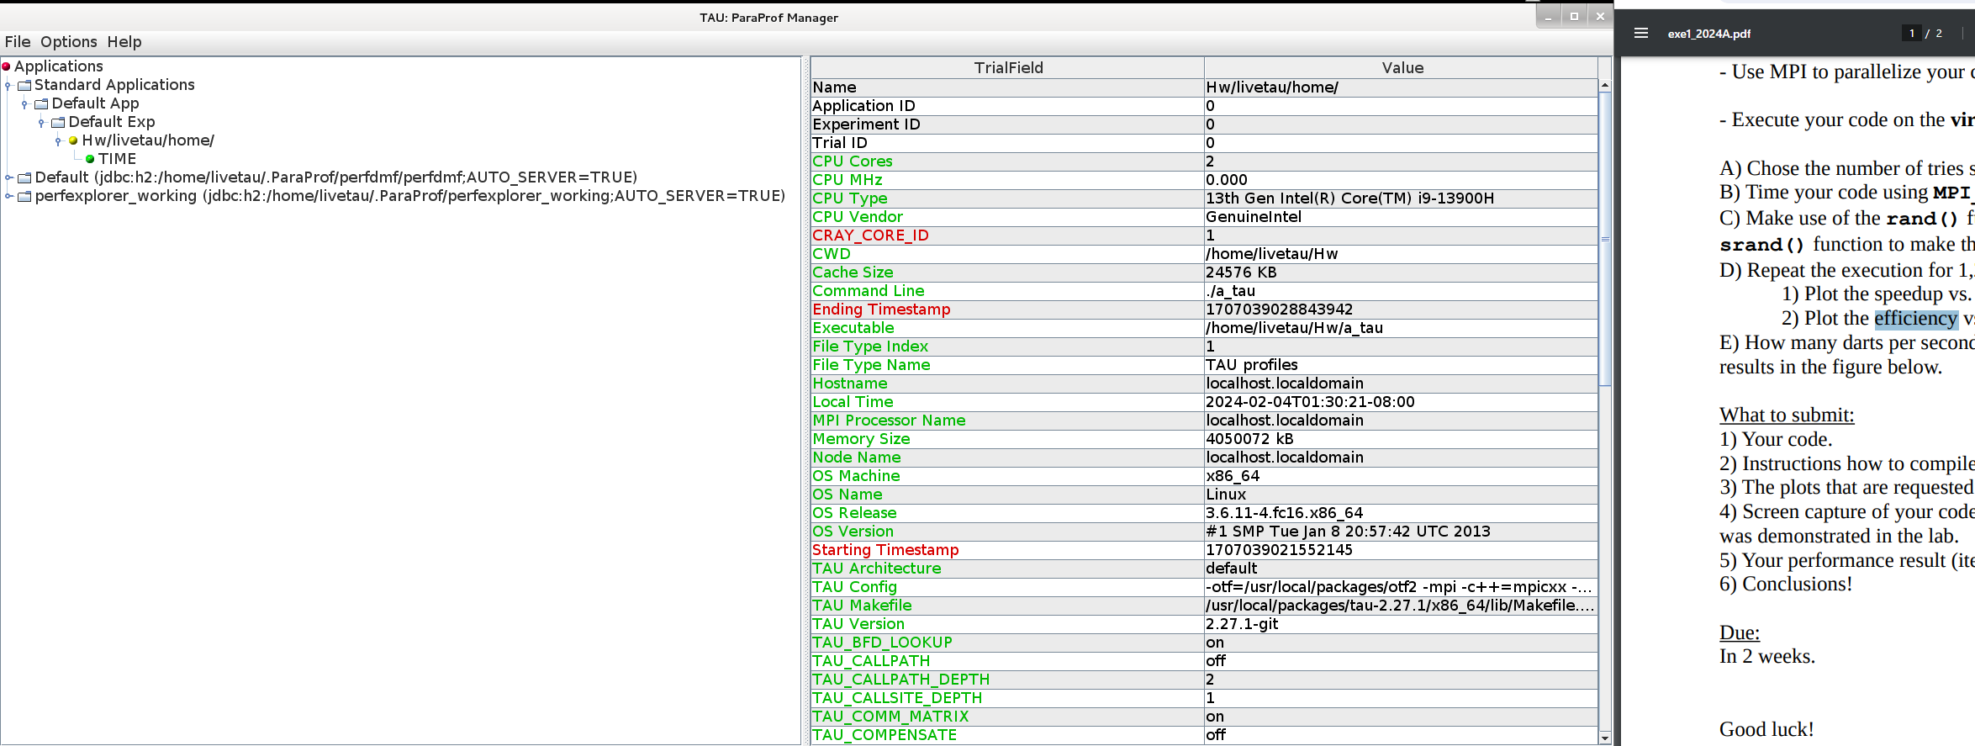Data about the system

Analysis on the system for 8 example processes:

Additional disconnections on the system with the help of jumpshot

