Final Report on
Brain Tumor Detection and Segmentation Tool

Software Project Lab 3

Submitted by

Md. Muntakim Hye Rashik
BSSE 1256
Institute of Information Technology
University of Dhaka

Supervised by

Dr. Ahmedul Kabir
Associate Professor
Institute of Information Technology
University of Dhaka


Submission Date: 1 December 2024
Signature Page

Project:

Author:

Submitted:

Supervised By:

Brain Tumor Detection and segmentation Tool

Md. Muntakim Hye Rashik

30-11-2024

Dr. Ahmedul Kabir

Associate Professor, Institute of Information Technology,

University of Dhaka

Supervisor’s

Approval:

_______________________________

Letter of Transmittal

1 December 2024

BSSE 4th Year Exam Committee
Institute of Information Technology
University of Dhaka

Subject: Final report on “Brain Tumor Detection and segmentation Tool”.

Sir,

With due respect, I am pleased to submit the final report of Software Project Lab 3 on “Brain Tumor Detection and segmentation Tool”. I have tried my best to deliver a good understanding of the technical details of the project. However, it might lack perfection. So, I, therefore, hope that you would be kind enough to accept my report and oblige thereby.

Sincerely yours,

Md. Muntakim Hye Rashik
BSSE 1256
Institute of Information Technology
University of Dhaka
Acknowledgment

I am grateful to the Institute of Information Technology for giving me such a tremendous opportunity to work on “Brain Tumor Detection and Segmentation Tool”. I would like to convey my immense gratitude to my supervisor, Dr. Ahmedul Kabir, Associate Professor, Institute of Information Technology, University of Dhaka, for providing guidelines for preparing this analysis document. Lastly, I would like to thank my classmates. They have always been helpful and provided valuable insights from time to time.
Abstract

This document contains the software requirements and specifications, architectural design, and testing of “Brain Tumor Detection and segmentation Tool”. This tool will help software users to segmentate and classify brain tumor detection Brain tumors are complex and can vary in size, shape, and location within the brain. Traditional manual segmentation methods are time-consuming and prone to human error. To address these challenges, our tool leverages the UNet architecture, a deep learning model known for its exceptional performance in image segmentation tasks. The “Brain Tumor Detection and segmentation Tool” will also feature an improved model which will help users to have customization according to their needs.

Chapter 1: Introduction |  |  | 8
1.1 | Purpose |  | 8
1.2 | Scope |  | 8
1.3 | Assumptions |  | 8
Chapter 2: Project Description |  |  | 9
2.1 | Quality Function Deployment |  | 9
 | 2.1.1 | Normal Requirements | 9
 | 2.1.2 | Expected Requirement | 9
2.2 | User Scenario |  | 9
 | 2.2.1 | Data Input | 9
 | 2.2.2 | Model Selection | 10
 | 2.2.3 | Segmentation | 10
 | 2.2.4 | Visualize output data | 10
Chapter 3: Scenario Based Modeling |  |  | 11
3.1 | Use Case Diagram |  | 11
 | 3.1.1 | Brain Tumor Detection and segmentation Tool | 11
 | 3.1.2 | Module of Brain Tumor Detection and segmentation Tool | 11
 | 3.1.3 | Input Data Management | 12
 | 3.1.4 | Model Selection | 13
 | 3.1.5 | Output Data Management | 14
Chapter 4: Data Modeling |  |  | 15
Chapter 5: Class-Based Modeling |  |  | 16
Chapter 6: Architectural Design |  |  | 22
6.1 | Architectural Context Diagram |  | 22
6.2 | Defining Archetypes |  | 22
6.3 | Refining the Architecture into Top-Level Components |  | 24
6.4 | Instantiation of Software Architecture Components |  | 25
6.5 | Mapping Requirements for Software Architecture |  | 25
Chapter 7: Data Flow Diagram |  |  | 27
7.1 | 0-level DFD |  | 27
7.2 | 1-level DFD |  | 27
Chapter 8: Methodology |  |  | 29
Chapter 9 : User Interface Design |  |  | 29
Chapter 10 : Implementation Details |  |  | 32
10.1 Data Collection |  |  | 32
10.2 Client-Side Implementation |  |  | 32
10.3 Server-Side Implementation |  |  | 33
10.4 Source Code Description : |  |  | 33
Chapter 11: Preliminary Test Plan |  |  | 34
11.1 Client-Side Testing |  |  | 34
 | 11.1.1 High-level description of testing goals |  | 34
 | 11.1.2 Testing Strategy |  | 34

11.1.3 Item Pass/Fail Criteria |  | 34
Chapter 12: User Manual |  | 37
12.1 | What does Brain Tumor Detection and segmentation Tool do ? | 37
12.2 | Why should you use it? | 37
12.3 | How to use it? | 38
Chapter 13: Conclusion |  | 42
Chapter 14: Reference |  | 43

Chapter 1: Introduction

Brain MRI segmentation is a critical process in the field of medical imaging. It involves the precise delineation and extraction of regions of interest within medical images, such as MRIs, CT scans, and X-rays. Accurate segmentation plays a pivotal role in diagnosis, treatment planning, and medical research. The Brain Tumor Detection and segmentation Tool aims to provide an efficient and user-friendly solution for automating this complex task.

1.1 Purpose

The purposes of this document are:

- Identify and analyze the requirements

- Design the architecture

- Design the test plan

- Describe methodology

- Reduce the development effort

- Improve understanding

1.2 Scope

The scope of the project is given below-

- A Web Application

- Ensure that the segmentation algorithms produce accurate and clinically meaningful results.

1.3 Assumptions

The assumptions of the project are-

- Medical images provided to the application will have sufficient quality, resolution, and contrast for accurate segmentation.
- Users of the application have a basic understanding of Brain MRI interpretation and segmentation concepts.
Chapter 2: Project Description

This chapter presents the quality function deployment and usage scenario of the tool.

2.1 Quality Function Deployment

Quality Function Deployment (QFD) is a technique that translates the needs of the customer into technical requirements for the software. Concerning this project, the following requirements are identified-

2.1.1 Normal Requirements

NR1: Web tool

NR2: User can upload image set

NR3: Output will be shown alongside the original picture

2.1.2 Expected Requirement

ER1: Easily understandable user interface

ER2: A user-friendly test result will be shown

ER3: User can upload images in 2 ways:

- File upload

- Drag & Drop

ER4: User can upload images in different formats

ER5: Classify and segment medical images accurately

ER6: Tool will be fast and efficient

2.2 User Scenario

Image segmentation will be a Web application. The proposed software tool will help medical image segmentation, especially MRI Brain Image detection. Users will be able to see brain tumor segmentation in the output.

The usage scenario for the app has been segmented and described below:

2.2.1 Data Input

Users can input Images in a particular format(.jpg,.png etc.). Users

can browse their local data files and load the input files from the local directory

2.2.2 Model Selection

Users can select a model from our pretrained model for a specific task. This is important so that we can integrate a new model into this project.

2.2.3 Segmentation

Our selected model will segment the brain tumor from the images

2.2.4 Visualize output data

After some post-processing, the tumor will be displayed in the output window. User can see the original image and the highlighted image from the data
Chapter 3: Scenario Based Modeling

3.1 Use Case Diagram

Use case diagrams are given below-

3.1.1 Brain Tumor Detection and segmentation Tool

Level 0: Brain Tumor Detection and segmentation Tool

Primary Actors: User

Goal in Context: The diagram shown in Figure 1 represents the high-level overview of the Brain Tumor Detection and segmentation Tool System

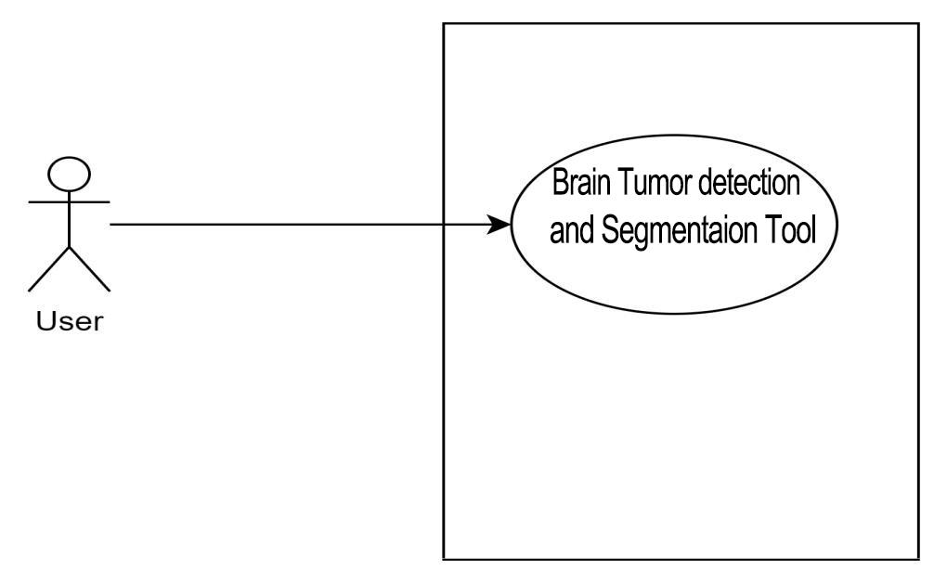

Figure 1: Level 0

3.1.2 Module of Brain Tumor Detection and segmentation Tool

Level 1

Primary Actors: User

Goal in Context: The diagram shown in Figure 2 represents the modules of the Medical Image Segmentation Tool. Modules of the projects are Data Input Management, Visualize Sample Data, Model Selection, Segmentation, and Output Data Management.
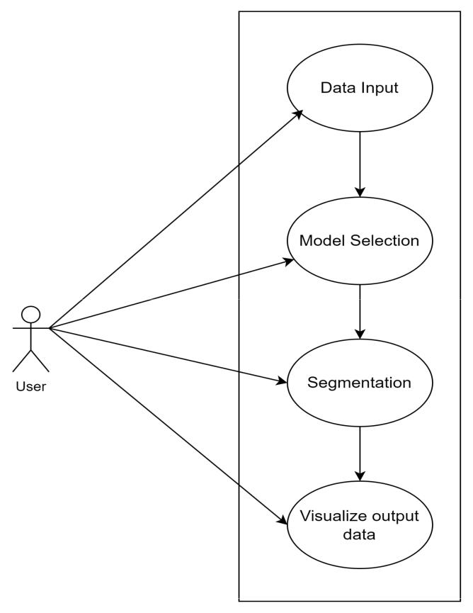

Figure 2: Modules of Brain Tumor Detection and segmentation Tool use case

3.1.3 Input Data Management

Level 1.1: Input Data Management

Primary Actors: User

Goal in Context: The diagram in Figure 3 represents the use case for the Input Data Management Module. Users can load medical Images and the system will preprocess the loaded data.
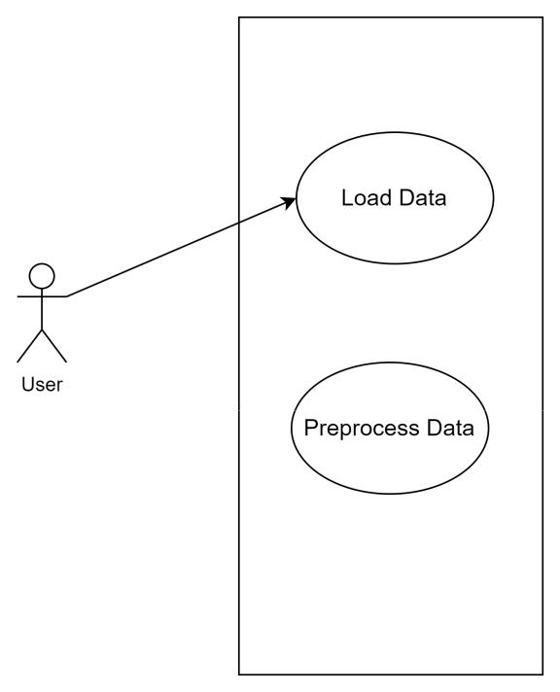

Figure 3: Input Data Management use case

3.1.4 Model Selection

Level 1.3: Model Selection

Primary Actors: User

Goal in Context: Figure 3's diagram depicts the use case for the Model Selection Module. Users can select an available pre-trained model. Moreover, the system will be responsible for training and evaluating the model.
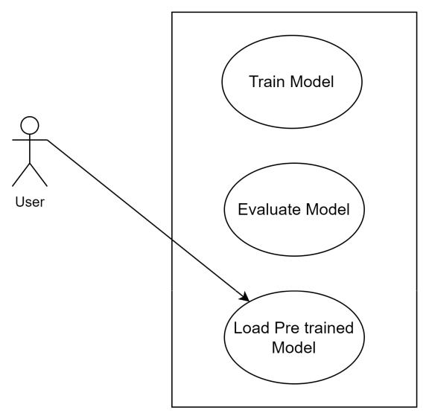

Figure 4: Model Selection use case

3.1.5 Output Data Management

Level 1.4: Output Data Management

Primary Actors: User

Goal in Context: The diagram in Figure 5 shows the use case of the Output Data Management Module. Users can display and save the output.
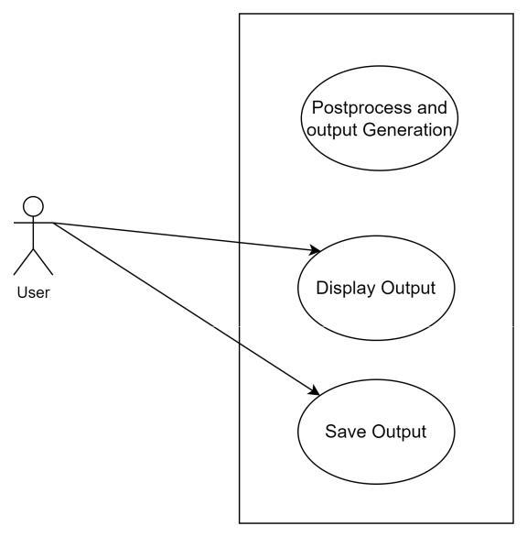

Figure 5: Output data management use case
Chapter 4: Data Modeling

The software development team will choose to design data models as part of the overall requirements modeling process if the software requirements call for the creation, extension, or interaction with a database or the construction and manipulation of complicated data structures.
The entity-relationship diagram (ERD) outlines each and every data object processed by the system, as well as the connections between them and details on how they are brought into the system, stored there, modified, and created. Our trained model and its parameters are stored locally in the Medical Image Segmentation Tool. In addition, for this project, we did not save any databases.
Chapter 5: Class-Based Modeling

This chapter describes the class-based modeling of the Brain MRI Segmentation

5.1 Analysis Class

After identifying the nouns from the scenario, I have filtered the nouns belonging to the solution domain using General Classification (External entities, Things, Events, Roles, Organizational units, Places, and Structures). Nouns selected as a potential class were filtered using Selection Criteria (Retained information, needed services, Multiple attributes, Common attributes, Common operations, and Essential requirements). After performing an analysis on potential classes, I have

found the following analysis classes:

- InputDataHandler

- ModelSelector

- ModelTrainer

- GUI

- ImageVisualizer

- MetricsVisualizer

- GUIController

- Segmentation

- OutputDataHandler
5.2 Class cards

The class cards of these classes are shown below :

InputDataHandler

Attributes | Methods
-input data: image | + user_input_handler()
- model_name: String | - preprocess_input_data()
 | + display_input_data()
 | + get_input_data()
 | + get_model_name()
Responsibility | Collaborator
● Handle User input and dispatch user | ●
instructions | ● | GUIController
 | ● | ImageVisualizer
Table 1: class card of InputDataHandler
ModelSelector
Attributes | Methods
- PretrainedModels: List of objects | + get_model_list()
- model_name: String | + get_best_model()
- best_model: String | + display_model_metrics
Responsibility | Collaborator
● Select task wise best models and | ● | MetricsVisualizer
display its metrics

Table 2: class card of ModelSelector

ModelTrainer

Attributes

Methods

- dataset | - data_loader()
- train_data | - model_trainer()
- validation_data | - pretrainedModel_loader()
- test_data | + model_evalutor()
- model | + update_best_model()
- model_metrics | + update_model_metrics()
- hyper_parameter | + get_model_metrics
Responsibility | Collaborator
● Manage pre trained and new models in a | ● ModelSelector
separate remote access directory
Table 3 : class card of ModelTrainer
GUI
Attributes | Methods
- ui_main_window | + setup_ui()
- widgets | + retranslate_ui()
 | + get_widgets()
Responsibility | Collaborator
● Manage User Friendly Graphical | ● GUIController
User Interface

Table 4: class card of GUI

ImageVisualizer

Attributes | Methods
- input_data | - transform_input_data()
- graphics_view | + display_input_data()
 | - mouse_controller()
 | - event_controller()
Responsibility | Collaborator
● Handle visualization of the image | ● GUI

Table 5: class card of ImageVisualizer

MetricsVisualizer

Attributes | Methods
- model_name | + display_model_metrics()
- model_metrics | - metrics_calculator()
- graphics_view | + get_model_metrics()
Responsibility | Collaborator
● Handle visualization of Model | ● GUI
Metrics Data
Table 6: class card of MetricsVisualizer
GuiController
Attributes | Methods
- input_data | + event_handler()
- output_data | + gui_controller()
- GUI | + graphics_controller()
 | + view_controller()
Responsibility | Collaborator
● Controls User interaction with GUI | ●GUI
 | ● InputDataHandler
 | ● OutputDataHandler
Table 7: class card of GuiController
Segmentation
Attributes | Methods
- pretrained_model | + segmentation()
- input_data | - load_pretrained_model()
- output_data | - get_data()
 | + get_output_data()
Responsibility | Collaborator
-Segment Brain tumor data using | ● InputDataHandler
pre-trained model | ● OutputDataHandler

Table 8: class card of Segme

OutputDataHandler

Attributes | Methods
- data | - postProcess_data()
 | + display_output_data()
 | + save_output_data()
Responsibility | Collaborator
● Handle the final output data after | ●
segmentation of brain image data | ● | GUIController
 | ● | ImageVisualizer

Table 9: class card of OutputDataHandler
5.3 Class Diagram
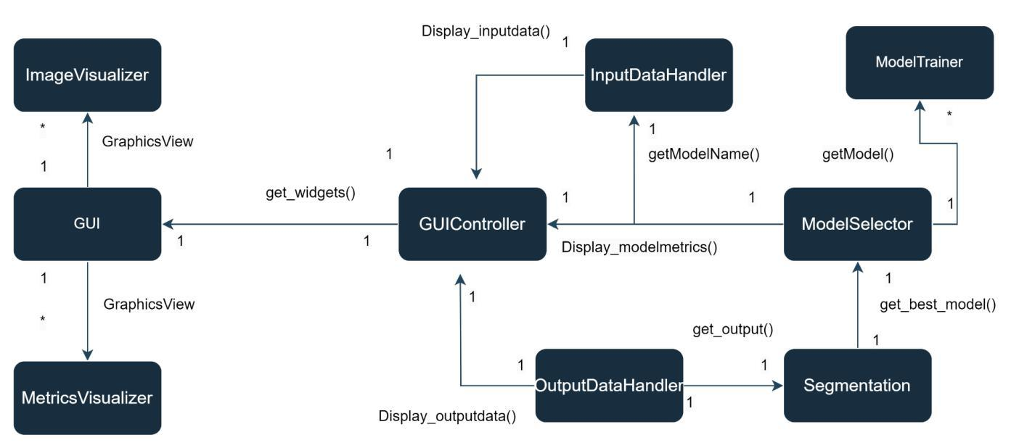

Figure 6: CRC class diagram of the Brain Tumor Detection and segmentation Tool

Chapter 6: Architectural Design

This chapter describes the architectural overview and architectural context diagram of the Brain Tumor Detection and Segmentation Tool.

6.1 Architectural Context Diagram

It is possible to model how software communicates with entities outside of its boundaries using an architectural context diagram. The target system's cooperating systems are denoted by the following symbols:

Superordinate systems: Those systems that use the target system as part of some higher-level processing scheme. Our system has no superordinate systems.

Subordinate systems: Those systems that are used by the target system and provide data or processing that are necessary to complete the target system functionality. Model Trainer is the subordinate system of our Brain Tumor Detection and Segmentation Tool.
Peer-level systems: Those systems that interact on a peer-to-peer basis (i.e., information is either produced or consumed by the peers and the target system (no peer-level system in this case).

Actors: Entities (people, devices) that interact with the target system by producing or consuming information that is necessary for requisite processing. The user of our system is the Actor in this case. Each of these external entities communicates with the target system through an interface (the small shaded rectangles).
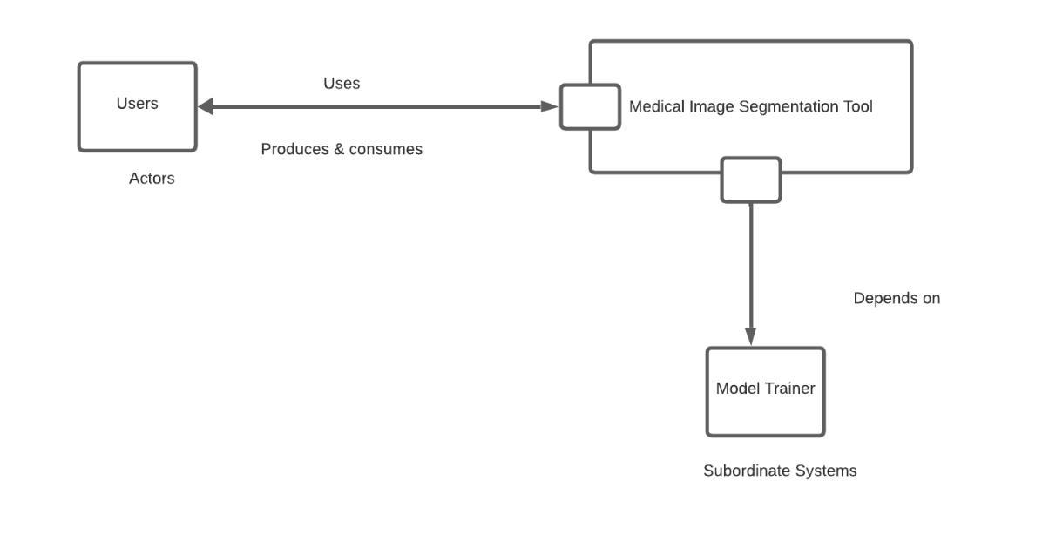

Figure 7: Architectural Context Diagram of the Brain Tumor Detection and segmentation Tool

6.2 Defining Archetypes
An archetype is a class or pattern that symbolizes a fundamental abstraction that is essential to the creation of the target system's architecture. In principle, even extremely complicated systems can be designed using a relatively small collection of archetypes. These archetypes, which stand for stable components of the goal system architecture but may be instantiated in several ways depending on the system behavior, make up the target system architecture.

Input: An abstraction that depicts all the input mechanisms.

Segmentation: Segmentation is an abstraction that represents a module that will only be responsible for Classifying user input data according to the best model selection.

Model generator: Model generator is an abstraction that represents a module that will only be responsible for training different models. It is an independent module and It trains and evaluates models separately; other modules are not dependent on these modules while it trains other models. After training and evolution, it updates the model's parameter in common storage, which will be accessed by other modules.

Dataset: Abstraction that depicts the datasets that will be used for modeling & analysis.

Output: Abstraction that depicts all the output mechanisms
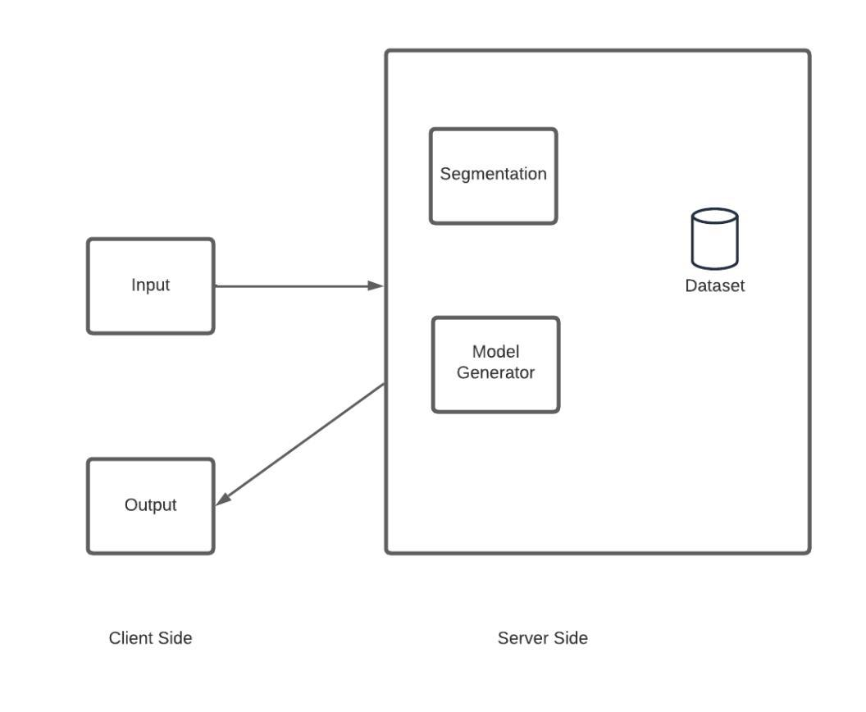

Figure 8: Identification of the Archetypes of the Brain Tumor Detection and segmentation Tool

The most appropriate architecture for this tool would be Client-Server architecture. From the client side, input data will be fetched and sent to the server. The server side will then extract appropriate data from the fetched data, perform some analysis and operations, and provide appropriate feedback responses back to the client. This would be a very simple yet effective architectural solution for the project.

6.3 Refining the Architecture into Top-Level Components

The system's structure starts to take shape as the software architecture is divided into its components. The Brain Tumor Detection and segmentation Tool's top-level parts are shown in the diagram below.
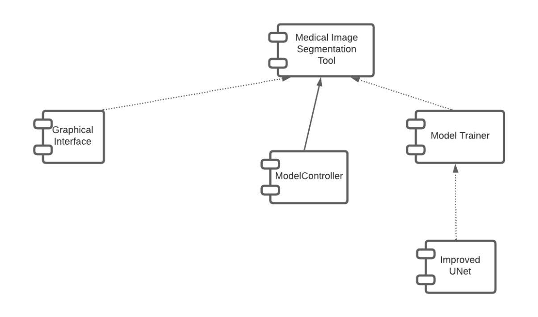

Figure 9: Top-level components of the Brain Tumor Detection and segmentation Tool

Graphical Interface: My application Brain Tumor Detection and segmentation Tool has a Graphical

User Interface and it is added as a top-level component. It will be responsible for handling all graphics views and user events.

ModelController: We need to consider multiple pre-trained models according to input data. The model controller is responsible for selecting the best available model and generating expected outputs.

Improved Unet: This is the basic architecture we will use for our model training.
6.4 Instantiation of Software Architecture Components

The architecture is created as an actual instantiation. The goal of architecture instantiation is to show that the structure and components are adequate for a particular problem. The implementation of the following instantiation is done for my system Brain Tumor Detection and segmentation Tool.
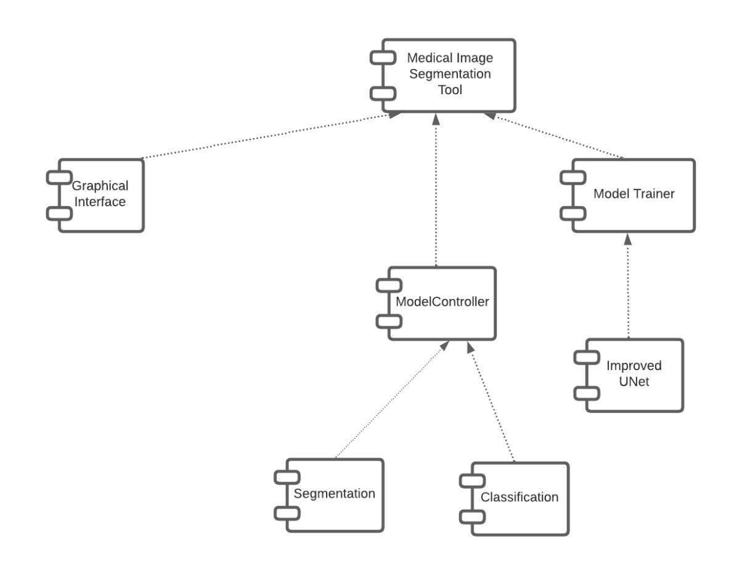

Figure 10: Instantiation of Top-level Components

6.5 Mapping Requirements for Software Architecture

Data will be displayed to the users by the presentation layer, which will handle user input. To classify user inputs, choose the appropriate model for the given user input, and show output in a GUI, it would interface with the business logic layer. The business logic layer will carry out all calculations. The data access layer will store, modify, and retrieve data to common Local storage as needed. To obtain the results, the user will simply need to click a few buttons. The
presentation layer, business logic layer, and data access layer will each effectively handle each of the remaining activities in the background. This architecture satisfies all needs.
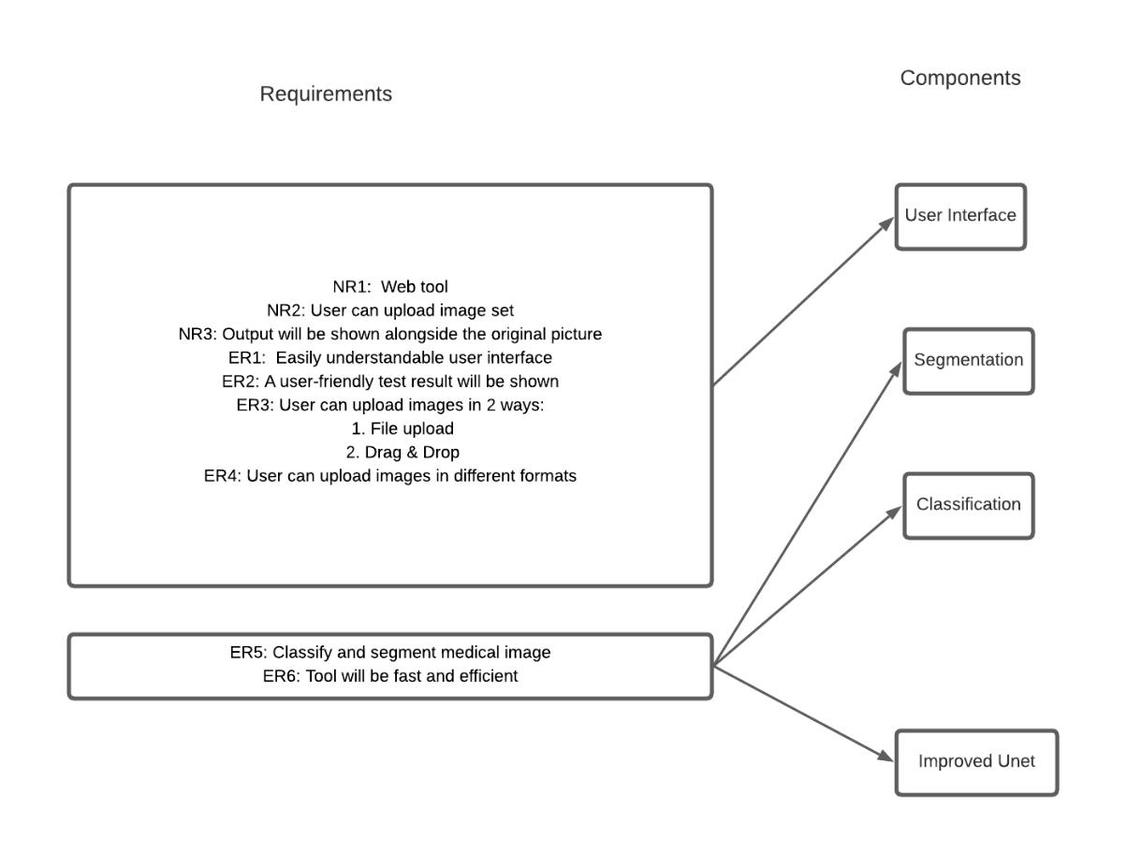

Figure 11: Mapping Requirements to Architecture

Chapter 7: Data Flow Diagram

7.1 0-level DFD
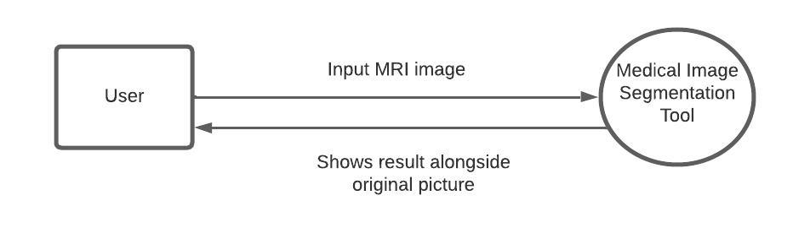

Figure 12: 0-level DFD of Brain Tumor Detection and segmentation Tool

The level-0 DFD gives a high-level description of the tool. The input data will be passed to the tool and a response after analysis will be generated and will be shown as output. External Entities: User

Process: Brain Tumor Detection and segmentation Tool

7.2 1-level DFD
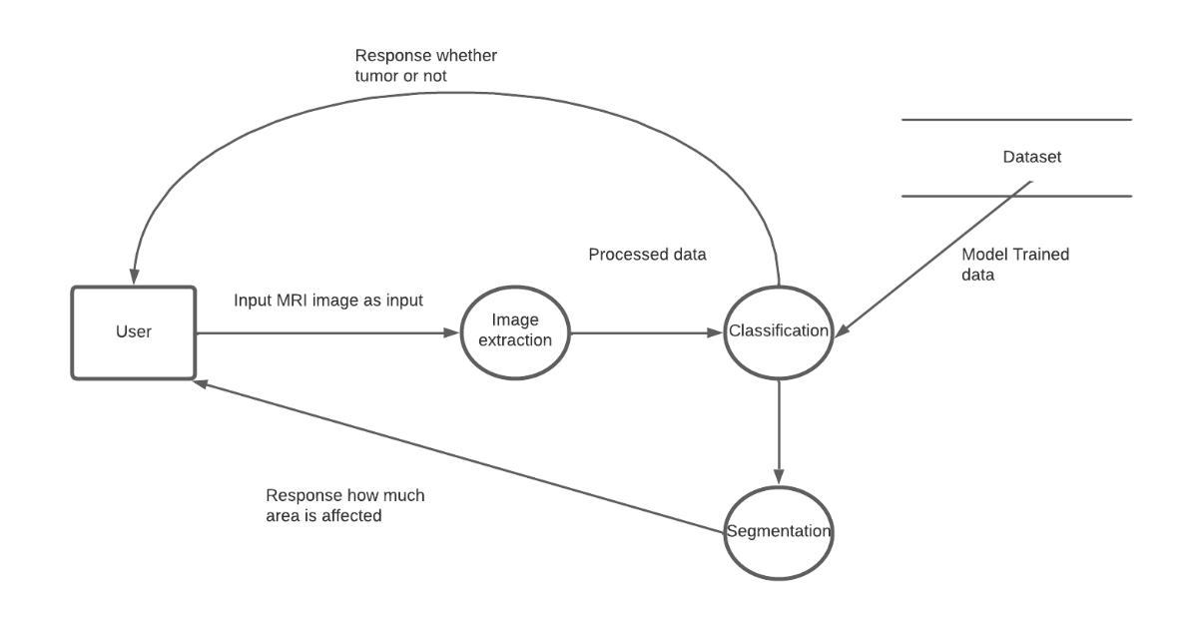

Figure 13: 1-level DFD of Brain Tumor Detection and segmentation Tool
The level-1 DFD gives descriptions of the main features of the tool. The input data will be

passed to the tool and a response after analysis will be generated and will be shown as output.

External Entities: User

Processes:

- Image Extraction

- Image Classification

- Image Segmentation
Chapter 8: Methodology

This chapter describes how the Brain Tumor Detection and segmentation Tool is prepared. I have used the UNet Technology Model.The U-Net architecture is a popular neural network architecture used for image segmentation tasks. Here is a simplified methodology of the U-Net architecture using four key points:

Encoder-Decoder Structure:

U-Net follows an encoder-decoder structure. The encoder is responsible for capturing the contextual information and reducing the spatial dimensions of the input image through a series of convolutional and pooling layers. The decoder, on the other hand, performs upsampling to restore the spatial dimensions and generate the segmented output.

Skip Connections:

One distinctive feature of U-Net is the incorporation of skip connections. These connections directly link layers from the encoder to corresponding layers in the decoder. By doing so, U-Net can leverage both low-level and high-level features, enabling precise localization of objects in the segmentation mask.

Contracting and Expanding Paths:

The encoder consists of a contracting path that progressively reduces the spatial dimensions through convolution and pooling operations. The decoder, conversely, involves an expanding path that upsamples the features to generate the final segmentation map. Skip connections connect corresponding layers in the contracting and expanding paths.

Final Convolutional Layer:

The final layer of the U-Net architecture typically involves a 1x1 convolutional layer that produces the segmentation mask. This layer is often followed by a suitable activation function, such as the sigmoid function for binary segmentation or the softmax function for multi-class segmentation. The output of this layer represents the pixel-wise predictions of the model.

Chapter 9 : User Interface Design

Figure 9.1 – Figure 9.4 show the User Interface Design of Brain Tumor Detection and segmentation Tool.

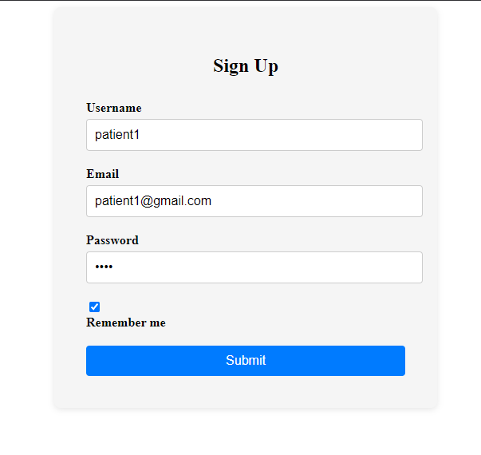

Figure 14: Sign-up page
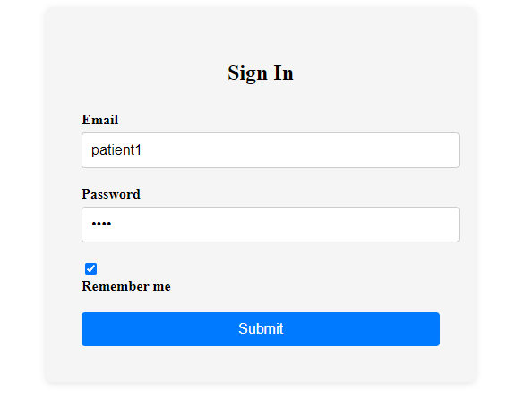

Figure 15: Sign-in page
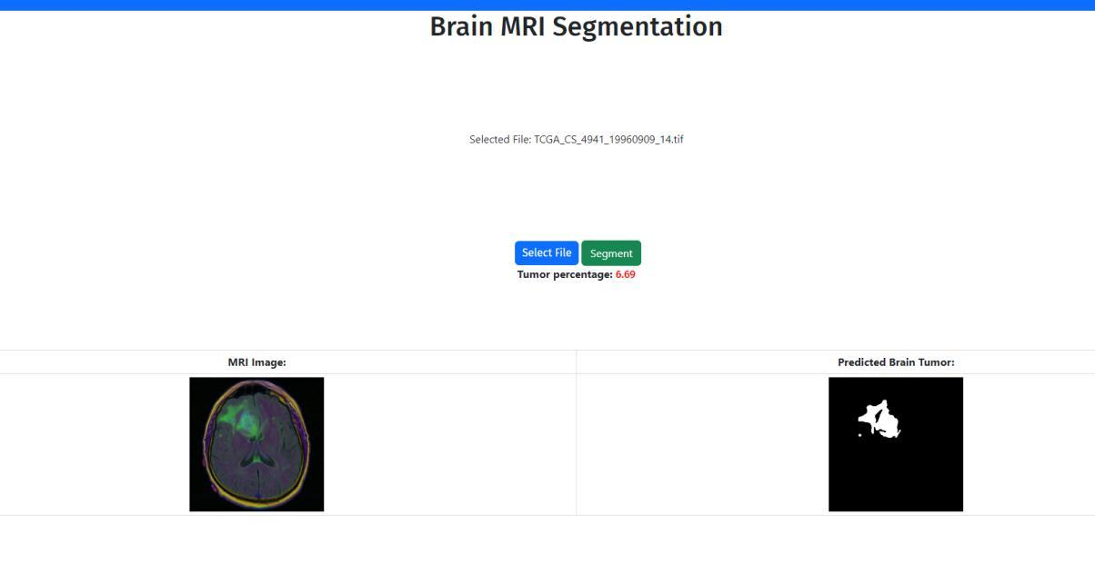

Figure 16: Result page

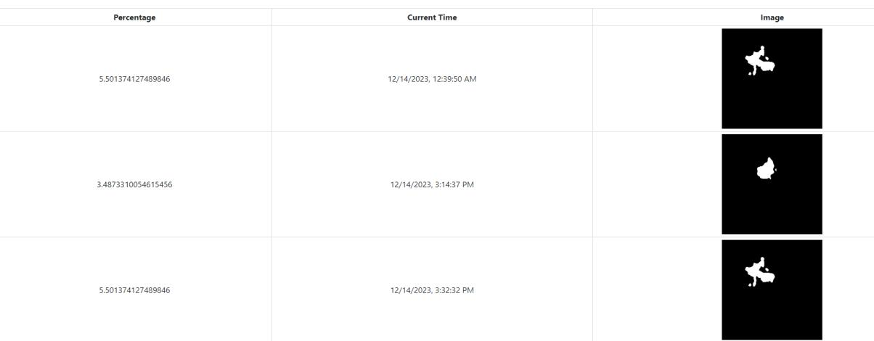

Figure 17: History page

Chapter 10 : Implementation Details

This chapter describes the implementation details for developing Brain Tumor Detection and segmentation Tool.

10.1 Data Collection

In 2019, an estimated 5 million people were diagnosed with a cancer of the gastro-intestinal tract worldwide. Of these patients, about half are eligible for radiation therapy, usually delivered over 10-15 minutes a day for 1-6 weeks. Radiation oncologists try to deliver high doses of radiation using X-ray beams pointed to tumors while avoiding the stomach and intestines. With newer technology such as integrated magnetic resonance imaging and linear accelerator systems, also known as MR-Linacs, oncologists are able to visualize the daily position of the tumor and intestines, which can vary day to day. In these scans, radiation oncologists must manually outline the position of the stomach and intestines in order to adjust the direction of the x-ray beams to increase the dose delivery to the tumor and avoid the stomach and intestines.

10.2 Client-Side Implementation

The client side implementation of Brain Tumor Detection and segmentation Tool is done using React.This framework helps to generate request made in the server side.

This makes it easier to create an app and simplifies the development process.This part there are login,signup,imageprocessing and history.HTML, CSS and Javascript are used for the frontend.
10.3 Server-Side Implementation

The server-side implementation of the web app is done using python 3 AND Flask, a web application framework in Python. I used Mongodb for database related works and pytorch for image processing and Cloudinary for storing images.

10.4 Source Code Description :

├── app.js

This is the entry point for the app.

├── config.json

This file specifies the port, local-baseurl, whitelist, that is, the overall configuration for the development and production environment.

├── credentials.json

This file contains the URL, username,secret key and password to match the credentials of cloudinary and mongodb.

The functions in app.py and their responsibilities :

Function | Task
signup() | Create user registration API with validation,
 | secure password storage, and appropriate
 | responses.
login() | Develop login API with authentication,
 | secure password verification, and token
 | generation
Upload_file() | Design file upload API with processing,
 | validation, and responses indicating success
 | or failure.
calculate_tumor_percentage() | Integrate UNet model, calculate tumor
 | percentage, store results, and return in API
 | response.
image_processing() | Implement image processing API with
 | format conversion, preprocessing, and
 | robust error handling.
get_history() | Create API to fetch user-specific historical
 | tumor percentage data with timestamps

Table 9:app.py functions

Chapter 11: Test Plan

11.1 Client-Side Testing

A black box testing technique has been used to test the Client-side Application. All the tests will be conducted on Windows 10 (64 bit).

11.1.1 High-level description of testing goals

The Brain Tumor Detection and segmentation Tool undergoes high-level testing which is popularly known as Black box testing. Black Box Testing is a software testing method in which the functionalities of software applications are tested without knowing internal code structure, implementation details, and internal paths. Black Box Testing mainly focuses on input and output of software applications and it is entirely based on software requirements and specifications. Serving as a bridge between users and the development team of a product, the ultimate goal of software testing is to troubleshoot all the issues and bugs as well as control the quality of a product. The goals of high-level software testing are given below:

- To ensure that the system works properly that means the system can segment tumors correctly.

- To ensure that the system satisfies the user requirements and works as desired.

- To find any existing bug.

- To improve the system.

11.1.2 Testing Strategy

The item to be tested is a web application. The project exists online and can be downloaded from GitHub. All functionalities of the system will be split into modules and black-box testing will be conducted on each feature. Boundary value checking, robustness testing, and worst-case testing will formulate test cases. Input specifications will be created in compliance with the software requirement specification document.

11.1.3 Item Pass/Fail Criteria

If the application’s outcome is exactly like the expected outcome then we will consider that the test case has been passed successfully.

Test Cases:

The following table provides the test cases that need to be executed for client-side testing

Test | Test Cases | Input Test | Steps to be | Expected
ID |  | Data | executed | Result
T1 | Test if Login Works | Input Username | Input Username | Login Succesful
 |  | and password | and password | alert shown
 |  |  | and click the
 |  |  | Login button.
T2 | Test if Signup Works | Input | Input | Signup
 |  | Username,Emai | Username,Emai | Succesful alert
 |  | l Address and | l and password | shown
 |  | Password | and click the
 |  |  | Signup button.
T3 | Test if a valid Input | Input a valid | i) Display the | Segmented
 | Works | image | input data | brain tumor
 |  |  | ii)Show options | image
 |  |  | for segmenting
 |  |  | data
T4 | Test if an invalid input | Input a 3D | i) Alert | Unsupported
 | works | image file | Message | file format alert
 |  |  | display | message
T5 | Test if model selection | Selection | i) Choose Unet | The model is
 | works | Button Choice | Model | selected as
 |  |  |  | desired
T6 | Test if segmentation | i) Input a valid | i) Display the | Segmented
 | works | image | segmented | tumor pic will
 |  | ii)Select model | tumor picture | be showed
 |  |  | along with an | along with
 |  |  | original picture | picture
T7 | Test if User History | Select History | Display the | User’s previous
 | works | button | history of an | segmented
 |  |  | user’s inputs | image will be
 |  |  | and see the | shown
 |  |  | results | alongside the
 |  |  |  | percentage of
 |  |  |  | Tumors present
 |  |  |  | in the brain and
 |  |  |  | the Time.There
 |  |  |  | will also be a
 |  |  |  | bar chart
 |  |  |  | showing
 |  |  |  | progress/decrea
 |  |  |  | se.
T8 | Test if Export as image | Select export | Export the Bar | User’s tumor

works

Button

Chart as png

File

percentage along with their date will be shown.

Table 10:Test Table functions

Chapter 12: User Manual

12.1 What does Brain Tumor Detection and segmentation Tool do ?

The Brain Tumor Detection and segmentation Tool is a specialized software designed for the automated partitioning of brain magnetic resonance images (MRI) into distinct anatomical regions. Utilizing advanced segmentation algorithms, the tool precisely identifies and delineates structures within the brain, such as white matter, gray matter, and cerebrospinal fluid. This segmentation aids in quantitative analysis, facilitating the extraction of crucial diagnostic information and enabling researchers and clinicians to study structural changes, identify abnormalities, and enhance the understanding of neurological conditions. The tool streamlines the image analysis process, saving time and providing valuable insights for medical professionals and researchers in neuroimaging.

12.2 Why should you use it?

If you are a physician, this tool is a must-have for you. This tool helps you to:-

- The Brain Tumor Detection and segmentation Tool employs advanced algorithms to achieve precise and accurate segmentation of brain structures, enhancing the reliability of quantitative analyses.

- By automating the segmentation process, the tool significantly reduces the time required for manual analysis, allowing for faster and more efficient extraction of anatomical information from MRI scans.

- The segmentation tool provides quantitative metrics related to different brain regions, enabling researchers and clinicians to quantitatively assess structural changes, track disease progression, and conduct statistical analyses with a high level of precision.

- With its ability to identify and delineate specific brain regions, the tool serves as a valuable clinical decision support system, aiding healthcare professionals in the diagnosis and monitoring of neurological disorders and abnormalities.

- Researchers benefit from the tool's ability to streamline the image analysis workflow, allowing for large-scale studies, population-level analyses, and the extraction of meaningful data to advance our understanding of brain structure and function in health and disease.

In a nutshell, this will help you for better decision-making.

Chapter 13: Conclusion

This report comprehensively covers technical aspects for developing “Brain Tumor Detection and segmentation Tool”. It includes discussions on scope, assumptions, tool demonstrations, and testing methodologies, supported by figures and tables for clarity. The document aims to articulate the system workflow clearly.

We followed the proper SDLC(Software Development Life Cycle) throughout the project. This report can be used effectively to understand the overall development of the extension facing minimal ambiguity.

I intend to continue working on this topic in the future as it has a lot of potential. However, covering all the branches depends on the different test inputs, and types of the inputs, where it requires lots of research to understand the behavior of the program. So, integrating automated testing to encompass all execution branches is a potential future work for this project.
Chapter 14: Reference

- Ronneberger, Olaf, Philipp Fischer, and Thomas Brox. "U-net: Convolutional networks for biomedical image segmentation." Medical Image Computing and Computer-Assisted Intervention–MICCAI 2015: 18th International Conference, Munich, Germany, October 5-9, 2015, Proceedings, Part III 18. Springer International Publishing, 2015.

[2]Trinh, Quoc-Huy. "Meta-Polyp: a baseline for efficient Polyp segmentation." arXiv preprint arXiv:2305.07848 (2023).

- Rahman, Md Mostafijur, and Radu Marculescu. "Medical image segmentation via cascaded attention decoding." Proceedings of the IEEE/CVF Winter Conference on Applications of Computer Vision. 2023.

[4]Minaee, S., Boykov, Y., Porikli, F., Plaza, A., Kehtarnavaz, N., & Terzopoulos, D. (2021). Image segmentation using deep learning: A survey. IEEE transactions on pattern analysis and machine intelligence, 44(7), 3523-3542.

[5]Yanowitz, S. D., & Bruckstein, A. M. (1989). A new method for image segmentation.

Computer Vision, Graphics, and Image Processing, 46(1), 82-95.

[6]Ghosh, S., Das, N., Das, I., & Maulik, U. (2019). Understanding deep learning techniques for image segmentation. ACM computing surveys (CSUR), 52(4), 1-35.

