1. Download hadoop binary

https://www.apache.org/dyn/closer.cgi/hadoop/common/hadoop-3.2.2/hadoop-3.2.2.tar.gz

1. download java(already done)
2. sudo apt-get install ssh

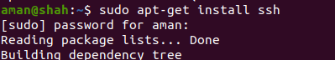

4. generate public key

ssh-keygen -t rsa -P “”

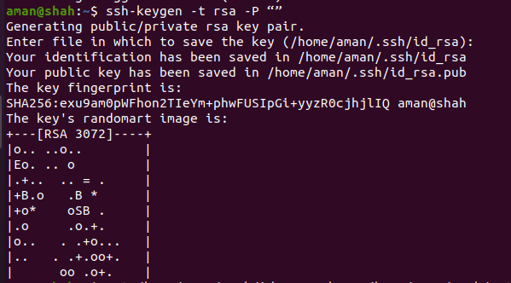

5. cat /home/aman/.ssh/id_rsa.pub >> /home/aman/.ssh/authorized_keys

**# configure files:**

**configure ~/.bashrc**

export JAVA_HOME=/usr/lib/jvm/java-11-openjdk-amd64  
export HADOOP_INSTALL=/home/aman/hadoop-3.2.2  
export PATH=$PATH:$HADOOP_INSTALL/bin  
export PATH=$PATH:$HADOOP_INSTALL/sbin  
export HADOOP_MAPRED_HOME=$HADOOP_INSTALL  
export HADOOP_COMMON_HOME=$HADOOP_INSTALL  
export HADOOP_HDFS_HOME=$HADOOP_INSTALL  
export YARN_HOME=$HADOOP_INSTALL  
export HADOOP_COMMON_LIB_NATIVE_DIR=$HADOOP_INSTALL/lib/native  
export HADOOP_OPTS=”-Djava.library.path=$HADOOP_INSTALL/lib”

**#provide java home to hadoop-env.sh**

#add following to core-site.xml

<property>

<name>hadoop.tmp.dir</name>

<value>/home/aman/hadoop-3.2.2/tmp</value>

<description>A base for other temporary directories.</description>

</property>

<property>

<name>fs.default.name</name>

<value>hdfs://localhost:54310</value>

<description>The name of the default file system. A URI whose

scheme and authority determine the FileSystem implementation. The

uri's scheme determines the config property (fs.SCHEME.impl) naming

the FileSystem implementation class. The uri's authority is used to

determine the host, port, etc. for a filesystem.</description>

</property>

**#mapred-site.xml**

<property>

<name>mapred.job.tracker</name>

<value>localhost:54311</value>

<description>The host and port that the MapReduce job tracker runs

at. If "local", then jobs are run in-process as a single map

and reduce task.

</description>

</property>

## Configuring hdfs-site.xml

sudo mkdir -p /usr/local/hadoop_store/hdfs/namenode  
sudo mkdir -p /usr/local/hadoop_store/hdfs/datanode

sudo chmod 777 /usr/local/hadoop_store/hdfs/namenode

sudo chmod 777 /usr/local/hadoop_store/hdfs/datanode

<property>

<name>dfs.replication</name>

<value>1</value>

</property>

<property>

<name>dfs.namenode.name.dir</name>

<value>file:/usr/local/hadoop_store/hdfs/namenode</value>

</property>

<property>

<name>dfs.datanode.data.dir</name>

<value>file:/usr/local/hadoop_store/hdfs/datanode</value>

</property>

**format new hadoop file system**

hadoop namenode -format

hadoop datanode -format

hdfs datanode -fromat

## Starting daemons of Hadoop

start-all.sh

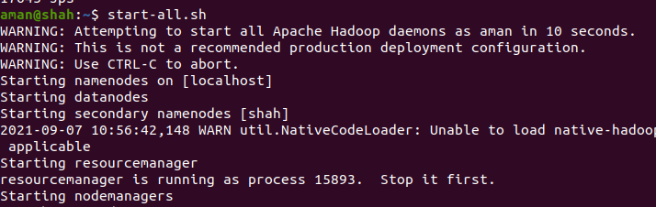

## Checking daemons

Jps

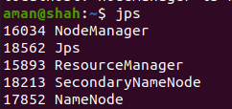

## Create HADOOP HOME

hadoop fs -mkdir -p /user/aman/

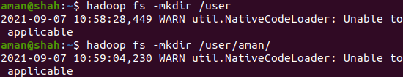

## Checking HDFS Web UI

localhost:9870

