1. Find all the tweets by user

ans.>>> tweets.select("text","user").show()

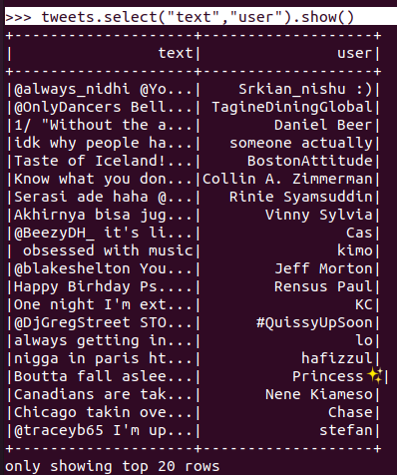



1. Find how many tweets each user has

ans. >>> tweets.groupby("user").count().show()

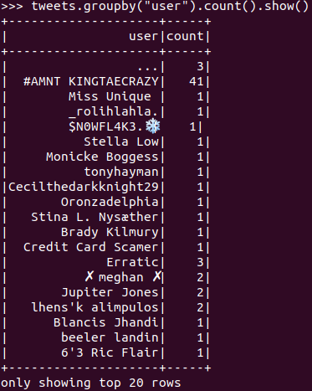

def persons_udf(x):

return re.findall(persons_reg, x)

persons = udf(lambda x: persons_udf(x), ArrayType(StringType()))

1. Find all the persons mentioned on tweets

>>> persons_mentioned_only=persons_mentioned.select("mentioned")

>>> persons_mentioned_only.show()

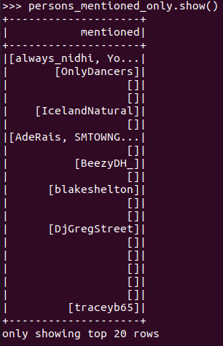

1. Count how many times each person is mentioned

>>> persons_count=persons_mentioned.groupBy("mentioned").count()

>>> persons_count.show()

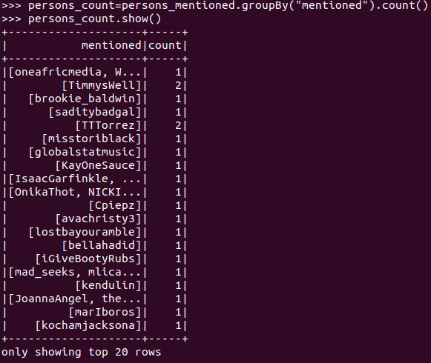

1. Find the 10 most mentioned persons

>>> persons_count.sort(desc("count")).show(10)

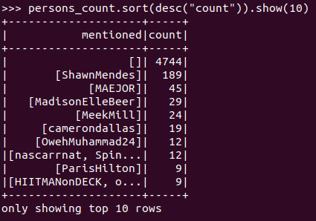

1. Find all the hashtags mentioned on a tweet

>>> tweets_hashtag.select("hashtag").show()

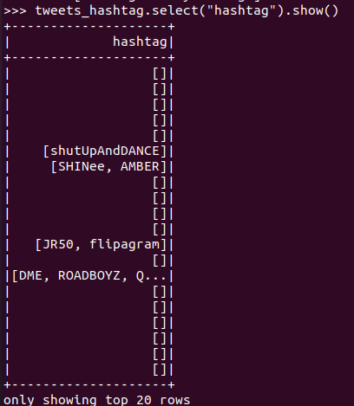

1. Count how many times each hashtag is mentioned

>>> hashtag_count=tweets_hashtag.groupBy("hashtag").count().show()

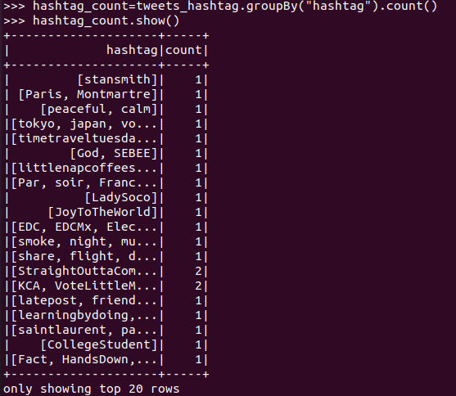

1. Find the 10 most popular Hashtags

>>> hashtag_count.sort(desc("count")).show(10)

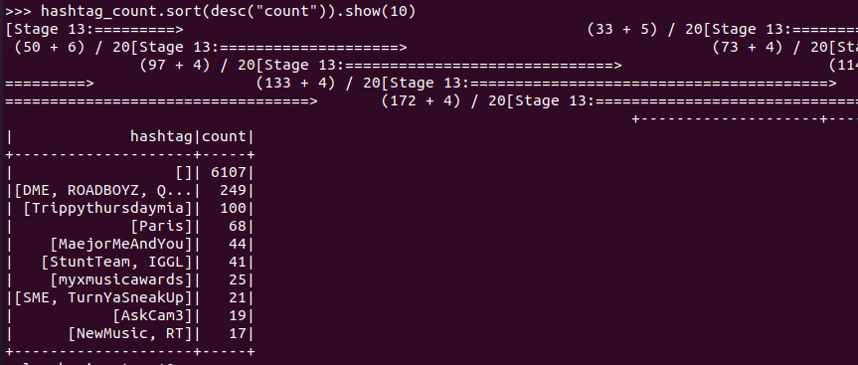

1. Find the top 5 countries which tweet the most.

>>> tweet=sqlCtx.read.json('/home/Downloads/tweets.json')

>>> a1=tweet.groupBy("country").count()

>>> a1.show()

>>> from pyspark.sql.functions import desc

>>> a1.sort(desc("count")).show(5)

